Segmentation

To get a product or service to the right person or company, a marketer would firstly segment the market, then target a single segment or series of segments, and finally position within the segment(s). .
Segmentation is essentially the identification of subsets of buyers within a market who share similar needs and who demonstrate similar buyer behaviour. The world is made up from billions of buyers with their own sets of needs and behaviour. Segmentation aims to match groups of purchasers with the same set of needs and buyer behaviour. Such a group is known as a 'segment'.
Segmentation is a form of critical evaluation rather than a prescribed process or system, and hence no two markets are defined and segmented in the same way. However there are a number of underpinning criteria that assist us with segmentation:
- Is the segment viable? Can we make a profit from it?
- Is the segment accessible? How easy is it for us to get into the segment?
- Is the segment measurable? Can we obtain realistic data to consider its potential?
The are many ways that a segment can be considered. For example, the car market could be segmented by: driver age, engine size, model type, cost, and so on. However the more general bases include:
- by geography - such as where in the world was the product bought
- by psychographics - such as lifestyle or beliefs
- by socio-cultural factors - such as class
- by demography - such as age, sex, and so on.
A company will evaluate each segment based upon potential business success. Opportunities will depend upon factors such as: the potential growth of the segment the state of competitive rivalry within the segment how much profit the segment will deliver how big the segment is how the segment fits with the current direction of the company and its vision.
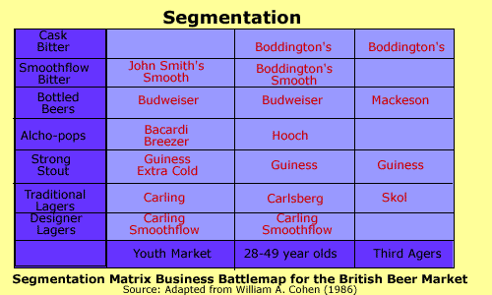
The Segmentation Matrix Business Battlemap is a useful segmentation tool. There are two bases for segmentation. Here we use beer brand versus ages groups. The various products are then plotted on the matrix. The result is a 'battlemap'

Targeting
Targeting is the second stage of the SEGMENT target POSITION process. After the market has been separated into its segments, the marketer will select a segment or series of segments and 'target' it/them. Resources and effort will be targeted at the segment. It's like looking at a dart board or a shooting target. You see that it has areas with different scores - these are your segments. Aiming the dart or the bullet at a specific scoring area is 'targeting'. There are three main types of targeting. They are considered below.
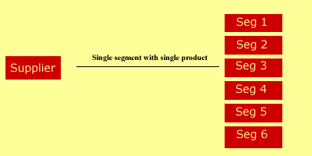
The first is the single segment with a single product. In other word, the marketer targets a single product offering at a single segment in a market with many segments. For example, British Airway's Concorde is a high value product aimed specifically at business people and tourists willing to pay more for speed.
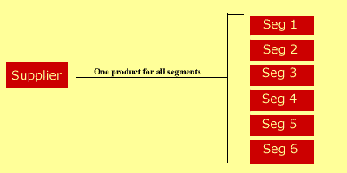
Secondly the marketer could ignore the differences in the segments, and choose to aim a single product at all segments i.e. the whole market. This is typical in 'mass marketing' or where differentiation is less important than cost. An example of this is the approach taken by budget airlines such as Go/Easyjet in the UK and Ryan Air in Eire.
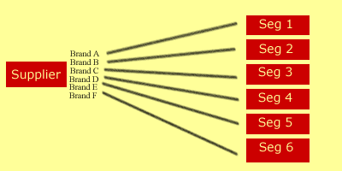
Finally there is a multi-segment approach. Here a marketer will target a variety of different segments with a series of differentiated products. This is typical in the motor industry. Here there are a variety of products such as diesel, four-wheel-drive, sports saloons, and so on.

Positioning
positioning
Now have a look at the final stage, positioning.
The third and final part of the SEGMENT - TARGET - POSTION process is 'positioning.' Positioning is undoubtedly one of the simplest and most useful tools to marketers. After segmenting a market and then targeting a consumer, you would proceed to position a product within that market.
Remember this important point. Positioning is all about 'perception'. As perception differs from person to person, so do the results of the positioning map e.g what you perceive as quality, value for money, etc, is different to my perception. However, there will be similarities.
Products or services are 'mapped' together on a 'positioning map'. This allows them to be compared and contrasted in relation to each other. This is the main strength of this tool. Marketers decide upon a competitive position which enables them to distinguish their own products from the offerings of their competition (hence the term 'positioning strategy').
Take a look at the basic positioning map template below.
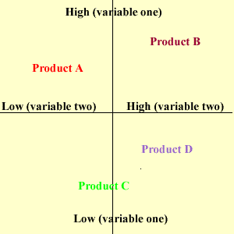
The marketer would draw out the map and decide upon a label for each axis. They could be price (variable one) and quality (variable two), or Comfort (variable one) and price (variable two). The individual products are then mapped out next to each other Any gaps could be regarded as possible areas for new products.
The term 'positioning' refers to the consumer's perception of a product or service in relation to its competitors. You need to ask yourself, what is the position of the product in the mind of the consumer?
Trout and Ries suggest a six-step question framework for successful positioning:
1. What position do you currently own?
2. What position do you want to own?
3. Whom you have to defeat to own the position you want.
4. Do you have the resources to do it?
5. Can you persist until you get there?
6. Are your tactics supporting the positioning objective you set?

Look at the example below using the car market
Product: Ferrari, BMW, Proton, Mercury Cougar, Hyundai, Daewoo.

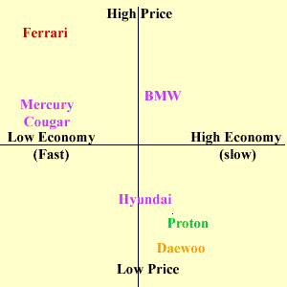
Positioning Map for Cars
The seven products are plotted upon the positioning map. It can be concluded that products tend to bunch in the high price/low economy(fast) sector and also in the low price/high economy sector. There is an opportunity in the low price/ low economy (fast) sector. Maybe Hyundai or Daewoo could consider introducing a low cost sport saloon. However, remember that it is all down to the perception of the individual.

