Newtown Pioneers Trading for Christmas (rider document)

This information will enable us to plan the facilities required for your stall which will allow us to prepare before the 10th of December 2014. It is crucial that all questions are answered and completed by Friday the 21st of November 2014.

- Name of your course:…………………………………………………………..
- Name of your course tutor: ……………………………………………………
- Name of your business:…………………………………………………………..
- How many students are in your group?……………………………………………
- What are your products? …………………………………………………………..
- Provide an estimate of how many products you have? ………………………………
- Do you require electricity for your stall? YES/NO
- Do your require wall space for your stall? YES/NO
- Do you require extra lighting for your stall? YES/NO
- Please state the time of setting up your stall. (Available times between 10:30am – 12:15pm, all stalls must be set up by 12:15pm).
…………………………………………………………..
- Do you require any other special requirements?……………………………………………
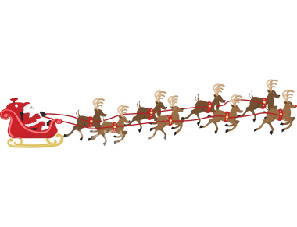
Document and £5 deposit to be handed in to Lucy or Clare at the back of the LRC between the 17th and 24th of November 2014 before 3.00pm at the latest.

