P7, P8, M3 – Health & Safety assignment

You have been appointed project manager of an adaptation and conversation of the brickwork workshop at NPTC group Neath Campus.
Your brief is to adapt the building to enable for it to achieve an A rating for energy performance. Extra floors are required to house a state of the art computer suit which needs to be powered by a green energy source. The building needs to be aesthetically in keeping with the surrounding buildings and the materials used must be from a sustainable source where possible. Explain what infrastructure is required to support the adaption process and evaluate three pieces of legislation applicable to the project.(M3)
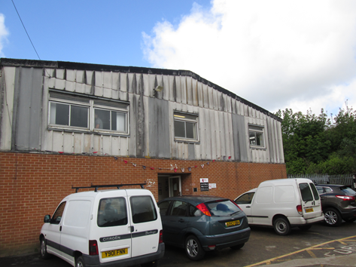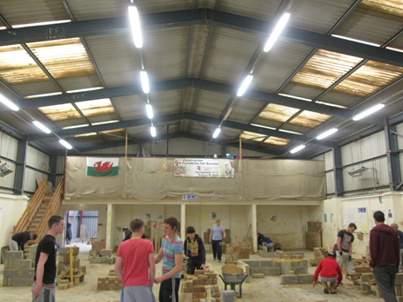

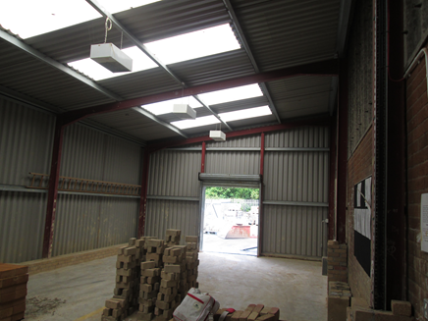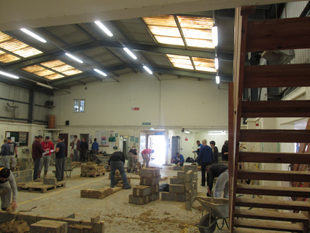

Temporary works
Temporary works will invariably exist on all construction works as they are usually required so that permanent works can be erected. They can vary from access through scaffolding or supporting material such as formwork. No construction is possible
In practice, temporary works will range from the provision of site hoardings or fencing, footpaths, signs, foundations and support to site cabins and accommodation units, trench and excavation supports, scaffolding, support of construction plant, through to the provision of falsework and formwork for reinforced concrete structures, temporary bracing and propping of structural frames under construction and temporary propping, shoring, facade retention and needling works for refurbishment. Temporary works can even include demolition projects.
Effective, safe and perhaps imaginatively designed temporary works solutions can bring significant benefit and add value to projects in terms of safety, certainty, productivity, efficiency, quality, completion times and cost.
On the other hand, poorly planned, designed, constructed, supervised and managed temporary works leave projects open to risks such as injuries or fatalities, the failure or collapse of both temporary and permanent works, damage to adjacent premises, and the consequent delays and increased costs.
Scaffolding – will ensure workers safety whilst working at heights.

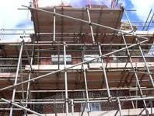

Road closure – as the building contains asbestos the road around the building and surrounding areas must be cornered off to prevent contamination.

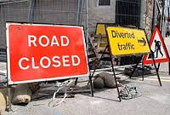

Sealed skips – professional teams must dispose of the asbestos materials in sealed skip containers to prevent .
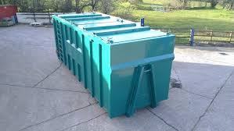

Showering facilities – because asbestos is present we need to ensure that showering facilities are in place for those who are working with it so that any lingering fibres can be washed off immediately.
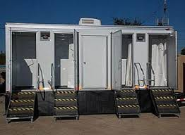

Toilets

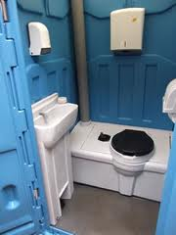
Canteen – provide a temporary port cabin to facilitate the workers so that they have somewhere to eat their lunch.

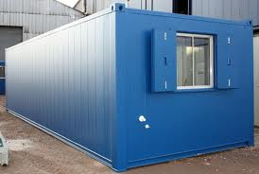

Disposable overalls – when removing asbestos disposable protective overalls must be work and disposed of in the correct asbestos bags.

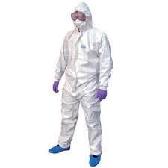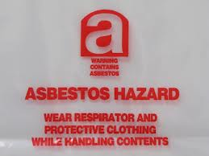

The steel frame of the brick workshop and the floor shall remain as both are in good working condition.
The brickwork itself is a cavity wall so this can be injected with cavity fill to provide insulation. The roof and asbestos cladding can be replaced with steel cladding which is an excellent insulator. Remember as the building has asbestos the proper precautions need to be taken to ensure the workers and those around the area are protected from asbestos fibres .
As you will see there is not enough natural light throughout the building so more skylights can be used to create this. Solar panels can be installed to generate electricity and also wind can be used to generate this also.

Legislations

COSHH
COSHH stands for the Control of Substances Hazardous to Health.
There are many different types of substances these are listed below:
- chemicals
- products containing chemicals
- fumes
- dusts
- vapours
- mists
- nanotechnology (is the manipulation of matter on an atomic, molecular, and supramolecular scale, this is laboratory use)
- gases and asphyxiating gases
- biological agents (germs). If the packaging which these chemicals come with has any of the hazard symbols then it is classed as a hazardous substance.
- germs that cause diseases such as leptospirosis or legionnaires disease and germs used in laboratories
Working at heights
- The purpose of working at height regulations is to prevent death and injury caused by a fall from height. If you are an employer or you control work at height (for example a supervisor) the Regulations apply to them. Employers and those in control of any work at height activity must make sure work is properly planned, supervised and carried out by competent people. This includes using the right type of equipment for working at height.
- Employers and those in control must first assess the risks.
- Employees have general legal duties to take reasonable care of themselves and others who may be affected by their actions, and to co-operate with their employer to enable their health and safety duties and requirements to be complied with.
- Working at height training is essential to minimise accidents, injury or even death.
Asbestos
The control of Asbestos came into force on 6 April 2012, updating previous asbestos regulations. They mean that some types of non-licensed work with asbestos now have additional requirements, i.e. notification of work, medical surveillance and record keeping.
Training is mandatory for anyone liable to be exposed to asbestos fibres at work. This includes maintenance workers and others who may come into contact with or disturb asbestos (e.g. cable installers), as well as those involved in asbestos removal work

Preparing the work area
_ Ensure safe access – you may need a mobile access platform.
_ Restrict access – minimise the number of people present.
_ Close doors. Use tape and notices to warn others.
_ Ensure adequate lighting.

Caution: AC roofs are always fragile and cannot bear weight.
Equipment

_ 500- and 1000-gauge polythene sheeting and duct tape
_ Warning tape and notices
_ Bolt cutter
_ Webbing straps and rope
_ Garden-type sprayer containing wetting agent
_ Bucket of water and rags
_ Asbestos waste container, eg labelled polythene sack
_ Clear polythene sack
_ Lockable skip for larger quantities of waste
_ Asbestos warning stickers

Personal protective equipment (PPE) – see sheet em6
Provide:
- disposable overalls fitted with a hood;
- boots without laces (laced boots are hard to
decontaminate); and
- respiratory protective equipment.

