Sample
Unit 2 Sustainable construction
Assignment 1
Lecturer: Bryan Shenton

Contents page
Page 1: Front Page
Page 2: Contents Page
Page 3: Pass 2- Explain four different forms of global pollution arising from construction projects?
Page 4: P3- Explain how four different forms of local pollution arising from construction projects may harm the local environment?
Page 5: P3- Explain how four different forms of local pollution arising from construction projects may harm the local environment?
Page 6: P3- Explain how four different forms of local pollution arising from construction projects may harm the local environment?
Page 7: P3- Explain how four different forms of local pollution arising from construction projects may harm the local environment?
Page 8: P3- Explain how four different forms of local pollution arising from construction projects may harm the local environment?
Page 9: P3- Explain how four different forms of local pollution arising from construction projects may harm the local environment?
Page 10: Pass 4 - Explain four key methods used to protect the natural environment from the impact of the construction and built environment sector.
Page 11: Pass 4 - Explain four key methods used to protect the natural environment from the impact of the construction and built environment sector.
Page 12: Pass 4 - Explain four key methods used to protect the natural environment from the impact of the construction and built environment sector.
Page 13: Pass 4 - Explain four key methods used to protect the natural environment from the impact of the construction and built environment sector.
Page 14: M1-Assess the potential environmental impact of a proposed construction project on the local natural Environment.
Page 15: M1-Assess the potential environmental impact of a proposed construction project on the local natural Environment.
Page 16: M1-Assess the potential environmental impact of a proposed construction project on the local natural Environment.
Page 17: M2-Compare the four key methods used to protect the natural environment in terms of cost, effectiveness and public perception?

Page 18: M2-Compare the four key methods used to protect the natural environment in terms of cost, effectiveness and public perception?

Page 19: D1- Assess the importance of addressing environmental issues for the mutual benefit of the community and individual construction firms?
Page 20:D1- Assess the importance of addressing environmental issues for the mutual benefit of the community and individual construction firms?
Page 21: D1: Assess the importance of addressing environmental issues for the mutual benefit of the community and individual construction firms?

Page 22: References
Page 23: References

P1-Describe six different features of the natural environment that must be considered at the planning stage of a construction project?
During the planning of the new super school Neath Port Talbot Council will have to consider these six features of the natural environment in order to gain planning permission to build the new school. These include:
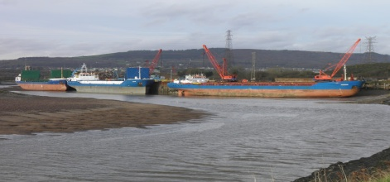
- Rivers are used for a number of water activities some of these could include swimming, fishing and sailing. Rivers need to be protecting also because of the wildlife that lives in the water. The waterways environment agency makes sure that people who fish in rivers have a license to do so. Rivers also control water usage and disposal. Rivers can also flood, meaning that the area may be prone to flooding.
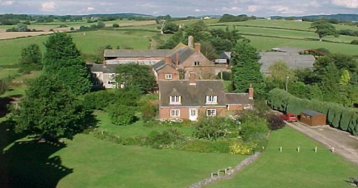
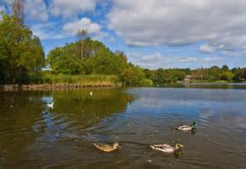
- Lakes are sometimes used in the tourism industry because of the lakes natural beauty. Some lakes are used by ferry companies’ example Lake Victoria in Africa. Lakes can sometimes flood so flooding needs to be taken into account. Flooding could mean that a project could be scrapped because of the risk of a flood.
- Agriculture needs to be considered at the planning stage because the local authority doesn’t allow planning permission on Greenfield sites. Also building on land used for agriculture will affect the local wildlife and environment as valuable land is lost.
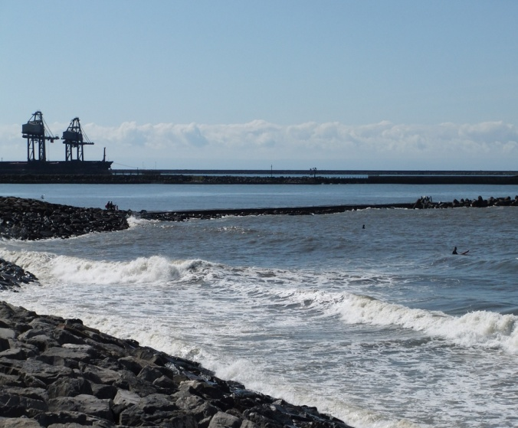
- Beaches need to consider at the planning stages of the new super school because beaches have natural beauty and also a lot of marine life. Sea life is unique and special test are taken to make sure sea life is not damaged. Beaches are protected by government laws and also developments near beaches are unlikely. As sandfields is near the beaches this needs to be monitored and tested in order to gain information about the harm the new school could course at the nearby beaches.
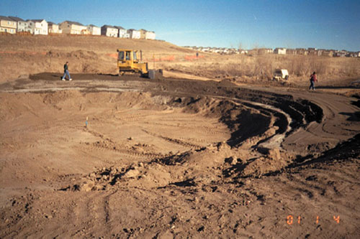
- Soil quality needs to be considered at the planning stages of the new super school because stronger soil particles meaning that the foundations don’t need to be dug that deep. Whereas weak soil particles mean that the foundations need to be dug deep. The type of soil can affect the planning stage because it the soil has to support the buildings and also the local environment example trees. The purpose area for the new super-school is near the beach so the land may be build on sand so tests need to be carried out to check for soil quality.
- Wildlife needs to be taken into account at the planning stages of the new super-school because wildlife is protected by national laws. Not obeying by the rules will results in a big fine and maybe prosecution. Certain animals are extinct so building on their habitats is forbidden. If a rare animal is found in the project area this will mean the project will be cancelled. The area around the proposed super-school needed to be monitored to check for habitats and wildlife around the area.

Pass 2- Explain four different forms of global pollution arising from construction projects?
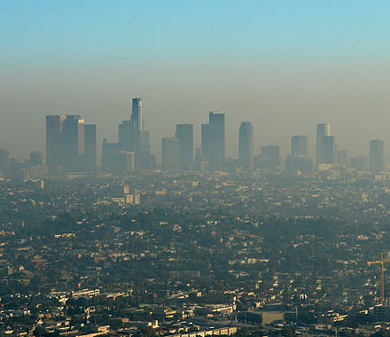
One form of global pollution arising from construction projects is Air pollution. Air pollution is caused throughout a project from the start to the finished project. Air population is caused by the burning of fossil fuels. Burning fossil fuels releases carbon dioxide when burnt; these carbon dioxide molecules are released into the ozone layer. A build up of carbon dioxide in the atmosphere will create a thick layer around the ozone layer which means the temperatures will rise. Normally in a construction site air pollution is given off during these periods in the construction timetable:
- Demolition of old buildings releases air pollution throughout the burning of fossil fuels to power demolition vehicles’.
- Dust is released into the local and global atmosphere due to the creation of concrete.
- The burning of fossil fuels to power machinery at the construction site.

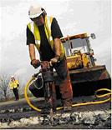
Another form of global pollution arising from construction projects is noise pollution. Noise pollution will normally occur during the demolition of a site and also the construction of the site. Noise pollution is the excess repeat of constant loud noise, at which can harm or seriously damage human hearing. Noise pollution cannot be stopped at construction sites but it can be minimized. Noise pollution at a construction site can cause a number of problems to people living near the construction project. In the United Kingdom money must be made available to give to local residents around a construction project as an act of compensation. Normally in a construction site noise pollution is given off during these periods in the construction timetable.
- The demolition of the previous building can create large amount of noise through the use of machines and sometimes explosives.
- The constant noise of vehicles’ (cement mixers) can cause problems to local residents and can cause large volumes of noise creating noise pollution.
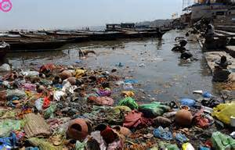
Another form of global pollution arising from construction projects is water pollution. Water pollution is the contamination of a local water supply caused by the dumping waste in a water course. Water pollution can cause a number of effects to local environments. Water pollution occurs on land when chemicals are disposed of through local drains, these drains lead to local rivers and this is then water pollution. Construction sites create water pollution when oil from machines leak on the ground and is then transported down the drains sometimes by rainwater. This oil then creates a thick layer of liquid which is released to local water supplies. Water pollution effects every corner of the globe in china around 90% of the water in its cities are polluted. In the United Kingdom water pollution is not common as water is monitored by the environment agency and if the water is polluted it can be traced to the source.
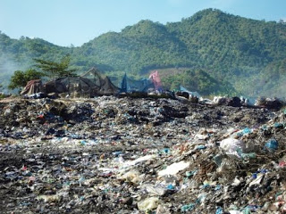
Another form of global pollution arising from construction projects is land pollution. Land pollution is the destruction of the earth’s land surface by the dumping of human resources example rubbish. In the construction industry land pollution is caused by waste material not being disposed off in the correct manner. Example: materials such as wood left over from a construction project are dumped in a local field. In the UK it is illegal to dump waste from a construction site; this is called fly-tipping. Land pollution can also be caused in a construction site when toxic waste/chemicals are poured or spilt onto local soil affecting the quality.

This is the design for the new super-school for sandfields.
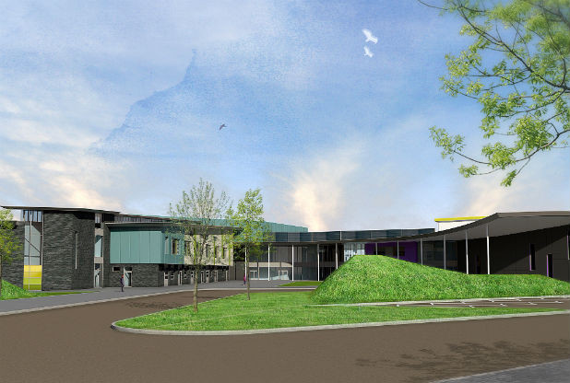
P3- Explain how four different forms of local pollution arising from construction projects may harm the local environment?
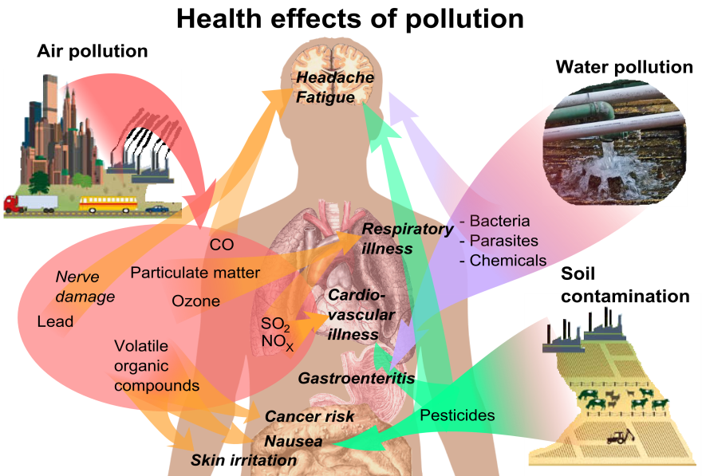
During constructing the new super school we need to think about different types of pollution that will be caused to the local area of sandfields. On nearly all construction sites around the world different types of pollution are caused. Some of these pollutions cannot be stopped or minimized, so I must make Neath Port Talbot a wear of the different types of pollution that can appear when construction projects are built. The 4 most common forms of local pollution that arise from construction projects are as follows:
- Noise pollution
- Air pollution
- Land pollution
- Water pollution

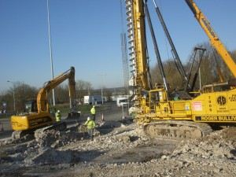
The most common form of pollution that arises from local construction projects is noise pollution. Noise pollution is the constant loud sound from construction projects that may cause harm to human health. Noise pollution will be caused throughout the super-schools construction some of the period large volumes of noise will be created are;
- Digging the foundations.
- Delivering of materials
- Building of the walls
- Uses of machinery i.e. cranes and cement mixers.

It is important to control the amount of noise being created during a construction project because the excess of noise can affect the local environment. A construction project in a busy urban area can affect the people of the areas sleeping patterns. The construction project can made people ill due to the lack of sleep as construction work starts early in the day and finishes sometimes late at night. Noise pollution can also affect the local environment such as wildlife. The constant volume of noise can scare the local wildlife and sometimes drive them away from their habitats. This will create a lack of wildlife around the site. The constant noise can annoy the local residents around the project as the loud noise distracts and stops them for their everyday lives .Noise pollution can also cause hearing problems due to the constant loud noises .This could mean that local people could turn deaf because of the constant noise.

Another form of pollution that arises from a local construction project is Air pollution. Air pollution is polluting of the atmosphere by the burning of fossil fuels. Air pollution will be created at different periods in the timetable of a construction project. Times that air pollution will causes are as follows
- During the manufacturing of materials to build the building.
- During the transportation of materials
- Burning fossil fuels to power machines
- Burning of fossil fuel to create concrete
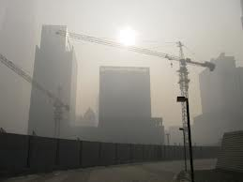
Air pollution can harm the local environment in a number of ways. Air pollution can cause harm to the environment by harming human health. High levels of air pollution around construction sites have caused a number of health problems some short-term others long-term. It has been proven that construction workers and local residents around construction project with high air pollution are left with deadly diseases such as lung cancer and heart diseases.
It has also proven that air population can also harm the local wildlife. It harms wildlife such as crop yields, flowers and animals. Air pollution can also kill wildlife in some extremely high levels of air pollution.
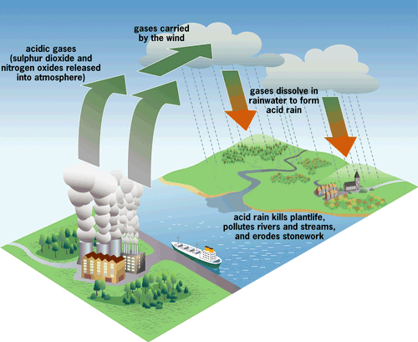
Air pollution being created from construction sites can also cause acid rain. Air pollution mixes with rain in the clouds and mixes together and causes acid rain. This acid rain can harm the environment as it damages old buildings (loss in heritage) and also damages the local planets by attacking the plants roots.
Possible affects on the area caused by acid rain.
A concrete factory
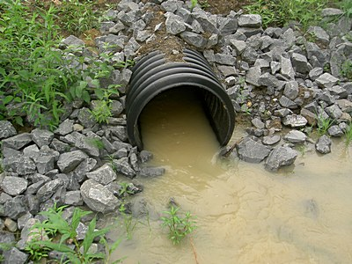
Another form of pollution that arises from local construction projects is water pollution. Water pollution caused by construction can harm the local environment. Water pollution is the contamination of a water supply due the dumping of toxic materials into a local water supply. In the United Kingdom not toxic waste is to be put down drains because it can affect local water supplies. All water supplies must be treated before beginning put down drains and all toxic waste must be disposed of correctly. Although water pollution is rare in the UK it can harm the local environment in a number of ways.
Water pollution can harm the environment in a number of ways some bad and some deadly. Water pollution can create water Bourne diseases through dumping in the river. Most water Bourne diseases can kill humans some of these disease include:
- Cancer (prostate cancer)
- Damage to the nervous system.
- Liver and kidney damage.
- Damage to DNA.
Most of the water Bourne diseases are created when chemicals are dumped in local water systems because people drink his water it is deadly. As a council you should make sure that liquids from the project must not reach local water supplies if necessary. These diseases harm the local environment as all the people will be affected or faced death. Water pollution can also affect the local wildlife by contaminating the wildlife’s water. Fishes can be badly affect by water pollution as algae builds up at the top of the water, this algae is eaten by local aquatic animals and may cause death. The algae can also kill local fish by spreading disease.
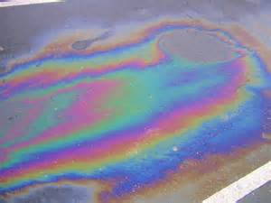
If a construction worker puts oil down a local drain this will causes an oil spill in a local water course. This is a bad case of water pollution and also can affect wildlife badly. The local wildlife example fishes can get covered in a thick layer of oil which will affect the animals. Oil spills will also prevent the animals from breading which will kill off a generation.
In a construction site if too much sodium chloride (salt) is poured down a local drill it will kill off the local aquatic wildlife. Water pollution can harm the local environment badly so when you as a council are going to dispose of liquid you should dispose of it correctly because if you dispose of liquids down a local drain it can harm the environment badly.

The last main type of pollution that arises from local construction project is land pollution. Land pollution is destruction of the earth land due to the misuse of resources example rubbish. On a local construction project land pollution can be caused by not disposing of materials or liquid properly, by not disposing the waste properly on the construction site can weaken and contaminate the soil. On a local construction project land pollution can be caused by the cutting down of large eco-logical areas (forests).Land pollution can affect the local environment badly some of these include.

- Human effects
- Environmental effects

Land pollution can harm humans badly, it can cause a number of health problems in humans some of these include some forms of cancer, cause problems to our skin and also affect our breathing. All of this comes from the disposal of materials near high populated areas. So humans get harmed by land pollution so we must minimize the chance of land pollution when building the new super-school. We must make sure that the land pollution does not reach these areas because if they do local people will be ill. Toxic waste from construction sites can reach human by:
- Coming into direct contact with the human skin.
- Being flushed into water supplies such as lakes and reservoirs.
- Breathing in particles from high risk areas of land pollution (example landfills)

Neath Port Talbot council must make sure that wasted materials should be disposed of correctly in order to prevent harm to the local environment.
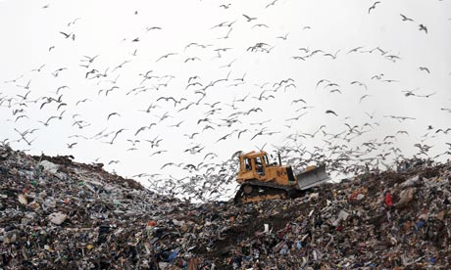
Land pollution can harm the environment badly. In order to dispose of materials correctly landfills must be created. A Landfill is a large hole in the ground and waste is dumped in the hole. Waste materials from construction project are taken to a dump in the UK if the materials can’t be recycled. Landfills can affect the environment in a number of ways.
Lots of land is lost in order to create the landfill and the land can never be used again as it is un-unable. Also landfill will mean an increase in the amount of rat because the rats breed as a result of the landfill. The rats may also cause diseases to both wildlife and humans. This means that there is a loss of wildlife. Neath Port Talbot council must try not to dispose of the waste in landfill.

Landfill which is a form of land pollution can affect humans in a number of ways. A landfill caused by the dumping of materials from construction site can create a bad smell/occur of a town. Landfills do not attract business and tourism which means a loss in business because of land pollution .Landfill causes a long of investment in a town so that means less income. Sometimes the waste is burned in construction sites which mean air pollution is created. Land pollution can harm the human environment with mostly an economic effect as a lot of money is needed to dispose of the waste in a way that does not harm the environment.

I have made neath port Talbot council are aware of the harm that pollution will cause to the local environment if the pollution is not controlled. I hope that Neath Port Talbot council have learned the effect that the new super-school will create to the area of sandfields if the pollution is not controlled. Neath Port Talbot council are aware that pollution can harm the local environment badly and must now put control measures in place to prevent the effects of pollution.
Pass 4 - Explain four key methods used to protect the natural environment from the impact of the construction and built environment sector.
When building the new mega school we need to be eco-friendly and also protect the local environment. To do this we plan on using four key methods that are used to protect the natural environment from the impact of the construction industry. It is important to look after and protect the Local environment around Sand fields. These four points include:
• Laws.
• Recycling.
• Design and specification.
• Minimization.
We need to apply these key methods to the design and building of the new super school in order to protect the local and natural environment around the area of sand fields.

1. The environmental legislation was created by the UK government to protect the natural environment. These are laws set by the United Kingdom’s government and monitored by the European Union in order to protect the natural environment from construction projects. These laws protect the environment by not giving planning permission if one of these areas is going to be affected by the new super school. These areas include:

• Water
• Air
• Chemicals
• Conservation
• Energy
• Land
• Noise and statutory nuisance
• Pollution prevention and control
• Waste

The environment agency monitors all of these areas in order to protect the natural environment. If we did affect one of these areas during building the new school you as a council could be left with a big fine and a court case. But all these areas are checked by the local authority/planning permission department before buildings can take place. If one of the areas were to be affected we may not gain planning permission as the legislation is protecting the environment.

2. one way of protecting the local environment is by designing the building to be eco-efficient. The design of a building is very important as some buildings can be extremely efficient the way they are built, maintained and powered. So During the planning stages of the super-school you as a council should ask the architect to design the school with a number of features. These features could include:

•Designing the school to run from solar panels on the schools roof. This would stop Fossil fuels being burnt in order to power the school. This would stop pollution and made the school more energy efficient.
•Designing the school to save rainwater in a water butt. Whenever a toilet is flushed it will use recycled rain water instead of fresh water. This will save the school money and also protect the environment as fresh water is not being wasted.
•Designing the school to use local materials such as slate, timber and many there materials. This would cut down on the amount of fossil fuels being burned to transport the materials to site. It would also benefit local business which is other plus side.
•By designing a building to let more natural light in the building to prevent lights being turned on during the day.

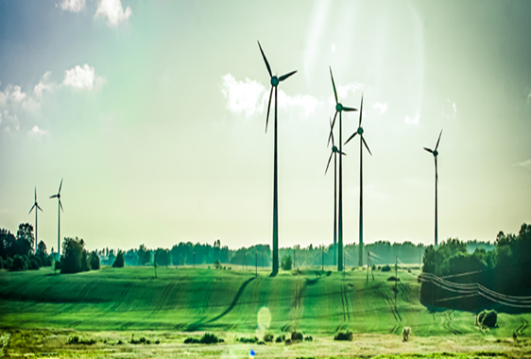
Normally old buildings are inefficient and have a negative impact on the local environment but an old building can also be made more energy efficient by some very easy methods. These include:
•Installing an energy efficient boiler which will cut down on the amount of fossil fuels needed to power it.
•Make sure that all lights are efficient by buying energy saving light bulb which will cut down on the brightness, power and also save money on the electric bills.
•Installing new more efficient insulation which will keep energy in the building and also cut down on the energy bills.
Through designing the building to be more efficient you as a council will make the school environment friendly as hardly no fossil fuels are being burned in order to power the school, so the school is not damaging the local environment by burning fuels which causes pollution.

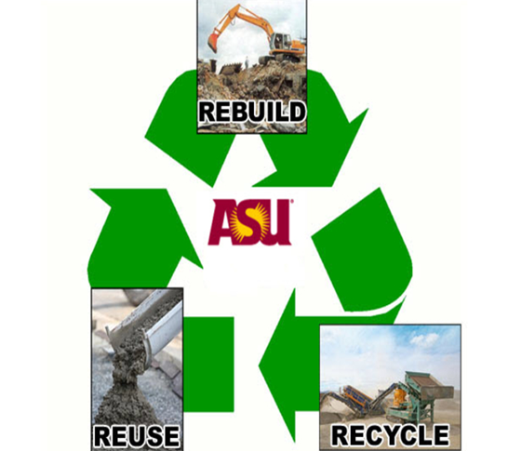
3. Recycling is one way of protecting the natural environment during the construction and completion of the new super school. Recycling is a big problem when constructing a building. Nearly half the time waste materials such as wood are put in a skip and transported to landfill. This is not helping or saving the local environment as landfills because land pollution as land is lost after landfill, Visual pollution is caused as landfills look ugly and also landfill can affect the health of local wildlife. So the only way to protect the environment is by recycling. We can recycle during the building and completion of the new super school these methods include:

•By making sure the quantity surveyor doesn’t over order on the amount of materials needed to construct the new school. This means that there are fewer materials that are thrown away.
•By making sure all excess materials are stored correctly in an area so the materials can be sold on or used on other project.
•By not using lots of skips, this prevents materials going to landfill.
•By using reduce, reuse and recycle methods.

These methods would mean that hardly any waste material is taken to landfill. This will protect the environment as land is lost, more materials are dumped and areas around landfills do not smell because of landfill.

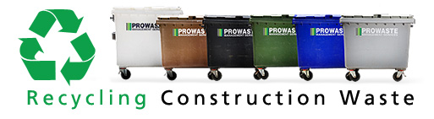

4. The last method that we can use to make the super school more eco-friendly is by the Minimization of natural resources. This means that we must make sure that little fossil fuels are burnt for the new super school. By minimization we are reducing the amount of pollution caused when constructing and maintaining the new school. Some ways of minimization of natural resources are as follows:

•Installing solar panels on the roof of the building which will mean constant power which will not damage the environment. By using solar panels we are using renewable energy which will minimize the use of natural resources because no fossil fuels are being burnt.
•Treating all foul water that is being used to construct the new school. By treating the foul water this will mean that there is less of a chance of water pollution. This means that no water systems are affected during the construction of the new school.
•Run a central heating system that is powered by bio-fuels. This will mean that no fossil fuels are being burned, which causes the greenhouse effect. This means that the school will produce zero emissions when powering the building.
•By reusing materials such as timber to make school benches and tables for the new school. This protects the environment as no more trees have to be cut down in order to make them.

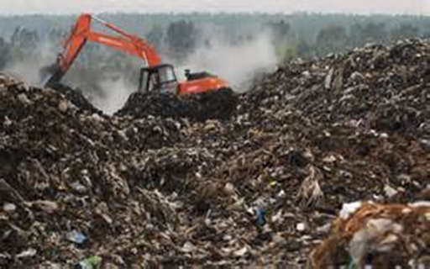
Through the method of minimization we will reduce the amount of natural resources being wasted .This will protect the natural environment as no fossil fuels are being burnt which will mean less pollution around the area of sand fields .I strongly belief that using these 4 key methods we will make sure that the new super school will be eco-friendly and not damage the natural environment around sand fields.

The architect’s final design of the new Sandfields super-school. This building will be sustainable and hopefully not pollute the local environment of sandfields due to the methods I have explained.

M1-Assess the potential environmental impact of a proposed construction project on the local natural Environment.

There are a number of potential environmental impacts of a proposed construction project; these impacts are spilt into 2 impacts.
• The local human environment
• The wildlife environment

Both of these factors are taken into account by the local authorities who give permission for projects to be built. A local building authority will look into the project and take facts into account. One account that must be taken into account is: can the project be supported by local services e.g. water, sewage and electricity. If a project does not have the services it can affect the local environment as pollution will Accor in the local natural environment. A proposed construction project will also mean an increase in traffic of an area; this will mean large amounts of air pollution are being created due to the increase in cars which can affect the local natural environment.
Sometimes a proposed construction project can cause deforestation in the local environment as Greenfield land is lost and trees are chopped down in order to build on the land. The removing of the natural land will release a sharp increase in the amount of pollution in the area because trees are not removing carbon dioxide from the area.
A proposed construction project can affect the local environment as sometimes habitats are lost in order to create new buildings. The loss of habitats in an area will mean that there is a loss of wildlife in an area. Wildlife from the area will be lost and animals will have to locate elsewhere.

First of all the site must be investigated in order to gain information about the future impact of a proposed construction project. Different land types (rural, urban and suburban) will all have different levels of impacts on the local natural environment. Also the size of the land can affect the impact of a proposed construction project, example a small house will have a less of effect on the environment rather than a stadium which will have a large scale affect. Then the local environment such as drainage pattern, soil type and bedrock conditions are tested and calculated to see if it the natural environment can cope with the new proposed project.

Some environment impacts of a proposed construction include:
- Polluting of water supply.
- Waste disposal.
- Combustion of product/machinery.

Polluting of water supply.

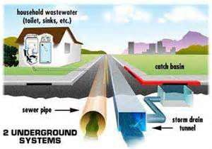
All properties in the United Kingdom are connected to a sewage control system.as the population is increasing and more construction project are arising there has been an increase in the amount of sewage that is being dispose of down our local sewage system. The increase of properties can put pressure on the sewage system. Areas were new housing or buildings are being built can increase the risk of flood. Much of our sewage system in the United Kingdom was built during the 1800th century our drain systems where built with drains to dispose of our surface water. At the time the purpose of the drains was to get rid of surface water as fast as possible. When this happens some of the surface water maybe contaminated. This contaminated water would go into local rivers increasing the risk of pollution. The drains were ineffective because there would be a high risk of floods when here is heavy rain water. The current system of drains cannot cope with the demands. Which means an increase of pollution around the area of a new construction site? The current system of drains cannot cope with the demands. There are a number of reasons why the system cannot cope, these include
• Concreting over grass which means the water cannot be filtered through the ground.
• The surface water has not where to go because of buildings so water built up and creates a flood.
• Over the last couple of decades the number of ponds have been filled in with soil so the rate of ponds around the United Kingdom have fallen meaning the water is not being filtered naturally.

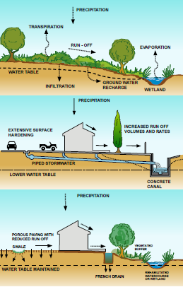
All of our sewage waste in the UK goes to a treatment centre to be cleaned and filtered.an increase of properties due to the increase of properties in area could mean that the treatment of the water could be treated slowly. A treatment centre may have to be upgraded or a new one would have to be built to support the increase of sewage created by the new development. This means more money but also a new treatment centre being built which is unpopular as it smells and creates high levels of pollution.

The increase in sewage and surface in our local drainage system means an increase of a likelihood of a flood. A flood which contains sewage could mean a huge environmental effect and also cost a lot of money to decontaminate the waste but also causes a number of health effects to humans and wildlife.

We can use sustainable urban drainage systems to reduce the pressure on local drainage systems. The design of (SUDS) is based on natural methods of reducing surface water. One method of (SUDS) is permeable paving, permeable paving allows storm water to flow straight the material and into the ground to create groundwater. Permeable paving reduces surface run off and reduces the risks of floods. Another method of (SUDS) is swales. Swales are a low and shallow channel where surface water flows down a gentle slope. The surface water is then soaked into the ground and encourages the growth of plants. This reduces the effect of flooding.
Another method of (SUDS) is to build a pond. A pond is effective because it stores lots of surface water.

Waste disposal
Every household in the United Kingdom creates household waste. The construction of the new school will result in an increase of de waste. The increase in the amount of houses being built means that the local council needs to deal with more waste. This means that money is being wasted by the local council; this money could have been better spent on the area. The council have to deal with waste such as household, plastic, cardboard and garden waste. When a new building is built it means that the council much find ways of disposing of the waste. During the disposing of the waste it create large of pollution such as
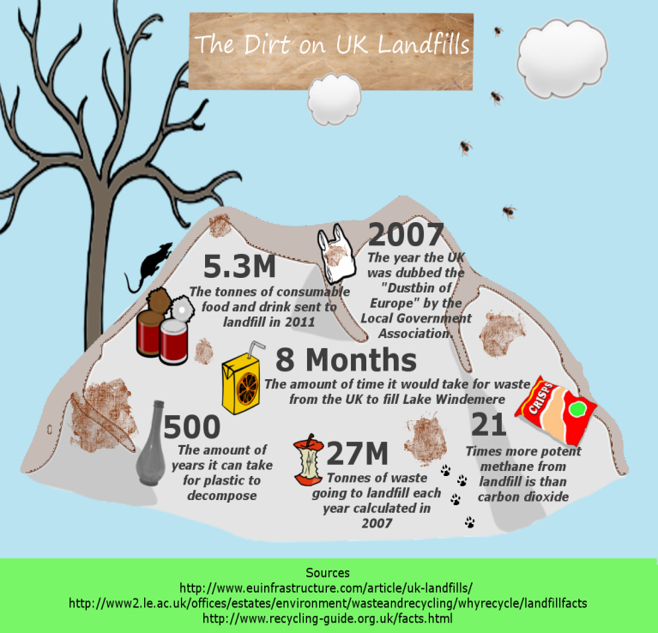
Landfill-this creates land pollution and also air pollution
Incineration creates large amounts of air pollution as burning the waste reacts carbon dioxide.
The main problem with the increase of waste caused by household waste means that few sites in an area are available to dispose of waste. This means higher council tax rates to local residents because the council needs to find new areas to dispose of waste.
The increase of waste caused by an increase of construction project in Swansea has left the council to limiting the collecting of black bags every two week and also every household can only dispose of 2 black bags every week. This has causes disputes against the local council and residents of Swansea city. This is all caused by the increase of housing being built in Swansea and the lack of landfill available. Swansea has no landfill left and black bags are sent to a Pembrokeshire landfills. This extra cost because of the increase of buildings which create waste.

Combustion of products/machinery
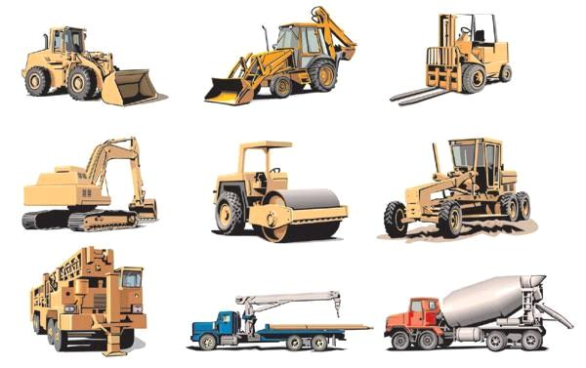
When constructing a building we will combust fuel in order to build the building. We normally combust fuels during the use of machinery. The effects of burning fossil fuels can be serious on the people of the local area, it can cause health effects such as asthma and lung cancer because the local people around an area live in an area with a high pollution level. The most common elements that results in the burning of fossil fuels are water vapour, carbon dioxide and nitrous oxide.

A construct project can also affect the people around the local environment by damaging the comfort of living in that area. When a new building is constructed it means that there is going to be an increase of noise which could annoy the local residents. The building of the super school will also result in an increase of cars using the main road by the proposed school. The road will also be extremely busy at peak times in the school timetable (8-9am and 3-4pm). This will annoy the past residents as they have to wait to get home. This traffic is caused by the increase of houses which also means an increase in cars in the local area. The increase of cars means an increase of pollution in the local area.
The construction of the new school could mean that sandfields becomes more unhygienic because more waste and pollution is being created from the building and maintaining of the school. The increase number of students using public transport will put pressure on transport inn sandfields. This will result in the people of sandfields being annoyed by the lack of public transport. The number of students travelling home from school will affect sandfields totally but also result in measures such as speed cameras, levelling crossings and reducing speeds limits.
M1-Based on information learnt from the book Building Services Engineering and Civil Engineering
By Topliss, Simon, Hurst, Mike, and Skarratt, Pearson Education, 2007. Web. 9 February 2015.
Copyright © 2007. Pearson Education. All rights reserved.
M2-Compare the four key methods used to protect the natural environment in terms of cost, effectiveness and public perception?

There are 4 main key methods I have used:
• Laws.
• Recycling.
• Design and specification.
• Minimization.

These 4 methods will protect the natural environmental but will also be efficient in terms of cost, effectiveness and public perception.
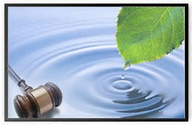
Laws such as the environmental legislation created by the UK government to protect the natural environment. These laws are effective because if they are disobeyed the perpetrator can face a fine or even a prison sentence. These laws prevent people damaging the environment because people will not want to face criminal changes. Some people find laws effective because they achieve their aim of protecting the environment. Laws set to prevent people from the local environment are also effective in terms of public perception. Some laws can annoy the members of the public because it results in them having to protect the environment which costs money. Laws are relatively cheap because they do not cost a lot of money to implicated laws. Laws are also set by government who speak on behalf of the people of a given country. Laws do not cost also to maintain because laws are rules at which a nation must follow to able to avoid damages to the country and its people.
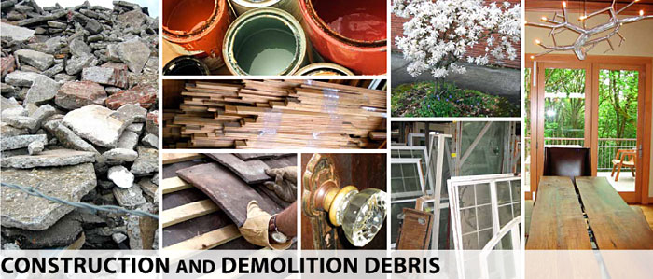
Recycling on a construction site can be a cost effective and time effective game.by the process of recycling can benefits both the company and local environment. Recycling can sometimes benefit the company because materials can be sold to a recycling company. This recycling company prevents materials going to landfill but recycled materials can also be returned back to other construction sites as new materials. Recycling also saves the company because it avoids having to pay a company to take the waste to a landfill site. When materials are separated it avoids the need for a skip, this prevents the company spending money to hire a skip. Recycling annoys some construction company because its means more effort because materials have to be stored and sorted in the correct facilities but some construction companies know think highly of recycling because it protect the environment and as a company they know it is their social responsibility to look after the environment. Recycling is effective because people now see it as positive because it is the way forward from landfill which damages the environment and also results in added costs to a project.
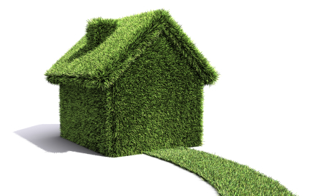
Designing buildings to be eco-efficient can protect the environment but also benefits the owner of the building for the long term. We can design the new super school to be eco-efficient by using a renewable energy source (Solar), grey water harvesting and geothermal heat sources. These sources of sustainable resources can benefits both the building and the local environment of sandfields. Designing the super school to be eco-efficient may cost a lot to implement but in the long time it will pay its self and the building will be earn money from being eco-efficient. http://www.moneymagpie.com/article/make-money-from-solar-panels states that you could get up to £750 a year from using solar panels on a small house roof. Imagine how much money we will earn from using solar panels on a school roof. Using eco-friendly methods pay them self so are cost effective. Designing the super school to be eco-efficient will be a good idea in the eyes of the general public as the site will be partially independent if it has its own energy source (solar) and its own water system (grey water system).This means that the new super school will not affect local serices.Also peoples believes that eco-efficient building are the future as they do not damage the local environment. As a hole designing the new super school to be eco-efficient is affective as it protects the environment, pays off its self-off in the long term but also save money/resources.

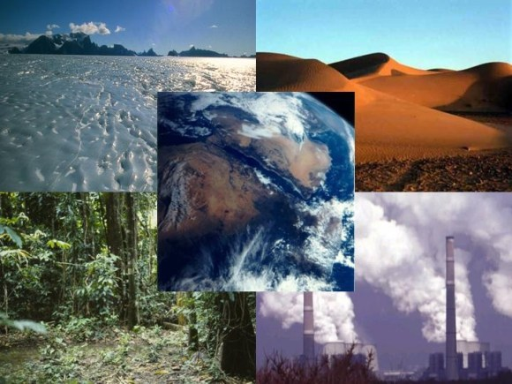
Another way of making the new super school eco-friendly is Minimization of natural resources. We can Minimization the use of natural resources by treating foul water, using solar panels and using a bio-mass fuelled central heating systems. Using these methods to use instead of fossil fuels are good in the eyes of the general public because people have realised that fossil fuel are running out.so people have realised that we need to limit the amount of fossil fuels we are using. Also people see fossil fuels as dirty so would approve of these methods when designing/building the new super school. Minimization of natural resources will cost a lot of money is implicate but when fossil fuel prices start to rise the school will save money because it is using a renewable energy source. Also it is cheaper to run from bio-fuel because they are cheaper to buy than petrol. As a hole Minimization of natural resources is effective as it is practically cost effective and people are starting to use more renewable energy sources.
D1: Assess the importance of addressing environmental issues for the mutual benefit of the community and individual construction firms?

In order to obtain a mutual relationship with residents living around the new sandfields super school we can use two environmental reports. Each report has the purpose of making sure that the local community and environment benefit from the construction of the new school. These include:

- BREEAM
- Environmental Management System Implementation.

In these reports we can identify problems at are going to occur due to the result of the constructing of the new super school. These 2 reports can benefit the company, the environment and most importantly the local community around sandfields.
BREEAM

BREEAM stands for Building Research Establishment Environmental Assessment Methodology. It was first used in the United Kingdom in 1990, since then it has been used on construction sites around the world. The purpose of BREEAM is to identify problems that will occur in the local environment due to a construction project. Another purpose of BREEAM is to make the client aware of ways to make the project as sustainable as possible by following steps set by assessors working for BRREEAM.If a project achieves the targets set by BREEAM the project will be rewarded with a BREEAM certificate.

BREEAM monitors a number of topics in the designing and constructing of a building to insure that it achieves a BREEAM certificate. The following areas are monitored in order for a site to become sustainable but also to benefit the local community around the site. These areas need to be sustainable in order to achieve a BREEAM certificate:
- That the site runs from renewable energy example solar panels, wind turbines and etc.
- That the site does not waste water and that some water is recycled in the building for example grey water systems.
- That the site will dispose of waste in the correct areas by using the three R’s (Reduce, Reuse and Recycling)
- That the site has good public transport links for example bike lanes, bus routes and other forms of public transport to reduce the amount of cars on the road of the area. The community around the new site will benefit from fewer cars on the road because it will limit the amount of pollution in the area.
- That the company is treating its workforce in a correct manner and also taking in to account how the workers are feeling. The employers also need to address problems that will occur to benefits the workforce.
- That the site is not polluting the local environment.
- That the site is following the planning authorities guide lines in order to protect the local environment but also to protect the ecology of the site.
- That the site is being managed correctly that that everyone in the hierarchy is being managed fairly and correctly.
- That the site is using sustainable materials and suppliers for example using local materials and suppliers.

One of the most important factors when planning a new project is to keep the local people happy but also not to damage the local environment. By using BREEAM we can identify how the site is unsustainable and use methods to make the site sustainable. Making the site sustainable will benefit the local area but also benefit the local community. The site will benefits from using BREEAM for the following reasons.
- The site and properties around the site will benefit from higher rent because the area has been redeveloped. The site will also benefit from higher rent because the area is environmental friendly community because of the BREEAM certificate.
- The site will benefit from being easy to market due to the BREEAM status of the site, which will encourage people to invest/buy into the site.
- Most importantly having a BREEAM certificate also means that the site has not damaged the local environment through the measures followed by the BREEAM guidelines.
- The site will be noticed internationally because of its BREEAM status because of BREEAM is recognised internationally which means that people can be informed that the site is “sustainable”
- The site will benefit from reduced energy bills because of the site is being run from renewable energy (solar) which run free of cost once installed.
- By using a BREEAM it makes the local people aware that the site is not damaging the local environment.

A construction company using BREEAM can be rewarded with benefits from using this assessment. These benefits include:

- The company will be promoting the fact that it is sustainable (green image)
- That the company is trying to look after the environment and fulfilling social responsibility of looking after the planet.
- The company and its workforce are well trained in using/following guidelines to achieve BREEAM; this implies that the company has a good practice.

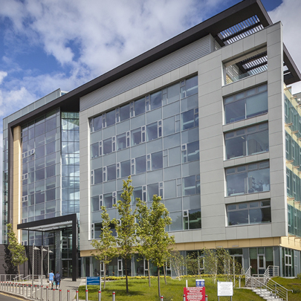
An example of A BREEAM Building is the Institute of Life Science building at Swansea University. The building has had an Excellent BREEAM rating with a score of 74.9%.The educational building gained BREEAM for the following reasons.
- The building has a Low energy usage (energy performance certificate score of 34 [B rated building).
- 90% of construction waste was diverted from landfill.
- The maximum available water credits were achieved.
- The maximum available water credits were achieved.
- The building is powered by a combined heat and power system which heats the building.
- BREEAM accredited professional employed from RIBA Stage B through to handover.

We should use this template when designing the new sandfields super school to achieve BREEAM status

BREEAM building learnt at http://www.breeam.org/page.jsp?id=520
Another Assessment we can use to identify environmental issues is environmental management system (EMS).A environmental management system is used by a construction company to plan out the environmental factors of a project. An EMS involves a company planning the project to insure that the environment is not polluted at any stage in the construction timetable. There are many different types of EMS but the most widely used is International Organization for Standardization (ISO) 14001.
One of the main targets of the EMS programme includes reducing the amount of waste created from the use and building of the site.EMS has 2 goals at which it will try to achieve.
- Compliance means conforming to a rule, such as a specification, policy, standard or law.
- Waste reduction is more important than compliance. The EMS insures that waste is reduced by recycling.

The benefits of using EMS can benefit both a construction company and the local residents around the construction site.

Benefits for the companies include:
- The company is known locally due to the fact of its EMS status.
- It also shows that the company can carry out a project to an EMS standard.
- Having completed an EMS project will promote a company. As it shows that the company thinks about the environment.
- The company may have an increase of sale opportunities because clients are now looking for construction companies that have experience Following a EMS programme.
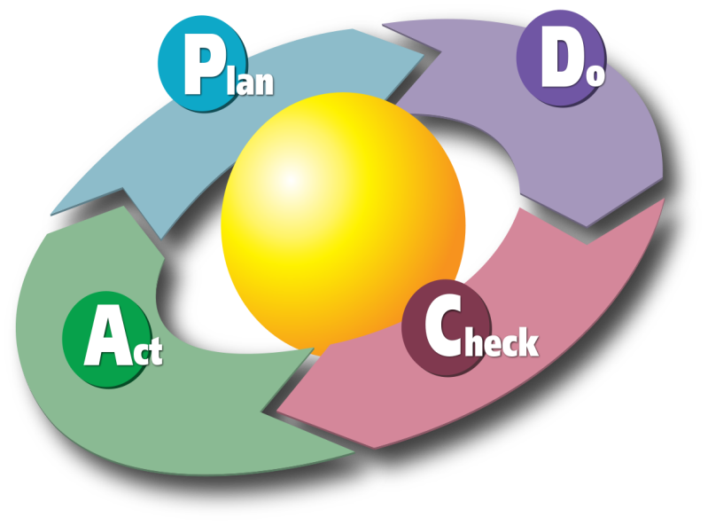
Companies that have implemented EMSs have experienced benefits such as:
- better environmental performance
- cost savings in operations
- increased efficiency of operations
- lower insurance costs
- improved public relations
Information found at http://www.epa.gov/dfe/pubs/pwb/case_stu/case8/index.htm

Benefits for the local community include:
- A better living environment for the local community because the local area has not been polluted.
- The area would have been redeveloped means better life style.
- The EMS could lead to more investment in the area.
- The EMS could also generate power for the local area.
- The EMS could also create jobs in the area as big and small business now like to be locate in eco-friendly buildings.

Picture References

Picture of | Taken from
Picture of health effects of pollution | http://upload.wikimedia.org/wikipedia/commons/d/df/Health_effects_of_pollution.png
Mouth of the river Neath | http://3.bp.blogspot.com/-9oG16aQzS8M/T0A3cwSE3DI/AAAAAAAAAqo/5ZNCLuwBWgY/s640/GIANTS+WHARF+1+25.11.11.jpg
Picture of Wildlife in Gnoll park | https://c1.staticflickr.com/9/8449/8048643755_1974d8bc1c_z.jpg
Welsh Countryside | http://1.bp.blogspot.com/--DfRAaYgSfg/T60ZAZWYKII/AAAAAAAAZGg/ZDigR-KRCSk/s1600/Farm+&+Countryside,+Wales.jpg
Sea life at Aberavon beach | http://www.ukwanderer.com/wp-content/uploads/2013/05/Aberavon-Beach-alexliivet-Flickr.jpg
Soil quality | http://www.landandwater.com/features/vol45no4/vol45no4_2A.jpg
Wildlife in Neath | http://1.bp.blogspot.com/-bCaQ_Sc2BSA/U4383mAE3qI/AAAAAAAAADc/ipJZM4OD06w/s1600/Stonechat+juvenile.jpg
Smog In city | http://img.allvoices.com/thumbs/event/609/480/60167883-air-pollution.jpg
Construction worker drilling | http://cravendc.gov.uk/media/image/k/1/Construction_Noise.jpg
Water Pollution in India | http://www.bing.com/images/search?q=water+pollution++&qs=n&form=QBIRMH&pq=water+pollution+&sc=8-16&sp=-1&sk=#view=detail&id=878A947AC537B3BBBF52B73D82B02D7C1A48F98D&selectedIndex=5
Land Pollution | http://2.bp.blogspot.com/_SVHwLqCV3Gw/SqunsNNE3uI/AAAAAAAAAAc/XCiW7icoC6Q/s320/M__ll.jpg
Super school design front | http://www.southwales-eveningpost.co.uk/images/localworld/ugc-images/276352/Article/images/23025275/6974809-large.jpg
Health effects of pollution | http://upload.wikimedia.org/wikipedia/commons/d/df/Health_effects_of_pollution.png
Drilling at a construction site | http://www.dacassociates.net/site_media/services/2010/06/24/Fawn_Drive_Pier_Drilling_Construction_Observation.jpg
Pollution in Chinese city | http://switchboard.nrdc.org/blogs/alin/peering_through_the_haze_addre.html
Acid rain effects on environment | http://4.bp.blogspot.com/-zQWe_rElox8/TcCXgCYJrmI/AAAAAAAAAAw/ZESFBH92c0w/s1600/chart.gif
Water pollution on construction site | http://www.bing.com/images/search?q=water+pollution+on+construction+site+&qs=n&form=QBIR&pq=water+pollution+on+construction+site+&sc=0-16&sp=-1&sk=#view=detail&id=87FDF2433FB6C2352DE1819110BAFDAADAB0A9B3&selectedIndex=18
Polluted lake | http://gallagher-photo.com/wp-content/uploads/2013/08/Jakarta-Water-Pollution-02-990x660.jpg
Oil in local water supply | http://images.tribe.net/tribe/upload/photo/855/548/8555485c-b30a-40b7-84ff-6f3cb72789bf
Picture of landfill | http://blogs.ft.com/energy-source/files/2011/01/Landfill.jpg
Eco-Friendly logo | https://healthylifesolution.files.wordpress.com/2010/07/ecofriendly.jpg
Law legalisation | http://alkeram.com/onewebstatic/75c584b2a5-LawAndLegislation.jpg
Environment agency logo | http://www.loeser.us/flags/images/england/environment_agency.gif
Sustainable buildings | http://blog.trilogybuilds.com/files/2012/12/sustainable-building.jpg
Wind turbine | http://s0.geograph.org.uk/geophotos/01/87/97/1879702_7a8f97d8.jpg
Reduce, reuse and recycle | http://www.greenwerkspro.com/wp-content/uploads/2013/03/Recycle-Reuse-And-Rebuild-e1363268866958.jpg
Recycling construction waste | http://www.prowaste.co.uk/images/recycling-construction-waste.jpg
Picture of landfill | http://blogs.ft.com/energy-source/files/2011/01/Landfill.jpg

Final Design for the new super school | http://www.southwales-eveningpost.co.uk/images/localworld/ugc-images/276352/Article/images/21206844/6191009-large.jpg
Environmental sustainable | http://www.denora.it/Img/Company/EnvironmentProtection/Environmental-Sustainability.png
Water drainage system | http://www.lvstormwater.com/pics/srtsrfce.jpg
SUDS design | http://www.capetowninvasives.org.za/sites/default/files/uploads/documents/SUDS%20Thumbnail.png
Landfill figures | http://naturallyearthfriendly.com/wp-content/uploads/2012/07/UKs-Landfill-Crisis.png
Combustion of construction products/machinery | http://darmtrading.webs.com/Construction_Machinery.jpg
plan act do check EMS | http://ideicuvinteculori.files.wordpress.com/2010/06/pdca-plan-do-check-act1.png
Laws | http://www.bing.com/images/search?q=environmental+laws&FORM=AWIR#view=detail&id=8E7EF90D23D9B495499846CED5DDCC8EEA06178D&selectedIndex=3
Recycled construction materials | http://www.clark.wa.gov/recycle/images/Const_and_Demo/ConstructionHeading.jpg
Eco-friendly building | http://homecareincremodeling.com/wp-content/uploads/2012/06/Eco-Friendly-House.jpg
Natural environment | http://tarcas.org/wp-content/uploads/2011/02/natural-resources.jpg
BREEAM logo | http://www.bouygues-projects.co.uk/sites/default/files/imagecache/zoom/Picture1774.jpg
BREEAM university building | http://www.barbourproductsearch.info/Marley_Eternit_Swansea_University_Research_Facility-file040688.JPG

Books

M1 based on information learnt from the book Building Services Engineering and Civil Engineering
By Topliss, Simon, Hurst, Mike, and Skarratt, Pearson Education, 2007. Web. 9 February 2015.page
Copyright © 2007. Pearson Education. All rights reserved.

Internet

BREEAM Case study http://www.breeam.org/page.jsp?id=520
EMS Company benefits http://www.epa.gov/dfe/pubs/pwb/case_stu/case8/index.htm

