Unit 2 Sustainable Construction

Assignment 2
Lecturer: Bryan Shenton

Contents page
Page 1: Front Page
Page 2: Contents Page
Page 3: Pass 4 - Explain four key methods used to protect the natural environment from the impact of the construction and built environment sector.
Page 4: Pass 4 - Explain four key methods used to protect the natural environment from the impact of the construction and built environment sector.
Page 5: Pass 4 - Explain four key methods used to protect the natural environment from the impact of the construction and built environment sector.
Page 6: Pass 4 - Explain four key methods used to protect the natural environment from the impact of the construction and built environment sector.
Page 7: P5-explain three different, fit-for-purpose sustainable construction techniques

Page 8: P5-explain three different, fit-for-purpose sustainable construction techniques
Page 9: P5-explain three different, fit-for-purpose sustainable construction techniques
Page 10: P5-explain three different, fit-for-purpose sustainable construction techniques
Page 11: M2-Compare the four key methods used to protect the natural environment in terms of cost, effectiveness and public perception?

Page 12: M2-Compare the four key methods used to protect the natural environment in terms of cost, effectiveness and public perception?
Page 13: M2-Compare the four key methods used to protect the natural environment in terms of cost, effectiveness and public perception?
Page 14: M3-Compare sustainable construction techniques in terms of relative cost and performance.

Page 15: M3-Compare sustainable construction techniques in terms of relative cost and performance.

Page 16: D2 Justify the use of appropriate sustainable construction techniques for a specified construction project.

Page 17: D2 Justify the use of appropriate sustainable construction techniques for a specified construction project.

Page 18: D2 Justify the use of appropriate sustainable construction techniques for a specified construction project.

Page 19: References

Pass 4 - Explain four key methods used to protect the natural environment from the impact of the construction and built environment sector.
When building the new mega school we need to be eco-friendly and also protect the local environment. To do this we plan on using four key methods that are used to protect the natural environment from the impact of the construction industry. It is important to look after and protect the Local environment around Sand fields. These four points include:
• Laws.
• Recycling.
• Design and specification.
• Minimization.
We need to apply these key methods to the design and building of the new super school in order to protect the local and natural environment around the area of sand fields.

1. The environmental legislation was created by the UK government to protect the natural environment. These are laws set by the United Kingdom’s government and monitored by the European Union in order to protect the natural environment from construction projects. These laws protect the environment by not giving planning permission if one of these areas is going to be affected by the new super school. These areas include:

• Water
• Air
• Chemicals
• Conservation
• Energy
• Land
• Noise and statutory nuisance
• Pollution prevention and control
• Waste

The environment agency monitors all of these areas in order to protect the natural environment. If we did affect one of these areas during building the new school you as a council could be left with a big fine and a court case. But all these areas are checked by the local authority/planning permission department before buildings can take place. If one of the areas were to be affected we may not gain planning permission as the legislation is protecting the environment.

2. one way of protecting the local environment is by designing the building to be eco-efficient. The design of a building is very important as some buildings can be extremely efficient the way they are built, maintained and powered. So During the planning stages of the super-school you as a council should ask the architect to design the school with a number of features. These features could include:

•Designing the school to run from solar panels on the schools roof. This would stop Fossil fuels being burnt in order to power the school. This would stop pollution and made the school more energy efficient.
•Designing the school to save rainwater in a water butt. Whenever a toilet is flushed it will use recycled rain water instead of fresh water. This will save the school money and also protect the environment as fresh water is not being wasted.
•Designing the school to use local materials such as slate, timber and many there materials. This would cut down on the amount of fossil fuels being burned to transport the materials to site. It would also benefit local business which is other plus side.
•By designing a building to let more natural light in the building to prevent lights being turned on during the day.

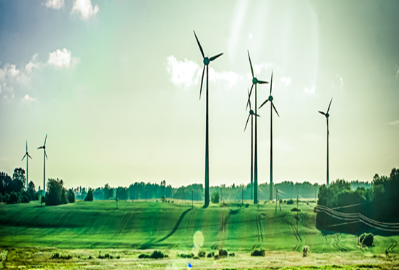
Normally old buildings are inefficient and have a negative impact on the local environment but an old building can also be made more energy efficient by some very easy methods. These include:
•Installing an energy efficient boiler which will cut down on the amount of fossil fuels needed to power it.
•Make sure that all lights are efficient by buying energy saving light bulb which will cut down on the brightness, power and also save money on the electric bills.
•Installing new more efficient insulation which will keep energy in the building and also cut down on the energy bills.
Through designing the building to be more efficient you as a council will make the school environment friendly as hardly no fossil fuels are being burned in order to power the school, so the school is not damaging the local environment by burning fuels which causes pollution.

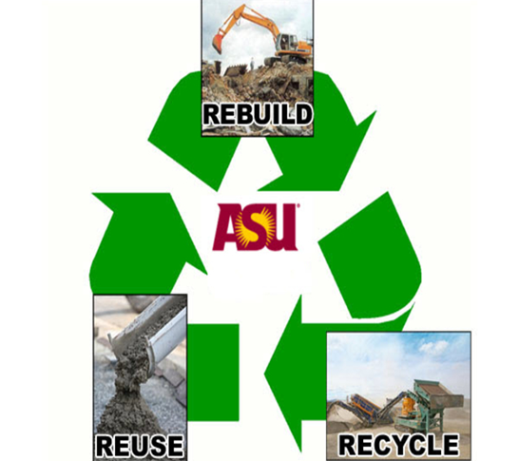
3. Recycling is one way of protecting the natural environment during the construction and completion of the new super school. Recycling is a big problem when constructing a building. Nearly half the time waste materials such as wood are put in a skip and transported to landfill. This is not helping or saving the local environment as landfills because land pollution as land is lost after landfill, Visual pollution is caused as landfills look ugly and also landfill can affect the health of local wildlife. So the only way to protect the environment is by recycling. We can recycle during the building and completion of the new super school these methods include:

•By making sure the quantity surveyor doesn’t over order on the amount of materials needed to construct the new school. This means that there are fewer materials that are thrown away.
•By making sure all excess materials are stored correctly in an area so the materials can be sold on or used on other project.
•By not using lots of skips, this prevents materials going to landfill.
•By using reduce, reuse and recycle methods.

These methods would mean that hardly any waste material is taken to landfill. This will protect the environment as land is lost, more materials are dumped and areas around landfills do not smell because of landfill.

4. The last method that we can use to make the super school more eco-friendly is by the Minimization of natural resources. This means that we must make sure that little fossil fuels are burnt for the new super school. By minimization we are reducing the amount of pollution caused when constructing and maintaining the new school. Some ways of minimization of natural resources are as follows:

•Installing solar panels on the roof of the building which will mean constant power which will not damage the environment. By using solar panels we are using renewable energy which will minimize the use of natural resources because no fossil fuels are being burnt.
•Treating all foul water that is being used to construct the new school. By treating the foul water this will mean that there is less of a chance of water pollution. This means that no water systems are affected during the construction of the new school.
•Run a central heating system that is powered by bio-fuels. This will mean that no fossil fuels are being burned, which causes the greenhouse effect. This means that the school will produce zero emissions when powering the building.
•By reusing materials such as timber to make school benches and tables for the new school. This protects the environment as no more trees have to be cut down in order to make them.

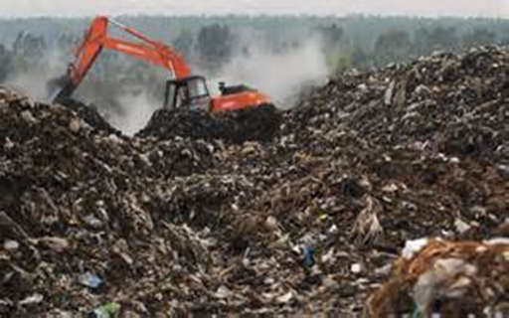
Through the method of minimization we will reduce the amount of natural resources being wasted .This will protect the natural environment as no fossil fuels are being burnt which will mean less pollution around the area of sand fields .I strongly belief that using these 4 key methods we will make sure that the new super school will be eco-friendly and not damage the natural environment around sand fields.

The architect’s final design of the new Sandfields super-school. This building will be sustainable and hopefully not pollute the local environment of Sandfields due to the methods I have explained.

P5-explain three different, fit-for-purpose sustainable construction techniques

As we well know sustainability is now an important area in construction. As years have developed clients have realised that there is now a need for sustainable construction techniques. All of these techniques with prevent us from wasting valuable human resources and help the client achieve a sustainable building. There are 3 main sustainable techniques that we can use when designing a project to be as sustainable as possible to achieve sustainable ratings such as BREEAM. These 3 sustainable construction techniques are:

- Waste based techniques
- Materials based techniques
- Energy based techniques

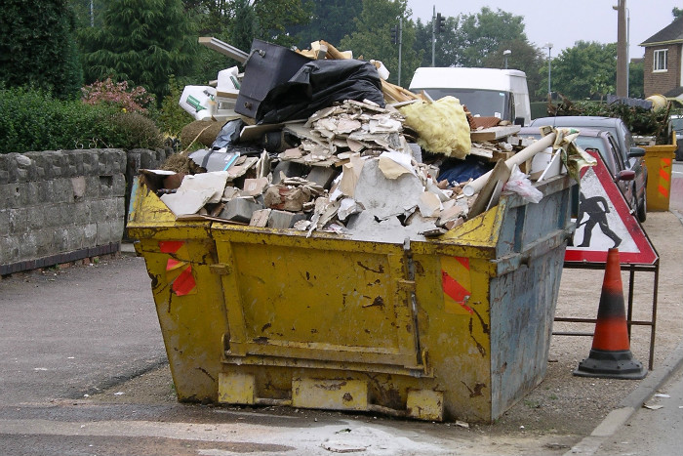
(1) The first sustainable construction technique is waste based techniques .Throughout a building lifetime we are creating waste both in the construction and demolishing processes. Most waste needed to be sent to landfill which takes up valuable land and harms the environment. When designing a building we need to insure how sustainable the material is. We must now insure that the materials can either by reused or recycled once a building has been demolished. When designing a building we must insure that we are not over ordering materials because this will be a waste of resources which we sent to landfill. We can do the following techniques when designing a sustainable building these include:
- Using steel frame construction because the steel can be re-melted in a steel works to create new steel.
- Using materials that can be reused after the building is knocked down for example wooden structure can be turned into wooden chippings.
- Find a company that will turn the waste products into new products.
- Burning the materials to create heat/energy for example burning wood for a fireplace.
- Educate labourers to teach them the importance of reducing waste to save the environment.
- Educate specially trained operatives to limit the amount of waste.
Many construction companies are now offering staff bonus and incentives for limiting the about of waste created during a project. This is because it will save money that would have been sent to put materials in landfill.

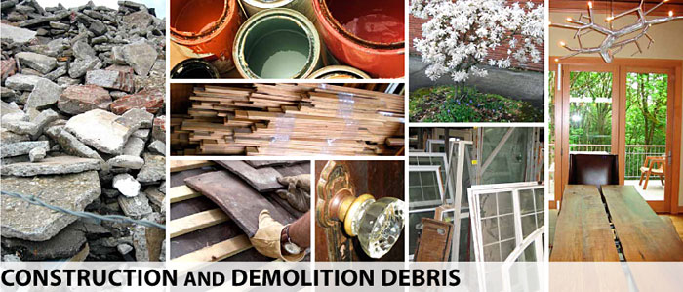
Recycling is another technique that we can use to make a project more sustainable. Many companies offer materials that have been used in sites that have been demolished. When a site is demolished we can recycle most of the materials. We can recycle lots of materials and use them as new materials for the new site. Typical materials that can be recycled and be reused as another materials include:
- Old facing bricks from old building can be put through a cleaning process to be reused in on a new project.
- Glass can be put through a process to create new fresh glass.
- Concrete can be crushed to be used to raise the ground of a new site.

We can also buy new materials from a supplier that overuse the amount of packaging put on a material.

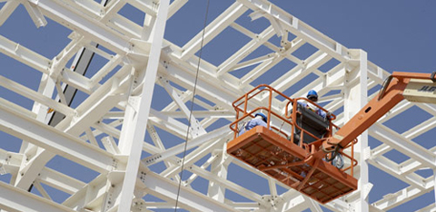
A lot of clients would rather prefer a building make offsite by using fabrication because it is a more sustainable construction technique. Offsite fabrication is when the structure and other features are constructed. Offsite fabrication involves a timber frame house being constructed offsite from the architects specification, the structure is then transported to site a number of times until the whole structure is on the site. A crane lowers the materials into place. Offsite fabrication is a sustainable technique for a number of reasons.
- Offsite fabrication structures are very energy efficient.
- Offsite fabrication structures are energy and time efficient.
- Offsite fabrication use renewable resources such as wood. I client can by timber from a sustainable manufacturer that will plant a number of trees for the ones that they have used to construct the house.
- Offsite fabrication also produces low carbon emissions.

(2) The second sustainable construction technique is energy saving based techniques. We have now identified area in which we can save energy during the construction and use of the building. As we well know to create energy we normally need to burn fossil fuels which harm the environment. In a school we would need a lot of energy to power the school building. So when planning the new super school we need to take into account how to save energy throughout the buildings functionally building.

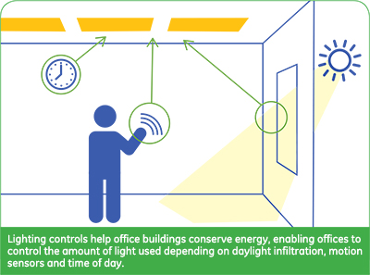
When designing the new super school we need insure that the building is energy efficient. In old building many features of the building are not energy efficient from example old building have lights on constantly unless the lights are turned off, whereas a new building would have light sensors which turn on when people are in a room and automatically turns off when it does not pick up human movements. We can make the new super school energy efficient by insuring that we reduce the amount of energy required to power the building. We can reduce the amount of energy needed to power the building by replacing old technology with more energy and also reducing the amount of waste created from the building. Another technique that we can use to make the building more energy efficient by running the building from a renewable energy resource which will prevent finite resources being burnt which damages the environment. Typical examples of how to be energy efficient in the new super school include:
- Using energy saving light bulbs which will save the school a small amount of money but also prevent more fossil fuels from being burnt to power a normal light.
- Using light sensors to prevent lights being left on when they are not being used.
- Using good insulation which will prevent heat from being lost from the building. By using better insulation we will prevent heat from being lost but also limit the amount of heat needed to keep the building at a comfortable temperature.
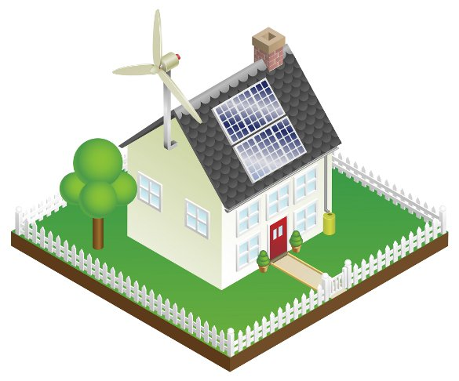
Another sustainable construction technique is running a building from a renewable energy source. It is sustainable to use renewable energy resources because we are preventing finite fossil fuels/resources being burnt which will damage the local and natural environment. The new super school will need a lot of energy to supply the building so to be able to achieve a BREEAM listed school we need to run the school from a renewable energy source. For the school there are many types of renewable energy sources that will save both valuable resources and in the long time support the school finically.
- We can install solar panels on the roof of the building. Solar panels will benefit the school finically after a number of years but also reduce the energy costs to run the building.
- We can use bio fuels to power the new school building. Bio fuels are biodegrade crops that will burnt to power the building. The school will have a construct supply of biodegrade fuel able to power the school building throughout its lifetime; this will divert food waste being sent to landfill. In the long term it will be sustainable to use Bio fuels to power the new school building.
Other types of renewable energy sources we can use in building include.
- Wind turbines
- Hydroelectric power sources which create power from the force of a local water supply.
- Wave turbines like the planned tidal lagoon in Swansea which will create enough power for 121,000 homes.
- Geothermal energy sources which is when heat from below ground is used to warm a building up.

(3) The last sustainable construction technique is material based techniques. This is a developing area of construction that involves using materials that are eco-friendly materials. Many materials have been identified as eco-friendly to use in buildings, if we are to aim to achieve a BREEAM listed school then these are some examples of eco-friendly materials we can use to building the school. These include:
- Using bricks from a demolished site. We then treat the bricks and use them for the external wall.
- We can also use sheep’s wool as an insulator. Sheep’s wool is a natural resource which is produced every year by the sheep to keep it warm during the winter months. The wool has these properties as an insulator and is thermal efficient but also allows the building to release some warm air during warm periods of the year.
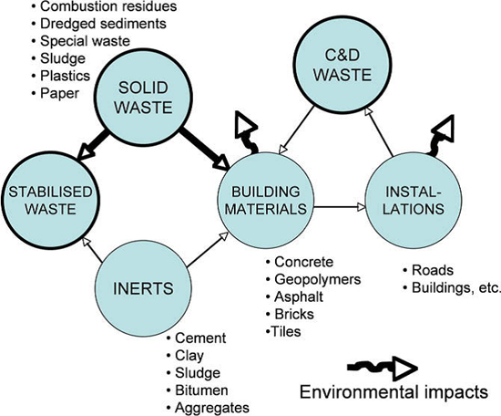
- We can install a green roof on the roof of the new super school. There is a large surface area of the roof and the green roof will keep the roof dry naturally but also provide a vegetation space for the school.

Another material based technique is Low Embodied energy consumption. Embodied energy consumption is when we reuse a material more than once and reduce the amount of energy needed to create the material which reduces the amount of energy needed to create materials for the new super school. Typical materials that can be recycled from a demolished site include glass, concrete, bricks and sometimes steel.

M2-Compare the four key methods used to protect the natural environment in terms of cost, effectiveness and public perception?

All four key methods used to protect the natural are cost effective, effective and a achieve a high level of public perception

Method | Is it cost effective | It is effective | Does it achieve a high level of public perception?
Environmental laws | Yes laws are cost effective they are set by the UK government and do not cost the client any money unless they break the laws and harm the local environmental in which they will have to pay a fine or face a prison sentence. These laws prevent people damaging the environment because people will not want to face criminal changes. | Yes laws are effective to protect the environment because people will not break the law because they are aware of the risks of breaking the law. A lot of people are aware that why must not harm or pollute the environment so many builders are aware of environmental laws. | Yes laws achieve a high level of public perception because the public understand that if you break the law you must be punished but if you prevent harming the environment you have nothing to worry about. Laws are also set by government who speak on behalf of the people of a given country. Laws do not cost also to maintain because laws are rules at which a nation must follow to able to avoid damages to the country and its people. Many people think highly of environmental laws because they prevent people from harming the environment by threading them with fines/prison sentences.
Recycling | Yes recycling is cost effective on a construction project because we did not recycle we would have to pay a lot of money to send our waste to landfill. Recycling can also make companies money because all the waste materials that have been recycled can either to resold or reused for other construction projects. | Yes recycling is effective because it cuts the amount of materials going to landfill.  Recycling is also effective because we save materials by recycling which saves money and valuable resources.  Recycling is effective because it saves valuable resources and land. | No Recycling may annoy a few construction companies because it takes times to sort out the waste materials BUT many people have realised that recycling is the way forward for the future. All though recycling takes time to sort the material out people have been made aware that the time pays off for a number of reasons. These include cutting the amount of waste bring sent to landfill, cutting down costs and saving money. In conclusion many people are now encouraged to recycle because of its effectiveness.
Design and speciation | No Designing a building to be can be expensive BUT techniques such as solar panels pay themselves off after a number of years and can save the client thousands of money over the course of the buildings lifetime. Design and specification can also make the client money after a number of years.  For examples having solar panels on a building will be expensive to start with but after a number of years the panels will pay themselves off through the energy they have create/saved. Solar panels will start to make the client money through the energy they create in the future. http://www.moneymagpie.com/article/make-money-from-solar-panels states that you could get up to £750 a year from using solar panels on a small house roof. Imagine how much money we will earn from using solar panels on a school roof. Using eco-friendly methods pay them self so are cost effective | Yes Design and speciation is effective because we preventing waste from being created in the building. We are saving the environment because the techniques used will benefits both the environment and the owner of the building. We can design the new super school to be eco-efficient by using a renewable energy source (Solar), grey water harvesting and geothermal heat sources. These sources of sustainable resources can benefits both the building and the local environment of Sandfields. | Yes the public now understand that when you design a building to Design and speciation you are making the building efficient. Designing the super school to be eco-efficient will be a good idea in the eyes of the general public as the site will be partially independent if it has its own energy source (solar) and its own water system (grey water system).This means that the new super school will not affect local services. Also people believe that eco-efficient buildings are the future as they do not damage the local environment. As a hole designing the new super school to be eco-efficient is affective as it protects the environment, pays off its self-off in the long term but also save money/resources.
Minimization of resources | Yes Minimization is cost effective because we are cutting down on the amount of natural resources being wasted. As we well know resources such as oil are going to be needed to provide power for the school but oil is very expense and pollutes the environment. We could install solar panels which provide cheap clean energy which will be used to power the school. Using Minimization techniques are cost effective for the future but also provide us with a renewable energy resource that will never run out and provide us with energy throughout the year. | Yes Minimization is effective because we are cutting down on the amount of non-renewable fuels to power the building. By using renewable techniques such as wind turbines we are creating clean energy which will not damage the environment but also save valuable non-renewable resources | Yes the general public think that cutting the amount of resources we use will make the building more environmental friendly. By cutting the amount the resources that we need to construct the project we are saving valuable resources but also reducing our carbon footprint. The labourers would also agree with the idea of Minimization. because we are saving resources such as oil and wood by using techniques such as  - Using a renewable energy resource  - Using recycled building materials  - Cutting the amount of waste by using fabrication

Compare: Is the method cost effective?
Laws protect the environment and are cost effective because laws don’t cost a lot of money to implicate. Recycling protects the environment because it prevents us from dumping waste in landfill. Recycling is also cost effective because although it will take time to sort materials a company will benefit from this because recycling can earn companies money because they can sell the unwanted waste to another company. Minimization of resources is cost effective because we are cutting down the amount of a resource required for the school. By cutting down the amount f resources needed we are saving money.
Out of all 4 methods I think Design and speciation is the only method that is not cost effective. It may be expensive to design the building to be sustainable because the techniques are quite expensive BUT techniques such as Solar panels pay themselves off after a number of years and you start to earn money from the techniques. So Design and speciation many not be cost effective to start with by after a number of years the building will benefit from the high starting costs BUT will save the school money in the long term. The only disadvantage is that cost a lot of money to buy the special sustainable techniques.

Conclusion: Laws, Recycling and Minimization of resources are also cost effective for the reasons I have said above BUT Design and speciation may not be cost effective because of the start up costs but will save the school money in the long term. All 4 methods have the advantage of making the school sustainable and also save the school money in the long term.

Compare: is the method effective?

All 4 methods protect the environment in certain ways. Laws prevent people from harming the environment but warning them with laws which will punish them if they disobey environmental laws. Recycling is effective because we are preventing waste from going to landfill by saving our resources and finding new uses for the recycled materials. Design and speciation is effective because we are using techniques to prevent us from over using resources such as energy and water. Design and speciation can also help us harvest energy and water buy techniques such as grey water systems, solar panels and geothermal energy. Design and speciation can make a building more efficient by making the building run from its own resources as said above (solar panels and grey water systems). Minimization of resources is effective because w cutting the amount of resources we are using but using certain techniques. Minimization of resources saves us from creating new resources such as oil by insuring that we do not over use the resource.

Conclusion: All the method are effective as they reach their aim of protecting the environment.

Compare: Does method achieve a high level of public perception?

Laws achieve a high level of public perception because people in the UK obey the laws; the general public insure that no one in society breaks the law so everyone in society understands that laws are an important part of life that we must follow. The general public think highly of Design and speciation because a lot of people know now that we must make building more efficient for the future in order to protect the environment. The general public also understand that we need minimize our use of resources because non-renewable energy resources are running out and in a couple of years the cost for these resources are going to rise. So when designing a building we must insure that the Minimization of resources is as low as possible and that we must use renewable energy.
Unlike the other 3 methods some of the general public find recycling annoying. The general public find recycle annoying and time consuming because we have to take time to sort the materials out. Many people see recycling as the way forward because it prevents waste going to landfill.

Conclusion: Laws, Recycling and Minimization of resources achieve a high level of public perception for the reasons I have said above BUT Recycling is seen as annoying because of the disadvantage of recycling being time consuming. Some people agree that recycling is the forward for the future and that it has the advantage of diverting materials from landfill.

M3-Compare sustainable construction techniques in terms of relative cost and performance.

There are 3 main types of construction techniques that we can use when designing the new super school .we are aiming for the new super school to be a BREEAM listed building. These methods include:
- Waste based techniques
- Materials based techniques
- Energy based techniques.

In a construction site cost is one of the most important factors that contributes to how the construction site is to be built. When deciding the techniques we are going to use on the new super school we must can into account the cost of these techniques and ensure that the client is get value for money.
- Waste based techniques can be cost effective because we are using recycled materials which can be bought cheap. For example using materials from a demolished site is cost effective because we are buying the materials at a relatively cheap price because the owner of the demolished site wants to avoid having to pay a lot of money for the waste materials to be sent to landfill. By using materials from demolished site we preventing resources from being wasted and sent to landfill. This is one reason why waste based techniques are relatively cheap. By using waste based techniques we are preventing from wasting materials on site which saves money because the materials that have been saved can be used on another project or sold to another construction company.
- Whereas Material based techniques can also be cost effective because we saving valuable materials from being wasted. Sustainable materials are a new area in construction that involves materials being grown under sustainable methods. For example sustainable wood is when we chop down a tree and replace the tree we have chopped with a new tree, by using this technique are replacing the materials we have used. Another material based technique is using sheep’s wool as insulation. In the Neath valleys there is plenty of sheep wool available which is cheap to buy and acts as a really good insulator. Sheep’s wool is a natural insulator and will keep the heat within the building and by using sheep’s wool we are preventing have to manufacture insulation for the site.
- Energy based techniques involve us cutting the amount of energy that the building is going to require in its lifetime. By cutting the amount of energy we are cutting the cost needed to power the building efficiently. There are a number of energy based techniques we can use for the new super school. One of the first techniques is running the school from solar panels which provide clean efficient energy, this opinion is expensive to install but in the long time the solar panels will pay themselves off and start to earn the school money through the energy that is being sent to the national grid. The option of running the school from a renewable energy resource is cost effective in the long term.

In conclusion waste based techniques are cost effective because they prevent us from wasting materials and creating waste through techniques which minimizes waste. Material based techniques are also cost effective because we preventing wasting materials by recycling or using sustainable materials. Energy based techniques are also cost effective because we are saving money in the long term because we cutting the amount of energy that the building is using by carrying out certain energy based techniques.

As a summary all 3 sustainable techniques are cost effective and will save the school money but also protect the environment in the mean time, these techniques will also help us achieve a BREEAM rating for the new super school. All 3 sustainable techniques have the advantage of saving the environment and making the school a more efficient building for the future. These techniques also have the advantage of not harming the local environment and global environment. The only disadvantage of all 3 sustainable techniques is that some of the techniques may be expensive at first but after a number of years will pay themselves off.

Another important factor is the performance of the sustainable technique we are going to use. When designing the new super school we must take it to account the quality/effectiveness of that given technique and insure that the technique is going to benefit both the client and the building for the long-term. I will explain the performance of all 3 sustainable techniques and how they provide a high performance level.

- Energy based techniques have been identified as achievement a high performance in buildings. Energy based techniques involve us either cutting down the amount of light in the building or either using a renewable energy resource. For example we can use light sensors to turn the light off when it is not need this technique saves energy but also provides us with a high performance of light that we can work with. Another technique is to run the school from solar panels, by using this technique we are not using fossil fuels to power the building but we still get the same high performance of electric by using solar panel. By using solar panels we are getting a higher performance because we are using clean free energy. So also energy based techniques still provide a high level of performance because they do not change the specification of light/energy needed to run the building.
- Material based techniques have been identified as achievement a high performance in buildings. Material based techniques involve us using either recycled materials or using sustainable materials. Both techniques will give us a high performance material to use in the building. For example if we were to use materials such as bricks from a demolished site then if they were a low performance we would treat them to insure that they were to a high enough quality to use for the building. If they were a low quality after treatment then that means they would have a low performance so would not be used in the building. Material based techniques achieve a high performance building material to use on the building because they are strong and can withstand the stress that the building is going to take over a number of years. If the material is to a low performance we either treat it or do not use it.
- Waste based techniques have also identified as achievement a high performance in buildings. Waste based techniques involve us using techniques to cut the amount of waste that a site creates. Recycling is one of the most popular Waste based techniques. When we recycle a material we insure that the material can be reuse and that it is to the highest quality.

As a summary all 3 sustainable construction techniques achieve a high performance as I have justified above. All techniques are sustainable and provide the same performance as normal unsustainable techniques.
D2 Justify the use of appropriate sustainable construction techniques for a specified construction project.

To be able to make the new super school as sustainable as possible we are going to have to use appropriate sustainable techniques to be able to achieve a BREEAM listed building. A BREEAM listed building is given a rating system to see how sustainable the building is and how the building is eco-friendly. I have identified 3 sustainable based techniques we can use during the construct of the new Sandfields super school these include:
- Energy based techniques (involves reducing the amount of energy the building needs/runs on).
- Waste based techniques (involves reducing the amount of waste that a building creates).
- Material based technique (Involves using sustainable materials/techniques for the construction of a building).
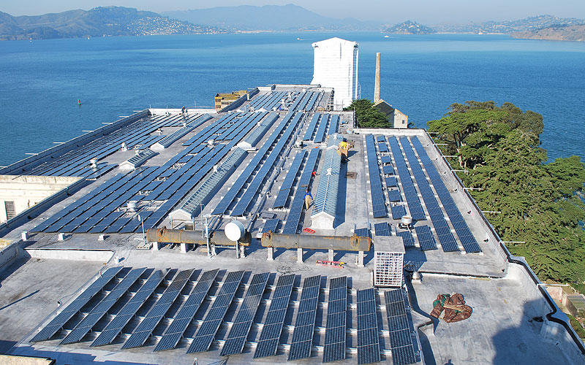
Based on my knowledge of energy based techniques I have decided that the new super school will run from a renewable energy source. It is important that the building runs from a renewable energy resource because they are sustainable but also produce clean eco-energy and prevent us using a non renewable energy resource from the local energy supply. By using a renewable energy we are preventing using non-renewable energy sources which harm both the environment and people. For the new super school I have decided that the school will run from solar panels which are placed through the whole span of the roof space. We can use solar panels to either heat or to power the building. this will create enough clean energy to power the school but also feed energy into the nation grid when the school is closed. Solar panels are effective because they are renewable. The school will require a lot of energy and to be able to achieve a BREEAM listed school we need to insure that there are a lot of solar panels to handle the large amount of power needed. Solar panels also help the school achieve a BREEAM listed building because it reduces the carbon footprint of the building. Solar panels are also efficient for the school because after a number of years the school will earn money when the energy being created is not used because the national grid will pay the school for the energy that the solar panels have created. Unlike running the school from non-renewable energy resources solar panel will last forever because the sun will always release energy whereas fossil fuels are running out and will be extremely expensive. In the long term Solar panels reduce the utility costs of running the school building which will help the school to save money for the future.
Conclusion
I have decided to run the new super school from solar panels because they earn the school money, renewable, sustainable, reduce running cost and also minimise the need to use non-renewable energy from the local energy supply which shows that school does not harm the environment thought the energy based techniques.
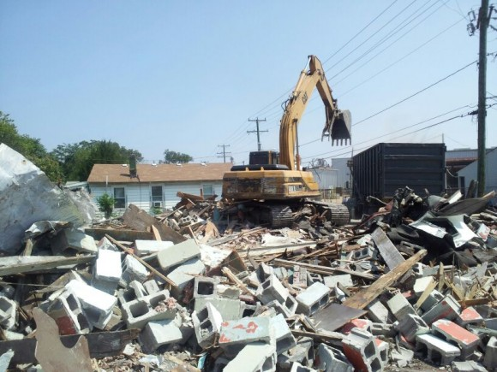
Based on my knowledge of Materials based techniques I have decided to use materials from demolished sites. Demolished sites are full of materials that could be reused for other uses on a new project. We have identified a sub-contractor that will provide us with materials from demolished sites the name of that contractor is stenor environmental services .It is effective to use materials from demolished sites because we are reusing materials that would have gone to landfill. The materials may also be cheaper to buy because the owner of the demolished sites may want to get rid of the materials cheaply because it will cost him a lot of money to send the materials to landfill and to be treated. By using materials from demolished sites we are also saving resources for example if we were to reuse glass we just simply re-melt the glass and we would have a recycled the glass whereas if we were to buy new glass from a supplier then it would mean that more fossil fuels have been burnt to create the new glass with harms the environment. By using materials from demolished sites we are saving resources, saving the environment and preventing waste from going to landfill. We may find the following materials on a demolished site and take them to a factory to be treated and reuse them for something else for the new Sandfields super school.
- Bricks can be treated and used on the new super school to give the building a rustic appearance.
- Concrete/stones can be crushed and used to raise the levels of the school.
- Glass can be re-melted and be reformed.
- Steel can be re-melted and be reformed.
- Timber can be burnt to provide heat.
- Steel rods found in reinforced concrete can be removed and re-melted/re-formed to be used as reinforced steel for foundations of the super school.
- Slates from the roof can be reused for chipping to decorate the landscape around the school.
Conclusion
By recycling the materials and finding new uses for them for the design of the new super school we are preventing waste from going to landfill, preventing burning fossil fuels to create materials but also benefiting the environment.

Based on my knowledge of energy based techniques I have decided to use light sensors throughout the lights throughout the school. By using these sustainable techniques we are reducing wasting light because the light switches have been left on when they are not being used. By using light sensors we are preventing wasting natural resources include fossil fuels, energy and also help us to save money. Light sensors work by turning the lights on when the sensors detect movement and when the lights have not detected movement for a couple of minutes the lights will automatic turn off until it detects movement. Light sensors are effective to use on the school building because it is such a large building then the room are not always going to be used and the lights will be kept on 24/7 whereas if we use light sensors we preventing wasting light energy.
Conclusion

By using light sensors we are going to save both energy and money for the school. By reducing the amount of energy we are making the school more efficient because we preventing wasting energy. We are also saving fossil fuels by insuring that the lights turn off automatically when no one is using a room. The school we have lot of room so by insuring light sensors are placed we are limiting wasting light energy which is sustainable. The BREEAM survey will identify that the school is limiting wasted energy which saves the resources and environment.
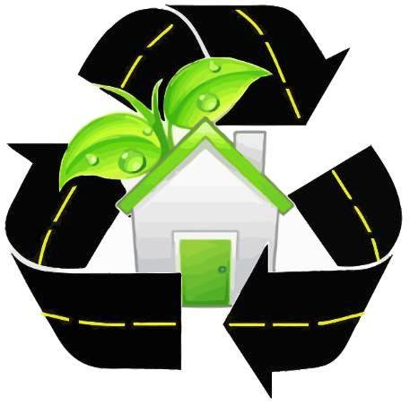
Energy based techniques (Training)

I have also decided that I am going to use energy based techniques. I have decided that I am going to train the labourers on site to minimize the amount of waste that is going to be created on site. I will do this by teaching them to recycle every bit of waste materials and insure that the labourers out the materials in the correct bins for them to be recycled or reused. By not throw materials in the bin we are preventing waste from going to landfill which harms the environment and also costs a construction company a lot of money. By teaching labourers to limit waste we are making the site more efficient because we reducing the need for rubbish skips which cost a lot of money to rent and dispose of. By teaching labourers to limit waste we are saving resources because once a specific materials has been sorted we can find other uses for them for example:
- Burn wood
- Reuse bricks
- Recycle plastic
- Recycle cardboard

Conclusion

The BREEAM survey will identify that the site as sustainable because the site has created minim waste which means less materials are being sent to site which saves the environment, resources and money.

References
Picture references

Picture of | Taken from
Eco-Friendly logo |  | https://healthylifesolution.files.wordpress.com/2010/07/ecofriendly.jpg
Law legalisation |  | http://alkeram.com/onewebstatic/75c584b2a5-LawAndLegislation.jpg
Environment agency logo |  | http://www.loeser.us/flags/images/england/environment_agency.gif
Sustainable buildings |  | http://blog.trilogybuilds.com/files/2012/12/sustainable-building.jpg
Wind turbine |  | http://s0.geograph.org.uk/geophotos/01/87/97/1879702_7a8f97d8.jpg
Reduce, reuse and recycle |  | http://www.greenwerkspro.com/wp-content/uploads/2013/03/Recycle-Reuse-And-Rebuild-e1363268866958.jpg
Recycling construction waste |  | http://www.prowaste.co.uk/images/recycling-construction-waste.jpg
Picture of landfill |  | http://blogs.ft.com/energy-source/files/2011/01/Landfill.jpg

Final Design for the new super school | http://www.southwales-eveningpost.co.uk/images/localworld/ugc-images/276352/Article/images/21206844/6191009-large.jpg
Materials from demolished site | http://www.clark.wa.gov/recycle/disposal/demolition.html
Skip on site | https://sourceable.net/cutting-construction-site-wastage/
Renewable energy sources. | http://realtybiznews.com/curb-appeal-for-the-energy-conscious/98722487/
Light sensors | http://www.gelighting.com/LightingWeb/na/solutions/industry/office/expert-insights/lighting-the-evolving-workspace.jsp
material based techniques construction | http://content.elsevierjournals.intuitiv.net/content/files/figure1-15154025.jpg
Laws |  | http://www.bing.com/images/search?q=environmental+laws&FORM=AWIR#view=detail&id=8E7EF90D23D9B495499846CED5DDCC8EEA06178D&selectedIndex=3
Recycled construction materials |  | http://www.clark.wa.gov/recycle/images/Const_and_Demo/ConstructionHeading.jpg
Eco-friendly building |  | http://homecareincremodeling.com/wp-content/uploads/2012/06/Eco-Friendly-House.jpg
Natural environment |  | http://tarcas.org/wp-content/uploads/2011/02/natural-resources.jpg
Solar panels on a large building | http://www.nrel.gov/news/features/images/20120723_at_pix21415_large.jpg
Recycling logo | http://www.environment-green.com/images/recycle_logo_arrows.jpg
Light sensors | http://www.usc.edu/dept/engineering/summerprograms/assets/001/75386.jpg
Recycling in construction | http://www.affordableroofingfl.com/roof_recycling_icon.JPG

Book references
Used for | Taken from
P4, P5, M2, M3, D2 | Building Services Engineering and Civil Engineering  By Topliss, Simon, Hurst, Mike, and Skarratt, Pearson Education, 2007. Web. 9 February 2015.page  Copyright © 2007. Pearson Education. All rights reserved.

Internet references
Used for | Taken from
Benefits of solar panels | http://www.solarpanels.co.uk/faq/benefits-of-solar-panels.html
Benefits of recycling building materials | http://constructionmaterialsrecycling.com/
Benefits of light sensors | http://www.vexrobotics.com/wiki/index.php/Light_Sensor

