Changing the Text and Background Colours in a PDF Document
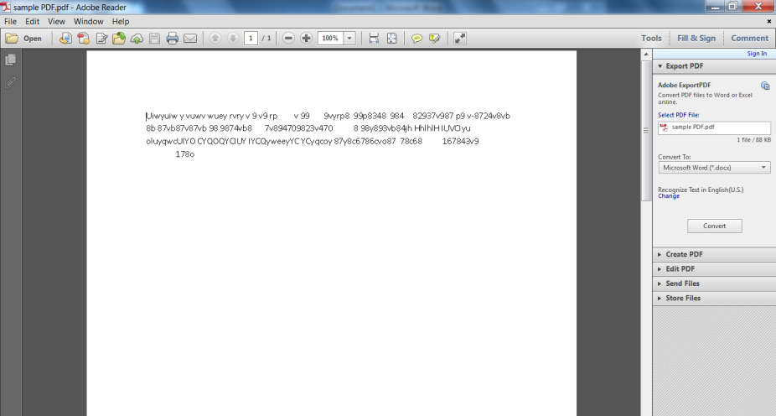

Above we can see a typical PDF document that has no meaning but will be used to illustrate how to change the colour of the text and background, which can help in reading certain documents.

Look across the menu bar and select Edit. Then select Preferences. A window will appear.
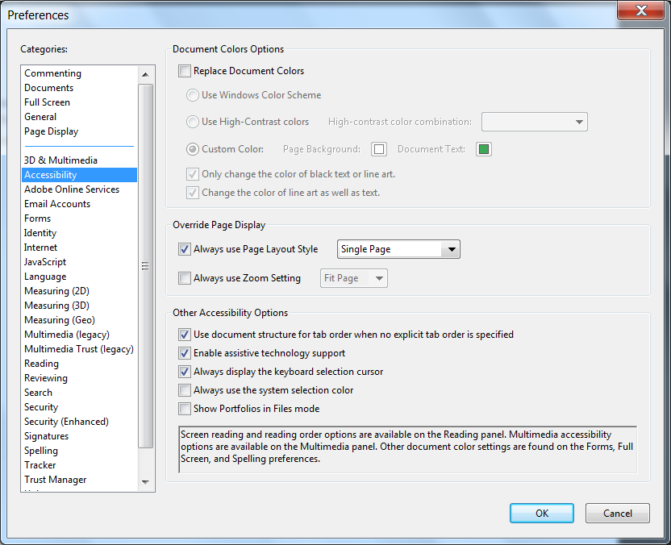
Under categories, select Accessibility.
Select the Custom Colour Radial. Then select your font colour by clicking on the box next to Document Text and selecting a colour. Do the same for Page Background. Then, select OK

The Document should reflect the changes you made.

