Unit 6 Building Technology
Assignment 2
Lecturer: Bryan shenton
Date: 10/04/2015

Contents page
Page 1: Front page
Page 2: Contents page
Page 3: P5 - Explain the principles of super structure design?
Page 4: P5 - Explain the principles of super structure design?
Page 5: P5 - Explain the principles of super structure design?
Page 6: P5 - Explain the principles of super structure design?
Page 7: P5 - Explain the principles of super structure design?
Page 8: P6 - Describe the techniques to construct and finish component Elements of the superstructure?
Page 9: P6 - Describe the techniques to construct and finish component Elements of the superstructure?
Page 10: M2- Justify the selection of suitable materials and techniques for use in the construction of superstructures for low-rise domestic and commercial buildings, for two different tutor-specified scenarios
Page 11: M2- Justify the selection of suitable materials and techniques for use in the construction of superstructures for low-rise domestic and commercial buildings, for two different tutor-specified scenarios
Page 12: M2- Justify the selection of suitable materials and techniques for use in the construction of superstructures for low-rise domestic and commercial buildings, for two different tutor-specified scenarios
Page 13: D2- Evaluate the environmental performance of modern materials and techniques used in the construction of superstructures for low-rise domestic and commercial buildings, for two different Tutor-specified scenarios.
Page 14: D2- Evaluate the environmental performance of modern materials and techniques used in the construction of superstructures for low-rise domestic and commercial buildings, for two different Tutor-specified scenarios.
Page 16: D2- Evaluate the environmental performance of modern materials and techniques used in the construction of superstructures for low-rise domestic and commercial buildings, for two different Tutor-specified scenarios.
Page 17: References
Page 18: References

P5 - Explain the principles of super structure design
A super structure acts as a shell which protects the building, the superstructure is from the foundations (substructure) up .The superstructure can be put into the categories of walls, windows and doors when designing the new super school we need to take into account the type of super structure design we are going to use. The superstructure needs to be able to keep the building water tight but the building also needs to be able to handle the pressure that the building is going to take; it must also spread the weight of the building using walls and breams to support it. The super structure needs to be able to handle the dead load (weight of the building) but also take into account the weight of the contents of the building (Imposed load).when designing the super structure we need to take into account these factors.
- Weathering
- Materials
- Insulation
- Sound proofing
- Efficiency
- Type of material
The new school is near the coast so will be affected by factors such as salt, water and wind. The external walls need to be able to take the forces that are attack. Wales is also prone to weathering attack because of the location of the country. So the superstructure needs to be able to have the properties to be able to withstand the constant attack at which it is going to face daily. The United Kingdom’s location in the world affects the type of superstructure because its location in the middle of the sea. Places like Wales, Cornwall and northern England will need materials that are resistant to weathering attack whereas places like east England are not affected by weathering as badly because there is a closer distance between the sea and France which will protect east England from storms. So when deciding the type of super structure to use we must think about the areas location in terms of weathering.
The substructure will have to be effective in a number of areas such as sustainability, cost and design. The design for the substructure must be effective in terms of sustainability because there is a going need for schools to be as green as possible. Councils now want new buildings to be given BREEAM status. The council also recons is that having a BREEAM building has a number of benefits such as
- Lower running cost in terms of energy.
- Better environment to learn
- More effective to run buildings in terms of waste.

When designing the substructure we need to take into account the amount of security that the school is going to require. We will need to install plenty of security cameras in order to protect the students of the new school. Security is now an important factor when designing the substructure because the demand for security is at a high level. So when designing the substructure we must insure the building is designed to cope with the need for extra plugs. We may also need to install fire doors in the case of a fire to protect the students from a fire risk.
One important principle of a substructure is sound proofing. We need to insure that sound is not going to escape from a given room or the building itself. Many buildings may not need sound protection but a school will need to have sound proof walls in classrooms to avoid sound leaving the room and distracting other rooms within the school. Sound proofing will be needed in area such as the music department within the school because this will create a lot of noise so when designing the room we need to insure that the walls will prevent sound leaving the rooms. When designing a building we must think about the thickness of the wall to prevent sound transferring around a building. The thicker the wall will result in less noise leaving a room but when a wall is thin there is a greater chance that noise will travel around the building.
Another important principle of a substructure is insulation. Insulation is when we install energy efficient materials (e.g. fibreglass) between the external and internal walls. The main purpose of using installation is preventing heat from leaving the building, but using installation we are keeping heat within in the building. When designing a superstructure we need to take into account the amount of insulation we are going to need in the between the external and internal walls to keep the building at a comfortable temperature. To be able to achieve a BREEAM listed school we need insure that the building is heavy insulated to be able to be as energy efficient as possible. We must only use the best material when deciding what to use as insulation. We can use U values to calculate the amount of insulation we will need in the building to prevent large amount of heat being lost through the superstructure.
The superstructure is made up of the following materials in the building.
- Walls
- Floors
- Roofs
- Stairs
- Windows
- Doors

Walls are an important part in a building. Buildings constructed in the last 90 years have all been designed with an external, internal and cavity wall. We have an external, internal and cavity wall for a number of reasons. A wall must be able to withstand weathering but also be able to support the building for a long period of time. In the United Kingdom a lot of houses have been built with bricks. In north England a lot of the buildings are made of bricks because there were a lot of a bricks available in the area because of the large amount of clay that surrounded area. Bricks are popular for a number of reasons these include.
- cheaper than other forms of materials
- Bricks also last for many years so require less maintenance
- Bricks a good durability
- Bricks are cost effective
- Bricks are also visual pleasing
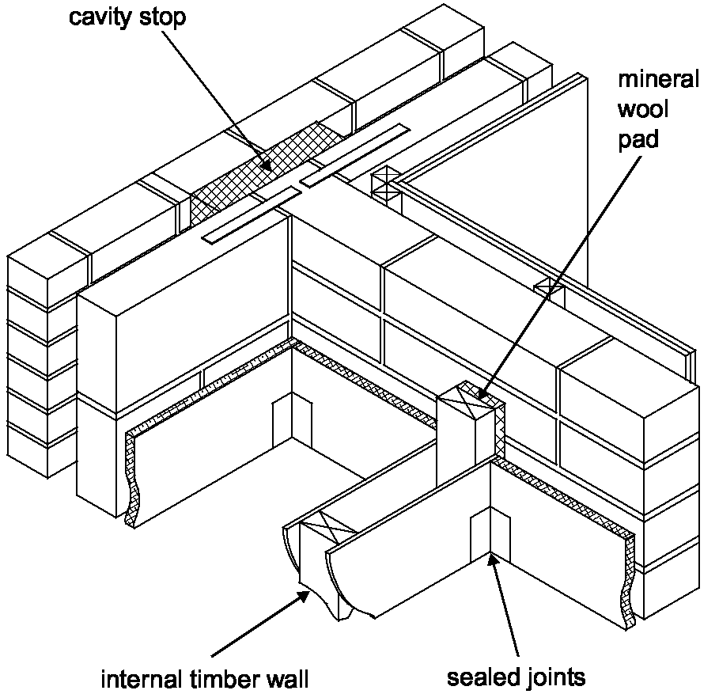
There are to 2 important types of walls that are needed to construct a wall an internal and external wall. An external wall is the outside walls of a building that is exposed to weathering whereas internal wall is the inner walls in a building. We use facing bricks for the external wall because they are visually pleasing but are also strong enough to be protected against the weather. We typically use concrete bricks for the internal wall. We use concrete bricks for the internal wall because they are hard wearing, dense and mostly importantly strong.
Between the external wall and internal wall is the cavity wall. Cavity wall is the gap in between the 2 walls. We install the insulation in the cavity wall and we tie the insulation to the internal wall to prevent heat from escaping from the building. We must also leave a gap between the insulation and external wall for air flow. We need this air flow because it is another good insulator.
Insulation
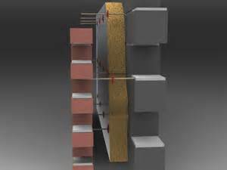
We also need a wall tie to tie the external wall, insulation and internal wall together. We use a wall tie for a number of reasons, one reason is that we use a wall tie to give support and hold the entire wall together. Wall ties are installed where the building needs support. We also use water ties to prevent water from breaching through the external wall and into the insulation and then external wall. When constructing a wall we need in check that mortar has not dried on to the wall tie, if the tie has mortar on it then water will penetrate into the building.
Concrete bricks
Facing bricks
We tie insulation to the internal wall using the inner leaf. The main purpose of insulation is to keep the property warm and also to stop the transfer of heat from outside. Insulation works by trapping warm air that otherwise would be lost in a un- insulated building.
Wall tie
Cavity wall
Floors play an important feature of a super structure. The techniques used to constructed floors are the same whatever type of structure we chose (bricks, concrete e.g.). The floor is normally supported by the wall panels. Wall panels are able to support the floor because of the use of external panel, load bearing partitions and the party wall panels. We use joints to support the boarding. The boarding is nailed to the wooden floor, we normally use ply wood as a material for the boarding because it is cheap but also fits it purpose.
A roof is one of the most important elements when it comes to a super structure. The roof has the following purposes.
- To keep the weather out of the building
- To be able to take the load bearing weight of elements such as snow and heavy rain.
- To be able last for a long period of time after 20 to 50 years depending on the roofing material used.
- To be able to be fire resistant
Most dwellings in the United Kingdom are built with a pitched roof. A roof pitch must be at an angle of at least 45°, and more likely 50°, to allow the rain to flow off quickly. The angle at which the roof is built to be different ranges for many different reasons. For example the occupations of a building may want the roof thrusts at an angle of 39 degrees to be able to use the attic space for living space.
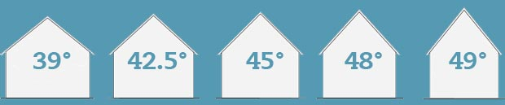
Another type of roof is flat roof. A flat roof is normally used in flats or where the property owner has had an extension to their house. Flat roofs are built at an angle of approximately 10.Flat buildings are common in hot climate countries like Spain, flat roofs are use because they provide more space. Flat roofs are used in Britain but can cause problem because the frequent rain that the country faces and the roof is frequently being damaged by the amount of rain that is on the roof. Another important feature of a roof is heat loss. As we well know heat always travels to the roof so heat is lost. To prevent this problem we install insulation in the room which will keep heat within a building. When insulating a roof we need in insure we do not insulated the roof rafter/ceiling joints to allow ventilation to avoid rot damage to the roof.
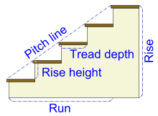
Stairs are also another important feature of a superstructure. We need stairs to be able to access the other floors in a building. We also need stairs for emergency if there is a fire by law there must be one stairs that are fire proof in a building. The pitch line is the height of the stairs. The rise height is the height of the step whereas tread depth is the length of wood to be able to stand on. Stairs can now be constructed off site which it more efficient because there is a higher quality. On the stairs we normally install stair handrails and banisters to prevent students from falling down the stairs; it will also support students who need help to walk up the stairs. The stairs design for the new school also need to be wide enough to let a large amount of students travel up the stairs during busy times in the day i.e. breaks. We can use two forms of materials to constructed stairs these include concrete and wood. Concrete stairs are manufactured in a factory off site and are easier to install compared to wood which needs to be installed by a carpenter off site. I would suggest using concrete stairs in the new super school because it is quicker and easier to install, plus also wood is a limited resource so it’s better for the environment and we need to take into account these factors when thinking of designing a BREEAM building.
Windows are another important feature of a superstructure. During the last 20th century we have used wood as a material to use as a window. Today we are using PVC windows, we use plastic because it cheap but also because wood is a limited resource. We typically do not use wood for windows today because it rots but is also un-environmental friendly .we can paint the wood to protect it against weathering but when this barrier is broken the wood will start to deteriorate. Whereas if we use PVC windows we are guaranteed that they are a high quality but also will not rot or break down. We can install child locks on the window to prevent the window opening fully. The child lock will allow the students to open the window a little bit but not enough to open the window fully, this will make it safer. It would also be ideal to use lots of windows in the design of the new school because windows let in a lot of natural light, by using natural light we do not have to use fossil fuels to light the building. We can also use Aluminium windows for the new super school. We can use aluminium as a window because it is light weight, high strength material that is very durable and highly resistant to corrosion but the only disadvantage is that the aluminium windows are expensive. It will be more practical to use PVC rather than aluminium because it is cheaper but also has similar properties. I would suggest using UPVC windows when it comes to designing the new superstructure.
Doors are needed to prevent unwanted visitors entering a property. A door also adds comfort because we feel safer with a door present. When constructing the substructure of the new school we need to install fire resistant doors to protect the students of the building in the case of a fire. I would us a hard wearing door in the new super school but the doors are going to be constantly worn away by heavy forces such as slamming doors. There are many types of doors we can use when designing the substructure of a building, some types of doors include:
- UPVC French windows
- Roller-shutter doors
- Gazed door
- Timber Front door
P6- Describe the techniques to construct and finish component Elements of the superstructure
To be able to construct the substructure as efficient as possible we need to use a few techniques to help us complete the building. We may have to use the following techniques:
- Plant machinery
- Man power
- Temporary equipment
When constructing the new super school we may need to hire plant to be able to carry out certain heavy tasks. We may need to use machinery due to the fact that labourers cannot complete the tasks. There are many reasons why we may need plant on site. By using plant and machinery we are saving time in the construct timetable. It is important to use plant/machinery because without out plant we cannot carry out the simplest of tasks. These situations where we will need heavy plant on a project include:
- Using a digger to dig the foundations. We use a digger because it carries out the task faster and more efficient than a labourer and also a digger reduces manual handling.
- Using a cement mixer to fill the foundations with concrete.
- Using a crane to construct the structure because the material is too heavy to be lifted in to place by the workplace.
- Using an industrial van to cool the rooms after plastering.
Manpower is the most important resource need to construct the substructure. We need manpower to build, organise and run the project efficiently. Once on the construction site we need to insure that the labourer force has the experience and skills to carry out the work to a high level of quality. When constructing the new super school we need to insure that we have enough labourers to complete the project. We need the workforce to carry out tasks when constructing the superstructure, every job is important.
We may need temporary equipment on site to be able to finish the superstructure efficiently. We may need temporary equipment for a number of reasons one of the most common reasons why we need temporary equipment is safety. Temporary equipment will be installed on site for a reason at which the site manger feels that there is need for that equipment to be on site. Scaffolding may be installed on site to protect the labourers working at a high level to prevent them from falling.
Once we have completed the Walls, Floors, Roofs, Stairs, Windows and Doors of the new super school we then need to use finishes to complete the building. We mainly use finishes on the inside of the building in order to decorate and tidy the inside of the newly constructed building. There are a number of factors that influence the type of finishes we can use on the inside of the building. Some of these factors include:
- The cost of the finishes
- The purpose of the finishes
- The location of the finishes
- The colour required for the finishes
- The health and safety of the finishes.
One of the main finishes used on buildings around in the world is plaster. Plaster has been used around the world for thousands of years. Plaster is used to coat the walls/ceiling of a building. Plaster was used because there was plenty in the local areas. Our great ancestors realised that plaster was very effective to use in buildings. Plaster is effective because it is fire resistance, hygienic and is also waterproof. Plaster can be using both on the internal and external of the building. Plaster can also prevent sound from transferring into a building. We can use plaster to render building, we use plaster because keeps the building windproof and watertight. But one of the main reasons why we use plaster is because it looks visually pleasing and can be painted any colour to the client’s requirements. There are many types of plaster that can be used for the new super school these include.
- Gypsum plaster
- Lime plaster
- Cement plaster
- Plasterboard
Gypsum plaster is created by heating gypsum to about 300 degrees. The formula for gypsum is CaSO4·2H2O + heat → CaSO4·0.5H2O + 1.5H2O.when the plasterer needs the gypsum he simply mix the gypsum powder with water.
Lime plaster has been used for thousands of years as a building material. Lime plaster has been widely used because there was a vast amount of limestone around cities such as Rome. Lime plaster is made of hydrated lime (slaked lime), sand and water.
Cement plaster has only been used for the past 100 years and is made up of plaster, sand, Portland cement and water and is normally used on the external/internal walls of the building. Cement plaster is commonly used for the external walls of a building to provide a smooth surface to be able to paint on the rendered wall.
Plasterboard has widely in the construction industry in the past hundred years to added finishes to the buildings. Plasterboard is made of gypsum plaster but we also add aggregates to give the plaster added strength. These aggregates contain thick paper linings which will reduce the surface condensation, the thick paper linings have a thermal capacity and are lightweight. Plasterboard is cost effective but also it quicker than traditionally approach’s to plaster. Plasterboards can be used on all types of sites and can be used throughout a building. Plasterboard can also be used to improve the building. Plasterboard can improve a building by
- Keeping the building warm by preventing heat escaping the building (thermal insulator)
- Keeping sound within the building.(sound insulator)
- Preventing fire spreading throughout a building ( fire resistant )
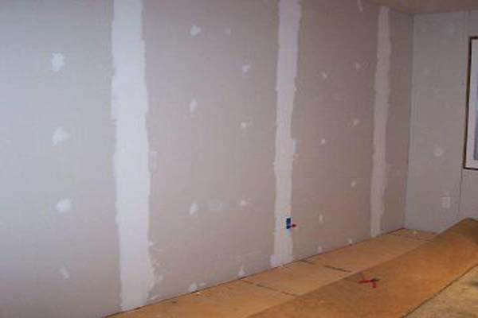
Drying is another method we can use when finishing the superstructure. Drying is when we use plasterboard as a finish to wet plaster on a wall. There are 2 ways we can apply the drying method is this
- Adhesive dabs
- Securing the boards to a metal structure nailed to the ground level of the building.
Adhesive dab involves a number of adhesive dabs being placed on the plasterboard .we normally place 3 column of dabs per 1 plasterboard. We place the adhesive dabs horizontally if we wish to install the plasterboards to the ceiling. We can also install plasterboards to the wall by fixing the boards to a number of metal channels. These metal channels are bonded to the floor using dabs. The plasterboards can be easily placed onto the channel using special screws. When installing the boards we need to ensure that there is no air follows behind the boards because this will cause damp and lower thermal performance for the building.
If we chose not to use plasterboards for the walls we can also paint the internal wall. This method is cheap but is not visually pleasuring.

M2- Justify the selection of suitable materials and techniques for use in the construction of superstructures for low-rise domestic and commercial buildings, for two different tutor-specified scenarios
The traditionally construction of a wall is bricks (internal wall, cavity wall, insulation, wall ties and external wall) but we can also use different materials to construct a structure for the design of the new Baglan super structure. Some of the materials we can use are as follows.
- Timber frame
- Porotherm
- Steel frame
- SIP panels
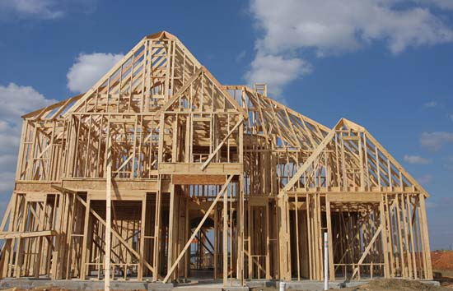
Timber frame is when we use wood as a material instead of bricks. Timber frame is popular in modern construction and is mostly used in America but in recently being used in the UK. Timber frame is effective because they come to site pre built so can be built in a matter of days whereas it would take twice as long if we are going to use bricks, so timber frame is quicker to install and build a site because they are built off site in a factory. One negative use of using timber frame is that it uses large amounts of wood which is a limited resource in our planet; we should avoid using wood because we are chopping down trees which will have negative effects. It is effective to use timber frame because the insulation is built in to the internal wall, this is more energy efficient but also gives us a better quality product compared to a masonry wall. We use a method called platform methods; this involves installing a storey which forms part of the next storey.
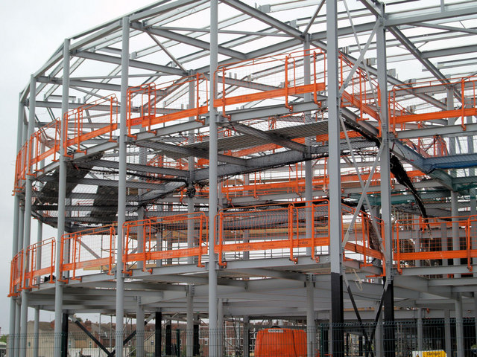
We also use steel frame instead of using techniques such as brick and timber. Steel frame construction has many different advantages compared to brick and timber framed building. One main reason why steel is effective is because steel does not rot, twist or warp compared to wood which needs preventative techniques added to extend the lifetime. Steel is also a safer frame to use because steel is potentially fire resistance which adds safety to the building. Steel is also one of the lightest structures to use compared to brick, wood and concrete. Compared to another metals, steel is moisture and rust resistance which is needed for the shell of the building. Steel frame construction also has it disadvantages. One of the biggest disadvantages of steel is that is has a lack of energy efficiency. As we well known Steel is an excellent conductor of heat, so heat can be lost through the steel frame, sometimes up to 50% of the heat can be lost in a building. Another disadvantage of steel is that a lot of builders are not trained/skills to be able to construct a steel frame building. Also builders may not have the tools/equipment to construct a steel frame building; local builders may not have the money and resources to construct buildings out of steel so would rather use bricks because of the experience.
I have briefly gone over the main types of structures we can use for the new school but I would suggest constructing the new structure for the super school out a material called Porotherm. Porotherm is made of clay bricks which are held together by a small amount of mortar and can be constructed at a fast rate. Porotherm has been used throughout Europe for the past 30 years but has only used in the Britain for the past few years. Porotherm is delivered to sites through a Porotherm distribution system. Although Porotherm has only been used in the UK for a short period of time it has become a popular material to use for the Superstructure. Porotherm is popular for a number of successful reasons. Some of these reasons can benefit the new school these include:
It will be quicker to build the school using Porotherm because no mortar is needed for the vertical joints and a minimal of 1mm bed joints. Porotherm can also be installed in all weather conditions/Temperatures because it has a zero plus mortar which can withstand temperatures below 0 degrees and above saving both time and money on the project. Porotherm is one of the fastest structures to construct out of brick, wood and steel. Wienerberger the company that created the material state that one labourer can lay up to 30-40m2 of Porotherm a day.
It will also be safer to construct the new school out of Porotherm because it is fire resistant. Porotherm is also a safer material to use for the labourers because it is light weight (Below 11kg) and will avoid health problems such as repetitive strain injuries/manual handing. Other reason why Porotherm is a safer material to use for the labourers is because it requires you to roll the mortar using a roller machine which lowers the chance of someone having a mortar burn. Porotherm is safer because the small amount of mortar requires holding the walls together is made on site means a safer and quieter construction site.
We also want the school to be constructed as environmental friendly to be able to obtain a BREEAM listed building. Porotherm is one of the most sustainable structures we can use to support the school. Porotherm is sustainable because Porotherm uses less than 85% of water compared to bricks; this is because Porotherm requires a thin layer of mortar using a small machine. But using Porotherm we can taking as much water away from local water supplies which will be taken into account when achieving a bream listened building. Porotherm is also environmental friendly because 30% of material is made from recycled products which reduce the amount of waste being dumped in landfill. If the new school were to be demolished after its recommended life expectancy (150 years) the whole building can be recycled which is good for the environment because it prevents waste from being dumped into local wildlife areas. Porotherm has achieved a high level of cases where it has achieved a high level for the code for sustainable levels. Porotherm is widely sustainable so strongly suggest we use Porotherm as the structure for the new super school because it is a sustainable material and will help us achieve a BREEAM listed building.

Another reason why I recommend we should use Porotherm for the structural frame for the new super school is because it is an efficient product .one reason why Porotherm is an affective product is because it helps keep the building temperature at a comfortable rate. Porotherm is also has a good thermal mass which can prevent heat from being lost in the walls. Porotherm does not have a lot of negatives but one major positive reason to construct buildings out of Porotherm is because Wienerberger the company that created the clay bricks offer a free training weekend to local builders how wish to be trained how to use Porotherm. Porotherm is starting to become a popular material because of this positive reason. So before beginning construction of the new school we can ask all local builders to go on this free course to gain the skills needed to use Porotherm for the structure of the new school.
Porotherm is widely sustainable, Safe, efficient and fast product to construct so strongly suggest we use Porotherm as the structure for the new super school because it is a sustainable material and will help us achieve a BREEAM listed building but is also the best material to use in terms of cost, time and resources.
I would recommend that we use a new type of material called SIP Panels as a structure frame for the Caretakers house. SIP stands for Structural insulated panels. SIP panels are made of a layer of 4 to 8 inch thick foam board instillation wedged between two pieces of wood commonly plywood, this creates the SIP panel. When the SIP panels come to site from the factory that are painted green this is done to prevent mould resistance layer which will prevent the structure from rotting. I would recommend that we use SIP panels as a structural frame for the caretakers’ house for the following reasons.
- Installing SIP panels is a fast procedure; it can be built in a matter of weeks. This safes time, money and resources.
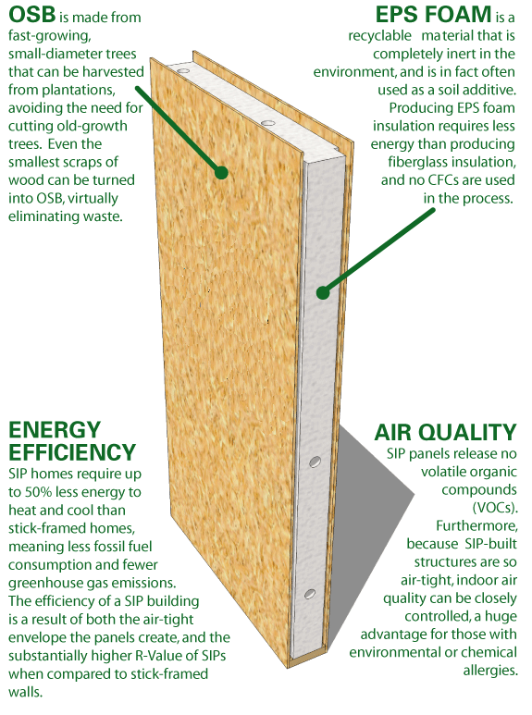
- SIP panels are constructed to clients brief for example if the client wanted a window above the staircase then the manufacture of the SIP panels would leave a gap in the panels for the windows to be installed.
- SIP panels are well insulated and have U-Values as low as 0.13.the SIP panel are efficient at keeping heat within the building because they are a good insulator. This will prevent heat from being lost in the caretaker’s house.
- SIP panels are constructed off site so prevents mess on the construction site making it a safer environment.
- Some SIP panels are eco-friendly which we need to take in to account if we want a BREEAM listened site.
- SIP panels are also cost effective compared to another forms of structures.

For the following reasons shows above I strongly think we should use SIP panels to construct the structure of the caretaker’s house because it is cost effective, energy efficient, sustainable and can also be installed in a number of weeks.
D2- Evaluate the environmental performance of modern materials and techniques used in the construction of superstructures for low-rise domestic and commercial buildings, for two different Tutor-specified scenarios.
When designing the new super school (commercial buildings) and caretaker’s house (domestic dwelling) we need to take into account the environmental performance of the materials and techniques if we are aiming for the building to be given a high BREEAM rating. There are many types of materials and techniques we can use to constructed the superstructure and I am going to evaluate these materials/techniques and choose my chosen materials for the two buildings.
One of the most important parts of the superstructure is the structure of the building. There are many structures we can use but only a few provide excellent environmental performance and helps achieve a high BREEAM level. I have chosen to use the following structures in the 2 building these include:
- SIP panels for the caretakers house (domestic dwelling).
- Poroframe for the super school (commercial buildings)
I have chosen these two materials for the structure because they both provide a high environmental performance.
SIPS panels for the caretaker house
SIP stands for Structural insulated panels, SIP panels are made of 2 pieces of wood with a thick layer of foam board instillation in the middle. Over the past 20 years SIPS have started to be used in Britain as a sustainable material for the structure of the building. I have chosen SIPS panels for the structure of the building because the materials provide a high environmental performance for the following reasons:
- Environmentally Friendly Materials
- High Insulation Value
- Minimal wastage
The materials that the SIPS board is made of Environmentally Friendly Materials but also provides an environmental performance.
SIPS panel are made of Environmentally Friendly Materials. The two pieces of wood used for the SIP panels are made of Orientated Strand Board. Orientated Strand Board comes from young fast growing trees which grow fast. By using young fast growing trees we are preventing using old slow growing trees which take hundreds of years to manure. By using young fast growing trees we are preventing wasting valuable wood which removes Carbon dioxide being removed from the air and the tree prevent global warming. By using Orientated Strand Board we are saving money because the young fast growing trees grow faster they are cheaper compared to Old slow growing trees. The foam insulation is also environmental friendly because the insulation is CFC and HCFC free. CFC and HCFC harm the environment because built up gases in the atmosphere.
SIP panel provides a high energy saving performance because of its High Insulation Value. U-values can be as low as 0.15W/m²K for the insulation in the SIPS panels. There is a minimal thermal bridging compared to traditional forms of construction. This minimal thermal bridging reduces energy consumption can lead to a reduction of up to 60% in carbon dioxide emissions. Over time the Insulation in the SIPS panels will save the building money because it keeps the heat within the building.
SIPS panels also provide Minimal wastage of materials compared to other forms of structures. The SIP panels are manufactured in a factory where they are accurately engineered to the clients chosen specification. By manufacturing the SIPS panels in a factory environment we are reducing the amount of waste because the machines used to construct the SIPS panels accurately manufacture the materials. If we were to manufacture the panels on the construction site we would create a lot of waste because there are no machines to accurate create the panels. By manufacturing the panels in accurately we are saving money because we are saving materials and also saving materials from being wasted.
In conclusion SIPS panels deliver a good environmental performance because they are made of Environmentally Friendly Materials, have a High Insulation Value and have a low Minimal wastage.
Porotherm structure for the super school
Porotherm is similar to the traditional approach of brick and mortar but Porotherm is made of clay bricks and only require a small amount of mortar. Porotherm is a new technique used to construct the structure of the super school. Many buildings that have been constructed using Porotherm have been given a high BREEAM rating because Porotherm has been highlighted as a sustainable material. Porotherm is environmental friendly because 30% of the materials are from either alternative, recycled or secondary sources. Porotherm bricks have achieved an A+ rating in the BRE green guide for external walling because Porotherm has been identified as achieving a high environmental performance. The code for sustainable homes material cater gory 1 also awarded Porotherm block with 3 points which shows that the environmental impact of the materials required to create the clay bricks are low. I have decided to use Porotherm because it provides a high enough environmental performance for the school to be able to achieve a BREEAM listed status. Porotherm achieves a high environmental performance because it is energy efficient, water efficient and waste efficient
Porotherm provides a high environmental performance in terms of energy efficiency and the environment. Porotherm required a low embodied energy level to fire recycled materials to turn them into Porotherm Bricks. Porotherm Bricks are made of Natural clay, recycled paper and sawdust. Some of these materials are recycled to created Porotherm bricks whereas if they weren’t the materials would be in landfill which harms the environment. By using Porotherm we are using recycled materials which saves energy because new materials do not have to be manufactured which saves energy and the environment because resources do not have to be harvested or burnt. Porotherm also achieved a high environmental performance level because they can last for up to 150 years. Porotherm bricks also Good thermal mass which prevents heat from being lost in the building.
Porotherm achieves a high environmental performance because it saves thousands of litres of water throughout its process. Porotherm reduces the amount of water needed to construct the site by 95% and reduces the pressure of taking water from local water supplies.
Porotherm achieves a high environmental performance because it prevents large amounts of waste from going to landfill. Mortar is not wasted because only a small amount of mortar is required to hold the walls together whereas normal brick walls require large amounts of mortar which creates a large amount of waste. In conclusion Porotherm achieved a high environmental performance because of a number of techniques and methods such as energy efficiency, water efficiency and waste efficiency.
Using sustainable building techniques for Caretakers house.
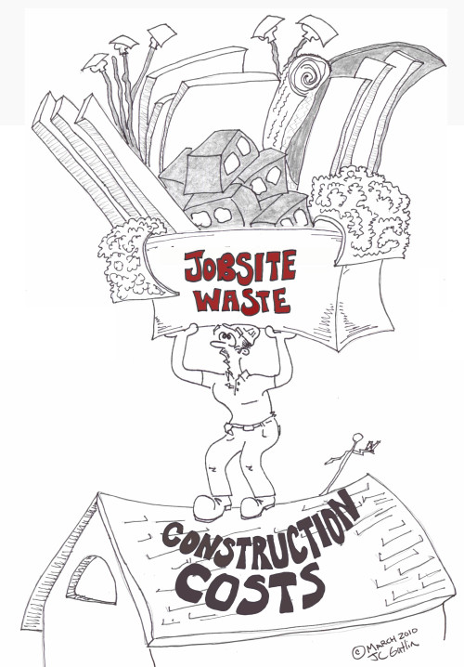
There are types of sustainable building techniques that we can use for both the super school and caretakers house. These 2 sustainable building techniques include:
- Waste based techniques
- Energy based techniques

Waste based techniques involve us cutting the amount of waste the building is going to waste over its lifetime. I have chosen to reduce the amount of waste creating the caretakers house as low as possible. By using this technique we are preventing waste from being sent to landfill because we cutting the amount of materials we are going to use but also by using techniques to prevent waste from being sent to landfill. By sending waste to landfill we are harming the environment in a number of ways BUT by reducing the amount of waste we are conserving the local environment around Baglan because we are stopping waste going to the local landfill site. We achieve this technique by:
- Ordering the required amount of materials required to construct the building. By insuring we are over ordering the required amount of materials we are insuring we materials are not sent to landfill.
- Educating all labourers to reduce the amount of waste created throughout the site.
- Burning over ordered materials .For example using waste wood for a fire.
- Using over order material for other projects. By using this technique we are reusing the materials and preventing waste from being sent to landfill.
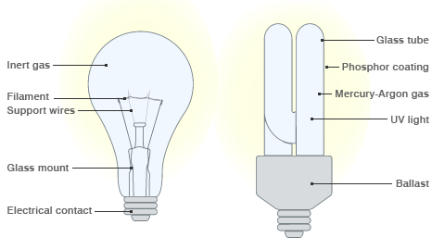
Energy based techniques involve us using techniques that will reduce the amount of energy needed to power the building. The Takers house is only a small building so I have chosen to use energy saving light bulbs throughout the building. Energy saving light bulb are environmental friendly because they require less energy compared to normal light bulb but still transfer the same amount of light as a normal light bulb. By using energy saving light bulb we are minimize the amount of energy needed to power the building. We are saving both energy and money by using the technique of energy saving light bulbs.

Using sustainable building techniques for the Super school building.
We are planning for the new super school to be a BREEAM listed building but to do this we need to use these 3 sustainable building techniques:
- Waste based techniques
- Materials based techniques
- Energy based techniques.

Waste based techniques involve us cutting down the amount of waste that the site is going to creates during it lifetime. We can cut down the amount of waste though reduction of waste, recycling and offsite fabrication. I think that the waste based technique recycling will benefit the super school. We can use materials from demolished site for the new super school. This involves taking materials from demolished sites and finding new uses for the materials for the super school. For example we treat materials from demolished sites and use them for materials for the new super school. Using this technique is effective because we are recycling materials but still achieving a high performance building material. The technique of recycling materials from demolished sites is effective because we are preventing a large amount of waste going to land fill. For example we can use the following materials from demolished sites and find new uses for them for the design of the new super school:
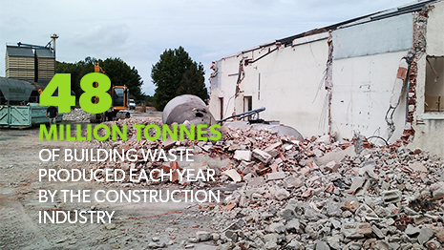
- Using Bricks from a demolished site to give the building a gothic old look.
- Using Glass from a demolished site can be re-melted and reformed.
- Using concrete from a demolished site and crushing the concrete to use to raise the ground levels of the school.
Energy based techniques involve us using technique to prevent the building from overusing fossil fuels to power the building. As we well know we need to burn fossil fuels to power a building, these fossil fuels damage the environment. We can prevent burning fossil fuels to power the new super school by running the school from a renewable energy resource. In the design of the school we have identified that there is a large roof space on the new super school. To be able to achieve a BREEAM listed school we can install solar panels on the roof which are sustainable and produce a constant supply of renewable energy. The school will run from solar panels which are environmental friendly because they do not require fossil fuels and collect energy from the sun. The solar panels will be used on the building throughout its lifetime compared to other forms of renewable energy resources solar panels are the easiest form of renewable energy. Solar panels also achieve a high environmental performance level because they create clean energy from the earth’s sun.
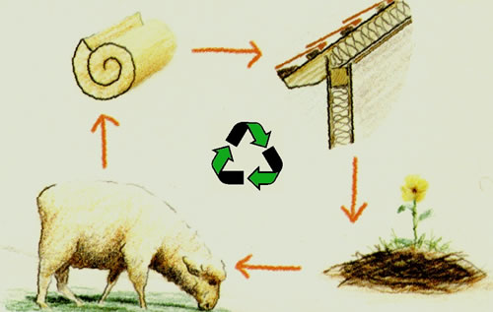
Materials based techniques involve us using materials that are renewable. In the neath valleys there is a large amount of sheep’s wool available. We can use sheep’s wool as an insulator. Using Sheep’s wool as an insulator has been identified as a sustainable materials because it does not harm the environment but also insulates the building extremely well because when wool fibres are packed together, they form millions of tiny air pockets which trap air, and in turn serves to keep warmth in during winter and out in the summer. We could use other forms of insulation but none are as sustainable and energy efficient as wool because wool natural has a high environmental performance level.
Taken from http://us.sheepwoolinsulation.com/why_wool/
References
Picture References
Picture of | Taken from
M2-steel frame | http://upload.wikimedia.org/wikipedia/commons/a/a7/Steel_frame_to_new_school_complex._-_geograph.org.uk_-_539951.jpg
M2-timber frame | http://www.britannica.com/EBchecked/media/153713/The-completed-frame-of-a-modern-timber-frame-house
Timber Frame Construction | http://sloansmill.com/
Internal and external wall diagram | http://soundproofingforum.co.uk/guides/documentE/036.gif
Wall ties | http://www.qwikfixings.com/why-gfrp-wall-ties.aspx
Roofs angle | http://www.homebuilding.co.uk/sites/default/files/images/0609pitch-01.jpg
Doors | http://www.jamesratfordbridge.co.uk/doors.asp
Porotherm brick | http://www.hhid.pl/?porotherm,23
Porotherm mortar roller | https://vimeo.com/61017823
SIP material | http://heavytimbers.com/sips.html
Plasterboard | http://www.vizimac.com/wp-content/uploads/2012/11/Sheetrock-Vs-Drywall-Unpaint.jpg
Reduction of waste in construction. | https://leanhomebuilding.wordpress.com/2010/03/21/construction-cost-reduction-starts-on-the-jobsite/
Energy saving light bulbs | https://www.google.co.uk/search?site=imghp&tbm=isch&source=hp&biw=1680&bih=955&q=reducing+waste+in+construction+&oq=reducing+waste+in+construction+&gs_l=img.3...14054.22527.0.22722.35.19.2.14.14.0.314.1882.13j5j0j1.19.0.msedr...0...1ac.1.64.img..1.34.1921.mB-s_3NCn7Y#tbm=isch&q=how+do+energy+saving+light+bulbs+work&revid=1069310355&imgrc=ypMkVmQ6X4LUfM%253A%3BUGsG_U2XAlkYWM%3Bhttp%253A%252F%252Fnewsimg.bbc.co.uk%252Fmedia%252Fimages%252F46304000%252Fgif%252F_46304916_lightbulb_comparison_466.gif%3Bhttp%253A%252F%252Fnews.bbc.co.uk%252F2%252Fhi%252Fuk_news%252Fmagazine%252F8406923.stm%3B466%3B270
Solar panels | http://www.greeleytribune.com/news/8642877-113/energy-panels-olmsted-power
Sheep’s wool | http://us.sheepwoolinsulation.com/why_wool/
Recycling on construction sites | http://www.brgm.eu/projects/sustainable-waste-management-setting-an-example-in-the-construction-industry

Book references
Used for | Taken from
P5,P6 | Topliss, Simon, Hurst, Mike, and Skarratt, Greg. BTEC National Construction: Building Services Engineering and Civil Engineering. Harlow, Essex, GBR: Pearson Education, 2007. ProQuest ebrary. Web. 23 March 2015.  Copyright © 2007. Pearson Education. All rights reserved.

Internet references
Taken from | Used for
http://porothermuk.co.uk/why/ | M2- Porotherm for use as a structural frame for the new super school.
http://www.fesconstruction.co.uk/Level%203%20Unit%206/P5_Superstructure.html | P5,P6 and M2
http://www.enviropanel.com/html/uk_sips_eco_advantages.html |  | D2 environmental performance of SIPS panels
http://us.sheepwoolinsulation.com/why_wool/ |  | D2 sheep’s wool
http://www.wienerberger.co.uk/walls/clay-blocks/porotherm-products/sustainability/porotherm-is-sustainable.html?lpi=1315323271571 |  | How does Porotherm acheive a high environmental performance.

Video references
https://www.youtube.com/watch?v=3uK-a8xh4HQ | M2- SIP panels
https://www.youtube.com/watch?v=UhcPErwsf20 | M2-Porotherm
https://vimeo.com/61017823 | M2-How to roll the mortar

