FACULTY OF SKILLS
School of Construction & the Built Environment

ACTIVITY ASSESSMENT SHEET AND ASSESSMENT CRITERIA

BTEC Extended Diploma in Construction
Unit: | 6  Building Technology in Construction | Assessment Ref. | 1/3
Assessment title: |  | Date issued: | April 2017
Issued by: | Bryan Shenton | Date due: | June 2018
Student name: |  | Date received:
Programme: | BTEC Diploma | Year: | 2016-17

Assessment method/s used | Class Exercise |  | Drawing Exercise |  | End of Module Exam |  | Laboratory Activity
 | Observation |  | Portfolio Building |  | Practical Activity |  | Questioning
 | Report |  | Research Based |  | Test

Grading Criteria to be assessed in this exercise: | P7, P8, M3

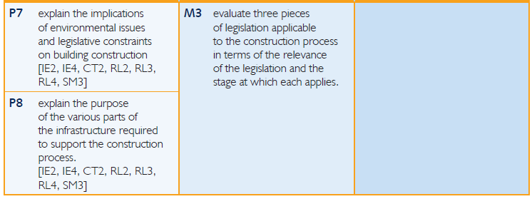

.
Brief has been Internally Verified |  | When? | Sept, 2013 | By Who? | CJ
Interim Assessment (no grade award until all module assessments are completed) |  | Overall Grade Achieved |  | Points Awarded

STAFF COMMENTS |  | ACTION PLAN
Student signature: |  |  | Date:
Tutor signature: |  |  | Date:
Internally Verified by: |  |  | Date:

Aim and purpose
This unit aims to give learners the opportunity to gain an understanding of common forms of low-rise construction, including the design and construction of their foundations, the techniques used in the construction of superstructures and the implications of issues and constraints on building construction.

Unit Introduction

Today’s buildings use combinations of traditional and modern techniques and materials in their construction, and these are influenced by the functional requirements of building elements and by legislation. This has become more apparent with the Government’s awareness of sustainable construction. Learners need to be aware of these factors in order to underpin their understanding of building technology.
This unit will introduce learners to the common forms of low-rise construction used for domestic and commercial buildings, including their substructures and superstructures. They will be shown how the recent development and use of prefabricated building components and systems has had a major impact on construction, particularly in terms of reducing site costs and contract completion time. Learners will develop an understanding of building technology by investigating and evaluating how techniques, materials, plant equipment and resources are used to construct buildings that will satisfy the functional and aesthetic needs of their users. They will come to understand that the impact of these technologies on lifecycle costs and the environment are of major importance, and that the choice of construction methods and materials must comply with all relevant legislation and constraints. These include the building regulations, elements of which are intended to reduce environmental impacts by using codes for sustainable homes. Consideration is given to specific provisions within the Health and Safety at Work Act and the Construction Design and Management Regulations, where they relate to site safety.

Learning outcomes

On completion of this unit a learner should:
1 Understand common forms of low-rise construction currently used for commercial buildings
2 Understand foundation design and construction
3 Understand the techniques used in the construction of superstructures for low-rise commercial buildings
4 Understand the implications of issues and constraints on building construction.

Assessment Brief

As a principle designer working for NPTC Group, you are to deliver a presentation to the client during the pre-construction phase of the new £3.5 million pound refurbishment. Highlighting health & safety and environmental constraints that will arise during the construction process. Also as part of the presentation explain the process of site set up and the infrastructure required.

Assessment Tasks

Task Description | Criteria Claimed | Page | Tutor Comment | Achieved | IV
You must explain the implications of environmental issues and legislative constraints, including health and safety issues and the Construction Design and Management Regulations for building construction. | P7 |  | This will be measured in Unit 1, Health & Safety.
You must explain the purpose of the various parts of the infrastructure required to support the construction process. A detailed treatment of how the infrastructure is constructed is not required but there must be evidence of an understanding of the different components of the infrastructure and the purpose of each. | P8 |  | Look at site set up & CDM  regulations
You must evaluate three pieces of legislation that are considered before and during construction of both substructures and superstructures. Evidence must address the relevance of each piece of legislation at each stage of the construction process. | M3

Achievement Progress

The following target dates identify what grades should be achieved by key dates throughout the academic year.

Key date | Performance Criteria that should be achieved by…..
Christmas
February half term
Easter
Whitsun

Additional Guidance

A close adherence to the grading criteria and the unit specification will enable you to maximise your potential to achieve the highest possible grade.

