Unit 6 Building Technology
Assignment 3
Lecturer: Bryan Shenton

Contents page
Page 1: Front page
Page 2: Contents page
Page 3: P5 - Explain the principles of super structure design?
Page 4: P5 - Explain the principles of super structure design?
Page 5: P5 - Explain the principles of super structure design?
Page 6: P5 - Explain the principles of super structure design?
Page 7: P5 - Explain the principles of super structure design?
Page 8: P6 - Describe the techniques to construct and finish component Elements of the superstructure?
Page 9: P6 - Describe the techniques to construct and finish component Elements of the superstructure?
Page 10: M2- Justify the selection of suitable materials and techniques?

P7 Explain the implications of environmental issues and legislative constraints on building construction

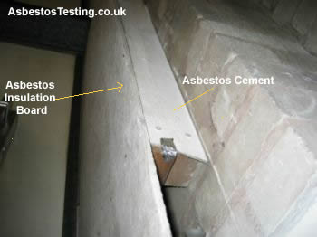
As a result of Asbestos being present at the currentBrickwork department it has a negative effect on the construction project. We must follow laws such as the control of Asbestos regulation 2012 in order to make the site safe but to limit the risk of workers being affected by asbestos. It is extremely dangerous for our workers to be breathing in Asbestos dust because it is deadly and kills around 5000 workers each year which leaves negative effects on our construction site. Asbestos is realised into the air on a construction site as a result of dusts from old building materials (Asbestos pipes and insulation).If a worker is constantly breathing in Asbestos dust then serious diseases/illness can develop these include Mesothelioma , lung cancer, Asbestosis and Pleural thickening.

Under the control of Asbestos (6 April 2012) we must follow these control measures for the conversion of the brick layering department.
- As a contractor we must carry out an investigation to see whether Asbestos is present at the brickwork site. We can be notified if the site contains Asbestos by the sites maintenance team who would be aware if any material in the building contained asbestos. The person in charge of maintenance in the college will be aware of where Asbestos in locate in the brick layering department. If the maintenance team is unaware if the building contains Asbestos then we need to survey the site and its materials.
- We must monitor the Asbestos materials and insure that they are not damaged and are in a good condition. This could result in high maintenance costs for both the client and the contractor.
- We must protect anyone using or working in the premises from the risks to health that exposure to Asbestos causes.
- We must control the amount of Asbestos in the air and insure that there are 0.1 Asbestos fibres per cubic centimetre of air. This will result in higher costs because we have to buy the machine that calculates the amount of asbestos in the air.
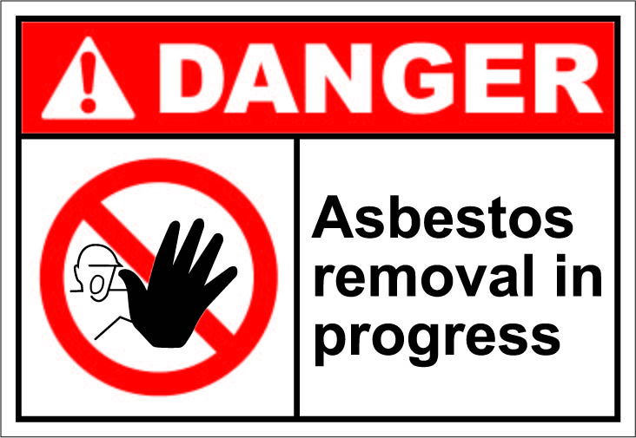
- We must provide training to every worker that is going to be in the presence of Asbestos dust to insure they have the capability to work with asbestos. This could mean added costs to a construction company because we have to pay for the workers to be trained. Training could also result in lost time in the project because we have to give them time off from the construction timetable for the training.
- Every worker working in an asbestos environment must be given PPE such as disposal able overalls, face masks and also showering facilities.
- We must also prepare a risk assessment to be made aware of the risk of asbestos in the building. This can also result in high costs for a construction company.
- We must provide signs to make both the workers and general public aware that asbestos work is being carried out on the site. This can also result in high costs for a construction company.

The control of Asbestos (6 April 2012) can reduce the chance of workers breathing in asbestos but can also involve added costs for a construction company. But the added costs are worth it because we reducing the chance of our workers from developing serious illnesses as a result of our NPTC site becoming unsafe as a result of not following the control of asbestos regulations 2012.
As a result of the class room a floor higher than the ground we must following the Working at Heights. The labourers will be working above ground level and there is a chance that someone could fall from the 2nd tier raised floor and fall. We must follow the working at heights regulations to insure that the site is safe but also that no one hurts in themselves as a result of not following the regulations. The purpose of the regulation is to prevent someone from falling from a height and hurting themselves in the process. The working at heights regulation states that
- The ladders/scaffolding should be properly planned. This requires time and planning and supervision.
- The person working at the height must be supervised. This can created added costs because someone needs to paid to watch them.
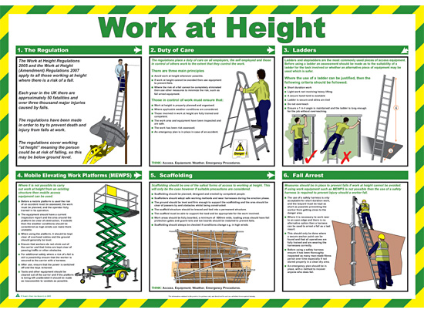
- That the work being carried out by competent people. We must insure that they are skilled and have experience are to carry out the task. This means that training needs to be given to all labourers that are going to working at heights this means added costs and time for a company.
- When working on roofs we need to insure that it is not a windy day. This can affect the timetable within the project because we cannot work at height when the weather is bad.
- That the structure is unstable and that the structure is safe enough to take the weight of the labourer. This means that someone has to check the safety of the platform.
- Stop materials or objects from falling. This means that the site needs to be clean at all times to avoid materials from falling from height.
- Installing structure/equipment to limit the chance of the labourer falling for example scaffolding holding and ladders.

As a construction company we must follow the CDM (Construction Design and Management) and the purpose of the regulations is to make the construction site safer and to improve the safety of a site. The CDM came into force in 1994 but since then has been changed 2007 but the modern recommended CDM came into force in 2015. The CDM has noticed that construction sites need to safer and that safety is important in construction between 2005/2006 there was 32% of all worker fatalities (77 killed).The CDM makes a construction site safer by co-ordination, management and co-operation within a construction company. The new CDM Regulations will help make our project safer by advising us:
- To Plan the work for the brick layering department so we can manage the risks throughout the project.
- Insure that all labourers are trained and capable of carrying out a task safety and effectively.
- Work with the clients, contractors and subcontractors to co-operate with us during the project.
- Have the ability to carry out risk assessment to limit risks on the project.
- Have daily meeting with workers to talk about the risks on site and the safety precautions to limit the risks.
P8 Explain the purpose of the various parts of the infrastructure required to support the construction process.

Neath Port Talbot College have proposed to convert a storage area in the brick layering department into a classroom. In the design the college have requested that the new class is to have state of the art computer will need to run from a renewable energy resource. The college have requested also that the work to construct the new class room must take place during the colleges holiday (summer holidays).We are also aware that the current brick layering area contains asbestos. We use following guidelines when working with asbestos.NPTC have also requested that the aesthetically in keeping with the surrounding buildings which are mostly portal frame. To be able to complete the project on time we must use the following infrastructure to make the site both efficient and also save time. Infrastructures that will be required to convert the storage area include:
- Hoardings
- Sealed skips
- Toilet facilities
- Signs
- site cabins
- scaffolding
- canteen
- Disposable overalls
- Showering facilities
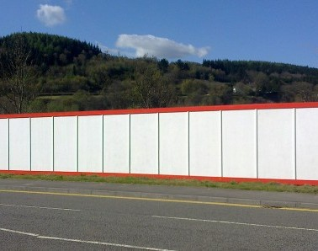
The purpose of using hoardings around a site is to prevent the general public from entering the site. Hoardings involve tall fencing being placed at the site boundaries. Hoardings also may us aware that we must wear our safety helmets because the area has become unsafe. We also use hoardings to prevent materials being stolen from the site. Hoardings are an important part of the infrastructure for the school because we need to minimize the chance of students entering the construction site which is dangerous. Without hoarding the students will be unaware that dangerous building work is being carried out in the area and could get hurt as a result.
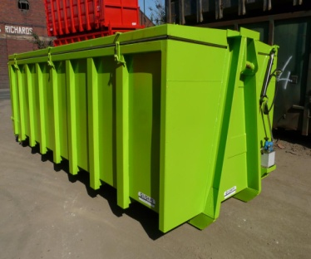
The purpose of sealed skips is to prevent harmful dust and chemicals from contaminating the air around the college affecting both the students and labourers. As we are aware the brick layering department contains large amounts of Asbestos which is deadly so when disposing of Asbestos we must insure that it is in a sealed skips that will contaminate the local air and affect peoples health. If we were not to use sealed skips then there would be a very high chance that a student/labourer would walk past the bin and breathe in the dangerous Asbestos so to limit the chance of this happening the college have decided to us sealed skips.
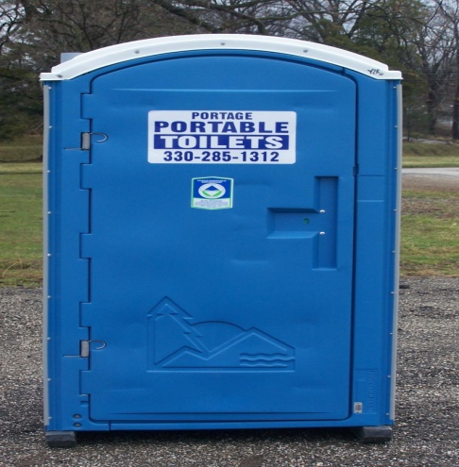
The purpose of toilets is to insure that the labourers on site have access to toilet facilities at all times. On site we must have both a male and female toilet. Without toilets the labourers will damage their health or have to find a toilet away from the site which takes a lot of time is lost within the timetable.

Under the Health and Safety at Work Regulations 1999 legislation we must provide sign around the site to make both students / labourers aware of dangerous things on site. Typical signs around the college construction site include:
- Signs on the hoarding to make the general public aware that they must not trespass the site that a safety helmet must be worn past the hoarding and to be aware of exercise caution as they pass.
- Warnings against more specific dangers related to construction, including incomplete scaffolding, Asbestos removal, the presence of forklift trucks, deep excavations or the possibility of suspended loads and falling objects.
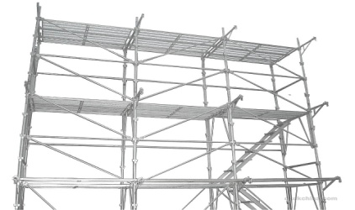
The proposed classroom will be at a height of less than 3 floors under the Working at heights legislation we must install scaffolding to prevent workers from injuring themselves as a result of falling from a high distance. The purpose of using scaffolding to prevent workers from falling from a height by installing metal poles (scaffolding) which provide a safe working environment to our employees.

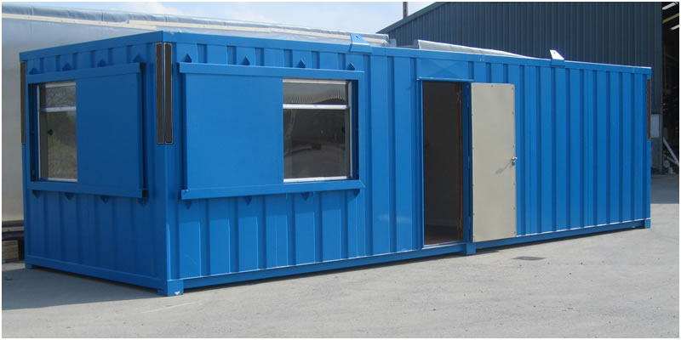
Site cabins are another type of infrastructure that is important to help us finish a project successfully. The purpose of a site cabin is to provide a safe hygiene environment for people to work in. Site cabins are normally used by project managers and site mangers as an office but are also used to communicate with a range of people on site. Site cabins will be needed at the NPTC site because the project manger will need the cabin to keep all the information about the project at his cabin safety. Without a site cabin the mangers would not have an office and would become unorganised as a result of not having an onsite cabin.

When converting the storage area into a class room we need to provide our employees which food facilities. On the NPTC site we will hire a canteen to feed our employees. The purpose of a canteen is to provide the workers with food on time and on site which prevents workers from leaving the site to have food. By not having a canteen our workers would have to buy food elsewhere and as a result turn up late to site.

As a result of the brick layering department having Asbestos in the building we must provide certain infrastructures to prevent our workers from breathing in Asbestos as a result. The infrastructures we can use to limit the chance of our employees breathing in Asbestos dust include:
- Making all workers wear Disposable overalls
- Showering facilities
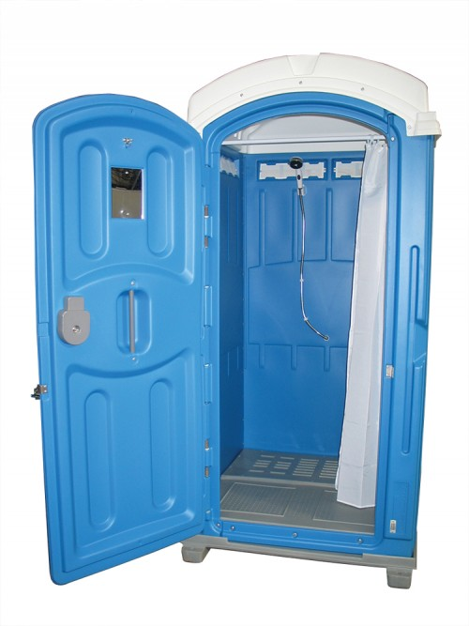
We are aware that the brick layering department contains large amounts of Asbestos which is deadly to human so we as a company need to insure that all employees that are working on the site must wear disposable overalls. The purpose of wearing overall is to insure that the employees don’t get Asbestos dust on their clothes and spread it to another people who come into contact with the asbestos. Another reason why we use overalls is because we limiting the chance of the employee breathing in the dust because they are wearing protective equipment and measures.

When our employees are working with Asbestos there is still a small chance that they can still have Asbestos on their body EG hair etc. So to limit the chance of the employee spreading Asbestos dust we must insure that all employees have a shower before they leave work. By insuring that all employees have had a shower then we are aware that they are clean and do not contain any small amounts of asbestos. Also by making our employees shower we are limiting the chance of them passing on Asbestos dust to people who are in close contact there for limiting the chance of someone having Asbestos diseases as a result.
The Speciation for the conversion of the storage area into a class room includes:
- The steel framing of the structure is to be painted and the ground floor space will still be the same.
- The bricklaying department is made up of a typical wall construct (cavity wall) we will continue to use the typical wall construction for the new classroom.
- Sky lights will be installed on the roof to provide more natural light into the building but also to limit the amount of light that the new building is going to require.
- By using about 30 solar panels on the roof to power the new state of the art computer room. By using solar panels we are making the building more sustainable but also limiting the use of fossil fuels to power the building.
- Removing the Asbestos for the safety of the students and replacing it with steel cladding. We will have to follow legislations by removing the Asbestos but also use the 2 steel cladding i have just discussed (overalls and shower facilitates) to limit the chance of people catching Asbestos related diseases.

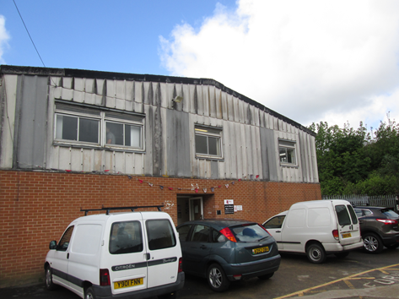

Current Steel framing is to be repainted silver to look more visually pleasuring

Traditional wall construction

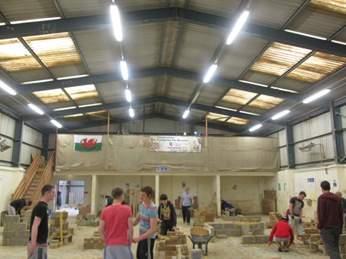
New glass sky lights to be installed to provide more natural light.
Storage area to be converted into class room.

Solar panels to be installed in these areas.

M3 Evaluate three pieces of legislation applicable to the construction process in terms of the relevance of the legislation and the stage at which each applies.

Following legislations and laws set by the UK government we must follow 3 legislations when converting the storage area into a classroom. These 3 legislations include:
- Working at heights legislation.
- The control of Asbestos legislation 6 April 2012
- CDM legislation 2015

The 3 legislation have been put in place by the UK government to make the construction environment safer and to lower the risks of accidents occurring frequently. As a construction company we must take health and safety seriously to withstand a good reputation but also to avoid having to pay fines as a result of lack of legislations. In my report I am going to evaluate these 3 pieces of legislation in-terms of the relevance and at what stages the legislation is going to be needed to be used for the new classroom.

Working at height legislation
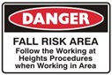
The working at height legislation is relevance is important for the following reasons:
- We are reducing the amount of accidents that will occur by adding infrastructure such as scaffolding which will protect labourers when working at height. Without using scaffolding a large amount of worker could be injured and will result in a lot of hidden costs such as sick pay, compensation and court cost. So I think that following the working at heights out weights not following it in terms of reducing accidents.
- We are going to have the site much safer by following the working at heights legislation.
- We are going to save lives by following the Working at height legislation.
- Workers feel much safer and work better when they know they are protected by scaffolding.
- Work can be completed quicker by using scaffolding because the workers can easy carry out the work.
- By following the Working at height legislation we are giving the company a better reputation because future clients will be aware we take health and safety seriously.
- We are avoiding fines/Prison sentences by following the legislation.

The relevance of the working at heights legislation can have negative effects for the construction company for the following reasons:
- Supervision needs to be given when labourers are working at heights. This can results in added costs and makes sure that someone is supervision at also times
- By installing infrastructure such as scaffolding and ladders we are resulting in added costs because as a construction company we needed to buy the equipment which can be expensive
- Scaffolding needed to regular checked before work can be carried out. This results in time being lost in the timetable as a result of the scaffolding being checked
- The legislation states that we cannot work at heights when the weather is bad. This wills results in added costs and lost time in the timetable.
- Labourers may need to be trained to work at heights if it is a tall building. This will result in worker having to be giver time off the construction site to be trained or could results in the company having to recruit labourers that have the skills to work at height.

We will need to follow the working at height legislation during these stages in the timetable:
- Using a ladder/scaffolding to paint the room after it is completed.
- Using a ladder/scaffolding to plaster the room after it has been completed.
- Using a ladder/scaffolding to remove asbestos from the walls.
- Using scaffolding to remove the roof and replace it with a new one.
- Using scaffolding to install the solar panels on to the roof.
- Using scaffolding to complete every bit of works that involves labourers working at height.

As a result of the new class room being on raised floor scaffolding will be needed throughout the timetable of the project both the inside and outside of the building. There is no possible-able way that we could carry out the project without the use of scaffolding.

In conclusion the relevance of following the working at height legislation outweighs the possible effects that could follow if we do not follow the working at height legislation. There will be an increase of workers falling from height and as a result will look bad on our company.

The control of Asbestos Legislation 6 April 2012
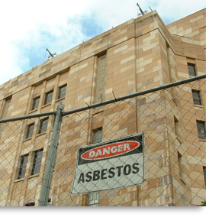
The Control of asbestos legislation relevance is important for the following reasons:
- Aimed to reduce the amount of workers who will be affected by asbestos illness as a result of lack of knowledge, Infrastructure and lack of PPE. If we decided not to follow the control of asbestos legislation then there will be a high possibility that our workforce could be affected by asbestos illnesses which will result in the company having to pay compensation, sick pay and low company moral. So the relevance of The Control of asbestos legislation is to lower the chance of asbestos related illnesses but also to avoid the hidden company costs.
- Another important relevance of The Control of asbestos legislation is to make the site a safer working environmental. Labourers will work more efficiently because they are aware of they are protected against the risk.
- Another important relevance of The Control of asbestos legislation is to avoid deaths as a result of asbestos diseases. If we weren’t follow the Control of asbestos legislation and there was a death then the whole workforce will be badly affected which could result in low morale. No one wants to contribute to a death as a result of asbestos so as a company we should follow the control of asbestos legislation to avoid blood on the companies’ hands.

The relevance of the Control of asbestos legislation can have negative effects for the construction company for the following reasons:
- The costs of buying the PPE such as Disposable overalls and shower can be expensive for small scale building companies.
- The site must be surveyed or investigated to see if asbestos is present on time. This results in lost time in the timetable, added costs and may also requirements the need for specialist subcontractors.
- All staff on site need to wear PPE at all time, this is requires constant supervision which requires time and resources.
- All members on site may need to be trained to work in an environment of asbestos. This will require the need for specially trained labourers who often hard to find at a good rate.

We will need to follow the control of asbestos legislation during these periods in the construction timetable:
- When removing the asbestos that is currently used as insulation in the building.
- Whenever someone is going to dispose of materials in the sealed skips.
- When we are nailing or drilling through the walls.

We will need to follow the Control of asbestos legislation throughout the construction timetable because asbestos will constantly have small fibres of asbestos within the building. The only time that I recommend that PPE does not have to be used is when the Building asbestos levels are being measured using a meters scattered around the Brick layering department. I recommend that the Legislation is also followed when carrying out work on the site because asbestos dust can still be breathed in when we are digging holes and working within the building.

Conclusion: I strongly recommended that we follow the Control of asbestos legislation as it has been approved by government to make a site safer and also to avoid asbestos illnesses. Although following the Control of asbestos legislation is a legal requirement I think that following it avoids illness, death and the added costs of asbestos. The positives of following the Control of asbestos legislation out weight the negatives of following Control of asbestos legislation because the legislation does safe thousands of lives.

CDM legislation 2015
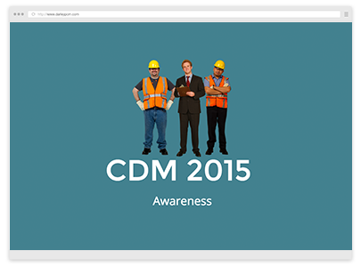
The CDM legislation relevance is important because its purpose is to make a site as safe as possible. The relevance of making the site safer includes:
- Insuring that every labourer has the correct training, skills, knowledge and experience to carry out a particular role. If the labourer was incompetent of carrying out a task than there is a chance that the labours could hurt themselves.
- Part of the CDM legislation is to insure that all hazards are identified before construction work starts. By doing this we are limiting the chance of accidents happening before the site has even been set up. By highlighting the hazards that are going to occur we are being more efficient and making the site safer.
- The relevance of the CDM is that every type of project must follow the CDM legislation under UK and EU laws.
- The relevance of CDM is to reduce accidents by insuring labourers are competent to carry out tasks, the risks have been prevented and the client, contractor and designers are all aware of the hazards before the project beginnings.
- Reduces the amount of accidents that take place on site by making sure all employees have a safety talk about the site every morning. These meeting make the workforce aware of fresh hazards that are on site.

The relevance of the Control of asbestos legislation can have negative effects for the construction company for the following reasons:
- Large scale projects such as the current project at NPTC may result in us having to hire CDM coordinators. These coordinators are expensive but can be expensive.
- Many construction companies are unaware of the 2015 update of the CDM legislation. This means thousands of companies are unaware of the new chances and are breaking the law.
- Training someone in the company to be a CDM coordinator can be expensive and will require time offsite to be trained.
- Risk assessment needed to be filled in daily because of new hazards that will occur on site. This requires time, resources and money to fill in a risk assessment correctly.
- Time is wasted when we are informing workers about the hazards on site.

We will need to follow the CDM before the construction project even starts to identify hazards that are going to occur and how we are got to stop or minimize the hazard. The CDM legislation will need to be followed throughout the timetable of the project because risk assignments and daily talks are part of the CDM legislation 2015.

Conclusion: I strongly think that we should follow the CDM accurately because the legislation does work and does prevent accidents occurring on site by using the method design and management. The positives of the CDM outweighs the negative of the CDM because we are saving lives by follow the legislation and a human life is worth more than money and time on a project.

References
Picture references
Picture of | Taken from
NPTC group logo | http://www.bing.com/images/search?q=nptc+group&qs=n&form=QBLH&scope=images&pq=nptc+gr&sc=8-7&sp=-1&sk=&ghc=2&cvid=e6dad6a4452e41e58cef4c4720657e8b#!?q=nptc+group&view=detailv2&&&id=90DB2D8896677D6AC11C3056E3C30621C8DFA4CB&selectedIndex=0&ccid=Ib1VOO%2fy&simid=608007257603114463&thid=JN.HDYdIHKTUiqM5zAJQJ2D8g&mode=overlay
Site hoardings | http://www.fencing-systems.co.uk/files/thumb/painted-site-hoarding.jpg/378/298/fit
Sealed skips | http://images.gileskips.co.uk/recycling2.jpg
Portable toilets | http://portageportabletoilets.com/yahoo_site_admin/assets/images/4_1_09_toilet.90200143.jpg#portable%20toilet%201320x2340
Scaffolding | http://www.okokchina.com/Files/uppic31/Scaffolding883.jpg
Site cabins | http://www.roanbuildings.co.uk/wp-content/uploads/2013/08/Image5-con.jpg
Disposable overalls | http://www.farmerboyag.com/images/99040006_l.jpg
Portable showers |  | http://www.andyloos.co.uk/wp-content/uploads/standard-individual-shower-unit-1-e1386159457552.jpg
Asbestos signs |  | http://www.wep-hse.com/news/wp-content/uploads/2012/04/dangH025_asbestos_removal_in_progress2.jpg
Asbestos materials |  | http://www.asbestostesting.co.uk/images/asbestos-insulation-board.jpg
Work at heights poster |  | http://www.workplacelearningcentre.co.uk/get/image/productmedia/4c1e268c74a98_A716-L.jpg
CDM |  | http://www.cdmductwork.co.uk/images/cdm-logo.jpg
Working at height sign |  | http://wpsa.net.au/media/24088/working%20at%20heights%20fall%20risk_127x85.jpg
Asbestos sign |  | http://www.scaconsulting.com.au/img/legislation-asbestos.jpg
CDM |  | http://www.darleypcm.com/sites/default/files/img/training/darleypcm_cdm2015course.png

Internet references
Information about | Taken from
Signs on the construction site | http://www.servicemagic.co.uk/tips-and-advice/safety-signs-for-your-construction-project.html
CDM regulations | http://www.hse.gov.uk/construction/cdm/2015/index.htm
CDM presentation | http://www.hse.gov.uk/construction/cdm/2015/index.htm
Work at heights legislation | http://www.hse.gov.uk/construction/cdm/2015/index.htm
Asbestos regulations | http://www.hse.gov.uk/asbestos/essentials/
Book references
Topliss, Simon, Hurst, Mike, and Skarratt, Greg. BTEC National Construction: Building Services Engineering and Civil Engineering. Harlow, Essex, GBR: Pearson Education, 2007. ProQuest ebrary. Web. 23 March 2015.
Copyright © 2007. Pearson Education. All rights reserved.
Video References
Video about | Taken from
CDM 2015 Update | https://www.youtube.com/watch?v=3QLIJDH0o0U

