Secondary research example
UK growth forecast cut by BCC after Brexit
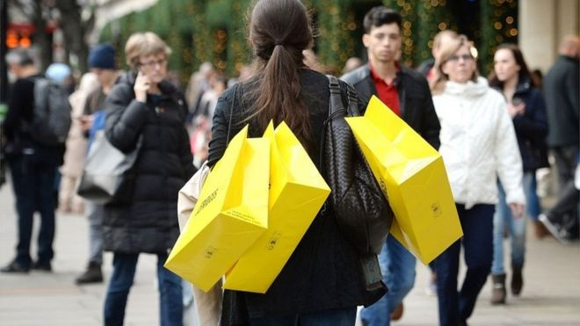
12 September 2016

Image copyright PA
The British Chambers of Commerce (BCC) has slashed its growth forecast for the UK in the light of the Brexit vote.
It now expects the UK to grow 1.8% this year, down from its March estimate of 2.2%, and by 1% in 2017 compared with its original forecast of 2.3%.
Uncertainty surrounding the UK's negotiations over its EU exit would "dampen growth prospects", it said, while consumer spending would weaken.
It said the UK "would skirt with", but avoid, a recession.
However, a separate report on business conditions from accountancy and services group BDO said optimism was improving, after falling to a three-year low last month.
The forecast from the BCC is the first it has made since the EU referendum, and it warned that, while it did not expect a recession, companies were still digesting the results of June's EU referendum.
In total, the business group said its downgrades implied the UK economy would be £43.8bn smaller by the end of 2018 then it had expected before the EU vote.
But it said the slide in sterling since the vote should improve the UK's net trade position.
"Although individual businesses continue to report strong trading conditions, the overall picture suggests a sharp slowdown in UK growth lies ahead," said BCC acting director general, Dr Adam Marshall.
He urged the government to set out "a clear timetable" for negotiations with the EU, and said it should push on with infrastructure projects such as a new airport runway and new nuclear investment to help encourage business spending.
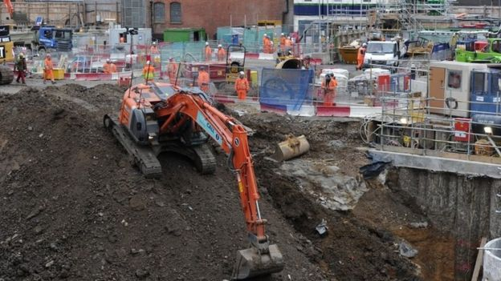

Image copyright Getty Images Image caption The BCC urged the government to push on with infrastructure projects to help encourage business investment
The BCC is a national body of 52 accredited chambers of commerce across the UK, representing over 100,000 businesses in total.
During the EU referendum it decided not to campaign for either side because its membership was split.
Data earlier this month suggested that the services industry - which accounts for nearly 80% of the UK economy - rebounded strongly in August following a shock fall in July immediately after the Brexit vote.
Analysts said the strong growth - which took the services sector back to pre-referendum levels - meant the UK was likely to avoid a recession.
Its index of business optimism, which looks at growth six months ahead, is up to 98.7 from 97.9.
'Back to business'
BDO's index of business optimism, which looks at growth six months ahead, rose to 98.7 from 97.9. It said that was well above the 95.0 level which would indicate the start of recessionary conditions.
"After the immediate Brexit scare, businesses are becoming more confident as they start to find that, for most of us, it's back to business as usual," said Peter Hemington from BDO.
"But ongoing uncertainty and the likely longer-term damage if we exit the single market, are concerns which continue to justify government support for growth.
"The government must prioritise taking advantage of cheap borrowing costs to invest in infrastructure and protect the growth of our economy as we move closer to exit negotiations."

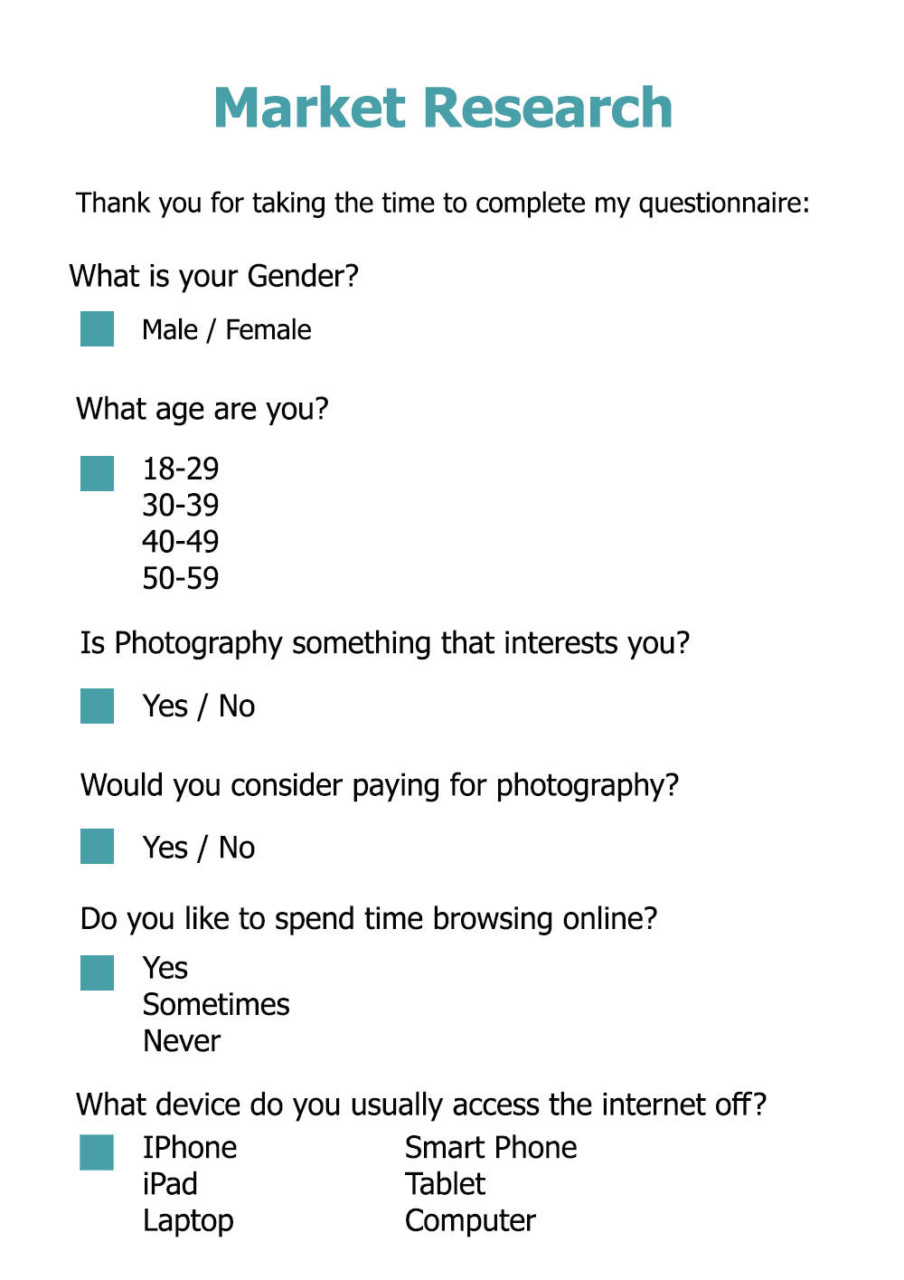
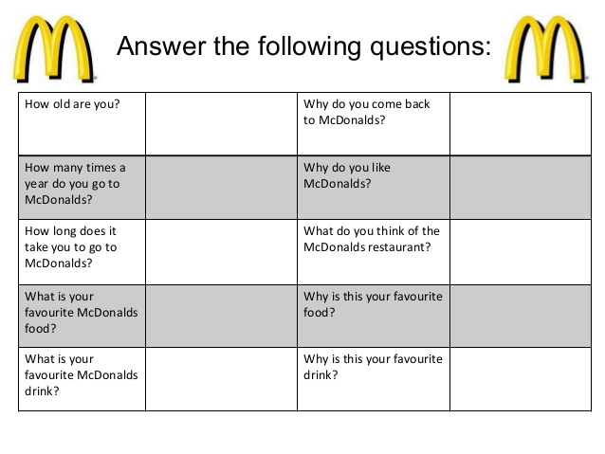
Primary research examples

