Stakeholders handout
Stakeholders in a business are any individual or group which is affected by the business and so has an interest in its activities. These stakeholders are not all driven by the same objectives; in fact, it is likely that different stakeholder groups will want very different things from the business concerned. Therefore, it is not unusual to find different stakeholders and stakeholder groups coming into conflict over a business’s activities and objectives.
Stakeholders
Shareholders, Directors and managers, Employees or workers, Customers, Suppliers, Local communities and Government.
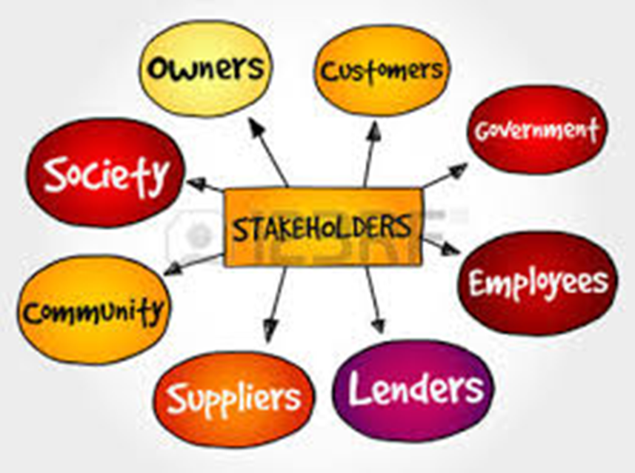

Shareholders
Shareholders are the owners of a limited company. In theory, all shareholders share the common objective of sustained long-term growth, giving both capital gain and increasing income. However, the reality is that even shareholders can come into conflict. Institutional shareholders (investment and pension funds) are often driven by the need to achieve in the short term.
This means that they require high dividends and strategies to achieve short-term growth from the businesses that they have invested in. However, these strategies may be at odds with achieving long-term growth through reinvestment of profits and investing in brand value, which are what the individual, long-term investor may be looking for. Unfortunately for the small private shareholder, the institutional view is the one that more often than not wins the day.

Directors and managers
Directors and managers in large organisations focus their efforts on achieving the long term objectives of the business. They use the resources under their control to achieve maximum benefits for the business and to gain the most from the assets that they manage. Often the success or failure of the business will be reflected in the rewards they receive. Unfortunately for some businesses, the main long-term objective of some managers is the protection of their position.
This idea of self-preservation is sometimes a motivator for middle managers which can result in the establishment of whole layers of hierarchy whose role is to preserve their position. Senior managers are also sometimes accused of personal objectives ahead of those of the business by attempting to maximise their salaries and benefits, whilst cutting costs through redundancies and rationalisations.

Employees or workers
Employees/workers from middle management down receive a wage and possibly fringe benefits such as pensions. Naturally, a major concern of this category of stakeholders is job security. With many businesses seeking to incorporate technology, and reduce the size of the workforce, there will be obvious conflicts in the views of stakeholders.
In the past this conflict would have often led to industrial action. However, over the last two decades it seems that the labour force has become more aware of the realities of modern employment, and are therefore less likely to take part in strikes. The labour force is more willing to accept job restructuring, and redundancy and to move jobs, relocate and retrain.
Customers
Customers are an increasingly important stakeholder. Satisfying customers’ needs profitably should lead to financial success to satisfy the other stakeholders. Customers want efficient service and a quality product, at a competitive price. These requirements should not be at odds with good business practice, but unfortunately sometimes they are.
The short term nature of businesses can mean that achievement of immediate profit comes ahead of long-term customer satisfaction. Also customers like to feel needed and respected; it is all too easy to alienate your customer base. Maintaining good public relations is increasingly important – something which the banking and financial industry has come to realise in relation to the treatment of its customers.

Suppliers
Suppliers depend on the success of businesses for their sales – and businesses depend upon suppliers in order to carry on their operations. They are mutually dependent. Suppliers want a fair price for their products whilst businesses wish to minimise costs.
The big four supermarkets dominate the UK’s farming industry, continually forcing down the prices they pay to producers, reducing farm incomes (for example, consider the recent milk price war and its impact). The situation is often worse when suppliers are based in developing countries, with the original producer receiving a tiny proportion of the product’s final sale value. Fair trade goods try to make the supplier–buyer relationship more balanced.

Governments
Government benefits from business success as it results in increased tax revenues, higher employment and lower benefit payments. However, the same economic success also means increased pollution, increased traffic, and loss of greenfield sites through development.
In the past the priority was invariably given to growth, but increased environmental awareness has forced the government into limiting developments, encouraging development of brownfield sites, and into imposing taxes such as the Climate Change Levy and the Landfill Tax.
These taxes on businesses increase business costs, reduce competitiveness, and potentially increase unemployment. As a stakeholder the government has to balance business and economic growth against external costs of business activity.

Local communities
Local communities need to be considered as a stakeholder. There are a number of benefits to a local community that stem from local business activity. These may include employment, increased regional wealth, improved facilities and infrastructure.
Often the economic prosperity of a community may depend on one large employer in their area – the presence of which may support a range of other businesses such as shops, garages and hairdressers. Businesses may also support local charities as well as being involved with local schools and colleges.
However, conflicts can also occur between local communities and the businesses that operate close to them. This can involve potential pollution, environmental damage and loss of open space. Heavy transport moving 24/7 can affect the peace and quiet of a community.

