Product handout
The product is any good or service offered for sale to customers. A product can be quite simple such as a biro or a pair of socks; but often there is more to a product than just the item itself.
For example: A jar of coffee is not just a jar of coffee – it is a gateway to a more exotic life, or a method of ensuring that friends come round for a chat in the morning.
Some products are purchased to show personal style or to pretentiously demonstrate wealth. Products often come wrapped in add-ons, such as service packages or free delivery and installation on electrical goods. Do not just think of a product as a purely functional item: personality and what it says about the consumer too. Consider its E.G – Sports car, designer cloths.
Product Portfolio
The product portfolio is the mix of products the business produces and sells. Having a product portfolio makes a great deal of sense in a number of ways.
A product portfolio:
• spreads fixed costs; allows for greater economies of scale; allows the targeting of wider markets; reduces risk; smoothes out overall sales; creates opportunities for growth.
Product Breadth and depth
Breadth is the number of product lines a business produces or retails: Its depth is the number of product varieties within each product line. The product portfolio of Proctor and Gamble is made up of over 20 brands (product breadth), but is also made up of the varieties within each branded product (product depth). There will be a number of sizes of Duracell batteries, but also different sizes of packs. We can multiply the 20 products by the number of varieties to measure the complete product portfolio. Having depth increases the number of repeat buyers looking for variations of the product and also allows targeting of different market niches (rechargeable, alkaline and quantum batteries, for example).
Branding
A brand is the name given to a product to help differentiate it from other similar products.’
‘A brand is a product consumers rely on, for quality, value and service.’
‘A brand involves a distinctive identity for a product with which users can identify.’
‘A brand is a name, term, sign, symbol or design which identifies a seller’s products and differentiates them from competitors’ products.’
Marketing is often brand driven – the objective is to establish a product with a separate identity in consumers’ minds, making the product desirable, wanted, even needed. Brands are important for customers because they represent attributes, values, benefits and personality. Brands can offer long-term profitability to businesses, offering a degree of predictability to sales and revenues. However, brands do not just happen – they must be developed carefully, and when mature, the development must continue so that full long-term value is extracted from the brand.
Advantages of branding
To create increased consumer loyalty – this is important when competition is intense.
To separate the product from the herd – especially in markets where there is otherwise little differentiation and products are marked by their similarities rather than their differences.
To increase price inelasticity of demand – this gives greater control over pricing strategies.
To increase value of the business – brand values are often higher than other asset values of a business.
To ease customer choice – brand identity makes recognition of products easier, making purchase more likely
Disadvantages of branding
High cost of advertising – brands must constantly be kept in the consumer’s eye.
Loss of brand value for one product can affect a whole range of similarly branded products.
Brands invite competition – often from copycat manufacturers.
High cost of research and development in ensuring that the brand continues to develop and lead the market.
USP – Unique Selling Point
By unique selling point, we mean that the product or service has a feature or features that can be used to separate it from the competition. This could be the result of a technological advantage. A good example of this is the Dyson range of vacuum cleaners. Dyson is now the market leader, with vacuums selling at around £250. Before Dyson, with its bag less system and bright colours, the market leader was priced at £90. USP can also result from some feature of the product and its design. For example, the hole in Polo mints or the design of the iPad.
Product differentiation
Making your products different from the competition is important. This separates your brand from competitor brands. Products might be very similar in the way that they are made or how they are used but may be perceived quite differently by consumers. Product differentiation helps create customer loyalty and gives a business more control over the pricing strategies used.
Products can be differentiated from the competition by:
• Methods of promotion – creating a personality for the product;
• Packaging – eco-packaging;
• Form – making your products look different from the competition;
• The provision of add-ons – Kia cars have a seven year warranty;
• Quality and reliability – these are features which can be emphasised (for example, BMW and Rolls Royce cars).
Product Life Cycle
This represents the different stages in the life of a product and the sales that are achieved at each stage. For some products the life cycle can be short – for example, one-hit wonder bands or this summer’s fashion. Others appeal for a longer period and then go out of fashion or are replaced by newer, more up-to-date or technologically advanced products.
However, there are some products that are unique: for these the life cycle goes on and on. Coca Cola, the VW Golf and Mars bars are examples of products with impressively long and ongoing life cycles. Whatever the product, it will have a life cycle of some sort.
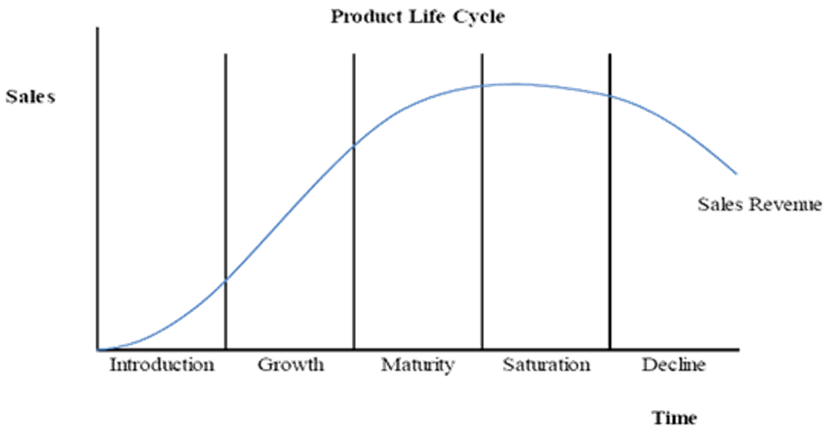

Product Life Cycle stages
In this example we see the five stages, starting with introduction, through growth, maturity, saturation and finally decline. The product life cycle measures the change in sales of the product that occurs over time. We can see that sales increase through introduction, growth and into maturity until we reach the saturation stage of the product life cycle. Sales now start to fall and the product moves into decline.
Introduction
The product is new to the market and few potential consumers know of its existence. Price can be high and sales may be restricted to early adopters (those that must have new technology, gadgets or fashions first). Profits are often low as development costs have to be repaid and advertising expenditure can often be high. Examples: iPhone 11 / Driverless car/ PS5.
Growth
The product is becoming more widely known and consumed. Advertising tries to establish or strengthen the brand and develop an image for the product. Profits may start to be earned but advertising expenditure is still high. Prices may fall. Example: Apple watch.
Maturity
The product range may be extended. Competition will increase and this has to be responded to. Advertising should be used to firm-up the image of the product in the consumers’ minds. Sales are at their peak, profits should be high. Example: Coca Cola, Ford Fiesta.
Saturation
Very few new customers are gained, replacement purchases are the trend. Businesses should try to reduce their costs, so that prices can be more flexible. The battle to survive is beginning and the market for the product is ‘full’. Profits may start to decline. Example: iPhone 6/ MP3 players.
Decline
Sales can now fall fast and the product range may be reduced, with the business concentrating on core products. Advertising costs will be reduced, with attempts made to mop-up what is left of the potential market. Overall profits will fall. Price is likely to fall, but by concentrating on remaining market niches there may be some price stability. Example: PC/ Cassette player.
Businesses will try to make the product stay in the maturity stage as long as possible as this will maximise profits and help the business gain the greatest return on the money invested in the product. To do this, the business will need to use extension strategies.
Product extensions
The ‘Extended’ product life cycle demonstrates that some products remain in the marketplace for a long time – often much longer than competitor products. These products stay in maturity and seem to avoid decline. Consider the shape of the life cycle of Coca Cola or Rice Krispies. Are these products in decline, or are sales being maintained?
These are used to extend the life cycle of the product. They may be necessary because a new product has not been developed to replace an ageing product. They may also be used as a product has a declining market share in a large or growing market.
Extension strategies could include
• repositioning (Coca Cola Life) the product in the marketplace;
• relaunching the product, aiming at a different segment, e.g. promoting the healthy aspects of consuming the product;
• using the ‘now with’ policy
Successful extension strategies
Successful extension strategies can transform the position of a product in the marketplace. Lucozade was once a drink for children who were unwell – now it is marketed as a sports drink.
Other extension strategies do little more than delay the end of the life cycle. Hopefully the delay will be long enough to allow a new profitable product to become established, replace the product in decline and help the business keep a balanced product portfolio. – this tactic is often used with limited edition cars.
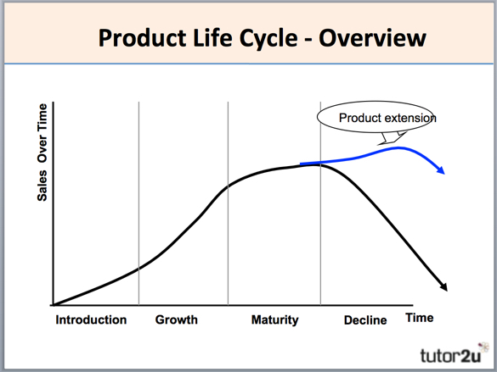

Profits and the PLC
Profits can be plotted against a life cycle. The red line below shows the likely change in profitability of the product over its life. Initially losses are made as research and development costs have to be recouped and advertising costs are likely to be high. As the life cycle moves through growth into maturity, profits are made. Profits are likely to continue to be made through to the end of the cycle, though at a lower level.
