Product - Boston Matrix handout
The Boston Matrix was devised by the Boston Consultancy Group in the 1960s and it allows the analysis of a business’s products by dividing the products into four categories. The categories the products are placed in depend on their market share and the level of growth that is occurring in the market. This structure can be used as a guide to product mix management.
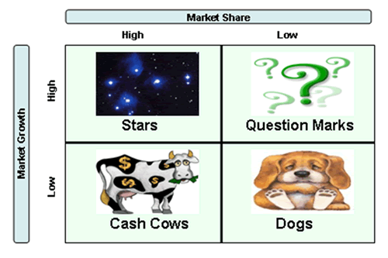

Cash Cows
Cash cows (High market share – slow market growth)
Cash cows are very profitable products and expenditure on such things as advertising is relatively low. Customers know and understand the product, and brand value has been established. It is also likely that development costs have already been recouped, increasing profitability further.
Examples: Ford Focus, Kellogg’s Corn Flakes, Cadbury’s Dairy Milk
Stars
Stars (High market share – fast market growth)
The market may be somewhat immature, with new customers being attracted to the marketplace and new competitors being tempted by potential profits and market share. Competition is high – businesses are fighting for a share of potentially huge profits. Stars are products that have a high market share in a fast growing market. Star products have high levels of revenue, but also have high levels of costs. Advertising and marketing expenditure is high. Brands have to be established and hopefully the products will develop into cash cows. The classic example of a recent product that was a star and has become a cash cow is the Apple iPad.
Examples : Apple watch/ Google glasses

Question marks
Question marks/Problem children (Low market share – fast growing market)
This is one of the worst situations for professional marketing people. They have a product in a fast growing market but the products are not selling. They are being beaten by the competition. They are failing, but it is likely to be worth doing something about it. After all, it is not good business for businesses to have products that fail to capture market share in markets that are growing in importance.
For products which are question marks, a product relaunch may solve the problem or a basic redesign may increase sales. In the mid 1980s jeans were out of fashion but the market for teenage clothes was growing fast. Levi's relaunched their jeans, led by advertising for 501s, which had never been a style of jean worn for fashion. Within a few months sales had increased by a 10 times – the product became a star. In contrast, there have been many competitors to the iPad since launch and most have ended up as question marks, heavily discounted and eventually withdrawn.
Dogs
Dogs (Low market share – slow growing or shrinking market)
Dogs have low market share in a mature market. It is not generally worth spending money on redeveloping, redesigning or advertising the products as it is unlikely to be recouped in increased revenue. Even so, dogs may still be marginally profitable. Problems with dogs exist as they may take up management time, tie up assets and give very low returns. The issues surrounding so-called ‘dog’ products can be quite complex.
Some businesses still sell hand carpet sweepers. You do not see them advertised on TV, competing for market share against the Dyson, but they still produce profits for niche businesses. The development costs of this type of product were paid back long ago, marketing is virtually non-existent and they are profitable enough to ensure that manufacture continues.
Currently sales of alcohol through public houses are falling and there is a shrinking market. Businesses with a portfolio of bars and pubs sell off the less successful ones (often small pubs with no food facilities) and focus on large city centre bars and gastropubs where profits are higher.
Can it be worth holding on to dogs?
A business may also subsidise loss-making products in order to appear ethical – thereby winning customers and enhancing their reputation. If a business has dogs that are unproductive, one solution is to sell off the dogs to small specialist niche businesses and use the money raised to invest in developing new products.
How to use the Boston Matrix?
Businesses must ensure that they use the Boston Matrix in the way intended:

• To judge how to manage individual products and the product range, given market conditions;
• To recognise the importance of using successful, profitable products to fund the development of the stars and cash cows of the future;
• To see whether they have products in fast growing and potentially very profitable market sectors.
The Boston Matrix can help businesses analyse whether they have the portfolio that they want and whether it matches the objectives of the organisation. From analysing their product portfolio using the Boston Matrix, managers can then establish their marketing strategy in order to obtain the desired portfolio.
Conclusion
Most businesses would like to have a product mix or portfolio which has no problem children, many cash cows and plenty of stars that look like developing into cash cows. However, in the real world there are very few businesses that are that successful. Even Microsoft, the world’s largest software company, is struggling in some sectors including tablets and mobile phones.

