Cash Flow forecast – Handout
It is often said that in business ‘cash is king’. This is because cash, at least in the short term, is the most important asset a business can have. Without cash, neither employees nor suppliers can be paid and, therefore, the business will grind to a halt. Cash is the oil in the machine of business and a cash flow forecast tells us how much cash is predicted to be available to the business.
A forecast cash flow statement shows the expected flows of cash into and out of a business over a trading period in the immediate future – e.g. the next six months or year.
A cash flow forecast predicts how much cash is, or will be, available in a business, or how much cash will be needed to keep the business running.
The cash flow forecast is made up of three parts:
Revenue/income; expenses/outgoings; balances.
To obtain a picture of what is included in a cash flow forecast we will examine the cash flow forecast of Good Wood Trading. Good Wood is a sole trader who is just setting up in business manufacturing wooden garden furniture. The items made will be sold through gardening exhibitions, and to local garden centres on a credit basis. The predicted cash flow forecast for the first six months of trading is shown on the next few slides.
Cash flow forecast – Revenue
Revenue is the income received by a business for goods sold or services provided. It is the cash flow into a business. For Good Wood it is sub-divided into cash sales and debtor payments.
Cash sales are created when sales are made and payment is immediate. This payment can be by cash or with debit and credit cards. In all of these cases the money is immediately available for use by the business.
Debtor payments occur because many businesses sell goods on credit – payment for the goods may not be due for 30 days or more. When goods are sold on credit, a debtor is created. We only enter the revenue from these sales when payment is made. All the payments received by a business within the time period are known as revenue.

Expenses
Under expenses or expenditure all of the money spent by a business within a time period is shown. This is the money flowing out of the business. There are many different types of expenditure – some of the more common types are shown on the cash flow forecast.
In a cash flow the expenses of a business are broken down so we can see exactly where the money is going. In January, Good Wood will spend £800 on wages, £60 on electricity and so on. All of these are examples of money flowing out of a business. Total expenses is the total of all categories expenditure for the time period. For Good Wood the total expenditure for January is predicted to be £2450. This means that the total of cash flowing out of the business is expected to be £2450.
As explained above total revenue is the total of cash flow into the business and total expenses is the total spending by the business.Net cash flow is calculated by taking total expenses away from total revenue.
If revenue is greater than expenses then this figure is positive (+): if expenses are greater than revenue, then the net cash flow is a negative (–).
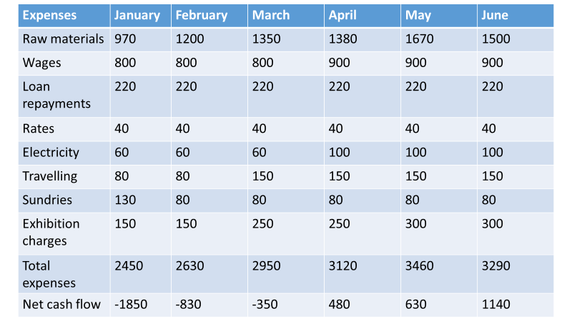
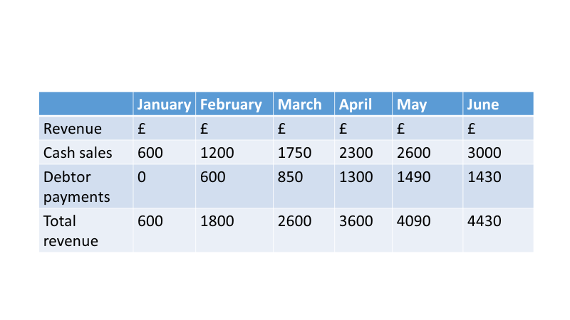

Closing balances
Once calculated, net cash flow can then be used to obtain the closing balance for the period. To find the closing balance, if the net cash flow is a negative we deduct this from the opening balance, or if it is a positive figure we add net cash flow to the opening balance. The opening balance is the amount of cash available at the beginning of the period.
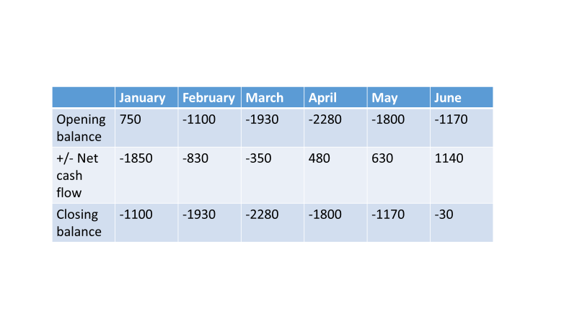
January there is a closing balance of –£1100, i.e. a predicted cash shortage of £1100. This was calculated by taking the net cash flow –£1850 from the opening balance £750. The closing balance for one month or period becomes the opening balance for the next month or period. In this case the closing balance for January of –£1100, becomes the opening balance for February.

Cash flow forecast problems
Forecast cash flow statements are a prediction of the likely flows of cash into and out of a business.
They will be based on past experience (when the business has a previous trading history), current and likely future economic and financial trends, along with the knowledge and understanding of the managers/owners and the future plans of the business.
As with all forecasts the further we look into the future the less certainty we have. Because of this, and because businesses operate in a world with changing fashions, changing economic climate, and changing competition, a business’ actual cash flow statement can be very different from its cash flow forecast.

Sales are not at the expected level
Increased/decreased competition, Economic growth/decline, Changing spending patterns of consumers/changing fashions and Government influences, e.g. increased or decreased taxation.
Costs increase
Raw materials cost increases Higher than expected level of inflation, Interest rate increases and Increased labour costs.
Internal factors
Poor initial predictions of income and expenditure, Late payment of debtor and Poor budgeting and lack of control of spending.
Making use of the cash flow forecast
All businesses should monitor cash flow and examine any differences between actual and forecast figures. This will allow action to be taken before a real business crisis arises. As experience is gained in managing and monitoring cash flow, business owners and managers will be able to improve the accuracy of their forecasts.
The forecast cash flow is also used to tell us if the business is likely to have enough money coming in to pay all of its expenses. If the forecast cash flow tells us that the business is unlikely to have enough money coming in to cover costs, then the business must arrange to obtain the required amount of money. Perhaps the most popular method of funding a shortage of cash is to borrow from a bank (external) and this borrowing can take the form of loan or an overdraft. However, there are other methods of funding, each of which has an important part to play.
So what happens when a business needs cash, or liquidity? Up to now we have just referred to cash, but the fact is we are talking about the liquidity of a business. Liquidity is a measure of the availability of working capital. If managers of a business say they have a liquidity or working capital problem, this means that they will have a problem meeting all their immediate or near future expenditure demands. In other words, they do not have enough cash in hand, or do not expect enough cash to be flowing into the business and cannot convert enough assets into cash in the short term to be able to pay all their bills.
This is important as businesses do not always (in fact rarely) need to keep enough immediate cash on hand to meet likely future expenditure. What they must do, however, is keep enough ‘liquid assets’ available, in order that cash flow can be effectively managed. So if there is a predicted cash shortage, what can managers/owners do?
Solutions to a predicted cash shortage
• Increase revenue – this is much easier said than done. A business may try to increase prices but this is likely to reduce demand. Alternatively, new methods of distribution (places to sell) may be found; but in the short run this will increase costs and worsen the cash flow situation.
• Reduce costs – wages are often a major cost. Reducing staff will cut costs, but will impact on output or service provided. Looking for cheaper suppliers makes sense, but there could be an impact on quality.
Delay payment – if the business has creditors then delaying payment will improve immediate cash flow. However, the impact could be delayed deliveries, interest charges on debts, as well as demand for cash on delivery for future supplies.
• Extra funding – this could be a new injection of capital from the owner, or perhaps a business loan. However, if cash flow is predicted to be poor, then loans become unlikely. Outside investors could possibly be interested, but are unlikely to act quickly and will want a share of the business. An overdraft is possible if the business has a good account management history with the bank.
Benefits of preparing a cash flow forecast.
• An accurate cash flow forecast will allow a business to get a clear idea of how it is performing (although it does not provide an accurate statement of profitability), and how it is likely to perform in the future.
• The forecast allows managers to be able to specify times when the business may need additional funding, such as when cash outflow exceeds inflow.
• In addition, inconsistencies in future performance can be identified and remedied.
Also, when there is predicted to be a large positive cash flow, businesses can plan ahead on how to use this money – perhaps by investing or paying off debts.
Limitations of preparing a cash flow forecast
• Drawing up cash flow forecasts takes management time that might be more productively used completing other tasks in the business.
• Cash flow forecasts need to be accurate to have value: this may be especially difficult to achieve if the business has little or no trading history to base the predicted cash flow on.
• The longer the timescale the less accurate the forecast is likely to be.
• Inflation can impact on the accuracy of figures.
• Cash flow forecasts needs to be monitored to have ongoing usefulness.

Cash flow forecast – Formula page
- Total revenue = Cash sales + debtor sales

- Net cash flow = Total revenue – total expenses

- Closing balance = Opening balance – net cash flow

- New closing balance = last months closing balance.

Cash flow forecast – Example

