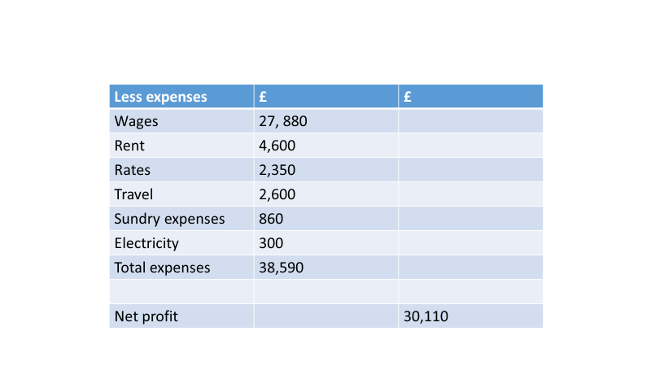
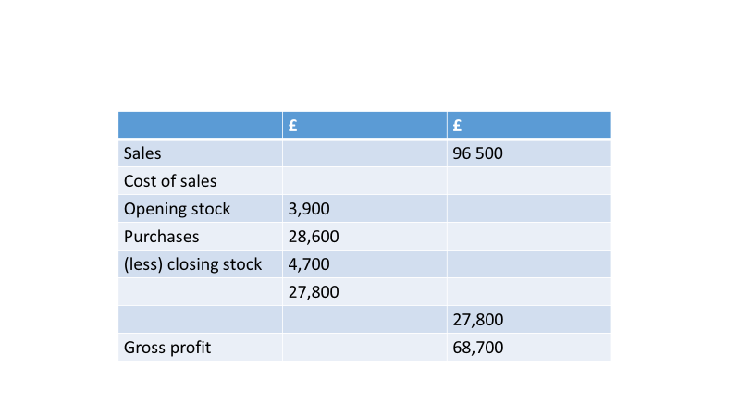
Profit and loss example – Frying tonight

Profit and loss – Step by step guide
1) Cost of sales = opening stock + purchases – closing stock (Left hand column)
2) Gross profit = Sales – Cost of sales (Right hand column)
3) Total expenses column (left hand column)
4) Net profit = Gross profit – total expenses

Profit and loss account – Handout
Profit and loss accounts are said to give a ‘historic view’ of the business’s trading income and expenditure over the previous 12 months. The account will show all income and expenditure received and incurred over the previous year.
The first section of a profit and loss account is sometimes referred to as the trading account. The trading account shows what the sales of the business have been and the direct costs of making those sales – known as the cost of sales.
The profit and loss account for Frying Tonite (a takeaway) for the year 2013–14 is shown to the right. It is normal practice for profit and loss accounts to be produced for 12 months trading. However, the 12 months do not have to run from January to December – they can cover any 12 consecutive months.
When we take the cost of sales away from the sales of a business, the figure we are left with is known as gross profit. This is the first figure of real importance.
The profit and loss account of Frying Tonite shows the income the business has received from its trading activities over the last 12 months, and all the money it has spent performing these business activities over the same 12 months.
Because the profit and loss account looks back over the past twelve months the first line always gives the business’s trading income for the year: i.e. the revenue gained from the goods the business has sold, or the services it has provided. Trading income can be called different things: ‘sales’ or ‘revenue’ or ‘income’ or ‘turnover’, but they all mean the same thing.
Cost of sales
Cost of sales – these are the direct costs of purchasing the stock that is used in sales. For Frying Tonite this would include fish, oil, potatoes etc.
To calculate the cost of sales, we must first add opening stock (i.e. the stock the business has at the beginning of the year) to purchases the business has made during the year. Once we have done this we take away closing stock (i.e. stock left over at the end of the year). We take away closing stock as it has not yet been sold or used, so it is not part of the cost of sales.

Cost of sales
Cost of sales = opening stock + purchases – closing stock
So for Frying Tonite the calculation would be:
£3900 + £28 600 – £4700 = £27 800
Gross profit
The figure for the cost of sales is placed in the second column, below the sales figure. Gross profit is calculated by taking the cost of sales away from sales.
Gross profit = Sales – Cost of sales
For Frying Tonite sales are £96 500, the cost of sales are £27 800, so:
£96 500 – £27 800 = £68 700
Gross profit is an indicator of how efficient the business is at making and selling its product. However, the figure for gross profit on its own does not help us judge the level of efficiency: after all, a large business is likely to have a much higher gross profit figure than a small business, but the small business could be better run or have less stock damage.
Net profit – Profit and loss account
Net profit is often referred to as ‘the bottom line’ in business. This is for two reasons. Firstly on a simple presentation of a profit and loss account, it is the actual bottom line. Secondly, the net profit figure tells us the actual profits of the business after all costs have been paid. The gross profit for Frying Tonite has already been calculated in the trading account. Now we have to allow for expenses. Expenses are the indirect costs that the business incurs. These expenses are not direct costs of production.
Examples of expenses include rent, interest payments and electricity. The total expenses figure is placed in the second column, beneath the figure for gross profit. To find Frying Tonite’s net profit we will have to total these expenses and take them away from the gross profit.
Net profit
To calculate net profit, we simply take the figure for total expenses away from the gross profit figure.
Net profit = Gross profit – total expenses
For Frying Tonite, gross profit is £68 700, expenses are £38 590. So:
£68 700 – £38 510 = £30 110 net profit
Net profit is an indicator of how efficient the business is overall, this is because all the business’s revenues and expenses are included in the calculation. Like the figure for gross profit, net profit on its own does not help us judge the level of efficiency. A large business is likely to have a much higher net profit figure than a small business because it manages its expenses better.

