Q&A: What are zero-hours contracts?

http://www.bbc.co.uk/news/business-23573442
Read more about sharing.

Image copyright Getty Images Image caption Zero-hours contracts have become increasingly popular in the UK
Ed Miliband has vowed that a Labour government would give employees on "exploitative" zero-hours contracts the legal right to a regular contract after they have worked 12 weeks of regular hours.
Q: What are zero-hours contracts?
A: Zero-hours contracts, or casual contracts, allow employers to hire staff with no guarantee of work.
They mean employees work only when they are needed by employers, often at short notice. Their pay depends on how many hours they work.
Some zero-hours contracts require workers to take the shifts they are offered, while others do not.
Sick pay is often not included, although holiday pay should be, in line with working time regulations.
Q: Who is on them?
The Office for National Statistics (ONS) says that 697,000 people were employed on zero-hours contracts for their main job between October and December 2014, based on figures from the Labour Force Survey. That represents 2.3% of the UK workforce.
This figure is higher than the figure of 586,000 (1.9% of people in employment) reported for the same period in 2013. The ONS said it was unclear how much of the rise was due to greater recognition of the term "zero-hours contracts", rather than new contracts being offered.
The number of contracts that do not guarantee a minimum number of hours was 1.8 million as of August 2014. That was 400,000 more than the previous estimate for January 2014.
The ONS said the differences in the two totals could reflect seasonal factors, because they cover different times of the year.
A survey of employers by the Chartered Institute of Personnel and Development (CIPD) found that a third of voluntary sector organisations used zero-hours contracts, along with a quarter of public sector employers and 17% of private sector firms.
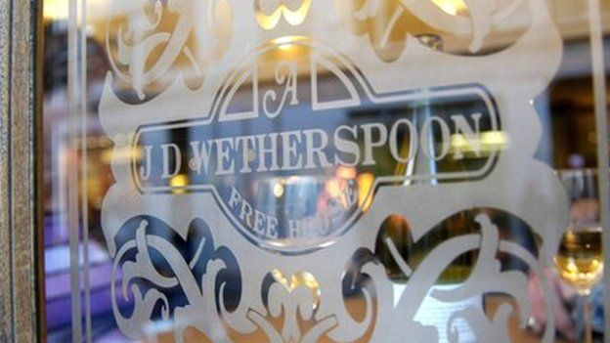Image caption Pub chain JD Wetherspoon uses zero-hours contracts
A high proportion of staff at companies including retailer Sports Direct, pub chain JD Wetherspoon and cinema operator Cineworld are on zero-hours contracts. They are also used by other employers, including a number of London councils and Buckingham Palace.
Q: Why are they controversial?
A: There is concern that zero-hours contracts do not offer enough financial stability and security.
The ONS found that employees on such a contract worked an average of 25 hours a week.
However, about a third of those on zero-hours contracts want more hours - mostly in their current job - compared with just 10% of other people in employment.
The CIPD research found that 16% of zero-hours workers said their employer often failed to provide them with sufficient hours each week.
The ONS said that zero-hours workers were more likely to be women or in full-time education and aged under 25 or over 65.
Employees on zero-hours contracts also do not have the same employment rights as those on traditional contracts, and critics are concerned that the contracts are being used to avoid employers' responsibilities to employees.
The CIPD warned that employers may also take advantage of zero-hours contracts by using them as a management tool - offering more hours to favoured employees and fewer to those less valued.
Q: Why do employers use them?
Employers say zero-hours contracts allow them to take on staff in response to fluctuating demand for their services, in sectors such as tourism and hospitality.
Employers also say that many workers appreciate the flexibility that a zero-hours contract gives them. Some 38% of workers in the CIPD research described themselves as employed full-time, working 30 hours or more a week, despite being on zero hours.
Michael Burd, joint head of employment at the law firm Lewis Silkin, says the majority of employers use zero-hour contracts, not to avoid giving employees their rights, but to avoid paying fixed overheads and give them flexibility over their workforce.
He points out that this flexibility is envied by employers in struggling economies such as Spain and Greece, where potential costs may dissuade employers from taking on staff.
The Institute of Directors has voiced concern about Labour's proposed policy, saying the changes would be unnecessary and potentially damaging.
Christian May, head of communications and campaigns, said: "Limiting the use of a zero-hours contract to just 12 weeks would apply rigid controls on an important element of our flexible labour market. They are used by a little over 2% of workers, which can hardly be described as an epidemic. Nobody supports the misuse of these contracts, but demonising and ultimately outlawing them will simply risk jobs."
Simon Rice-Birchall, partner at law firm Eversheds, said it was not clear how the proposed new right would apply, given that Labour refers to "employees" rather than "workers".
"Many staff on zero-hours contracts are workers and do not have full employment status. In addition, depending how the change in the law is drafted, there is a risk that some employers may simply offer contracts with minimal fixed hours to limit its impact," he said.

