Organisational design – Handout
All but the smallest businesses will have a recognisable internal structure and there are a wide variety of structural types that could possibly be adopted by any business. The form that a business’s internal structure takes will depend on a number of factors.
Whatever the influence and interaction of each of these factors, the outcome will always result in the creation of a structure made up of layers of hierarchy, spans of control, chains of command, communication pathways and levels of responsibility. It is these component parts that make up organisational design.
Organisational design factors:
The views and philosophy of management; the need for different communication systems; the industry within which the business operates; the traditions of the business and the skills of the workforce.
Views of management
The type of manager that operates within the business will have a large impact on the internal structure of the business. Managers with a democratic leadership style will encourage workers to take responsibility; whilst managers with an autocratic leadership style will prefer a recognisable hierarchical structure.
Communication systems
Where communication is controlled and closely monitored, the business structure is likely to contain many layers with narrow spans of control and definite paths of responsibility. However, where more open and free communication is encouraged, the business structure is likely to be less hierarchical and more flexible.
The industry
Retailing encourages a hierarchical structure, with clear-cut responsibilities and chains of command. In other industries, such as software development, the boundaries of responsibility are less clear and the chains of command tend to be much shorter.

Traditions of the business
The standard pyramid-shaped hierarchical structure is one that many businesses develop as they grow. Often businesses that have been owned by the government for many years have a traditional structure: when privatised these businesses find many difficulties in changing this hierarchical structure. Other businesses, often in the ‘new economy’, work towards achieving a less rigid organisational structure, consisting of fewer layers of hierarchy.
Skills of the workforce
The more highly skilled the workforce, the more likely they are to need less supervision. This results in a flatter, more open structure where involvement in the decision-making process is encouraged at all levels.
Organisational structure components
Layers of hierarchy
This is the management structure of an organisation and indicates who is responsible to whom. For example, in the police force, there is a chain of command all the way from Chief Constable down to Constable. In between we have Assistant Chief Constable, Deputy Assistant Chief Constable, Chief Superintendent, Superintendent, Chief Inspector, Inspector and Sergeant. There are nine layers or levels of hierarchy in this organisation.
Chains of command
These are the paths along which communication takes place and instructions or orders are passed down. Using the police force as an example, the Chief Constable may make a decision to stamp out begging.
This instruction is passed down through the layers of authority and decisions will be made as to what methods will be used to carry out the policy. The constables, who will have responsibility for carrying out the task of removing beggars from the streets, will eventually be ordered to carry out the policy using the methods devised by their superiors in the chain of command.
Levels of responsibility
Each layer of the hierarchy will have its own level of responsibility. The amount of responsibility and the freedom to make decisions based on this responsibility will depend on the amount of control that has been delegated from above. The amount of delegated control will depend on business structure, style of management and the type of business involved.
Span of control
The span of control tells us how many workers are directly responsible to a manager or supervisor. When there has been a high level of delegation the span of control is often wide. Workers are trusted to achieve quality and complete their tasks without constant supervision or monitoring. A narrower span of control operates in strictly hierarchical organisations where control is tight and centralised.
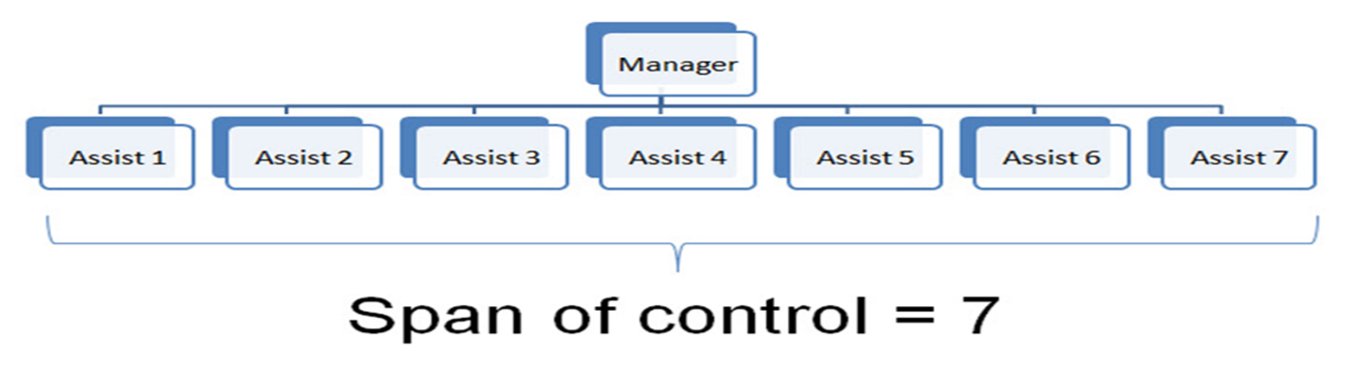

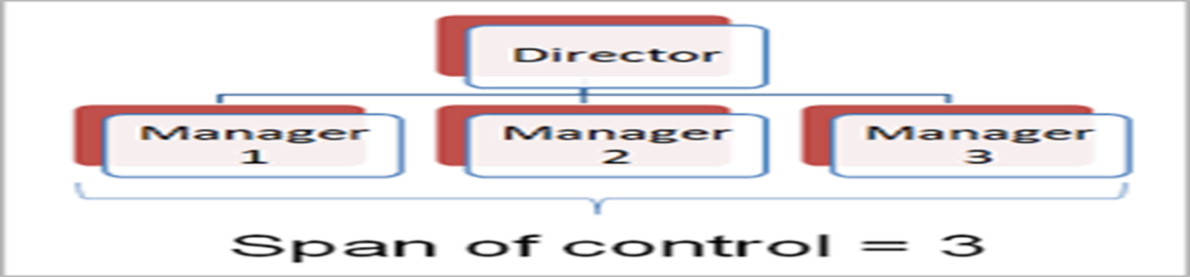

Traditional hierarchical structure
There are many levels or layers to the hierarchy and the span of control is narrow at the top, but will widen somewhat at the bottom where supervisors’ key role is to monitor performance. The path in red is one typical chain of command. At the top of the hierarchy are the senior management.
At the bottom of the hierarchy are the shop floor workers; in between there are layers of middle management and supervisors. Functional departments in large organisations have been typically organised in this way. This type of organisational structure is often referred to as a ‘tall’ structure.

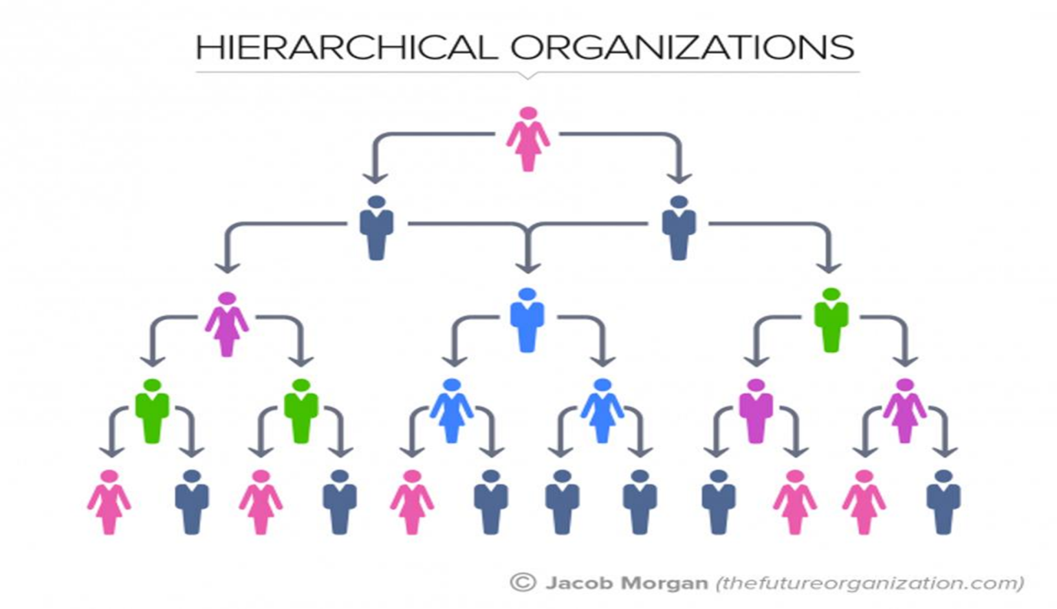

Hierarchical structure advantages
- Control is at the centre, and senior management fully understand exactly who does what, and what their responsibilities are.
- Paths of communication and responsibility are clearly defined.
- Departments understand their position in relation to other departments within the organisation.
- Each worker knows how they fit into the organisational structure.
Hierarchical structure disadvantages
- Senior management are distanced from those who implement decisions. What senior managers perceive as being the case may, in reality, be very different.
- Communication between different departments is hampered by the lack of direct contact between departments.
- Vertical communication is difficult, with information that is received by management distorted by the layers it must pass through. Very long chains of communication could even mean that instructions are out of date by the time they are received.
Flat hierarchical structure
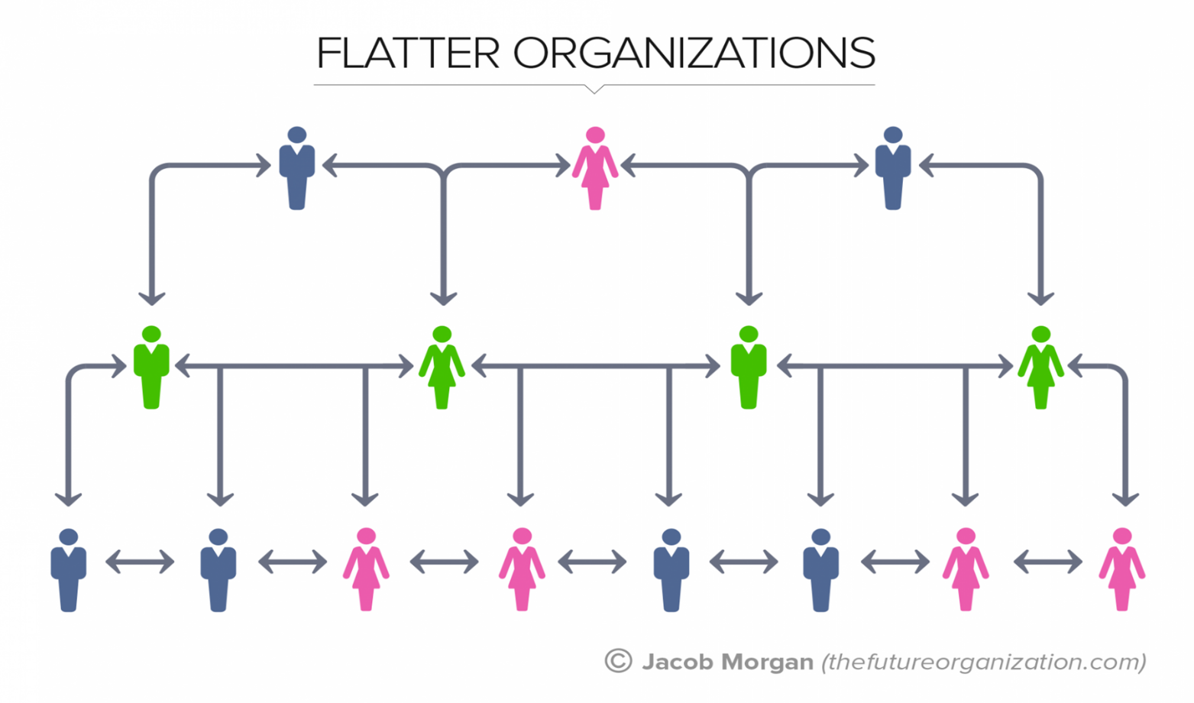
The span of control is wider, the chain of command is shorter and there are fewer layers in the hierarchy. If existing traditional businesses wish to achieve this structure, delayering must occur. Delayering means the removal of whole layers of hierarchy and management. This is normally achieved through compulsory redundancy programmes.

Flat organisational structure advantages
- increased motivation as a result of the delegation of authority;
- decisions are made more quickly by those nearest the ‘ground’;
- communication is quicker and suffers less distortion;
- empowerment of workers.
Flat organisational structure disadvantages
- loss of central control of the workforce;
- different departments may not be working to the same objectives.

Matrix organisational structure
Matrix structures attempt to organise the management of different tasks in a way that cuts across traditional departmental boundaries. This structure enables people with particular specialist skills to work together in project teams.
For example, Project A could be the formation of a new product development team. It might consist of a designer from the R&D department, an engineer from Production, a researcher from the Marketing department and a cost accountant from the Accounts department.
Each individual in the team will have their own responsibility for certain aspects of the project but they will be working together to achieve a specific objective. In the diagram three projects are ongoing: this means that more people will have the opportunity to use their abilities. However, this does mean that each member of a project team has two bosses and this can be problematic.
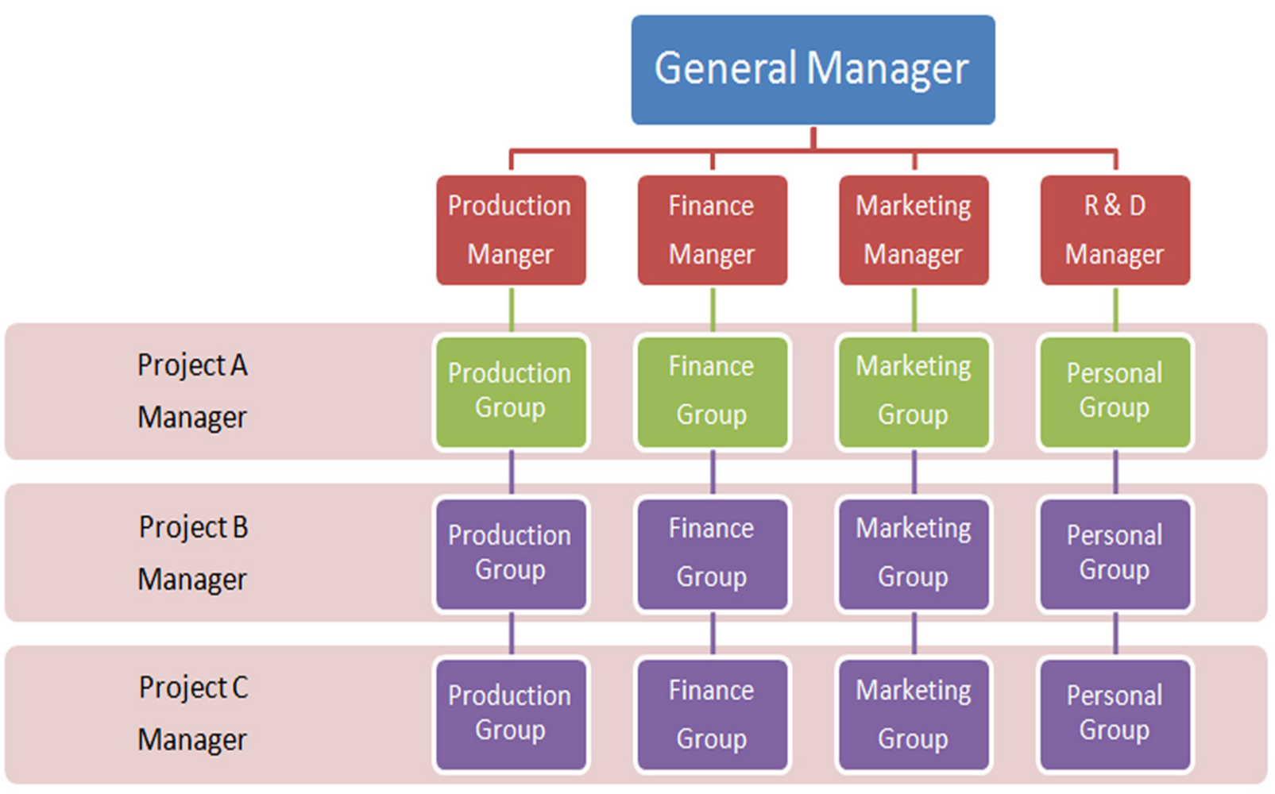

Matrix structure advantages
- It allows individuals with specific skills to contribute to a number of different projects.
- It breaks down barriers to communication and ensures that projects can be better coordinated.
- It helps ideas and innovation spread throughout the business.
- There is more efficient use of human resources. The structure can improve flexibility and the motivation of employees.
Matrix structure disadvantages
- Defining what each employee’s main responsibilities are is difficult – being answerable to two bosses may put a lot of strain on individuals. Placing too great a burden on individuals may slow down decision-making.
- Project management using a matrix structure can be expensive because extra support systems, such as ICT and office staff, may be required.
- Coordinating a team drawn from a number of different departments may be difficult as the culture and methods of operation in each department may be very different.
Organisational structure conclusion
Each of these alternative systems has been designed with one overall objective – to improve efficiency of the organisation. It is still rare to find business organisations that have completely abandoned traditional structures; instead it is much more likely to find alternative structures operating within the hierarchy.

