

NVQ L2 Gym Instruction

Assessment Record/Evidence Checklist

Candidate Name ______________________ Candidate Signature ______________

Evidence

The student will be able to:

 | UNIT 1 Before the session (Health & Safety) | Evidence | IV |  | EV
1.1 | Screening form / PAR Q | Worksheet
1.2 | Verbal screening | Worksheet
1.3 | Informed Consent | Worksheet
1.4 | Health & Safety checklist | Worksheet
1.5 | Lesson Plans/Session Planners x 4 | Session Planners

 | UNIT 2 During the session | Evidence | IV |  | EV
2.1 | Assessors Observation ON | Practical
2.2 | Assessors Feedback sheets | Practical
2.3 | Tasks 2.3 & 2.4 | Worksheet

 | UNIT 3 After the session | Evidence | IV |  | EV
3.1 | Session Evaluation (Task 6) | Worksheet
3.2 | Task 4 and Task 5

 | UNIT 4 Promote regular Activity | Evidence | IV |  | EV
4.1 | Task 4 and scenario | Worksheet

 | UNIT 5 Customer Care | Evidence | IV |  | EV
5.1 | Customer care worksheet | Worksheet

 | UNIT 6 Exercise & Fitness Knowledge | Examination/worksheet

UNIT 1

BEFORE THE SESSION

UNIT 1

BEFORE THE SESSION

Task 1.1 – Design your own written screening form: (PAR Q)

Use the guidelines under screening and the sample screening forms to design your own form.

N.B. This must be your own design and not one you use in your workplace.

1.2 – Prepare a list of questions below to use for your verbal screening.

Task 1.3 – Prepare a script to use when you meet a client for the first time:

Task 1.4 – Design your own informed consent form:

Use the guidelines and sample text for informed consent to design your own informed consent form.

N.B. This must be your own design and not one you use in your workplace.

Task 1.5 – Complete a Health & Safety Checklist:

Base this either on where you are working currently or an imaginary health club.

Health & Safety Checklist

Name______________________________________ Venue_______________________

Date__________________ Level ___________________________________

Aim of Session

How will I achieve aims

Health & Safety Information

Nearest Telephone ________________________________________________________

Location of First Aid Box ___________________________________________________

Duty First Aider & How to contact them ________________________________________

Environment
Type of Floor ______________________________________________________________

Temperature and Ventilation ___________________________________________________

Obstacles To Be Aware of _____________________________________________________

Emergency Exits Position _____________________________________________________

Participants
Fitness & Experience Level _____________________________________________________

Footwear & Clothing __________________________________________________________

Injuries/Medical conditions _____________________________________________________

Any other relevant information _________________________________________________

Equipment
List of equipment required for the session___________________________________________

Candidates’s Signature ________________________________ Date _____________________

Assessor’s Signature ________________________________ Date ______________________

1.6 – Planning a Safe & Effective Gym Session

Design an exercise session for an apparently healthy individual who is new to exercise.

- Male aged 25 – 35 years.
- No current regular exercise.
- No experience of using a gym or any gym equipment.
- Occupation – sedentary, sitting for most of day.
- Non-smoker.
- Motives for exercising are to have more energy, lose some weight and tone up mid-section.
- Is only able to train twice a week.

When designing your programme use a session plan for each of the components listed below.

Your session plans must be submitted in the format provided, a sample blank session plan is provided for you to photocopy at the end of this unit. All headings must be completed and each plan signed and dated.

Sessions plans must include detailed information on the timing and content for a safe and effective session and include the following:

Mobility }
Pulse raiser } Warm up (Lesson Plan 1)
Pre-stretch }

CV build up }
CV maintenance } Aerobic Curve (Lesson Plan 2)
CV cool-down }

Resistance training Clearly indicate the training method
Produce 2 session planners you have chosen (Lesson Plan 3)
1 free weight, 1 machine weights i.e. simple circuit etc.

Stretching }
Cool Down } Cool-down (Lesson Plan 4)

Task 1.6- Session Planner
Name:_________________________ Date: __________________

Session (please Circle)
Warm Up Prep Stretch CV Machine Weights Free Weights Cool down

Considerations/ Fitness Level ____________________
Aim of session

Intensity (time/Reps /Sets / Heart Rate | Exercise/ Stretch | Teaching Points | Alternative  Adaptations Progression.

Candidate Name: _________________________________ Date: ____________________

Assessor Name: _________________________________ Date: ____________________

UNIT 2

DURING THE SESSION

UNIT 2

DURING THE SESSION

TASK 2.1.

This unit requires you to produce appropriate written materials to carry out your planned combined CV and Resistance session from unit one on a colleague, friend or relative. After you have taught the session you need to evaluate how safe and effective the session actually was.

Find a suitable Client & Venue

Find a colleague, friend or relative who can act as your client and a suitable venue where you could carry out your induction.

Health & Safety

Produce a health and safety checklist for the session.

Screening & Informed Consent

To ensure that it is safe for your client to undertake physical activity, ask them to complete a screening and informed consent form that you have previously designed.

Planning

Use the session you planned in unit one:

- Warm up – mobility, pulse raiser and prep-stretch
- Aerobic curve – CV build up, CV maintenance and CV cool down
- Resistance workout – i.e. simple circuit etc.
- Cool down – stretches for relevant muscle groups to maintain for a wake up
- Revitaliser – introduction to a third CV machine for a wake up
- Additional plan for – the deadlift and a bench lift showing how you will teach spotting technique

Teaching your planned session from Unit One.

Teach your planned session from unit one to your client.

TASK 2.2

ASSESSOR FEEDBACK SHEET

Candidate Name ________________________ Unit/Element: ___________________

Assessor Name ____________________________ Date: ______________________

Assessors Signature: _____________________________Date: __________________

Candidate Signature: _____________________________Date: __________________

IV Signature/Date: ___________________EV Signature/Date: __________________

TASK 2.3 – Teaching Position

What is the appropriate teaching position to adopt when giving demonstrations and instructions to your client? Tick the appropriate box.

IN FRONT OF THE CLIENT
BEHIND THE CLIENT
BY THE SIDE OF THE CLIENT

What teaching positions you would use whilst teaching the following activities?
Tick the appropriate boxes.

FRONT SIDE BEHIND

1. | Lateral pull down
2. | Cycling
3. | Leg press
4. | Standing calf stretch
5. | Dead lift
6. | Bench press

Correction

Explain the methods you would use to correct your client.

___________________________________________________________________________

___________________________________________________________________________

___________________________________________________________________________

TASK 2.4 – Complete the general and specific teaching points for the following activities

ACTIVITY  EXERCISE | PURPOSE | TEACHING POINTS
Treadmill  Walking | Pulse raise or aerobic curve
Upright Cycle | Pulse raising or aerobic curve
Sitting  Hamstring  stretch | Flexibility training
Sitting adductor stretch | Flexibility training
Deadlift | Resistance  Training
Leg press | Resistance  Training

UNIT 3

AFTER THE SESSION

TASK 3.1

SESSION EVALUATION

Candidate Name: _____________________________________ Date: ________________

FEEDBACK FROM THE CLIENT

After the session I received the following feedback from my client:

EXERCISES/ACTIVITIES

How do you feel about: | Comment – Good/Bad
The safety of the exercises you chose?

Did you SEAM the activities you used to ensure current good practice?

The effectiveness of the exercises you chose?

Did they achieve the aims of the session?

TEACHING AND INSTRUCTING

How do you feel about: | Comment – Good/Bad
Your own personal exercise technique?

Was it clear, precise as per guidelines?
Your voice projection?

Could your client always hear you clearly?
The clarity of your instructions and explanations?

Your demonstrations and whether you asked your client to move and observe as appropriate?

The use of general and specific teaching points and how often you reinforced them?

Your teaching position when demoing/explaining and whilst the client performed the exercise/activity?

Your observation and correction of your client’s technique?

Did you move to the appropriate position?

Your ability to offer alternatives or to adapt exercises/activities for your client?

The way in which you motivated your client?

Did you smile, say well done, and generally encourage your client?

ACTION PLAN

List the changes you would implement in your next session:

Candidates Signature: _______________________________ Date: __________________

Assessor’s Signature: ________________________________ Date: __________________

Ending the Session and Gaining Feedback

Prepare a script to use for ending the session and gaining feedback from your client. See guidelines to ending the session and gaining feedback in the Gym instructor manual.

Unit 4 – Promoting Exercise and Healthy Lifestyles.

Task 4.1 - List the barriers to exercise and suggest ways of overcoming these barriers.

- _____________________________________________
- _____________________________________________
- _____________________________________________
- _____________________________________________

Task 4.2 – What are the health benefits of regular activity?

Task 4.3 – Describe one approach of encouraging your client to adhere to the programme.

Task 4.4
Fact File
The client: Max is a 40 year old computer programmer who is married with two children.
He has gained weight slowly over the last 10 years and is now a typical 'pear shape' weighing 21 stone (133 kg). Most of his fat is deposited around his abdomen.
His lifestyle: Max enjoys a fried breakfast most days. As both he and his wife work late they often pick up a takeaway on the way home. Max's job makes him pretty stressed most days!
Recently Max has cut down his smoking from 15 to 5 cigarettes a day but is worried he will put on more weight if he gives up completely. He also likes beer and drinks between 20 and 30 units a week.
His concerns: Max's wife is always telling him he is heading for a heart attack and his GP has said that if he doesn't lose some weight and get fitter, his wife will be right!
His aims: Max wants to lose weight so that he feels fitter and feels better.

What could you suggest for Max ?

Short term goals

Long term goals

Having found out all about Max, answer this question.
What type of exercise do you think Max should be doing?

- Muscular Strength
- Muscular Endurance
- Cardiovascular
Fill in the following table to prescribe safe and effective exercise for Max. This covers 7 days.

Exercise Aim : Aerobic Curve
Client Name: Max |  |  | CV Build Up completed
CV Maintenance
Exercise | Machine | Frequency | Intensity | Time | Type

Give recommendations relating

Unit 5 – Dealing with complaints

1. Have a look at this scenario and answer the following points.

I’m Max. I am really angry that my gym session with my instructor has been double booked!!

How would you deal with this?

Having heard the customer's complaint, what should Alice do first?

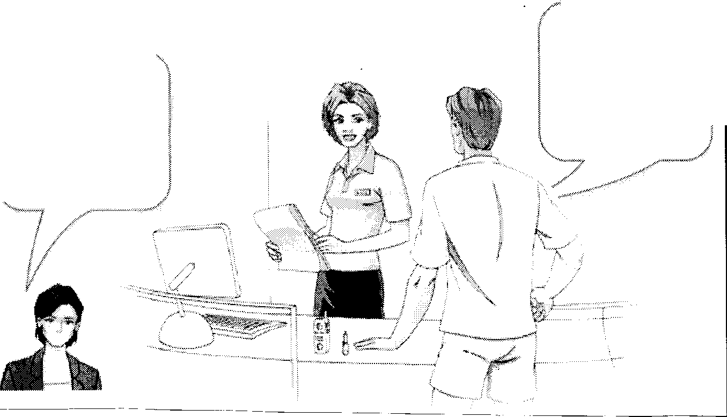
- Call her manager. She shouldn’t deal with this type of aggressive behaviour.
- Tell him her name and admit it’s your fault and tell him you will try and resolve the problem.
- Give Max a copy of the customer complaints book so that he can lodge a complaint.

2. List three ways in which an instructor can present a positive personal image to customers.

- ________________________________________________

- ________________________________________________

- ________________________________________________

3. Apply “LEAP” to describe the 4 steps in dealing with customer complaints.
4. Give three methods of communication you can use with your clients.

5. What does the code of ethics say about relationships with clients.

6. What type of behaviour could contravene the “Advertising” criteria of the code of ethics?

Unit 6 – Exercise and Fitness Knowledge
The Skeleton – an overview
1 Identify four functions of the skeleton.
(i)
(ii)
(iii)
(iv)
2. Using additional resources, research the five types of bone that can be found in the human skeleton. Use your answers to complete the table below.
Type of bone | Examples from the body
Femur
Ulna
Phalanges
Short bone
Sesamoid bone
 | Vertebrae
Skull bones
Sternum
Scapula

3 On the skeleton below use colour coding circles to shade in:
ten long bones
two regions where short bones are located
one sesamoid bone
four irregular bones
three flat bones
two sites where hyaline cartilage is located
4 On the skeleton label the following bones :
tibia, humerus, femur, radius, ulna, scapula, thoracic vertebrae, lumbar vertebrae, clavicle, carpals, tarsals, phalanges, sacrum, patella
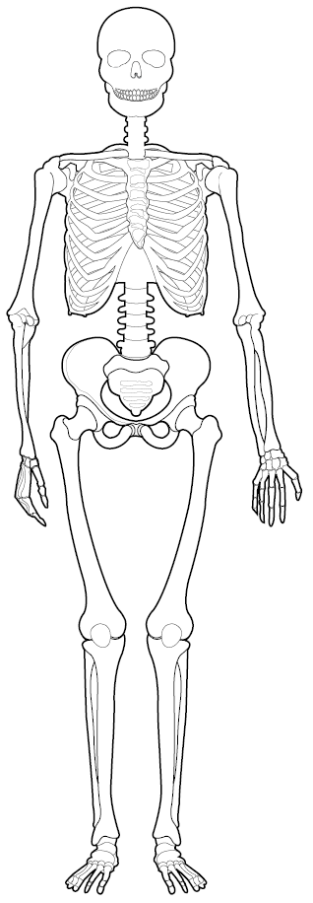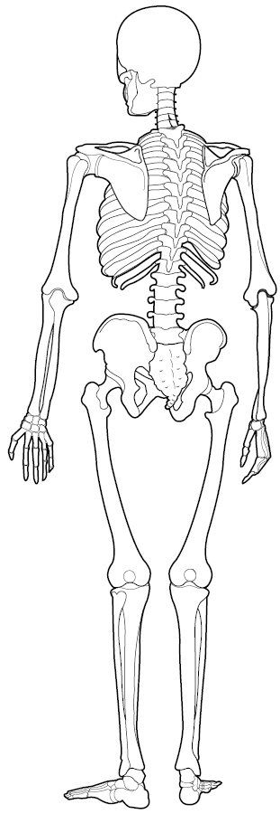

Synovial Joint Types and Their Anatomical Movements
5. Complete the following table by:
- naming the joints of the upper and lower limbs
- identifying the joint type
- listing the articulating bones
- naming and illustrating (using stick men/women) the joint movements that occur at the joint.
UPPER LIMB
Illustration | Joint name | Joint type | Articulating bones | Movements possible
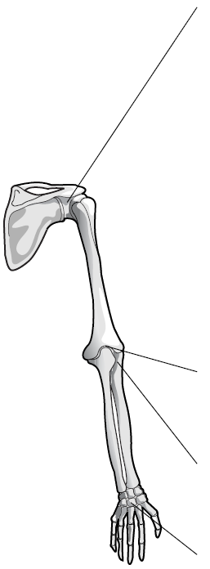 |  |  |  |   flexion

LOWER LIMB
Illustration | Joint name | Joint type | Articulating bones | Movements possible
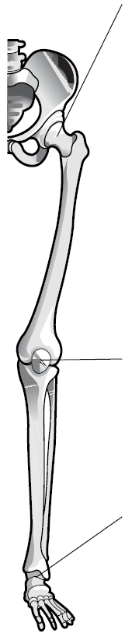 |  |  |  | 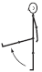  flexion

6. Group each of the following bones into one of the four major bone categories. Use ‘L’ for long bones, ‘Sh’ for short bones, ‘Se’ for sesamoid bones, ‘F’ for flat bones and ‘I’ for irregular bones.
(a) | Fibula |  | (f) | Skull
(b) | Humerus |  | (g) | Vertebra
(c) | Patella |  | (h) | Femur
(d) | Phalanges |  | (i) | Tarsals
(e) | Sternum |  | (j) | Metacarpals

7. Fill in the missing information about the spine.
(a) The spine has a total of bones.
(b) It joins the skull to the .
(c) There are regions of the spine.
(d) These are the spine, thoracic spine, spine,
, and .
(e) The top two vertebrae are called the and the .
(f) There are types of joint in the spine:
(i) a pivot joint between the and the .
(ii) joints between the bodies of adjacent vertebrae.
(iii) fixed joints in the and the coccyx.
(iv) gliding joints between the surfaces of the vertebrae.
(g) The spine protects the _______________________

8. Complete the following table:
Feature | Structure | Function
Ligament
Articular cartilage
Synovial membrane

Types of Synovial Joint
9. Match the correct pieces of information together.
Diagram | Type of joint | Name of joint
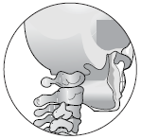 | Hinge | Thumb
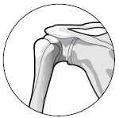 | Condyloid | Atlas/axis
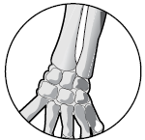 | Gliding | Elbow
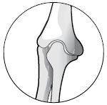 | Pivot | Articulating surfaces of vertebrae
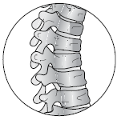 | Ball and socket | Shoulder
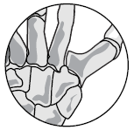 | Saddle | Wrist

Major Muscles of the Body
10. Look at the diagrams below. Can you correctly name 7 muscles?
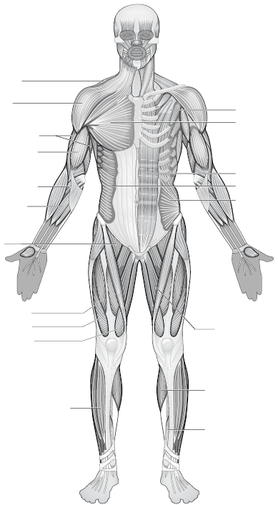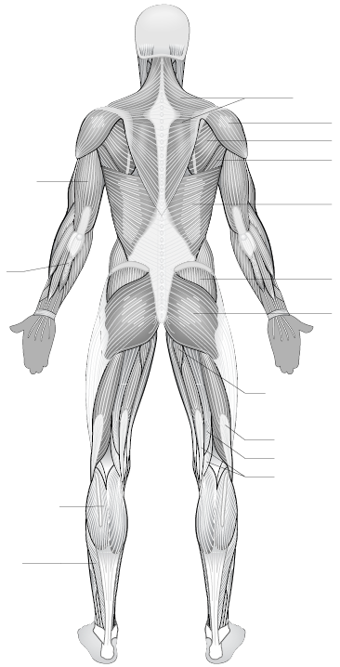

11. Choose seven of the muscles you have identified and give an exercise that could be used to develop the strength of that muscle.
Muscle | exercise
1
2
3
4
5
6
7

12. Look at the strengthening exercises given below. For each one, identify the muscles that are working together to allow for the coordinated movement to take place. In each case, identify the muscle working as the agonist, the muscle working as the antagonist and a muscle working as a fixator. In each case consider the lifting (upward) phase only.
Strengthening exercise | Agonist muscle | Antagonist muscle | Fixator muscle
Chin ups
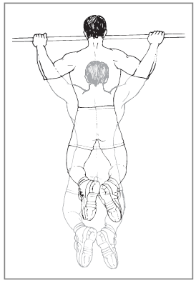
Leg curls
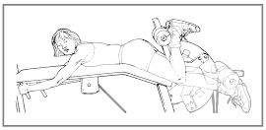
Bicep curls
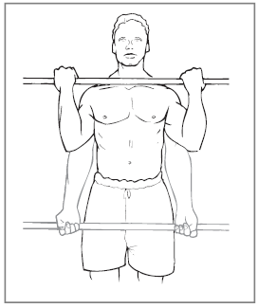

Strengthening exercise | Agonist muscle | Antagonist muscle | Fixator muscle
Sit ups
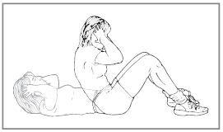
Tricep extensions
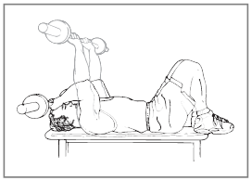

13. Link each of the muscles below to the appropriate strengthening exercise.
Biceps brachii | Biceps femoris | Rectus abdominis
Gastrocnemius | Pectoralis major | Gluteus maximus
Deltoid | Rectus femoris | Trapezius

Strengthening exercise | Muscle being worked
Shoulder press
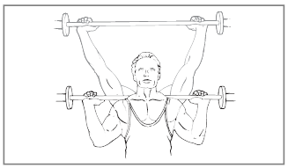
Leg curls
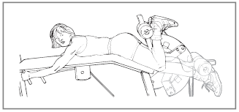
Bent knee hip extensions
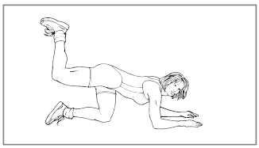
One leg toe raises
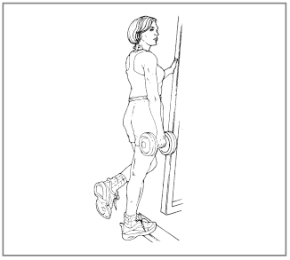

Strengthening exercise | Muscle being worked
Bicep curls
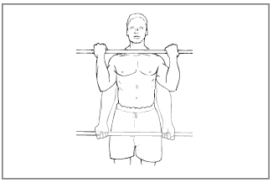
Seated rows
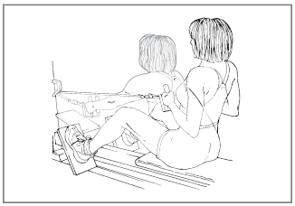
Dumbbell squats
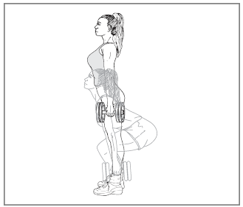
Bench press
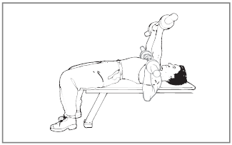
Crunches
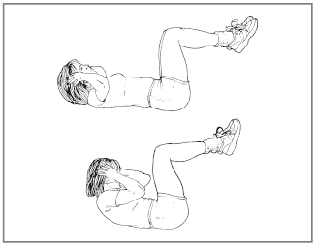

Chambers of the Heart
14 On the diagram, use your ruler to draw lines to identify the structures of the heart listed below.
- Right and left atrium and ventricle
- Pulmonary artery
- Pulmonary vein
- Aorta
- Tricuspid valve
- Bicuspid valve
- Atrioventricular (AV) valves – tricuspid and pulmonary valves
- Semilunar (SL) valves – aortic and pulmonary valves
- Septum
15 Indicate with arrows where blood enters and leaves the heart.


16. Describe the structure and function of the following blood vessels, showing the differences between each type.

Arteries

Veins

Capillaries

17. What is the function of the different components of the blood?
Red blood cells

White blood cells

Platelets

Plasma

18. Fill in the blanks in the table with the answers suggested below

Summary of energy system

Criteria | Creatine Phosphate | Lactic Acid | Aerobic
Speed of energy production |  |  | Slow
Energy source | Creatine Phosphate
Amount of ATP produced |  | Limited
Production of waste products | None |  | Carbon dioxide and water are eliminated
Duration of energy production |  |  | Up to 2 hours
Intensity used as % of maximum intensity | Max Intensity (95-100%)
Length of time to recover | 30 seconds to 4 minutes

Lactic acid is produced as a by-product, Glycogen and fat, Glycogen, Unlimited, Very limited, Time to rest and replace glycogen stores, 20 minutes to 2 hours, 8-10 seconds, 1-3 minutes, Very fast, Fast, Low intensity (<60%), Moderate to high intensity (60-90%).

19. What variables can be used to increase “overload”?

_____________________________________________

_____________________________________________

_____________________________________________

____________________________________________

20. Explain the general guidelines used when planning the following:

a) a strength building programme

_____________________________________________________

b) an endurance building programme

______________________________________________________

