School of Hairdressing and Applied Therapies

Level 1 Diploma in the introduction to the Hair and Beauty sector
Unit UV30340 – Themed Face Painting workbook

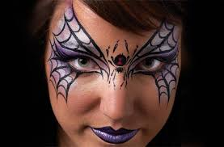

Name:

Group:

Date of completion:

Tutor signature:

Question | √ or X
Q1

Q2

Q3
Design 1

Design 2
Literacy Alert:

Q1.State the factors that could influence the choice of themed face painting techniques.
Q2. State the importance of the preparation and removal procedures for themed face painting.
Q3. Design a 2D image
Design 1

Design 2

