D1-Evaluate the environmental performance of modern materials and techniques used in the construction of substructures for low-rise domestic and commercial buildings, for two different projects.
Concrete is used widely throughout the construction industry. Concrete is made out of port land cement, water, aggregates and sometimes admixtures. Port land cement was first used in the 1800th century and was named after the Isle of Portland in the British Isles. There is a global demand for the use of cement because it is a major compound in concrete.
The manufacturing of cement creates large amounts of pollution. The creating of Cement requires a lot of resources (rocks and water etc.) and energy. The manufacturing of concrete totals for 5 % of the carbon emissions globally. The cycle of creating cement creates pollution.
To be able to create concrete we need aggregates. Most aggregates are located in Quarries. We need to blow up the landscape to be able obtain the aggregates. This is damaging the wildlife because of the excessive noise and destruction of landscape.
To be able to create concrete we need a lot of energy to be able to power the machinery. Without this machinery we cannot create concrete at a large scale. To be able to have energy we need to burn a lot of fossil fuels which damage the environment. A lot of energy is needed to create concrete because the concrete needs to have a very high temperatures in order to form correctly.
Cement has been seen as a major pollutant so techniques have been identified to limit the risk of pollution when manufacturing cement. I have discovered that there are two local concrete manufactures’ that claim they are “green companies company”
The first company is Cenin cement; the company has a site in Bridgend, Wales. They use tradition approaches such grinding to creating cement but are sustainable because they are carbon free cement. The Company has spent 20 years experimenting on how to be as sustainable possible but also maintain a low –carbon footprint. The company have achieved their aim meaning the company are not damaging the local environment. The company has a low carbon footprint for a number of reasons. These include:
- Using a renewable energy source (wind turbines/solar panels) to power the machinery. This means that no fossil fuels are being burnt to provide power for the manufacturing department. Using a renewable energy source prevents contributing to global warming.
- Reducing the amount of new materials being added to cement. This reduces the amount of new materials that need to extracted from the ground.
A PAS2050 low carbon emissions standard assessment procedures concluded that the cement company are sustainable and that the products pass above low-carbon standards.
Based on information learnt at http://www.cenin.co.uk/sustainability/default.aspx?id=23&Cement & Sustainability
Aggregates are an important in the manufacturing of concrete. Aggregates are added strength to the concrete. Aggregates need to be mined in order to obtain them; this involves blowing up large amount of earth which creates pollution. We can use a range of materials that are suitable to use for aggreates.Tradiational aggregates include sand, gravel and stone. These traditional aggregates are non-environment friendly and are unsustainable.
A company called Dewen manufacture sustainable aggregates. Dewen has a factory in Neath abbey and they recycle General soil, aggregates and sand. They then recycle these materials to create new aggregates. This process of recycling will limit the amount of land and energy used to source aggregates. These recycled aggregates have pass the British standards (BS) meaning that they are a good quality product. All the recycled aggregates are available in different sizes from 3mm to 75mm.All recycled material are tested to insure that it achieves the ISO9001 Quality Management system requirements. These aggregates are not affecting the environment as they are recycling/reusing the materials which mean than it is a sustainable product to add to cement, water to create partly sustainable concrete.
Based on information learnt at http://www.derwengroup.co.uk/inert-waste-disposal.php
CEMEX is a Multinational concrete company that operates around the world and has a concrete factory in Swansea. They produce sustainable concrete because they are increasing the amount of alternative fuels such as municipal waste, commercial waste and biomass fuels. These alternative fuels will help to power concrete factories during the manufacturing of concrete. Using alternative fuels such as commercial waste will reducing the amount of materials going to land fill but also prevent fossil fuels being burned to power the factories.
CEMEX is also encouraging workers to be more energy efficient in the production of concrete. The EPA (environmental protection Agency) has listed CEMEX its energy star partner for the last two years in America for its efforts in energy manage. This award is one of the many reasons that explains how CEMEX is trying to produce as sustainable concrete as possible.
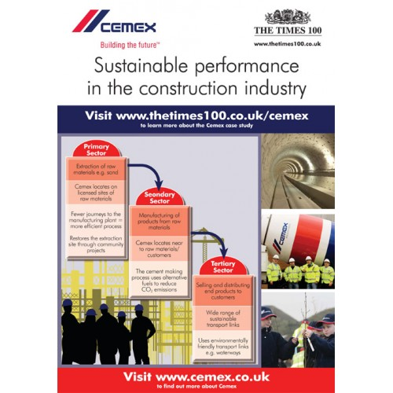
All sites operate an Environmental Management System which is designed to identify any environmental issues than the site is creating. This shows that CEMEX is trying to limit its carbon footprint but also to manufacture sustainable concrete. CEMEX has a good standard of Sustainable concrete as its has been used in a lot of BREEAM listed building which means it is considered as Sustainable concrete to architects and planners.
By using local companies that produce sustainable environmental products it will reduce the carbon footprint further. Using local companies means that we don’t have to transport the materials a large distance, we will save fossil fuels by using local traders. But also support local traders.
Based on information learnt watching the video http://www.cemex.co.uk/sustainableconstruction.aspx
A company called Affresol based in Swansea constructs a lot of the building from a new material called TPR3.TPR3 is a “thermo set polymer” that is produced from a cold process.TR3 is made of waste products that have been diverted from landfill.TR3 can be used as a foundation instead of using a concrete foundations. The processes of creating TR3 as a foundation are as follows.
- Waste is taken away from landfills and taken to a factory to create TR3.
- The waste is condensed to a smaller size.
- The reduced waste is mixed with TPR Polymers.
- This process leaves us with a liquid that will harden to create a foundation or brick to use for the lower foundation.
TR3 has good properties similar to concrete. Some of the properties are:
- TR3 is stronger than concrete.
- TR3 is waterproof/Fireproof
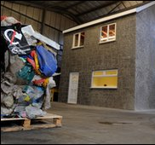
- TR3 lasts forever as it is made of materials that are non-biodegradable.
- TR3 is 100% recyclable.
TR3 has many properties that are better than concrete.TR3 can be used to create the entire house and will save 18 tonnes of waste material that would have gone to landfill.TR3 is a good material to use inset of concrete because its make of recycled material and stops waste going to landfill.TR3 is also a good material because it has the same properties as concrete but is more sustainable.
Based on information learnt at http://www.affresol.com/non-timber-framed-low-cost-housing.asp
References
Raft foundation example | https://wsuzana.files.wordpress.com/2010/03/raft.png
CEMEX  Sustainable  Premonition. | http://shop.businesscasestudies.co.uk/image/cache/data/posters/cemex-poster-13-500x500.jpg
CEMEX LOGO | http://www.cemex.co.uk/index.aspx
Video about sustainable concrete manufactured at CEMEX | http://www.cemex.co.uk/sustainableco nstruction.aspx
information on Dewen | http://www.derwengroup.co.uk/inert-waste-disposal.php
Dewin logo | http://www.derwengroup.co.uk/
Cenin information | http://www.cenin.co.uk/sustainability/default.aspx?id=23&Cement & Sustainability
Cenin cement logo | http://www.cenin.co.uk/sustainability/default.aspx?id=23&Cement & Sustainability
TP3 house | http://news.bbc.co.uk/1/hi/wales/8531170.stm

