Rubella (German Measles): Symptoms, Diagnosis and Treatment
Last updated Wed 3 February 2016 Last updated Wed 3 Feb 2016
By Tim Newman
Rubella is an infection caused by the rubella virus; it can cause severe harm to the unborn child. The number of rubella cases has fallen dramatically, thanks to vaccination programs, but the battle against this infection is not yet won.
The symptoms of rubella (also known as German measles) are often so mild that more than half of people with the infection do not even notice that they have contracted it.¹
However, rubella contracted during early pregnancy can cause substantial negative outcomes for the unborn child. This is known as congenital rubella syndrome.
Rubella is a preventable disease; the vaccine is often given in conjunction with measles and mumps (MMR vaccine). Before the vaccine was widely available, the US would see widespread outbreaks every 6-9 years. In Europe, outbreaks would occur every 3-5 years.
Although the World Health Organization (WHO) declared the Americas officially free of rubella transmission on 29 April 2015, the current rate of vaccination is only around 80%. Because the disease can arrive with overseas travelers, it is essential to maintain a high rate of immunization.
In this article, we will discuss the symptoms, diagnosis and treatment of rubella.
- Rubella, its symptoms and congenital rubella syndrome
- Diagnosis, treatment and prevention of rubella
Fast facts on rubella
Here are some key points about rubella. More detail and supporting information is in the main article.
- "Rubella" is Latin for "little red"
- Rubella is viral and predominantly transmitted by coughs
- The rubella virus can pass across the placenta and affect the fetus
- Roughly half of rubella cases present very few symptoms
- The predominant symptom of rubella is a rash, but other symptoms include a runny nose, headache and fever
- Rubella in pregnant women can cause congenital rubella syndrome in the unborn child
- Congenital rubella syndrome is the leading cause of congenital deafness
- Diagnosis can be made by testing blood or saliva samples
- There are no medications that shorten the rubella infection
- The rubella vaccination is the only way to prevent the disease.

What is rubella?
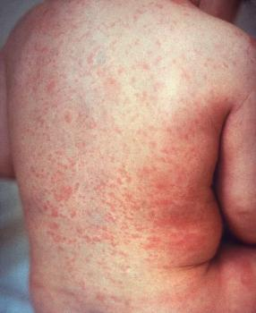Rubella's rash is less bright than measles but itchier. Image credit: CDC
Characterized by a red rash, "rubella" is Latin for "little red." The rash from which it gets its name is generally less bright than measles but can be itchy.
Rubella was first described as a separate disease from measles by scientists in Germany, hence its alternative name - German measles.
The virus replicates in the lymph nodes and the nasopharynx (the tube connecting the nasal cavity and the soft palate) and is transmitted via coughs. An individual with rubella is contagious for 1 week before the rash arrives and for 1 week after.
Between 5 and 7 days after infection, the virus can be found in the blood as it spreads throughout the body. The rubella virus is capable of passing through the placenta and has teratogenic (mutation-causing) properties. The virus can destroy cells, or prevent them from dividing - this causes congenital rubella syndrome.
Rubella rarely strikes in young infants or people over 40. In general, the older the individual, the worse the symptoms of rubella will be.

Symptoms of rubella
Around half of rubella cases pass unnoticed. For infections that are serious enough to take hold, the major symptom is a pinkish-red rash that appears 2-3 weeks after exposure to the virus.²
The rash often starts on the face and moves to the trunk and limbs. After 3 days of the rash, it fades and disappears, hence one of its alternative names - 3-day measles.
Other symptoms of rubella include:
- Stuffy or runny nose
- Headache
- Mild fever (102 °F or lower)
- Inflamed, red eyes
- Testicular swelling
- Inflammation of nerves
- Lymph nodes enlarged and tender
- Joint aches.

Congenital rubella syndrome
Congenital rubella syndrome occurs when a pregnant woman contracts the rubella virus and it passes through the placenta to the unborn child. The infection can trigger miscarriage or stillbirth, or cause severe damage to the developing fetus. Congenital rubella syndrome is the leading cause of congenital deafness.
If infected during the first trimester, there is a 51% chance that the fetus will be affected. This likelihood drops to 23% if infected 13-26 weeks after conception. Worldwide, there are an estimated 100,000 cases of congenital rubella syndrome every year.³
Often, more than one defect can arise, with deafness being the most common. These effects on the infant can include:⁴
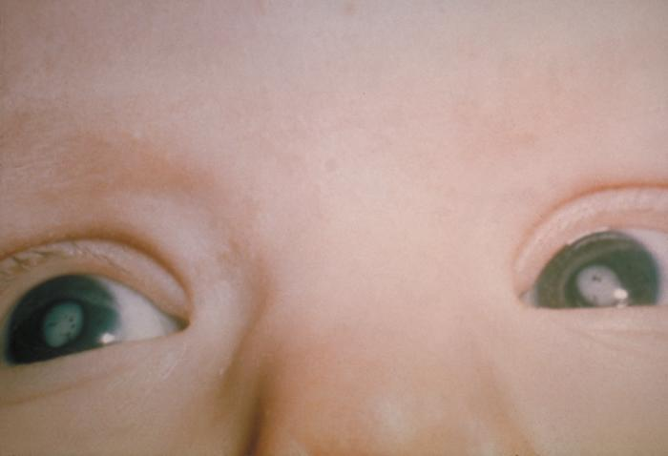Cataracts due to congenital rubella syndrome. Image credit: CDC
- Deafness or hearing impairment
- Cataracts
- Congenital heart disease (especially pulmonary artery stenosis and patent ductus arteriosus)
- Anemia
- Hepatitis
- Developmental delay
- Retinopathy (acute damage to the retina)
- Microphthalmia (abnormally small, deformed eyes)
- Liver, spleen or bone marrow issues (sometimes disappearing shortly after birth)
- Small head
- Low birth weight
- Micrognathism (small lower jaw).
As the child develops, there might be conditions that appear as they age. These might include autism,⁵schizophrenia,⁶ learning disabilities and diabetes.⁷ However, if rubella is contracted after the 20th week of pregnancy, problems in the newborn are rare.

