Your health, your choices

Mumps

Symptoms
The symptoms of mumps usually develop 14 to 25 days after becoming infected with the mumps virus (this delay is known as the incubation period). The average incubation period is around 17 days.
Swelling of the parotid glands is the most common symptom of mumps. The parotid glands are a pair of glands responsible for producing saliva. They're located in either side of your face, just below your ears.
Both glands are usually affected by the swelling, although only one gland can be affected. The swelling can cause pain, tenderness and difficulty with swallowing.
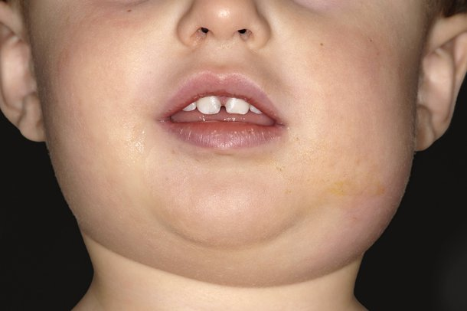Credit: DR P. MARAZZI/SCIENCE PHOTO LIBRARY
More general symptoms often develop a few days before the parotid glands swell. These can include:
- headache
- joint pain
- feeling sick
- dry mouth
- mild abdominal pain
- feeling tired
- loss of appetite
- a high temperature (fever) of 38C (100.4F), or above
In about one in three cases, mumps doesn't cause any noticeable symptoms.

When to seek medical advice
If you suspect mumps, it's important to call your GP.
While the infection isn't usually serious, mumps has similar symptoms to other, more serious types of infection, such as glandular fever and tonsillitis. It's always best to visit your GP so they can confirm (or rule out) a diagnosis of mumps.
It's also important to let your GP know in advance if you're coming to the surgery so they can take any necessary precautions to avoid the spread of infection.
Page last reviewed: 07/08/2015
Next review due: 01/08/2018

