P5
You must explain three different, fit-for-purpose sustainable construction techniques. The techniques should cover one from each of the following areas: energy, materials and waste.
Notes
Waste
The construction industry and is responsible for 1/3 of all waste annually in the UK.
Reduction
Management
Bespoke
Landfill

Materials
Timber farming
Recycling
Plastic
Glass
Rubble aggregates

Energy
Wind
Solar
Hydro
Geo tech
Biomass

Fit for Purpose
Sustainability is a very important area in the construction industry. Sustainability means to preserve for the future. To do this we must try to reduce our carbon emissions and come up with more efficient, environmentally ways to live that don’t involve burning as many fossils fuels. To control sustainability, we can use different techniques to ensure that we reduce the amount of waste we produce and try to improve the efficiency of different jobs. There are 3 main sustainable techniques that can be used to reduce the amount of waste and improve the sustainability ratings on sites. They are:
- Waste
- Materials
- Energy
Waste
Firstly, waste is a big issue within the UK. We need to try and reduce the amount of waste produced so that we reduce the amount that we dispose of in landfill. Disposing of waste costs, a significant amount of money, so if we can cut down the amount we waste then we save money and it benefits the environment. Another way of reducing waste is with off-site prefabrication, this allows for you to put up all the parts for the house with little to no waste, almost everything is used. This makes it very sustainable and environmentally friendly. We also want to try and increase the amount of recycling that we do, so that we reduce the amount of materials that need to be extracted from the earth. This way we can make non-renewable materials such as iron last longer and reduce the amount of pollution etc. that’s needed to extract them from the ground. Whether we are constructing a building or demolishing it, we create waste and must find ways of either reducing the amount of waste. We can do this by using more recyclable materials such as aggregates. Obviously, it’s not possible to make a building that’s 100% recyclable but we should try to use recyclable materials where possible and financially viable. The site manager should reinforce this whenever possible. They should also try to ensure that the job is being done as efficient as possible so that delays don’t occur. On top of this we should only order the required amount of materials so that we don’t overspend buying materials that we might not use. Educating workers that waste costs money to dispose of and showing them ways to be less wasteful will reduce the amount of waste on site. Also, giving packages as an incentive for workers to work less wastefully can be a way of getting workers to do a more accurate and environmentally friendly job.
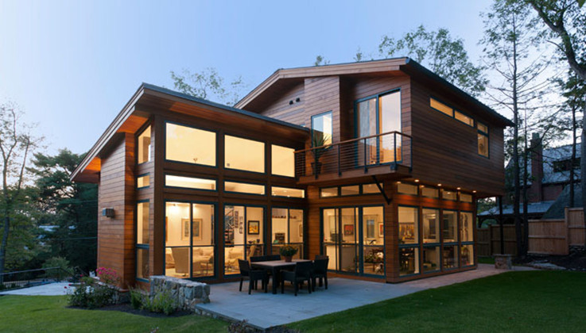
Materials
Newer techniques such as using sheep’s wool for insulation are catching on. This is because this is a renewable resource that if looked after will last forever. If we protect sheep from extinction and look after them then we can benefit from them. Another option is paper products such as newspaper, which can also be used for insulation. The key to ensuring that we never run out of paper is to look after our forests and look after our planet so that the trees can survive. Other new technology such as timber cladding is also renewable and if we have trees then we can make timber cladding. We should also look for effective ways to reduce our carbon emissions, such as using trees rather than concrete for beams where possible etc. Other materials such as plastic are seriously affecting the environment and are killing many animals. Therefore, we want to try and lower the amount of plastic we use and only use it where necessary. We should also try to use more recycled glass so that we’re not throwing it into land fill and using it beneficially. Using aggregates is another way of reducing the amount that ends up in landfill. Most of these aggregates have been made due to recycling and reusing older materials that no longer had a use. We want to order the correct amount of materials so that we don’t end up over spending or wasting useful materials. By doing all these things it protects the environment and ensures that we make the earth more sustainable.
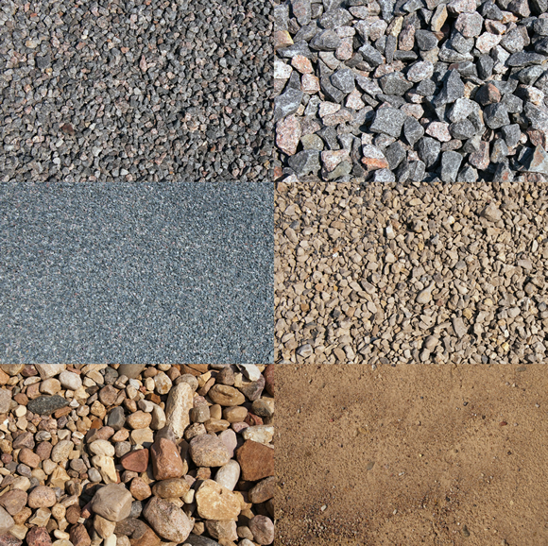
Energy
With energy we want to attempt to reduce the amount of energy that we use by using more efficient technology, reducing waste and utilising alternative energy sources. By doing this we can make the current resources we have last longer. We also want to try and increase the amount of renewable energy we use so that we’re less reliant on the earth’s resources e.g. fossil fuels. Other factors such as improved technology means that appliances will use less electric and therefore, will be more efficient and environmentally friendly. Other types of technology can improve your energy efficiency such as efficient boilers, double glazing, solar panels and rainwater harvesting. All of these reduce the amount of carbon emission and improve the building’s energy efficiency. Examples of renewable energy are:
- Wind Turbines
- Solar Panels
- Geothermal energy
- Biofuels
- Wave Turbines
- Hydroelectric Schemes
- Hydrogen fuel cells
All of these can be used as an alternative to non-renewable energy, which will in turn benefit the environment, reduce the amount of carbon emissions and make the earth a more environmentally friendly place. These are the best types of energy production because if they’re maintained then they’ll never run out, unlike coal and oil.
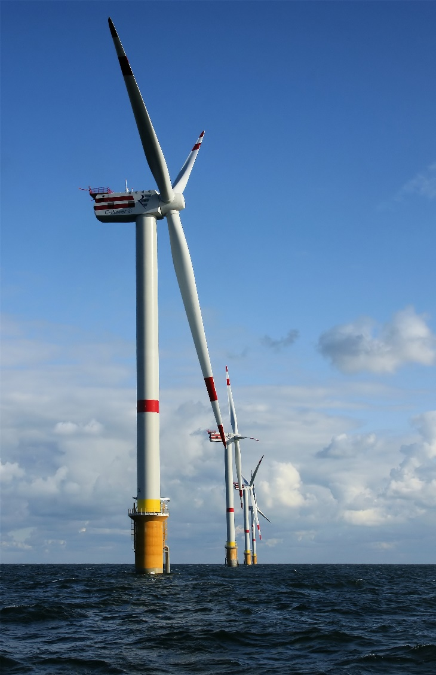

M3
You must compare each of the techniques described for P5 in terms of how well each achieves what it is intended to do (performance) and the relative outlay associated with each in lifecycle terms (cost). You do not need to provide precise figures and relative expressions of cost will suffice (cheap, moderately expensive, and so forth). Diagrams should be used to support the text, wherever appropriate, but the standard of sketching and drawing is not an issue here.
Cost
Waste Based Techniques
Waste is a big issue in construction and therefore we must have things in place that reduce the amount of waste on sites. For example, using the specified amount of materials rather than using more than necessary. This reduces the amount of money spent on materials, therefore reducing the amount of waste. Another way of reducing waste is ensuring that builders etc. have been on a course teaching them why they should try to reduce the amount of waste and how they can reduce the amount of waste. This should end up reducing the amount of waste on site, which in turn saves you money. Another way to reduce the amount of waste is using materials that are recyclable or environmentally friendly, this way you can reduce the amount that ends up in landfill, therefore reducing the amount of extra cost you need to pay for landfill and reducing the amount that we pollute the environment. Another proven technique is recycling/reusing materials wherever we can. For example, if there’s materials from other sites we can use them on this site for free. Even demolished sites can be cleaned up and we can reuse the rubble for aggregates and melt and reuse the glass rather than sending it to landfill. Finally, using recycled materials reduces the amount of energy that needs to be produced to power the factories to make the materials. It also, reduces the amount of carbon emissions and pollution from the factories because they need to produce less material. Incentive schemes for workers might be a way of reducing the amount of waste. This works by workers producing less waste and getting paid extra for it.
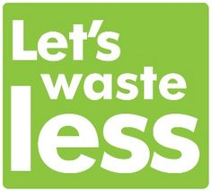
Materials Based Techniques
Materials are key within construction, but where we can we want to try and use sustainable, recyclable materials that can be reused. This is beneficial because it reduces the amount that ends up in landfill, this is because we can break down old bricks and use them as brick chips for fill etc. Another example of an environmentally friendly material is Triple glazed wooden windows, which are very energy efficient and the materials can be recycled to use again. Furthermore, they reduce the amount of oil that needs to be used to make these products, which is beneficial considering they’ve said we’ll run out of oil in 100 years. Using timber is a good sustainable method of construction because whenever we cut down a tree we can place another to replace it. Other ways of managing materials is ensuring that the amount of materials we use is the correct amount for the job. This way we ensure that we don’t overspend on materials we don’t need that could go to waste. Furthermore, you’re losing money and having to use more energy to produce the materials, which affects the environment due to pollution. Other materials such as sheep’s wool can be used for insulation rather than other insulation because if we look after the sheep then we have a sustainable reliable source of insulation.
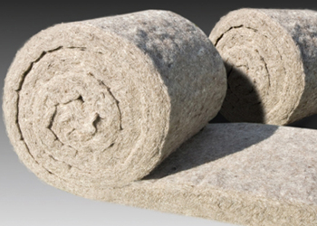
Energy Based Techniques
Other environmentally friendly schemes such as BREEAM are beneficial because by following the scheme you have a building that is energy efficient, environmentally friendly, self-sufficient and sustainable. These are all beneficial to the environment in reducing the amount of energy and waste produced. Other things with construction that improve your energy efficiency is solar panels and wind turbines. These allow the building to produce electricity to power itself, therefore making it self-sufficient. They’re expensive but they pay themselves off eventually. Furthermore, you spend less on electric and gas, but also reduce the amount that needs to be produced by fossil fuels. Other beneficial materials are energy saving lightbulbs which require less electricity to power the lightbulb at the same brightness. Biofuels or Geothermal energy can also be used if the building is in a suitable location.
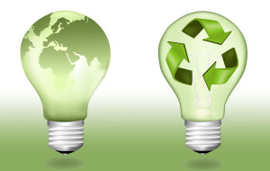
Conclusion
Overall, using these techniques are beneficial and help achieve a high performance environmentally friendly, sustainable building. This also allows for the building site to run smoothly and efficiently with minimal waste. Furthermore, the little waste that we have we want to try and either recycle or reuse materials. Energy Based techniques are beneficial because they save you money over time. Since we used these 3 techniques we’re eligible for a BREEAM rating.

Performance
Waste Based Techniques
Waste based techniques involve us reducing the amount of waste produced on a building site while constructing a building. To do this we can use lots of different methods such as waste management schemes or incentive schemes to encourage workers to worker cleaner and less wastefully. A popular waste management scheme is recycling where instead of putting things in to land fill and waste we reuse it on other sites etc.
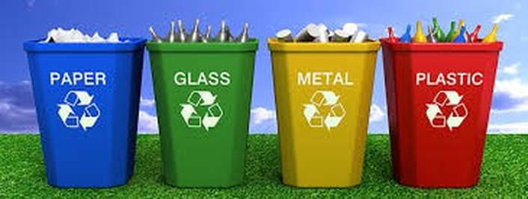
Materials Based Techniques
Material based techniques involve us using recycled materials or using sustainable materials. Both methods are beneficial and work well if the materials are up to the required standard. For example, if we were using older materials then we’d try to improve them in any way we could to make them suitable for use in the building. If these materials weren’t improved then we’d have to use some other type of sustainable, environmentally friendly material. Materials used for newer projects must be higher quality and performance materials because they need to last for a very long period. If the materials aren’t up to the required standard, then they must be improved or not used because it’s important that we achieve a BREEAM rating.
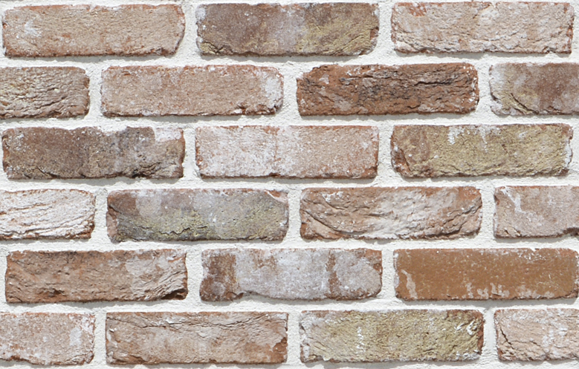
Energy Based Techniques
Energy based techniques involve us cutting down the amount of light inside the building or using a renewable energy resource such as wind turbines, solar panels, energy saving lightbulbs etc. Other things that can work are light sensors that turn off the lights once you’ve left the room, this technique reduces the amount we spend on lighting and increases the energy efficiency of the building. Solar panels reduce the amount of money that you spend on electricity and therefore reduces the amount of power required from fossil fuel power stations. This is environmentally friendly, sustainable and reduces the amount of carbon emissions from power stations. These techniques provide a high performance because they do not affect the building from functioning, but improve it due to the amount of money that you save etc.
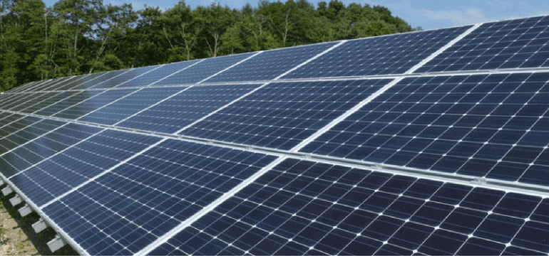

D2
You must justify the use of appropriate sustainable construction techniques for a specified (real or virtual) construction project, for example that used for M3, in terms of the associated environmental and sustainability issues. Non-specific responses that refer to construction projects in general are not acceptable.
Bae Baglan
For the new super school, we will be using appropriate sustainable techniques to make the school as environmentally friendly and sustainable as possible so that we are able to achieve a BREEAM listed building. This is a rating system to see how sustainable and eco-friendly a building is. The 3 techniques I will be using are:
- Energy based techniques
- Waste based techniques
- Material based techniques
Energy Based Techniques
Energy based techniques involve reducing the amount of energy that the building needs. To reduce the amount of energy required to power the building we will be using a renewable source of energy. This is important because we’re lower our carbon emissions, improving the sustainability and self-sufficiency of the building. It will produce clean eco- friendly energy that reduces the amount of non-renewable energy we have to use and therefore, is beneficial to use them. By using a renewable source of energy, we reduce the amount of power that has to be supplied by non-renewable energy, which is bad for humans and the environment due to the burning of fossil fuels which causes pollution. The new super school will run on solar panels and small wind turbines which will be installed on the roof. These will fill up the entire roof space if we have the required funding to do so. This will supply heat and electricity for the building. Therefore, making it one of the best forms of renewable energy. On top of this it will create clean and renewable energy that can be used elsewhere when the school is shut, for example during the summer. This is beneficial to the local area that will be run on solar power rather than non-renewable methods. Solar panels are effective because they pay for themselves over a period of time and provide renewable, clean energy. The school will require a lot of energy, so this is why we have decided to fill the entire roof with solar panels to ensure that we have enough energy to power the entire school sufficiently. Due to us using solar panels for the power source of the building it reduces our carbon footprint, which helps us achieve our goal as a BREEAM listed building. The school will also be earning money from the national grid when it’s not in use which can be spent on new technology for the school or an increased number of solar panels etc. Solar panels are a very long-term source of renewable energy and don’t rely on materials, due to the sun always releasing energy. Wind turbines are suitable for Bae Baglan because it’s located very close to the sea which pretty much always has a coastal breeze. Therefore, the majority of the time the turbines will be producing energy. By using these we reduce the amount of fossil fuels being used and increase the sustainability and energy efficiency of the school. Other things that I will install in the school are light sensors so that if the room is empty then the lights are turned off. By using these we save money on electricity bills and reduce the amount of wasted energy. This makes the building more energy efficient.
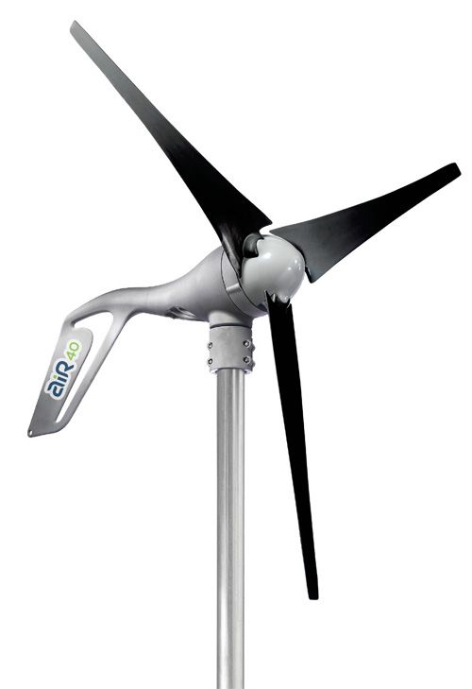
Conclusion
In conclusion I have decided to use solar panels and wind turbines because they earn the school money, are a renewable source of energy, they reduce running costs and minimise the need for non-renewable energy, which is beneficial because we reduce the amount of pollution due to non-renewable methods. The light sensors will be used to reduce the amount of wasted light energy when there’s no one in different rooms. Therefore, lowering the overall cost of electricity bills.
Waste Based Techniques
Waste based techniques involve reducing the amount of waste that a building creates. To lower the amount of waste produced by a building we want to be as eco-friendly as possible. So, we’re going install compost heaps that can be used to grow crops/food or supplied to a farmer for use. We will supply the compost heap with wasted food etc. from the canteen. Furthermore, we will supply bins with separate bins for different waste. This increases the likelihood of the children recycling. On top of this instead of letting rainwater go down the drains we will reuse it to flush the toilets in the school. This saves money on water costs and increases the self-sufficiency of the building.
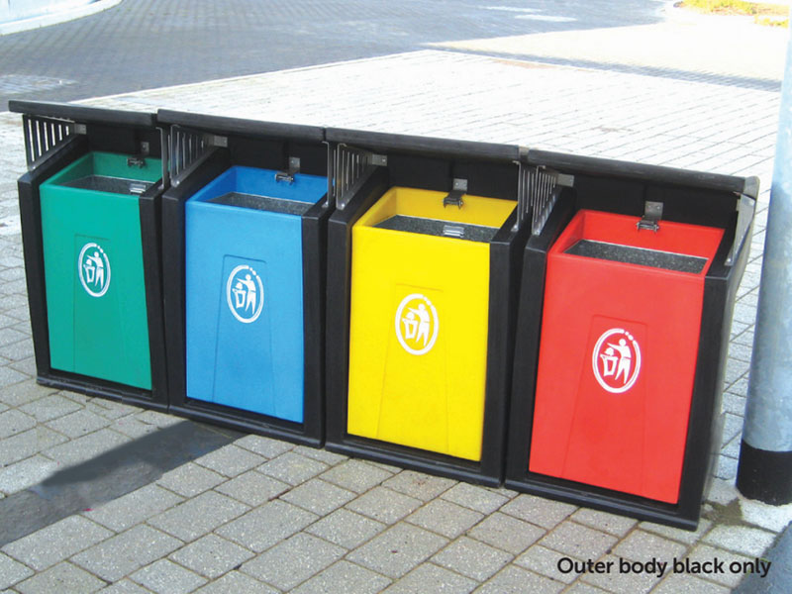
Conclusion
By implementing these we will increase the chances of having a BREEAM rating and reduce the amount of unnecessary waste produced by the school, therefore, making it environmentally friendly and reducing the amount of waste that ends up in landfill.
Material Based Techniques
Material based techniques involves using sustainable material/techniques for the construction of the building. Therefore, where possible we want to try, and use recycled or recyclable materials. For the new super school, I have decided to use a mixture of demolished sites materials, aggregates and sustainable, environmentally, recyclable materials. We’re going to use these materials because they can also be reused again once the building is knocked down. Furthermore, we’re going to use recycled materials because we reduce the amount of useful materials that end up in landfill. We have identified sub-contractors that will provide us with the demolished site materials and aggregates. Derwen aggregates will be supplying us with our aggregates in Neath Abbey. It’s beneficial to use recycled materials because we reduce the amount that would’ve ended up in landfill. Furthermore, these tend to be cheaper than to buy compared to newer materials because the owner of the demolished site might just want to get rid of the materials. On top of this they’re selling a used product, so we should be able to get the materials for slightly cheaper. The materials that we get from the demolished site can be reused for different jobs depending on the purpose of the material. For example, we can break down the bricks from the site and use them as brick chips for fill etc. We can also, melt down the broken glass from the old site and reuse it to produce new double/triple glazed windows for the school. This in hand saves money due to the fact that we don’t need to buy brand new windows. We’ll find different usable materials from the demolished site that can be treated so that they’re sufficient for the school. For example, any decent bricks can be treated and used as a rustic appearance and any broken bricks can be broken down into brick chips to use for fill. Also, stones/concrete etc. will be used as fill to increase the level of the school where necessary. Steel can be re-melted to be used as beams or fencing etc. On top of this we will train workers to be as efficient as possible when working to try and reduce waste and teach them what they can do with any waste supplied to save money on the project. We will also teach them the importance of recycling and putting separate waste in separate bins so that it’s easier to dispose of.
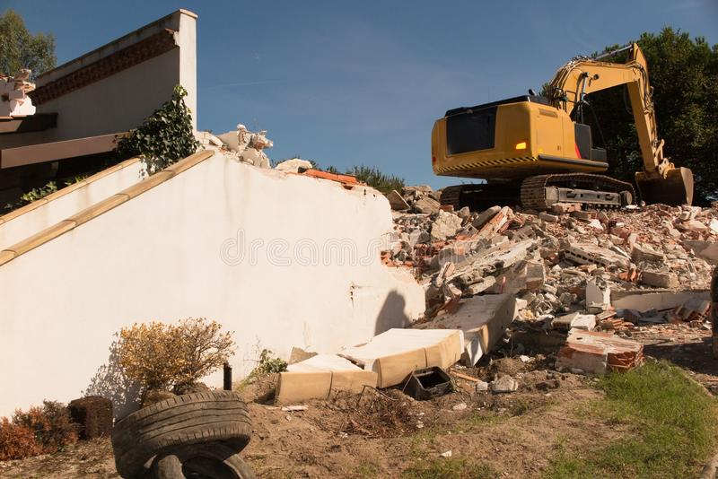
Conclusion
By recycling materials, we ensure that useful materials don’t end up in landfill and prevent the burning of fossil fuels to produce new materials, which reduces the amount of pollution and greenhouse gases being released in to the environment. The BREEAM survey will identify that the site has tried to minimise waste wherever possible.

