Sample

Contents Page
Pages | Content
1 | Front Page
2 | Contents Page
3 | P5
4 | P5
5 | P5
6 | P5/P6
7 | P6/M2
8 | M2
9 | M2
10 | M2
11 | M2/D2
12 | D2
13 | D2
14 | D2/Reference List
15 | Reference List

P5
Explain the principles of super structure design
What is a superstructure?
Image Source: https://www.google.co.uk/search?ei=5u5hWryXH4uXgAb5hqCgDg&q=what+is+a+superstructure&oq=what+is+a+superstructure&gs_l=psy-ab.3..0l5j0i22i30k1l5.825741.832245.0.832496.34.24.6.4.5.0.120.1368.23j1.24.0....0...1c.1.64.psy-ab..0.34.1370...0i131i67k1j0i131k1j0i67k1j0i10k1j0i13k1j0i13i30k1.0.6uNrzPeinMc
This could be loads of different things. Such as walls, stairs, ceilings, rooves and floors. A superstructure in construction is anything on or above the ground floor. It starts in the foundations which the walls and floor will be built on top of. The superstructure is made up of the following parts of a building:
- Walls
- Roofs
- Floors
- Stairs
- Windows
- Doors
Floors
Flooring comes under the ground and above the ground depending on the purpose of the flooring. It can be put into a basement below ground or on the second floor of a standard house. One of the most common types of flooring is timber flooring. This is because it is cheap and gets the job done. They’re made by spanning wooden joists across the base of a house. They tend to be built into the wall like in the picture below. Then we span floor boards and carpet across the top of the joist to create the floor. The floors tend to be built off the ground to avoid damp, however sometimes they are, but they are just more susceptible to rotting. Other types of floor include solid concrete floors that tend to have a small layer of insulation below the concrete. This type of floor tends to be used in a garage or warehouse. After we’ve sorted the floor we can establish what type of finish we want for the floor. Whether that is laminate flooring, tiles or carpets. This will be different depending on the room. For example, you might like having carpets in bedrooms and laminate flooring in the living room and kitchen.
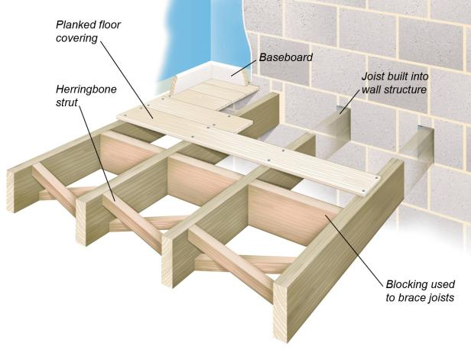
Walls
There are 2 main types of walls, internal walls and external walls. Internal walls are mainly unaesthetically pleasing bricks and tend to be cheaper and less weather resistant. Whereas, external bricks tend to be high quality bricks that are more weather resistant and tend to look better. They also tend to be more expensive and therefore it can cost you a significant amount more if you only use these on a house. On the inside of the house there might be internal walls that are made from timber which don’t support any weight so therefore, can be taken out if needed. Furthermore, internal walls can be made from bricks as well depending on the type of house and whether the house needs a retaining wall. Whereas if you wanted to get rid of an inside retaining wall these would be made from either bricks or blocks, then you’d have to find a different way of supporting it before any work is done. You could support a wall by using a retaining beam to hold the load of what’s above it or you could use a pillar which would do the same job. All walls external walls need to have a 50mm gap between the two lots of bricks called a cavity wall. There are three main different types of cavity walls. A clear cavity, a partial fill cavity and a fully fill cavity. You will use different types of cavities depending on the purpose and design of the building. The purpose of a cavity is to trap air and insulate the building trapping air inside the cavity. This is on top of any insulation foam panels that might be stuck onto the internal wall. This ensures that your house stays warm, insulates your house and prevents heat from escaping the building. Also, therefore older building even though they have thicker walls tend to be cooler. It’s because they have no cavity or insulation in the walls which therefore, means that more heat is lost and the cold can conduct through the walls easier. When finishing walls, you must plaster them first, before painting them or applying wallpaper later. Another possibility is wood panel finishes which might look decent depending on the style of the house. Finally, you must account for thermal movement. So that when the temperatures drop, and the wall expands it doesn’t end up cracking and spalling. You might want to invest in quality bricks for the external walls so that this won’t be as much of a problem in the future. However, if spalling does occur it’s simple to replace the bricks. Another thing, that they tend to use when building walls for houses are wall ties. These hold the two walls together providing support for the walls, sometimes these are not needed. In hotter countries they tend to paint the walls brighter colours such as white so that the sunlight reflects off the wall, therefore keeping the house cooler compared to colours such as black which would make the house hotter and uncomfortable to live in.
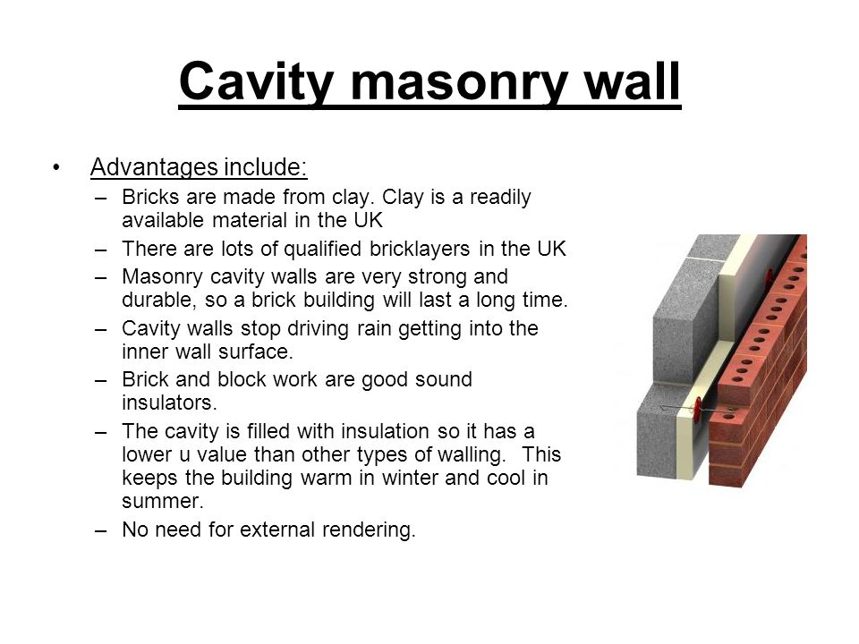
Roofs
Replacing the roof on a house can cost you a ridiculous amount of money to replace so it’s best if you spend a good amount of money on a good quality roof that will last a decent amount of time. This way you won’t have to worry about replacing it. A roof has multiple purposes, however the main purpose of a roof is to keep the weather out of the building and ensure that everything inside is kept dry and protected from the elements. Another quality of a roof is it should last for 20 to 50 years depending on the types of materials used. Finally, a roof has to be fire resistant so that if there is a fire it delays the process and allows people to escape etc. Roofs in the UK tend to be pitched roofs which tend to be at an angle of at least 39 degrees. However, it’s more common for the pitch to be closer to 45/50 degrees to allow for rain to flow off quickly, therefore meaning it’s less likely to build up and cause leaks especially during very heavy rainfall. The types of materials used on a pitched roof are tiles or metal sheeting. Tiles are heavy, but higher quality and last longer. Whereas, metal sheeting is lighter and is cheaper, but doesn’t last as long. This type of roof can also be turned into a loft conversion, however the pitch of the house may have to be adjusted to make it suitable for such a change. A different type of roof that tends to be used in hotter countries is a flat roof. These roofs are not exactly flat and have a slight pitch of roughly 10 degrees for when it rains, however it is not necessary for them to have a steep pitch because they rarely get heavy rainfall. You tend to cover this type of roof in felt or cheap tiles.
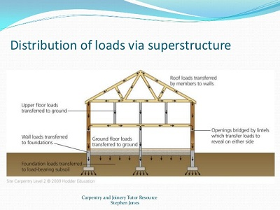
Stairs
Stairs are essential in houses with multiple stories so that the occupants can access the different floors. We also need these in case of an emergency in tower blocks and offices etc. There must be fireproof stairs in the building so that the occupants can escape the premises in an emergency. However, your stairs must have less than the maximum pitch of 38 degrees. If they’re over this you will be forced to replace them in an office building by law. Stairs tend to be built by carpenters on site in the house and are constructed at a certain pitch depending on how much room you have to spare and what you want. However, you can construct stairs off site and transport them on site, then set them up. A hand rail must also be included in public buildings to provide help for people who need it to get up and down the stairs. Furthermore, the stairs have to be 3ft wide or more, however if they’re over 1m wide then there needs to be a hand rail on both sides. There are two different types of stairs, wood stairs and concrete stairs. For a larger building such as a school I would use concrete stairs because it’ll hold more weight and is quicker and easier to install. Furthermore, it might be cheaper to buy than wood.
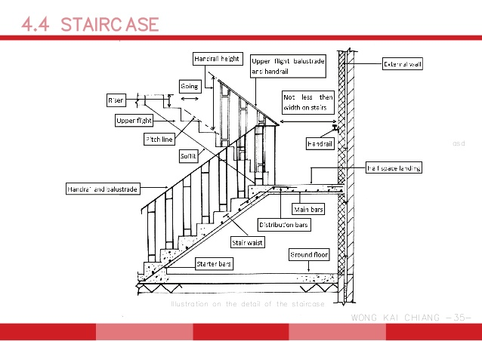
Windows
Windows are important for light, air and sound. They allow natural light into a room or passage way or allow air to enter the house if there isn’t an alternative way of it entering. During the 20th century it was most common to have wooden window frames and then paint these or cover them with some type of cuprinol or paint to protect the window. However, once it’s worn off then it will start to deteriorate and potentially rot if it’s not covered. Now in the 21st century it is more common to use PVC windows which deteriorate at a significantly slower rate, are lighter and have features such as child locks which stop the window from opening fully. However, adults or teenagers will be able to open these easily. Another type of window that they tend to use is a skylight window, these are more commonly used in hallways and conservatories, however can be used elsewhere if it’s suitable. Another different type of window which is less common is aluminium windows which are cheaper than PVC but have similar properties. However, these are lower quality and don’t look as aesthetically pleasing as PVC windows, so if possible try to go with PVC windows unless you are on a budget.
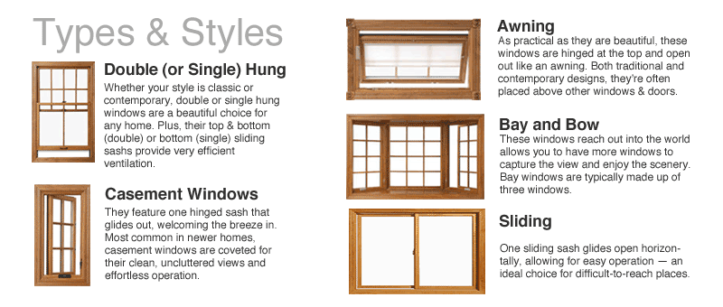
Doors
Doors are needed so that you can enter and leave the building. They are also used for security and privacy so that no one can enter your house unwanted. They have locks on them for this that can only be opened with a key. Doors can be made from lots of different materials, for example, wood or PVC. The outside doors on most buildings need to have proper locks, however internal doors tend to not have any locks. However, in college we have digital doors that open with a digital key. This is for security reasons so only tutors with the key can open it and so that pupils don’t go in there and steal things or damage equipment. Furthermore, there must be fire doors which open when you push the bar down for safety reasons, so in case there’s an emergency everyone can get out quickly and efficiently. Other types of door that can be used in different types of buildings are, Roller shut doors, French doors and sliding doors. These tend to be used in larger houses or conservatories.
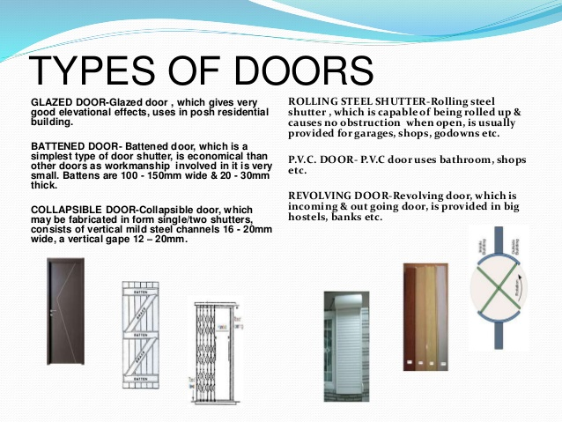
P6
Describe the techniques to construct and finish component elements of the superstructure
To be able to construct the structure efficiently and productively we need to employ, buy or rent certain things to help us complete the build on schedule. We will need:
- Machinery
- Man Power
- Equipment

Machinery
When constructing any type of superstructure, we will need to hire machinery that can carry out the different tasks required to complete the job. For example, to lift heavy supporting beams and frames we might need to hire a crane that can lift such heavy objects. This needs to be planned so that when the equipment arrives it doesn’t sit around not being used. Therefore, this can save the clients’ time and money. Especially because cranes are very expensive to rent and can cost a significant amount of money per day. Other equipment like mini diggers and dump trucks tend to cheaper due to multiple factors such as availability and price. Other tasks where we might use machinery and equipment because it’s more efficient and faster compared to hand digging the foundations, we will use an excavator. Furthermore, we could also hand mix cement, however this takes longer and requires lots of effort. It also, might include twisting and therefore, people might end up with repetitive stress injury or injury to the spine. That’s why we use cement mixers. On top of this cement mixers can mix more material at once due to it being larger than a wheel barrow. The only issue is, this type of machinery is expensive to buy, own and maintain, and therefore you need to make sure that it’s economical for you to buy one or whether you’re better off renting one. A crane will also need to be used on heavy parts of the building such as the frame or supporting beams. Sometimes this can be done by hand but only if the weight isn’t too heavy. Also, it is possible to build the frame on top of the house, but you will need some sort of crane/lift to get materials up to the roof as you’re unable to carry materials up a ladder due to safety regulations. However, even though you’re not meant to, lots of carpenters still do this and go against health and safety laws.
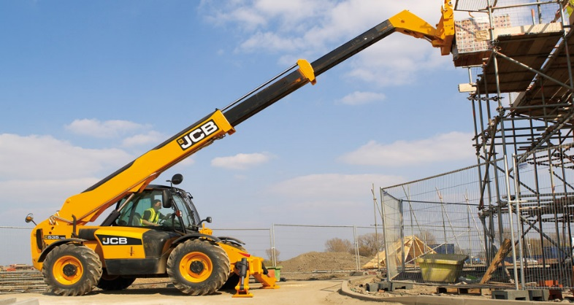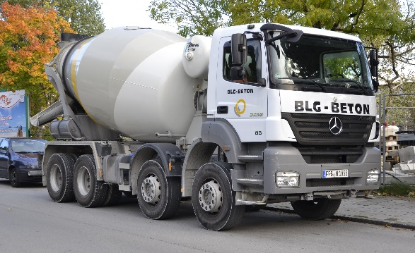
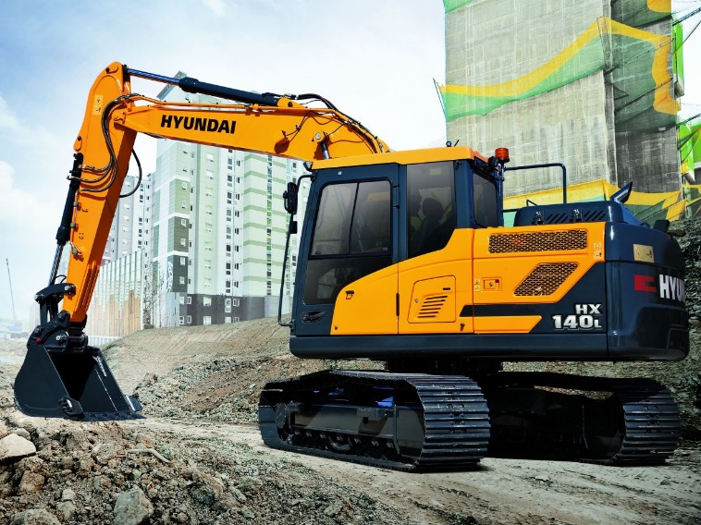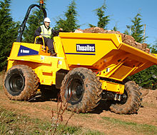
Manpower
Manpower is very important when it comes to constructing a structure. Because without, manpower it could take ages to complete on your own and you probably wouldn’t have to correct training to complete all the tasks. Therefore, we need to employ people that can organise and run the project smoothly and efficiently to a very high standard. When planning a project you want to ensure that you have enough workers to complete the job before the finish date. You also want to make sure that your workers have the correct training to do the required jobs necessary. Other things that are necessary are temporary jobs to complete specific jobs. For example, scaffolding if you’re working on the outside of the building. This allows workers to be up at the level that they need to be, while being able to access the structure easily to do work on it, whether that be fitting cladding, laying bricks or installing a window. This scaffolding should also always have toe boards which stop any materials or equipment from accidentally falling off of the scaffolding. They’re also there to stop people from falling from height when working high up on the scaffolding.
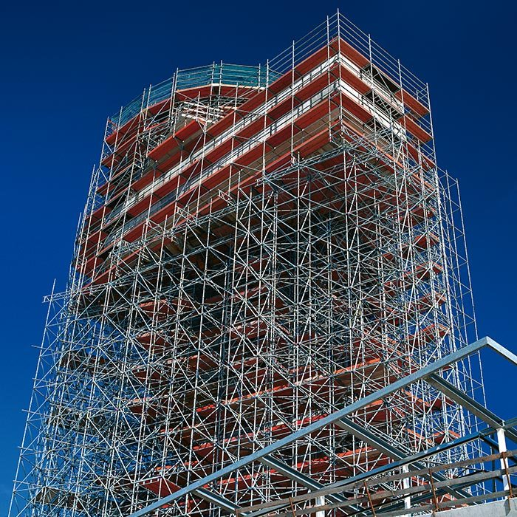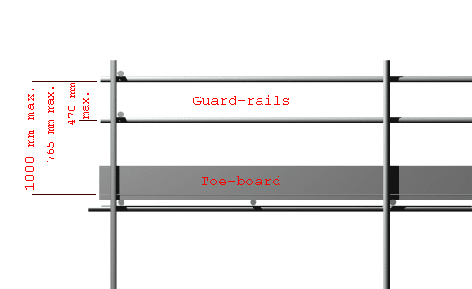
Equipment
Once we have completed the main parts of the building. For example, walls, roofs, stairs, windows and doors we must finish the rest of the building and make it presentable. So this might include painting the building, fitting cladding or just generally tidying up the building and making it look presentable. There are a number of factors that can affect the type of finish that you can have on your building. This depends on government requirements, the cost of materials and health and safety requirements. For example, some council might want certain colour schemes used on the building so that it blends in with the surrounding environment. One of the main finishes on buildings around the world is plaster. Plastering tends to be used mostly on the walls, however, it can be used on the ceiling of a building. If it’s used on the ceiling of a building it tends to be thinner plaster so that it decreases the price and so that you don’t use material unnecessarily. It tends to be used on the insides of buildings the majority of time, however some buildings have it on the outside used as a finish, then it’s given a coat of paint to protect it. It’s the same principle on the inside, however, instead of being used to protect the plaster it is more used for aesthetics. Plaster is used to because it’s fire resistant, hygienic a waterproof. It also, prevents sound from transferring in to the building. There are lots of different types of plaster that can be applied to the building depending on multiple factors, including your budget or preference. For example, nowadays the most common type of plaster is cement plaster. This is a mixture of plaster, sand, cement and water. It provides a smooth surface which is able to be painted on, or able to apply wall paper on to.
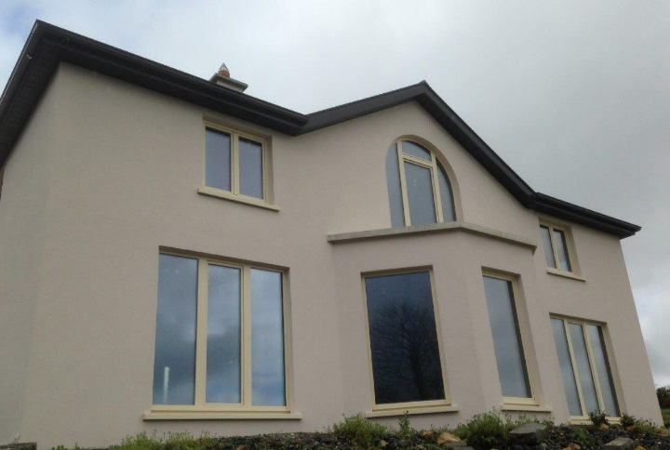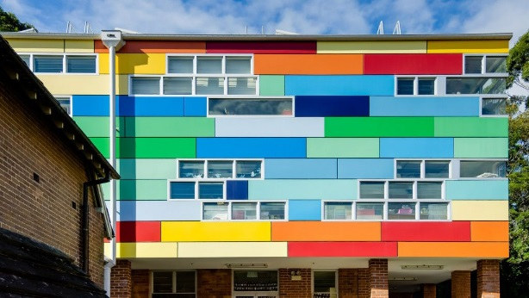
Finally, plasterboard has be used in construction for hundreds of years. It is made from gypsum plaster and aggregates which give added strength. They tend to be used to increase the thermal capacity of a wall and are quick and easy to fit. However, they tend to be of a poorer quality than proper plaster and are mostly used on internal walls of a building. They have very similar properties and benefits to plaster. A key thing to remember with plasterboards is not to have a gap in between them when fitting them. If this occurs you might have serious issues with damp and air flow increase, which can cause a decrease in temperature and an increase in the amount of draughts.
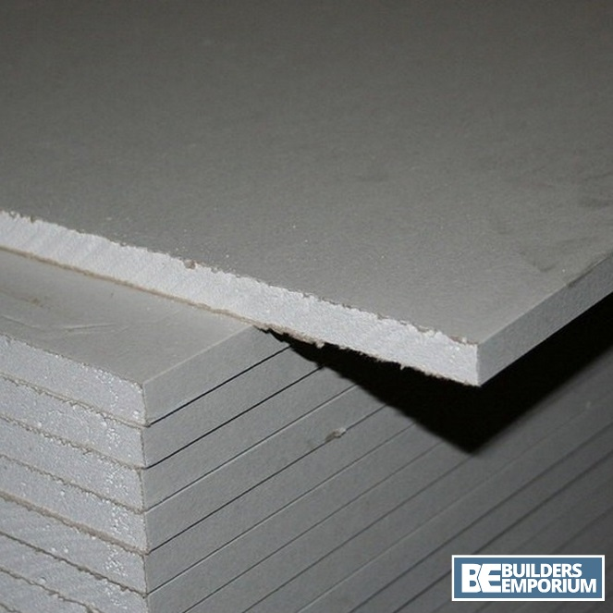
M2
Justify the selection of suitable materials and techniques for use in the construction of superstructures for low-rise domestic and commercial buildings, for two different tutor-specified scenarios.
In this assignment we’ll be deciding what types of materials should be used for different types of buildings. One of the buildings that we’re going to suggest materials for is the Bae Baglan School and the other is the old caretaker’s accommodation. Firstly, I’ll talk about the Bae Baglan School. Traditionally in construction we use bricks, but we can also use other materials to design newer structures such as:
- Timber frame
- Steel frame
- Bricks/Blocks/Porotherm
- Pre-built buildings

Timber Frame
Timber frames are used when we use wood instead of bricks and other standard building materials. Timber frames are popular in newer types of construction. They’re uncommon in the UK due to being very flammable and not very fire resistant. These tend to be very effective and fast to construct due to them being pre-built off site and then transported by Lorries in pieces which are then constructed on site. This makes the process a lot quicker compared to having to wait for brick layers to complete the job on site. Furthermore, brick layers also can cost a significant amount more depending on how long the job lasts. The negatives of using large quantities of wood is that it’s flammable. You also must worry about factors such as rotting and woodworm which can cause serious issues for timber frames. Wood is also a limited resource, so we should therefore try and avoid using large amounts of wood where possible. However, it’s good because wood is a good insulator due to its high energy efficiency and the insulation is contained deep inside the structure, so a typical timber wall can be a lot thinner than bricks.
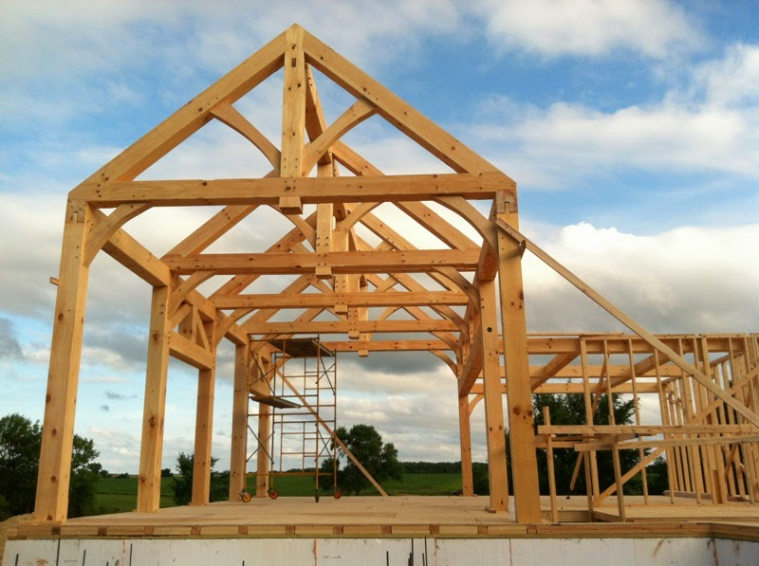
Steel Frame
Steel frames are used instead of using techniques such as timber and bricks. There are lots of different advantages when it comes to using steel frames for construction such as its fire resistance and strength. It’s can also be flexible and will bend without cracking. Steel is strong unless temperatures reach higher than 500 degrees Celsius. If temperatures increase higher than this then it can cause the steel to become weaker and therefore resulting in the structure collapsing. However, it’s fire resistant to a certain extent and is better than a timber frame would be. Other advantages of using steel frames is that it’s moisture and rust resistant, compared to timber frame which needs to be preserved and even still takes in a certain amount of moisture if exposed to the weather. Furthermore, they’re insect resistant, so therefore there is no chance of them causing any problems to the structure unlike timber frames. Also, steel frames tend to be lighter than timber frames which makes them easier to position and fit. The disadvantages of using steel frames is the amount of heat that is lost through them. This is due to steel being a good conductor which allows the heat to transfer through the material easier than wood for example. On top of this lots of builders are not trained to be able to erect these types of structures and even if they wanted to try and give it a go then they might not have the correct equipment to do so. Therefore, lots of people tend to prefer using bricks where possible to avoid these issues.
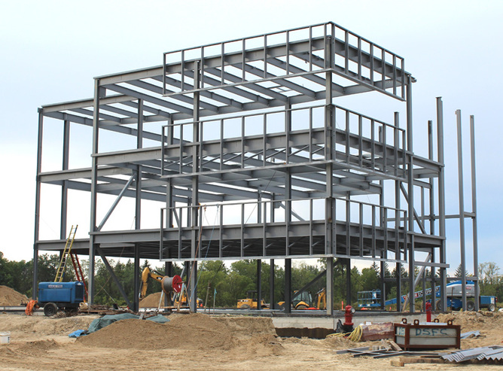
Bricks/Blocks/Porotherm
The school should be constructed using more traditional methods such as bricks and blocks. These standard methods tend to be decent but there are improvements that can be made to improve your house’s energy efficiency. Such as a new type of brick called Porotherm which is a clay block walling system which uses a small amount of mortar which can save you a decent amount of money overall. I would recommend using this material on the school due to lots of different reasons. Firstly, it can be constructed at a fast rate which means that it won’t take extremely long to construct, and you won’t be employing brick layers etc. for an extortionate amount of time. These bricks are also fireproof, so the school will be safer for pupils and there will be more time bought for them to escape in case of an emergency. On top of this, the building will be almost entirely recyclable which makes it extremely environmentally friendly and therefore is a great material to use especially considering we want to aim for a BREEAM standard of building. Furthermore, if local builders/bricklayers haven’t got the skills required to lay the Porotherm then they can go on a course that’ll teach them all they need to know to complete the job. This will be a small price to pay for results to get a BREEAM standard. If we use these blocks, they will have a very low r value and with good insulation we can ensure that the building stays warm with minimal heating. An r value is how much heat energy transfers through the wall. The positives of building your walls thicker is that sound proofing is improved, and you’ll have lower noise levels in the building, which would be very beneficial if you live in a noisy neighbourhood. A standard building should also be fitted with a minimum of a 50mm cavity that is fitted with some type of insulation on the internal wall. This makes sure that the inside of the house stays warm and that water etc. doesn’t make the building damp. This 50mm cavity contains air in it which acts as an insulator and a barrier against moisture that comes from the external bricks. A building with good insulation will save a lot more on heating etc. compared to a standard building without out it. This is because with good insulation the heat will take a lot more time to escape and therefore, you don’t need to use the boiler as much. This is used to insulate a building from weather conditions such as colder weather or drafts. Since there is an air gap between the 2 walls it keeps the air that’s outside of the building out and the heat on the inside in.
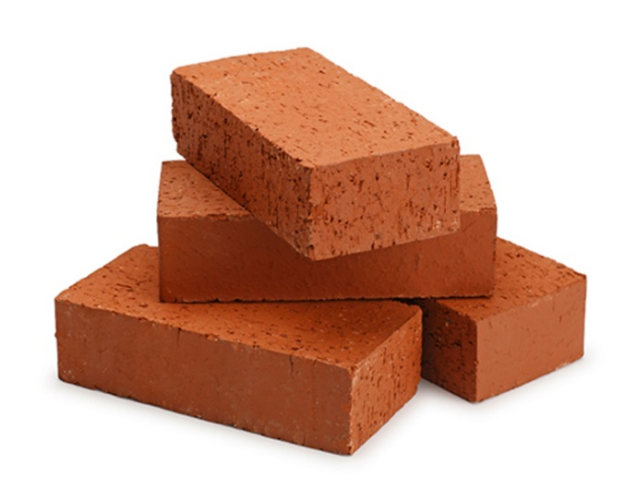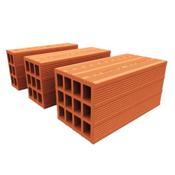
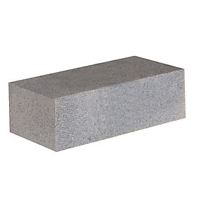
Pre-fabricated/designed buildings
Personally, I would also recommend that the school was pre-fabricated. This way the school can be constructed quickly and efficiently. This means that schools can be constructed during summer holidays etc. so that it doesn’t affect different aspects. These buildings are very uncommon in the UK. However, their popularity is starting to rise due to the speed of assembly and price. These modern homes tend to have high energy efficiency which can save you lots of money on bills. This is due to them having lots of windows that let in light, causing heat which then heats up your house. They’re quality homes that will last the same amount of time as a standard home but have a lower carbon footprint then a typical American suburban home. These homes generally tend to be cheaper than standard homes mostly because of the savings made from labour. With pre-fabricated homes you need fewer people there for fewer days. There’s also less need for specialists like painters, decorators and carpenters etc. However, they do have a few cons, one being that you need an upfront payment of around 20%, which can be a lot of money. Also, transportation of the materials can be risky and there’s a possibility that damage can occur while it’s being transported. Issues with the building might turn up after the building has been completed, which could end up causing you lots of money down the line. However, pre-fabricated buildings are very environmentally friendly, which can in turn save you money on heating and other bills compared to a standard house.
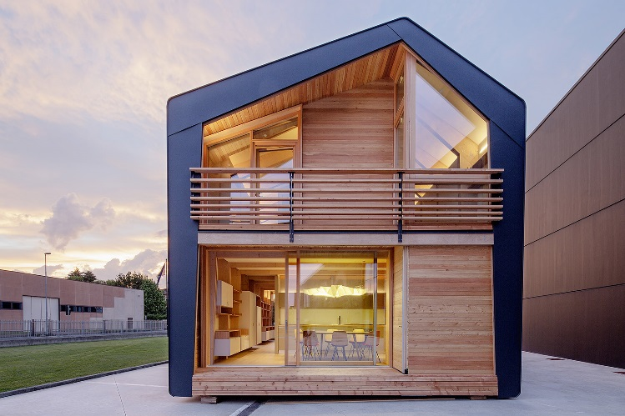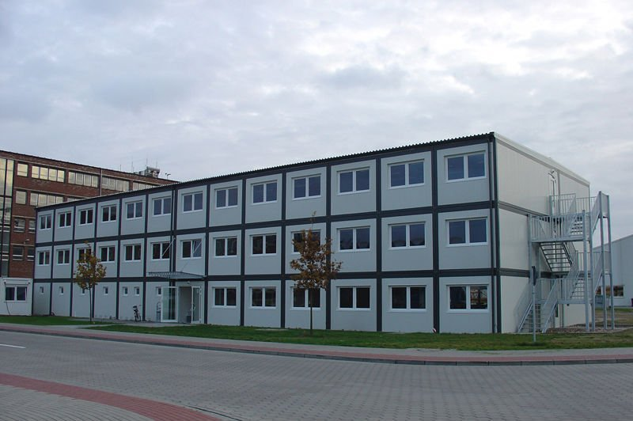

Secondly, I’ll be talking about a caretaker’s accommodation, this is an older building which uses more old-fashioned/standard building techniques such as:
- ICF
- Double/Triple glazed PVC large windows
- Slate roof with solar panels
- Strip foundations

ICF
I would recommend using ICF to construct the caretaker’s accommodation due to lots of different reasons. ICF or insulating concrete foam is a newer technique which involves filling the insulation blocks with reinforced concrete to make up the wall. The insulation then stays on the outside of the concrete as a permanent exterior. These blocks interlock and are very similar to Lego blocks. They can be made pretty much any shape depending on what you require for different jobs. This allows you to use them for curves etc in buildings where it would be significantly more difficult to do so with bricks. Furthermore, according to BuildBlock they’re 5 times quieter than a standard wood-frame home. On top of this, you can have up to 70% savings in energy consumption and costs compared to standard building techniques. However, concrete can be expensive especially when used in large amounts like this. I would not recommend using this technique for larger projects unless concrete prices were very low, so that it doesn’t end up costing a significant amount more than other techniques. Also, it’s difficult to remodel or adapt things such as plumbing or adding new windows once the concrete is added so you need to be sure that you are designing things correctly. However, this won’t be an issue because we’ll ensure that everything is done to an extremely high standard and check thoroughly that it’s being done correctly throughout.
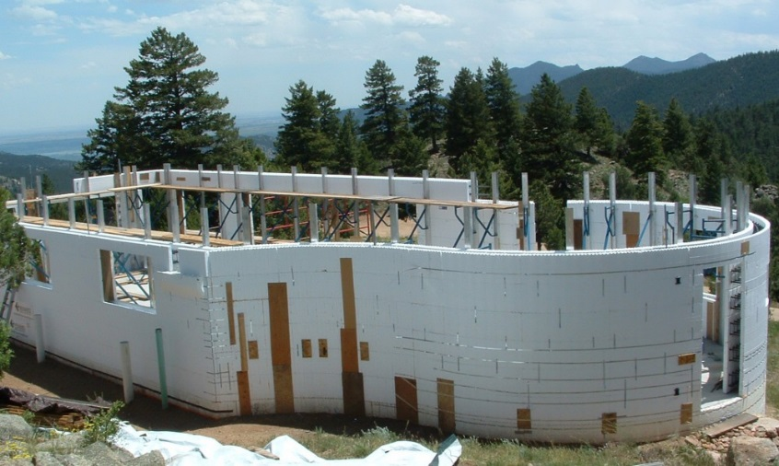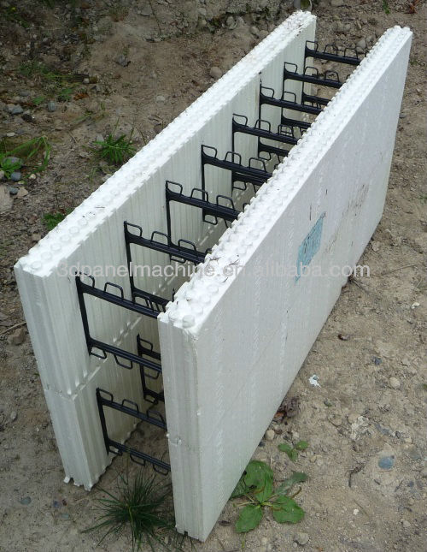
Double/Triple glazed PVC large windows
These windows used to be used a lot more because it was cheaper to use timber frames rather than metal window frames. It was also better value for money, so you’d prefer to go with wood and just replace it when necessary. This is used to insulate a building from weather conditions such as colder weather or drafts. Since there is an air gap/vacuum/gas in between the 2/3 panes of glass the gap is used as an insulator. This is because air is a poor conductor therefore, it’s hard for air to get in or escape. Also, PVC window frames have been prevalent since the 70s. They were used over wooden window frames because they last longer, do a similar job and are weather/insect proof. They’re also environmentally friendly and very easy to maintain. On top of this they’re significantly cheaper than both wooden and aluminium options. However, even though there are very few disadvantages with PVC windows they are weaker than aluminium options and this means that they can be susceptible to sagging and sashing due to their light weight.
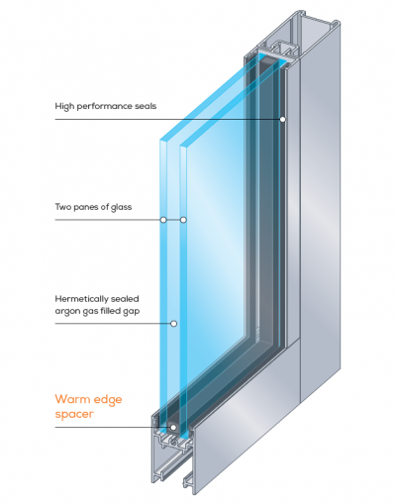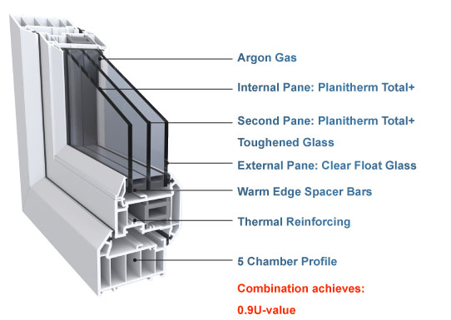
Slate roof with solar panels
Slate tends to be the most common and best material to use on roofs due to it being durable and aesthetically pleasing. Furthermore, it’s waterproof, can last for up to 50 years or more and they are fireproof which increases the safety of the building. On top of this they don’t end up in land fill like other materials such as asphalt which means that it’s better for the environment. With roofs you can add lots of different features to a building such as rainwater harvesting or solar panels. The rainwater harvesting means that you can use it to flush your toilets and save money on your water bill. The solar panels can be used to produce electricity or heat which is then used with your boiler to heat a building. This will save you money and makes the building more environmentally friendly. Furthermore, your house will be more energy efficient which reduces the amount you pay for gas and electric per month and produces fewer greenhouse gases. Timber is most commonly used traditionally in building, this is because it’s cheaper than other alternatives such as steel and concrete. Furthermore, they tend to be easier to fit compared to other methods due to the weight and availability of people to do the job. The disadvantages of using timber are that it’s susceptible to insect/weather damage if it’s not protected correctly when it’s installed.
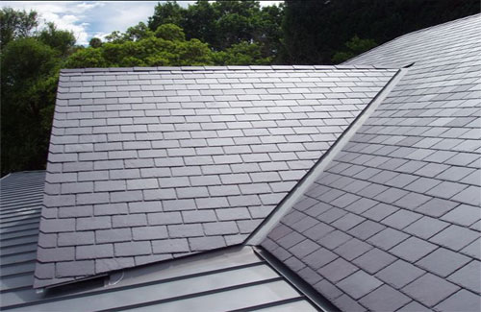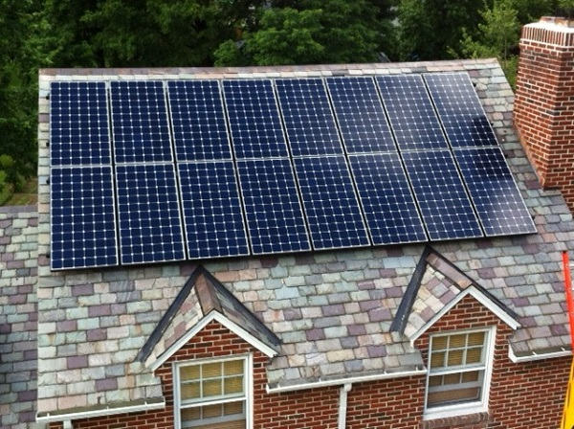
Strip foundations
Strip foundations tend to be used most commonly in standard houses traditionally because they’re reasonably affordable and they can be accessed easily if anything happens. Furthermore, they’re just as strong as loads of other types of foundations such as a raft foundation. They also tend to last for a very long period, meaning that if they’re maintained when necessary then you shouldn’t have any problems. Strip foundations also allow you to insulate your floor much better compared to other types of foundations due to the easy access to the ground. Also, you can raise the floor up a certain amount so that moisture etc. doesn’t come through the floor. Whereas with a raft you must use concrete for the floor. However, the disadvantages of using strip foundations are that it’s not suitable for every type of soil which means sometimes it might not be possible to use them and you’ll have to go with other alternatives. Also, there’s quite a bit of concreting involved which can be costly depending on the price of concrete.
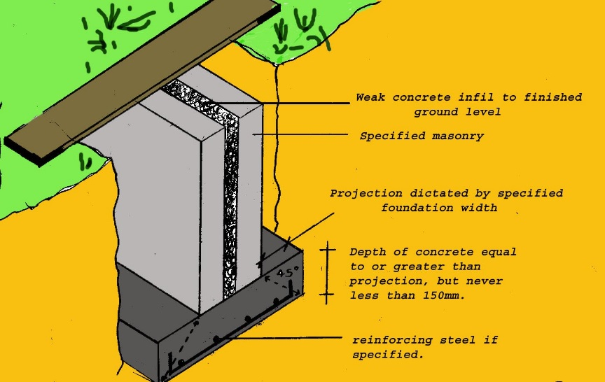
D1
Evaluate the environmental performance of modern materials and techniques used in the construction of superstructures for low-rise domestic and commercial buildings, for two different tutor-specified scenarios.
When designing the two different specified scenarios we need to take in to account how these different materials perform environmentally. This is so that we can ensure that these buildings are up to a high BREEAM standard. There are lots of different techniques and materials that can be used for these two incidences and I am going to evaluate the different ones that I’ve chosen for the two scenarios.
To ensure that we achieve a high BREEAM standard of building we will use materials that are sustainable and durable for the two buildings. The two main materials that I have chosen to use are:
- Porotherm
- ICF
I have chosen these materials because of the good properties such as being environmentally friendly and reusable. For example, Porotherm will last for 150 years with little to no maintenance and ICF can be broken.
Porotherm for super school
Porotherm is a very similar to traditional methods such as bricks, blocks and mortar. However, it uses interlocking lightweight blocks with a layer of mortar over the top which is applied using a roller. It uses a very small amount of mortar, therefore, will reduce the amount of money spent on the project and reduce the risk of contaminating the land. Porotherm has also been recognised as a sustainable material and therefore, lots of buildings that use this material tend to get high BREEAM ratings. On top, of this Porotherm is environmentally friendly because 30% of materials are from either alternative, recycled or secondary sources. On top of this they’ve received a reward due to the sustainability and high performance of the blocks. I decided to use them because they would allow us to get a high BREEAM rating. Furthermore, these bricks have high energy efficiency due to factors such as good thermal mass and can be recycled or reused for other things. They’re made from clay, recycled paper and sawdust. Some of these materials would just end up in landfill if they weren’t used in this material, therefore, it’s reducing the amount of damage to the environment. Furthermore, because we’re using recycled materials we don’t need to dig up and produce new materials which uses lots of energy. Instead we just produce this from existing materials and therefore don’t need to extract as much from the ground. On top of its impressive list of benefits so far, it also saves an incredible amount of water due to the small amounts of mortar that need to be used compared to standard methods. This can save a considerable amount constructing the building and it also affects the local area a lot less because they don’t need to supply as much water for this type of construction. Also, most of the waste tends to be in the mortar and having a considerably smaller amount of it means that you’re going to reduce the amount of waste dramatically. In conclusion Porotherm has very few downsides and is very environmentally friendly. This makes it perfectly suitable to build the new school with.
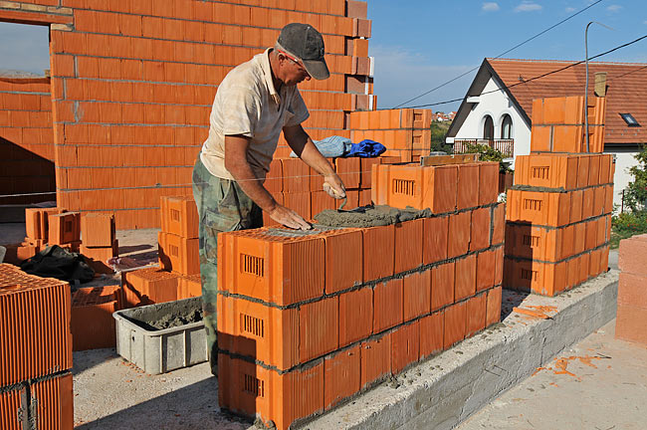
ICF for the caretaker’s accommodation
ICF is a whole new method of construction. It tends to be used in smaller builds due to the large amount of concrete that needs to be used when using this type of material. ICF blocks are very similar to Lego, they interlock with each other and can be all different shapes and sizes due to them being made from foam/polystyrene. The construction process is relatively simple too and can be done with relatively basic skills. All that you need to do is construct the block to how the design looks in plans and then fill the walls to the top with concrete. This means that the building process can be done quickly which avoids lots of machinery and pollution being around while the building is being constructed. Most of the work can be done using your hands and doesn’t require machinery. However, obviously some type of concrete lorry will have to visit the site to provide the concrete for the walls. Also, using ICF is a healthier way of living due to concrete being an organic material which doesn’t need any type of preservative used to protect the material which can be potential damaging to your health over time. Environmentally this building uses recycled materials which reduces the amount that ends up in landfill which benefits the environment. It’s also a lot easier to extract the materials required to make concrete compared to the amount of forests harvested for timber. On top of this once the building has had its life span then it can be recycled and used in aggregates to produce new concrete. It’s also extremely safe and has a very high fire resistance therefore, increasing the amount of time that you have to escape the building in case of an emergency. A study published by the Portland Cement Association show that over the life span of a house, ICF has a reduced CO2 burden vs. wood-frame construction, by 220,460 lbs. This will considerably improve CO2 levels if this idea catches on. So overall, ICF is a great option that can be used for the caretaker’s accommodation because of its versatility and sustainability. Also, it can be constructed quickly, efficiently and with minimal disturbance to the surrounding area.
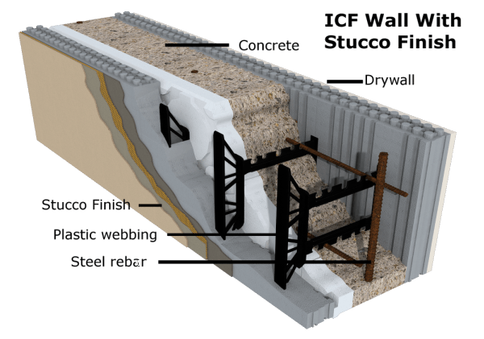
Sustainable building techniques for the super school
Due to the super school aiming for a BREEAM listen building we will need to us three building techniques for the super school. These are:
- Waste based techniques
- Materials based techniques
- Energy based techniques
Waste based techniques involve cutting down the amount of waste the site creates while in use. We can cut down the amount of waste by recycling, making less mistakes and fabricating things offsite and transporting them, rather than producing them on site. I think this will considerably benefit the school because we can use the demolished site for the new super school, reuse the materials for landfill where necessary or produce aggregates that can be used in the project. For example, the rubble can be used as fill for the foundations etc. This technique is significantly effective because we use materials that weren’t going to be used to create a building with BREEAM standards. On top of this it also saves you money for the materials you’d have to buy and prevent them from going to landfill. For example, we can use bricks from a demolished site which can be crushed into brick chips which can then be used as a landscape material. Another example of materials that can be reused is concrete which can be turned into aggregate to raise the ground level of the school if necessary.
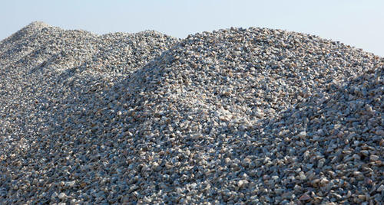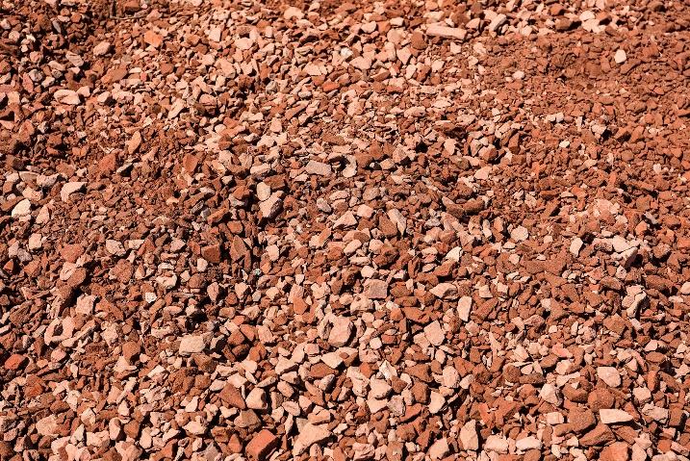
Energy based techniques involve us using newer technology to reduce the amount of fossil fuels that need to be used to power buildings. For example, only 25% of our power in the UK comes from renewable sources. This means we’re using a considerable amount of fossil fuels etc. to power our homes. When we burn fossil fuels it creates greenhouse gasses. If we have too many greenhouse gases in our atmosphere, then our o-zone layer can be damaged. So, we want to try and make the new super school as environmentally friendly as possible by using lots of newer technology such as solar panels and wind turbines to produce electricity for the school so that we’re not reliant on the national grid. Another benefit of producing our own electricity is that when there’s an incident of a power cut there will be stored energy that can be used to power the school. To fit these turbines and solar panels on the roof we have designed a large open space flat roof that can have loads of wind turbines or solar panels fitted to increase the energy supply of the school. We also did this to achieve a BREEAM listed school which is energy efficient, sustainable and environmentally friendly. On top, of this we might not be able to afford to power the school entirely on renewable energy, but if this is the case there will be plenty of room left so that it can be installed in the future if necessary. Due to the super school being located near the beach, wind turbines might be a feasible idea. The wind will often be blowing 24 hours a day and therefore, they will be producing power all the time.
Materials based techniques involve us using materials that are renewable and environmentally friendly. In Neath Abbey there’s Derwen aggregates that produce loads of different types of aggregate that can be used when constructing different buildings. These can be used for the foundations of the school or to build up the level if necessary. For example, the school is going to be built in Sandfields where the material tends to be soft. By putting aggregates etc. in to the ground it will make it sturdier and less likely to move once constructed. Also, if these materials weren’t turned into aggregates they would simply be thrown into landfill which is bad for the environment and the fact that it can be used for something else is great. We could use other materials for the foundations, however, these aggregates are very cheap, effective and are environmentally friendly because we’re recycling a product for a different use.
Sustainable building techniques for Caretakers accommodation
There are two main techniques that can be used in both the super school and the caretakers house. The techniques are:
- Waste based techniques
- Energy based techniques
Waste based techniques involve us reducing the amount of waste produced by the building over its lifetime. I have chosen to reduce the amount of waste created as low as reasonably practicable and feasible. To reduce the amount of food waste that is taken away by the council such as tea bags, etc. we could install a compost bin in the garden which can be used to dispose of any food waste. This can then be used later if necessary in the garden. By doing this we reduce the amount of waste that goes to landfill and use it for something beneficial. We also, reduce the amount of waste when the building is being constructed. We do this by ordering the required amount of materials and by doing this we ensure that we don’t waste unnecessary material. We can also educate the labourers to try and reduce the amount of waste created throughout the site. This can be done by showing them how to work efficiently and teaching them to be more accurate, therefore, reducing the number of mistakes. Furthermore, if we do end up ordering too much material it can be used on other sites to reduce the amount of waste going in to landfill.
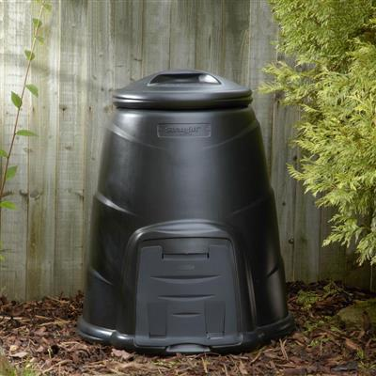
Energy based techniques involve using techniques that will reduce the amount of energy required to power a building. Due to the care takers accommodation being relatively small we have chosen to fit energy saving lightbulbs and fit double-glazing windows to reduce the amount of energy need to power the house. The lightbulbs require less energy compared to a standard lightbulb but still transfer the same amount of light. This reduces the cost of electricity used around the house. This saves us money and makes the house more energy efficient. With the double-glazing windows it means that the boiler won’t be required as often due to the heat escaping at a slower rate. Furthermore, the cold air outside will take longer to cool the house down. This saves you money too, while also improving the energy efficiency of the building.
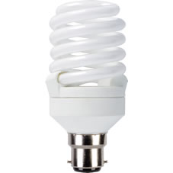
Pictures Reference List
Picture | Taken From
Floors | http://www.diynetwork.com/how-to/rooms-and-spaces/floors/all-about-joist-and-concrete-floor-structures
Walls | http://slideplayer.com/slide/5783588/
Roofs | http://quality-wp.com/super-structure-membarane-system/
Stairs | https://www.slideshare.net/thienhee9/04-superstructure
Windows | http://nandc-construction.com/windows-doors/
Doors | https://www.slideshare.net/kuntansourav/a-powerpoint-presentation-on-superstructure
Excavator | http://www.hyundai.eu/products/construction-equipment/crawler-excavators/hx140-l-crawler-excavator
Dumper | https://en.wikipedia.org/wiki/Dumper
Telescopic Forklift | http://www.forklift-training.com/telescopic-handler-training/
Cement Mixer/Concrete Lorry | https://de.wikipedia.org/wiki/Datei:Mercedes-Benz_Axor_based_cement_mixer_truck.JPG
Scaffolding | https://www.generationscaffolding.com/en-gb/scaffolding-products/
Toe Boards | https://www.uprightaluminumscaffolds.com/listing/6-feet-double-wide-aluminum-scaffolding-toeboard/
Plaster and Paint finish | https://www.smetbuildingproducts.com/products/renders/final-top-coats/siliconesilicate-plaster-1-5mm-or-2-0mm-2/
Cladding | https://valcan.co.uk/information/
Plasterboard | https://www.ebay.co.uk/itm/Plasterboard-Standard-Sheets-9-5mm-12-5mm-15mm-All-Sizes-Knauf-Wallboard-/122724254745
Timber Frame | https://www.blueoxtimberframes.com/virginia-timber-frame-homes/
Steel Frame | http://www.understandconstruction.com/steel-frame-structures.html
Bricks | http://mailbricks.com/product/box-of-bricks-5/
Porotherm | https://www.indiamart.com/proddetail/porotherm-blocks-16762815291.html
Concrete Block | https://www.travisperkins.co.uk/Product/Building-Materials/Bricks+Blocks/Common+Concrete-Bricks/c/1502019
Mortar | http://www.constructionphotography.com/Details.aspx?ID=13706&TypeID=1
Pre-Fabricated House | https://inhabitat.com/tag/prefabricated-housing/
Pre-Fabricated Office | https://www.havitsteelstructure.com/container-office-buildings.html
ICF Construction | http://cpeky.com/our-services/icf-construction/
ICF Blocks | https://www.alibaba.com/product-detail/EPS-concrete-form-block-machine-ICF_1139925613.html
Double Glazed Windows | https://www.bradnams.com.au/smart-solutions/energy-efficiency/double-glazed
Triple Glazed Windows | http://www.yorktradewindows.co.uk/triple_glazed.htm
Slate Roof | http://www.theslatecompany.co.uk/shop/welsh-penrhyn-roofing-slate/
Solar Panel Slate Roof | http://www.aurorasolarenergy.com/solar-panel-installation-on-slate-roof/
Concrete Strip Foundation | https://www.diydoctor.org.uk/projects/strip-foundation.htm
Porotherm Method Example | http://beodom.com/en/education/entries/building-with-wienerberger-porotherm-visual-guide-part-1
ICF Method Example | http://davesworldtravel.com/icf-house/icf-homes-commercial-residential-builders-icf-house/
Aggregate | https://www.indiamart.com/proddetail/coarse-aggregate-11037737848.html
Brick Chips | https://palmettobrick.com/product/brick-chips/
Fossil Fuels | https://www.carbonbrief.org/study-most-fossil-fuels-unburnable-without-ccs
Small Scale Wind Turbines | https://www.which.co.uk/reviews/wind-turbines/article/installing-a-wind-turbine/home-wind-turbines
Compost Bin | https://getcomposting.com/profile/login
Energy Saving Lightbulb | http://www.wilko.com/energy-saving-bulbs/wilko-energy-saving-bulb-cfl-spiral-bc-23w-1pk/invt/0434241

Reference List
Fox, J. (08/03/12). Superstructure Design. [Online] Available at:
https://www.slideshare.net/iltatcnwl/superstructure-design [16/05/18]
Owen, J. n.d. Pros & Cons of Timber Frame Buildings. [Online] Available at:
http://www.constructionchat.co.uk/articles/timber-frame-buildings/ [16/05/18]
N/A. n.d. Benefits ICF Advantages of ICFs. [Online] Available at:
http://www.forms.org/index.cfm/Benefits [16/05/18]
White, G. (26/10/17). The Advantages & Disadvantages Of Steel Frame Construction. [Online] Available at:
https://blog.glwengineering.co.uk/the-advantages-disadvantages-of-steel-frame-construction [16/05/18]
N/A. n.d. Why Choose Insulating Concrete Forms (ICFs)? [Online] Available at:
http://buildblock.com/icfs/ [16/05/18]
Josephson, A. (28/01/16). The Pros and Cons of Prefab Homes. [Online] Available at:
https://smartasset.com/mortgage/the-pros-and-cons-of-prefab-homes [16/05/18]
Joseph, C. n.d. Prefab Housing Disadvantages. [Online] Available at:
https://budgeting.thenest.com/prefab-housing-disadvantages-24540.html [16/05/18]
Sidler, S. (02/01/12). 5 Worst Mistakes of Historic Homeowners. [Online] Available at:
https://thecraftsmanblog.com/5-worst-mistakes-of-historic-homeowners-part-4-plaster/ [16/05/18]
Team WFM. (03/01/18). Advantages and Disadvantages of uPVC Doors and Windows. [Online] Available at:
https://www.wfm.co.in/upvc-doors-windows-advantages-and-disadvantages/ [16/05/18]
McFadden, D. n.d. Advantages and Disadvantages of a Timber Truss Roof. [Online] Available at:
https://www.hunker.com/12613319/advantages-and-disadvantages-of-a-timber-truss-roof [16/05/18]
TMFacades. (30/11/11). 03 Wienerberger Final. [Online] Available at:
https://www.youtube.com/watch?v=UhcPErwsf20 [16/05/18]
PorothermUK. (05/09/14). Porotherm and Sustainability. [Online] Available at:
http://porothermuk.co.uk/2014/09/05/porotherm-and-sustainability/ [16/05/18]
N/A. (17/05/18). Benefits of ICF. [Online] Available at:
http://www.eoicf.com/index.php/icf-walls#W2 [17/05/18]
N/A. n.d. Why Recycle? [Online] Available at:
http://businessrecycling.com.au/recycle/bricks [17/05/18]
N/A. (12/05/18). Renewable energy in the United Kingdom. [Online] Available at:
https://en.wikipedia.org/wiki/Renewable_energy_in_the_United_Kingdom [17/05/18]

