[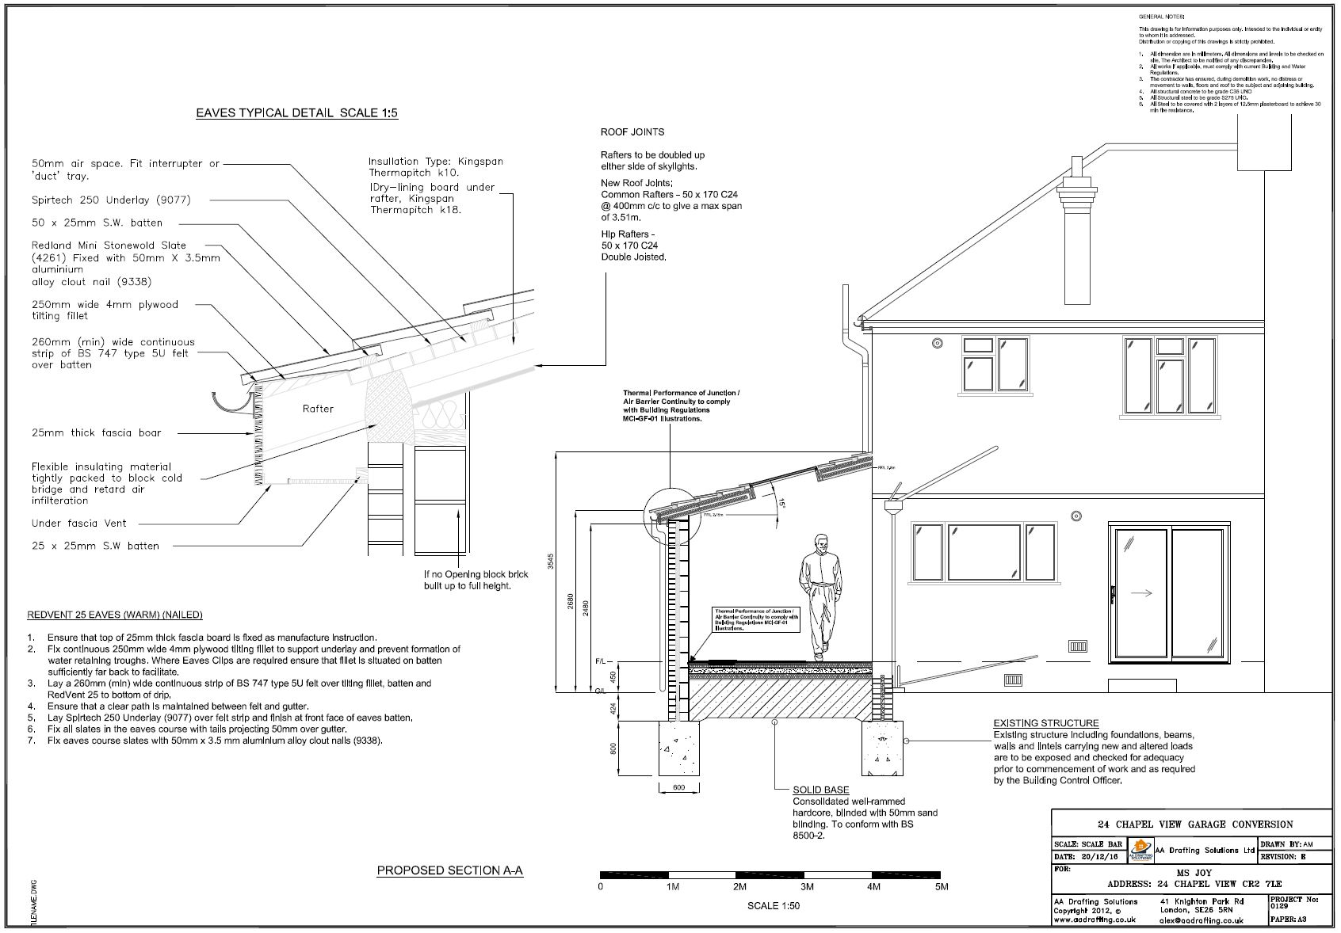](http://www.google.co.uk/url?sa=i&rct=j&q=&esrc=s&source=images&cd=&cad=rja&uact=8&ved=2ahUKEwi-nrv_8MfhAhWhx4UKHYOLCOYQjRx6BAgBEAU&url=http://www.aadrafting.co.uk/building-control/4576200426&psig=AOvVaw2t0ylbXCcBo825AKxoDL3Z&ust=1555066662078219)

[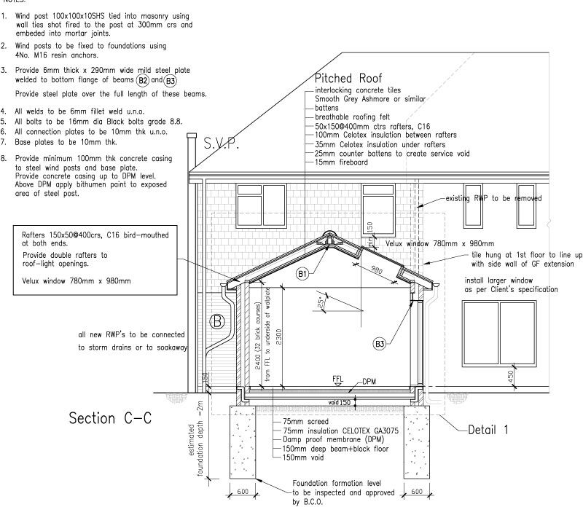](https://www.google.co.uk/url?sa=i&rct=j&q=&esrc=s&source=images&cd=&cad=rja&uact=8&ved=2ahUKEwi-nrv_8MfhAhWhx4UKHYOLCOYQjRx6BAgBEAU&url=https://www.carmichaelbuildingdesign.co.uk/21-web-drawing-4/&psig=AOvVaw2t0ylbXCcBo825AKxoDL3Z&ust=1555066662078219)