Project Management and Research Methods

An Investigation into Digital Literacy Blended Teaching Tools in Further Education

Supervised by: Jeanette Adams
Date: 16/10/2018

Contents
1. Statement of the Problem 2
1.1. Introduction 2
1.2. What is Digital Literacy? 2
1.2.1. What is Digital Responsibility? 3
1.2.2. What is Digital Learning? 3
1.3. Digital Literacy in Further Education 3
1.4. Teaching Methods and Learning Styles 4
1.5. Current Tools & Technologies Available 4
1.5.1. Web-based Blended learning application – Moodle 4
1.5.2. Mobile Blended Learning Application – Theory Test Pro 5
1.5.3. Desktop Blended Learning Application – Blackboard Learn 5
2. Conclusion 6
3. Aims and Objectives 6
3.1 Aims 6
3.2 Objectives 6
4. Research Methodology 6
4.1 Philosophy 6
4.2 Approach 7
4.3 Strategy 7
4.4 Time Horizon 7
4.5 Data Collection Method 7
5. Resources 7
6.1 Hardware 7
6.2 Software 7
6. Project Plan 7
8. Bibliography 8
9. Ethics Form 9

Statement of the Problem

Introduction
This research proposal consists of the various topics and sub-topics surrounding digital literacy and more importantly how it is applied to the blended learning aspect. An analysis below will present the different areas that need to be understood and discussed in order to move forward with this project. The types of topics that will be covered below will be focusing around the security of the students and any data that may be stored about them as well as how the student should behave when in a blended learning environment and as well as how blended learning compares to more traditional teaching methods and what are the readily available technologies and applications that are out there for students currently.

What is Digital Literacy?
The name digital literacy can be misleading when taking the words at face value as it does not explain the entire definition behind the words themselves. One definition that aids in the explaining of what digital literacy truly is, comes from Paul Gilster, saying, “«the ability to understand and use information in multiple formats from a wide variety of sources when it is presented via computers» and, particularly, through the medium of the Internet” [1] this definition covers the main basis of why digital literacy has evolved into much more than just reading and writing, especially when combined with the online element where individuals are required to take into account far more than just the original definition.
The UK Development Economics quite simply defines digital literacy into three categories that round up digital literacy into three different that those users are ranked when using forms of digital media, which are:
- “Advanced Digital Skills” [3] – This entails the more breakthrough technology that could be used amongst students, such as coding and the development of new software whilst dealing with conveying these projects in a professional manner in the form of presentations.
- “Intermediate-level digital skills” [3] – Tends to focus more on the development within the applications made from the advanced digital skills individuals and will primarily be the focused skill group within this proposal.
- “Entry-level digital skills” [3] – Entails in the management of data from various sources that involves capturing and transforming data that is collected.
Digital literacy within further education is made up of six strands which are:
- Digital Responsibility
- Digital Productivity
- Digital Information Literacy
- Digital Collaboration
- Digital Creativity
- Digital Learning
From these fundamental within this research, the proposal that stands will be analysed further in this particular part of the project proposal are responsibility and learning, this is to cover some initial points where students responsibilities in further education they would have to uphold as well as the type of information they would need to know and learn in order to use the technology effectively and appropriately.

What is Digital Responsibility?
Digital responsibility is important as it is the users’ job to gain an understanding of the issues that may occur from learning in an online environment and the type of precautions that are necessary to take in order to mitigate those issues. An organisation by the name ISTE (International Society for Technology in Education) has a standards page towards how students should use technology responsibly, one such standard is listed, and “Students manage their personal data to maintain digital privacy and security and are aware of data-collection technology used to track their navigation online.”[2] These standards set in place by the ISTE to ensure that students understand the consequences that can occur if the standards are not followed and therefore are informed and educated on what websites are safe to use and input their personal data to without running the risk of the data being used in a malicious manner, the same can be applied back to digital literacy when learning from unauthorised technologies and websites.

What is Digital Learning?
Digital learning is interchangeable to the established blended learning that as Curtis J describes as, “these two learning environments have remained largely separate” [4] this is important as it is essential that students are still having the same support and information available to them between the more traditional ways of teaching face-to-face when compared to the digital blended learning counterpart. A study carried out from 1990-2002 found from 86 studies that students found themselves in a similar position through learning and understanding from a digital environment and when compared to face-to-face learning Shachar and Neumann had found that, “an effect size for student achievement of +0.37, which, if it holds up belies the general impression given by other studies that DE and classroom instruction are relatively equal.”[5] There are multiple studies that correlate with this one in particular and the majority show little change in student performance which in turns makes this proposal a feasible option in the first place as there will be no negative impact on students overall performance in online blended learning and digital exams.

Digital Literacy in Further Education
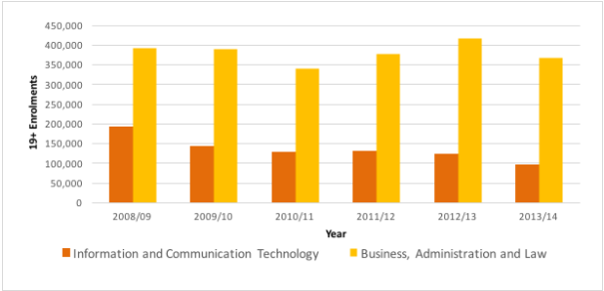
Now that the two most important sub-topics have been discussed and analysed in this research proposal it is important to understand digital literacy means for students in further education and what is currently available out there in practice for students specifically in the UK. From research conducted in 2016 by Diana Laurillard, Jay Derrick and Martin Doel, they found an overall downward trend on students aged 19+ not choosing ICT which in turn is causing an overall lacking of competent digital literacy skilled workers in the work place for future work placements that are necessary in the commercial sector in the UK. [6]
FELTAG (Further Education Learning Technology Action Group) also understands that improvements are required in the digital learning area with regards to teachers; they are currently undergoing improvements to improving FE digital learning such as hiring more teachers that are specialised in being able to innovate and develop courses that are online for students as well as increasing the overall standard of work that should be result to these improvements [10]. This shows that there is lots of room for improvement with the applications that are used to teach and learn from as well as just the teaching side.

Teaching Methods and Learning Styles
Understanding the various teaching and learning methods that are available between the teacher and students is necessary to be able to understand where using digital blended learning over other conventional teaching and learning methods can excel teaching capabilities and the students understanding of a subject at matter. Richard Mayer explains that through the use of multimedia learning which is a similar approach to blended learning he found that students and employees were able to retain their memory of words accompanied by imagery/videos than just words alone [7] This reinforces one of the fundamentals aspects of digital blended learning where imagery will be a key point that will be present for further educations students to be able to pick up upon, understand and be able to take in more information.
A survey research that was carried out by Rita Dunn on the types of learning styles showcased one particular learning style that will benefit potential future users of digital blended learning applications which is known as time-of-day preferences this method of learning allowed learners the ability to be able to book with educators if needed their own personal preference time slot that they felt they were able to achieve the most out of their blended learning sessions [8]. The result of this research showed that the overall attitude and behaviour of the students improved when compared to the same students that had to attend classes that was outside their optimal time of learning, with this method implemented into a digital application that can book specific slots for leaning this can lead to a better quality of information retention and overall quality of work improvement.

Current Tools & Technologies Available
There are various applications available for blended learning and is becoming more prolific within education there are various ways in which an application can be developed to cater its audience. The three main application examples below are based on their running platform, so there will be analysis on a; web application, desktop application and mobile application.

Web-based Blended learning application – Moodle
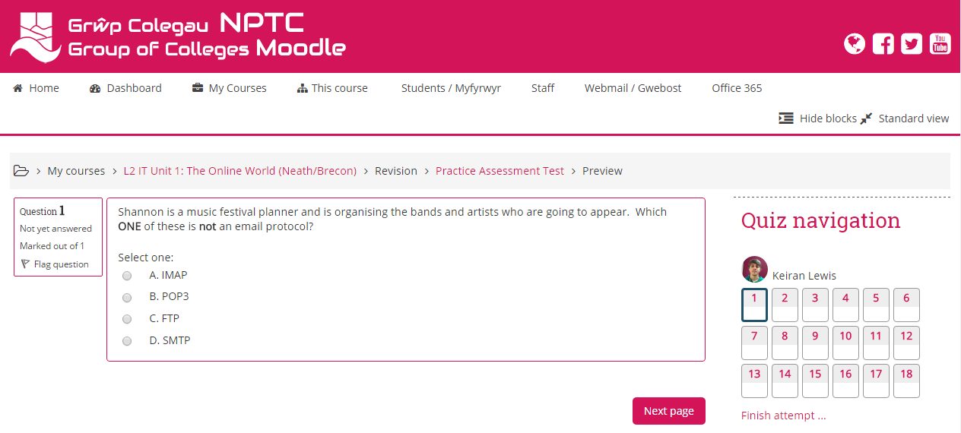
A current web tool available for is the website Moodle and with the example to the right shows a simple interface with multiple choice questions that the student has to select from. The most important strength that IBM has listed them in a business environment was when they were training colleagues they removed the multiple-choice assessments to an online-blended learning application which, “allowed the training department to automate scoring and made it easier to track and report scores.” [9] However, this application requires a teacher to mark any of the questions manually that involve a written answer that is more subjective instead of being an automated method of marking.

Mobile Blended Learning Application – Theory Test Pro
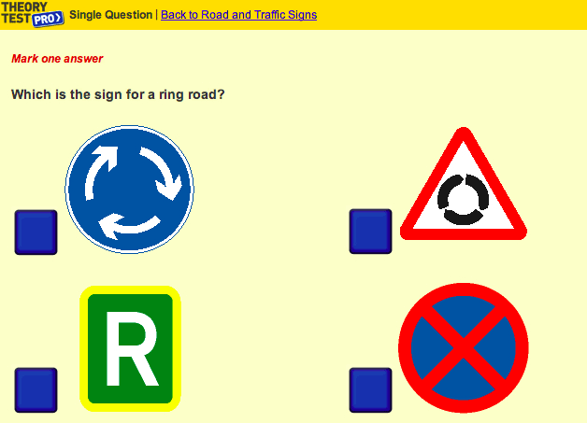
A theory tests mobile application that involves the student with in-depth knowledge on the various subjects of driving including the ability to run mock tests of a theory exam with one such example being another multiple choice question. Other media is available on the application such as the hazard perception test which involves much more complex level of being able to record and store the results accurately for the student. This type of blended learning can open up many more ways as Bryan Alexander suggests that students would have the ability take “digital photographs of plants, editing and annotating the images, and uploading them to a campus forum” [11] this additional media can allow for far more interaction between learner and teacher when compared to traditional teaching methods of face-to-face teaching.

Desktop Blended Learning Application – Blackboard Learn
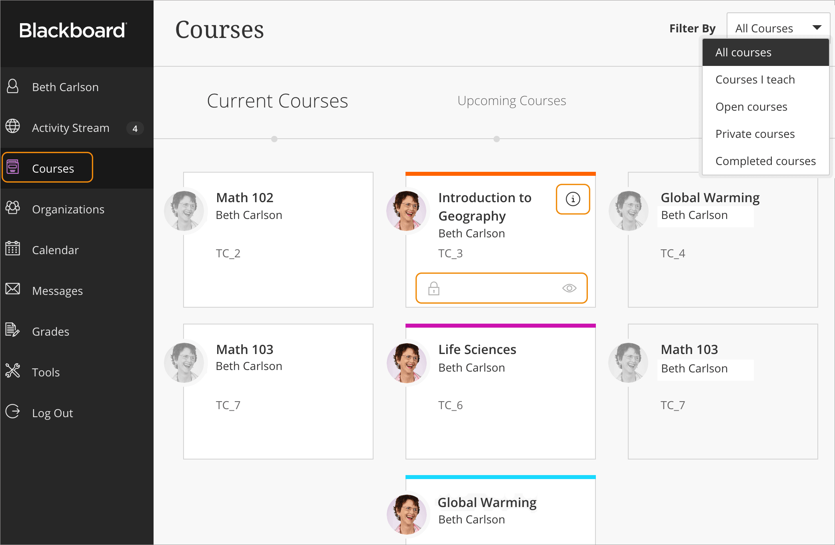
The final application available for Desktops is Blackboard and in particular Blackboard Learn where it is desktop focused application similar to that of Moodle where it allows students and teachers to interact within courses that are readily available and easy to setup. Desktop goes a bit further with have a more intrusive program allows for far more complex learning courses as it has more access to media use and data. The University of South Wales has stated that, “Blackboard is the primary virtual learning environment (VLE) used here at the University of South Wales.” [12] This further encourages the overall ability of the program where it ensures that students have the appropriate information and resources from a desktop application such as Blackboard Learn where they will the most optimal learning experience.

Conclusion
In summary digital literacy is a constantly evolving subject in the world of education that not only has the front of educating students in further education in a different that may improve overall knowledge of subjects when compared to more traditional methods of teaching but to ensure that the appropriate measures and policies are taken into consideration during the development of the application that students are protected from any malicious acts that may occur and that they also have a duty to use the application appropriately and efficiently.
To conclude from the previous sub-topics, the chosen technology for this research proposal will be in the form of a desktop application due to limitations with the use of the language in which the project would be developed upon. Using a desktop application and basing it off of a platform such as Blackboard Learn will give the end user much more variety on the type of media that will allow more than just multiple choice questions. The unique selling point that will come with the proposed program would be to be able to verify and correctly mark subjective data that is answered on the application, where written work would be compared to a model answer that is already stored away in the application and will look for relevancy in the words used, sentence structure, etc.

Aims and Objectives

Aims
Having identified the outlying problem that is concurrent from the research that has been presented among the various technologies/applications available and the literature review above gives the clear aim of; investigating into digital literacy blended learning tools into further education and whether there is a gap in the subject area to be filled and improved upon when compared to the current applications and their respective technologies research above.

Objectives
This overall aim will be met by a set of objectives that need to be met in order, which are:
- Conduct an initial literature review to gain an understanding of the topic area and make justified analysis on the certain sub-topics researched.
- Development of application based on initial research along with a more in-depth approach report to conduct on the side
- Future improvements through feedback on the build application and reporting to suggest in future iterations of the application.

Research Methodology
Choosing the appropriate research methodologies is important to ensure that research that has been conducted and needs to match the outcome that is expected and wanted from the final application that is built eventually along with an evaluation of how it was developed.

Philosophy
Phenomenology will be used as “It seeks to understand how people experience a particular situation or phenomenon.” [13] As this supports the way in which this research proposal was conducted from past experiences from other individuals and analysing their findings.

Approach
A deductive approach has been applied throughout this research proposal and will continue to be used to in order to gain an understanding and build an application that mimics current applications but tackles the issues that they possess also.

Strategy
Case Study is the strategy of choice as again it has been used throughout this initial research proposal and draws upon focusing “on an in-depth investigation of a single case (e.g. one organisation) or a small number of cases” [14] which is very useful research strategy when there are a lot of practical and real examples of case studies to choose from within this research proposal.

Time Horizon
The time horizon will be longitudinal due to the prototyping along with the combined development method being time boxing as it allows for change to be monitored over the duration period of this project. Any issues that occur from the iterations can be altered or added to at a later date of development.

Data Collection Method
The data collected will be through both qualitative and quantitative secondary data which is from the various sources researched above and will require thorough analysis of the above secondary data along with case study to gain an understanding of how the application is going to develop.

Resources

Hardware
The system that was will be used to develop the application initially is sufficient enough to be able to run the application once it has been developed, the hardware used is:
- Processor – i5 6700 Quad Core (3.2GHz)
- Graphics Card – GTX 1060 6GB
- Storage – 2TB Hard Drive
- 8GB RAM

Software
Windows 10 – Operating system required in order using application once developed
Visual Studio – IDE program that allows for development of the application
Microsoft Access – Build and store the necessary data in the application

Project Plan
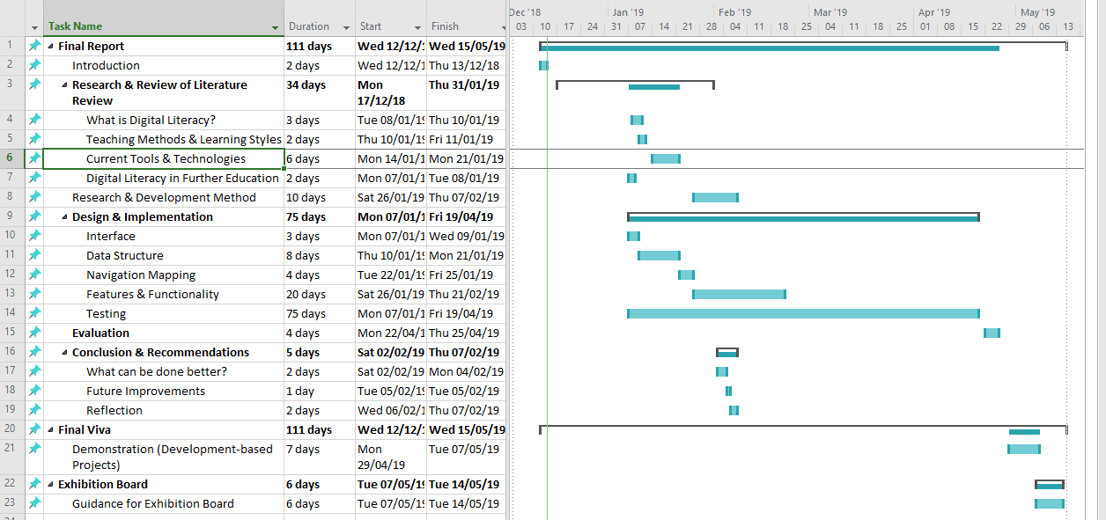
A project plan has been implemented amongst the research proposal which will be updated and followed to ensure that tasks are completed on time. There have been downtimes allocated to dates leading into New Years due the holidays as well as extra allocation of days to all of the sub-tasks in the occurrence that time problems become an issue.

8. Bibliography
1. Gilster P. Digital Literacy. New York, USA: John Wiley & Sons, Inc; 1997. Page 6
2. ISTE. ISTE STANDARDS FOR STUDENTS. https://www.iste.org/standards/for-students (accessed 26 November 2018).
3. Ecorys UK. DIGITAL SKILLS for the UK ECONOMY. https://assets.publishing.service.gov.uk/government/uploads/system/uploads/attachment_data/file/492889/DCMSDigitalSkillsReportJan2016.pdf (accessed 6 December 2018).4. J Curtis. The Handbook of Blended Learning: Global Perspectives, Local Designs. San Francisco, USA: John Wiley & Sons, Inc; 2006. Page 3
5. Schachar, Neumann. How Does Distance Education Compare to Classroom Instruction? A Meta-Analysis of the Empirical Literature. Baton Rouge, LA, U.S.A.: Louisiana State University; 2004. Page 8
6. DfE-SFA FE Trends. FE Choices learner satisfaction survey 2016. https://www.gov.uk/government/statistical-data-sets/fe-data-library-other-statistics-and-research%23fe-trends (accessed 27 November 2018).
- Mayer R. Applying the Science of Learning: EvidenceBased Principles for the Design of Multimedia Instruction. Santa Barbara, California, USA: University of California; 2008.
- Dunn R. What We Know About How People Learn. California Journal of Science Education 2002; 2(2):. http://marric.us/files/CSTA_learnjournal.pdf#page=76 (accessed 3 December 2018).
- Driscoll B. Blended Learning: Let's Get Beyond the Hype. E-Learning (E Learn) 2002; 1(1): 2.
- FELTAG. Paths forward to a digital future for Further Education and Skills, 2nd ed. UK: Prospective Technological Studies; 2014. – Page 15
- A Bryan. Going nomadic: mobile learning in higher education. Washington, USA: University of Washington; 2006. – Page 62
- USW. Modules in the Blackboard VLE. http://teach.southwales.ac.uk/blackboard/ (accessed 7 September 2018).
- CIRT. Phenomenology Research Overview. https://cirt.gcu.edu/research/developmentresources/research_ready/phenomenology/phen_overview (accessed 14 December 2018).
- OpenLearn. Research strategy. https://www.open.edu/openlearn/money-management/understanding-different-research-perspectives/content-section-6# (accessed 14 December 2018).
15. Jalote P, Palit A. Timeboxing: a process model for iterative software development. Journal of Systems and Software 2004; 70(2): Page 117-127

9. Ethics Form
An ethics form has been enclosed in the zipped file supplied.

