WEST (WALES ESSENTIAL SKILLS TOOLKIT) SCREENING GUIDE
Login Details
Student Username: Student ID
Student Password: Student D.O.B- format is DD/FEB/YYYY
All students will need to complete 3 assessments (Communication, Numeracy, Digital Literacy)
Headphones will be needed for the Communication part (please contact Natalie Joseph or a Study Skills Coach, alternatively please ask students to bring their own)

- Go to the main NPTC Group Moodle page for the WEST Link.

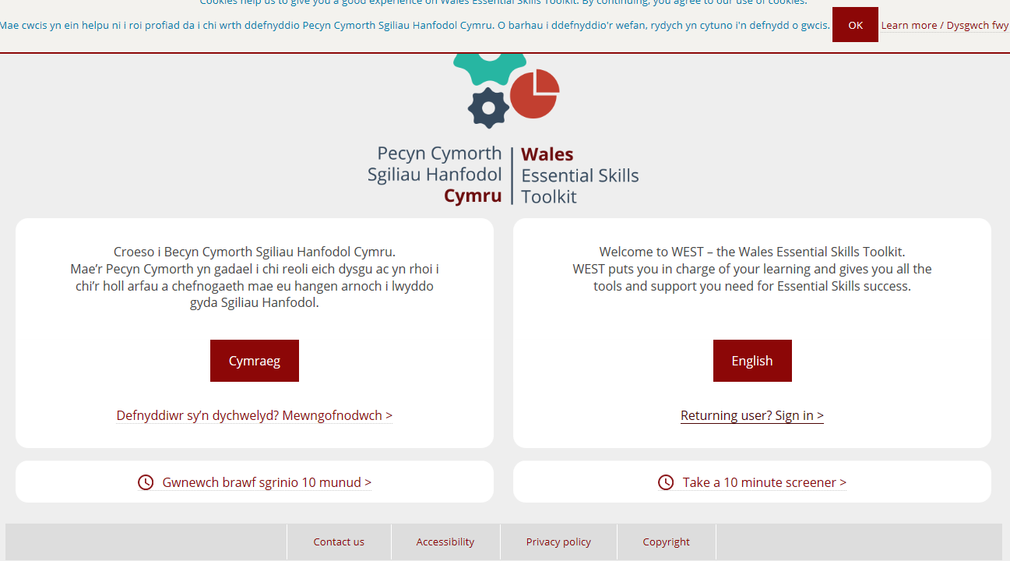
Click on ‘Returning User’

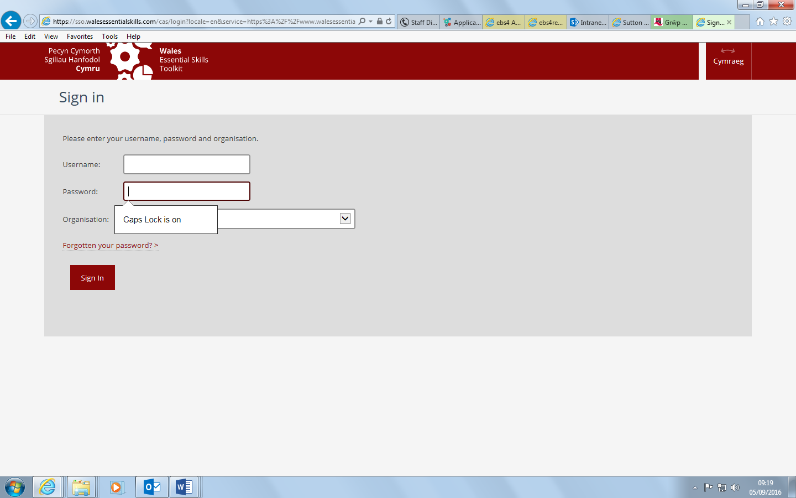
Complete student info- see above.
Select NPTC Group from organisation drop down bar.
Sign in.

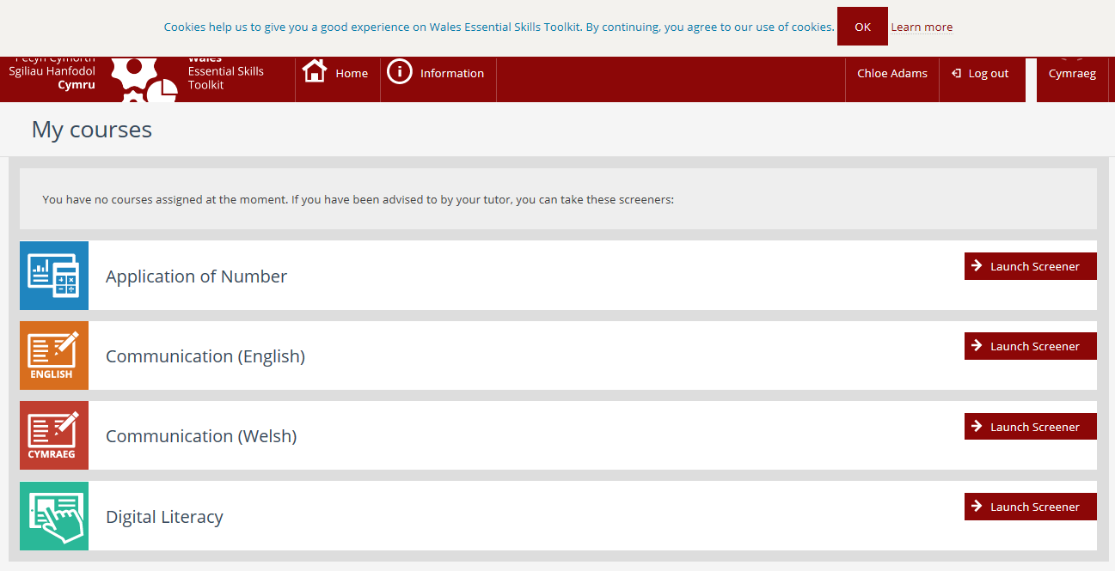
Launch Screener.
The assessment will save if not completed.
Once completed an ILP and a level will be shown.

More detailed information can be found in the handout: WEST Tutor ‘Quick Start’ Guide, which can be found on SharePoint under- Functional-Student Support-Skills check.

Information on Tutor Login:
Tutor Username- Staff login (josenat)
Password- staff ID number (some will have an N at the beginning)

Please contact Natalie Joseph (Essential Skills Co-ordinator) for further information- 01639 648074.

