**Supermarket self-service checkout**

Label the diagram to identify the ways the inputs and outputs are used:

[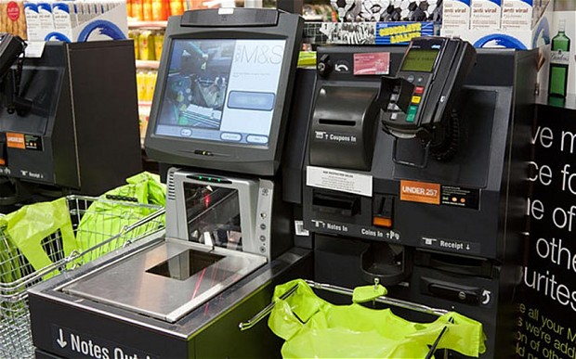](http://www.google.co.uk/url?sa=i&rct=j&q=&esrc=s&source=images&cd=&cad=rja&uact=8&ved=0ahUKEwic49vgptvKAhVLnRoKHV-iCTgQjRwIBw&url=http%3A%2F%2Fwww.telegraph.co.uk%2Fnews%2Fshopping-and-consumer-news%2F11925193%2FShoppers-leave-2.5m-at-supermarket-self-service-tills-each-year.html&psig=AFQjCNGAUZ_dhvCsP3lG8M1vw_DvvfyHcg&ust=1454578868142413)