



Retired Onscreen Test Version 2 Unit 2: Technology Systems

BTEC Firsts Level 1/2 Information and Creative Technology

This retired onscreen test has been made available to centres to help you prepare your learners for their BTEC Firsts Level 1/2 external assessments.

We recommend that you use this test as a written assessment which is then either teacher marked or peer assessed.

This retired test should be used in conjunction with the Mark Scheme and the Lead Examiner’s Report to clearly identify the assessment requirements. These documents are available at:

<http://www.edexcel.com/quals/firsts2012/information-and-> creative-technology/Pages/default.aspx

We are currently working towards a simulation test where mock onscreen tests can be taken in a real environment.

However as this is being developed, we have temporarily created these PowerPoint based tests to support you.

# How can I view the videos in the test?

This document has been produced using screen captures of the retired onscreen test. As such, videos are not available in this PowerPoint document. This document should be used in conjunction with the retired onscreen test which is available on the website: <http://www.edexcel.com/quals/firsts2012/information-> and-creative-technology/Pages/default.aspx

# How can I see the drop down menus in the test?

Where a drop down menu may obscure information the learner requires to answer a question, we have instead supplied a text box containing the options from the drop down menu. To view drop down menus please use the retired onscreen test.

🗸

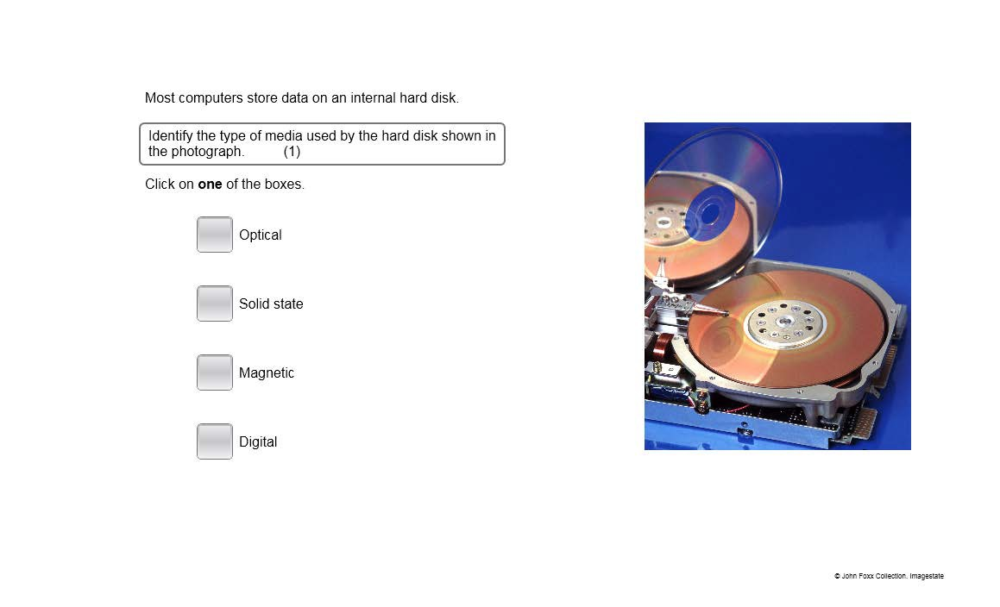

🗸

🗸

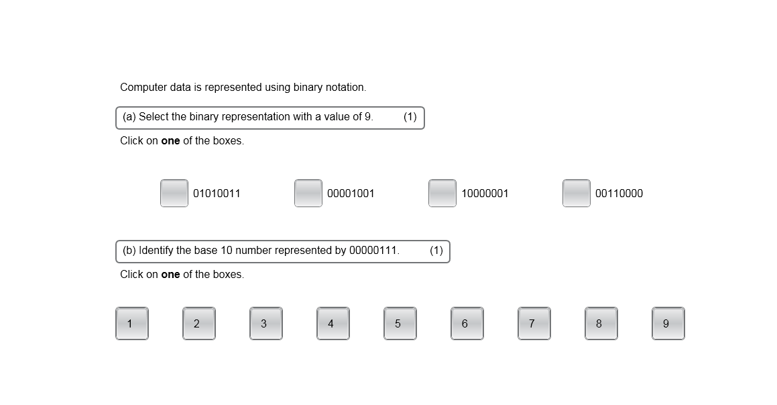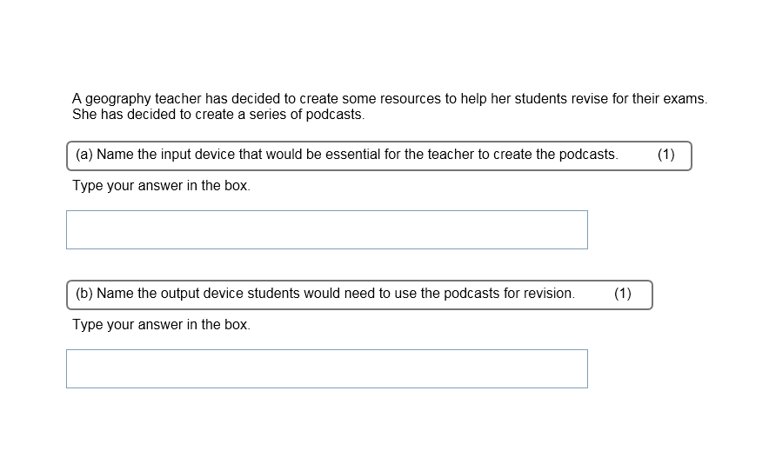

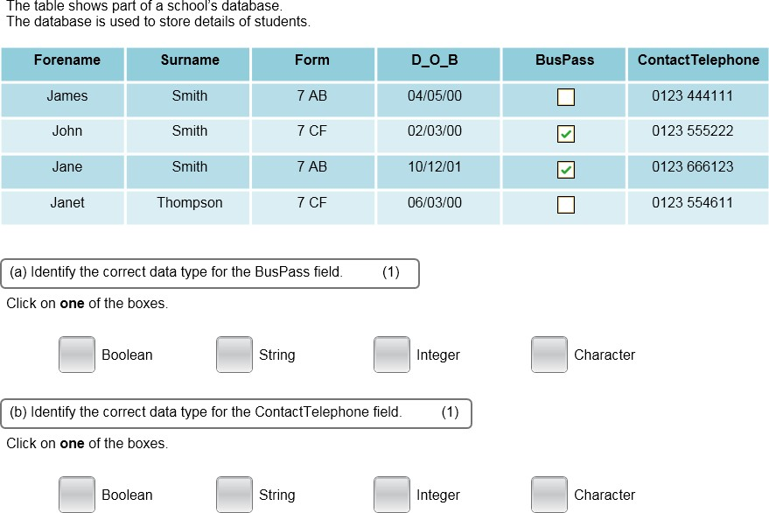

🗸

🗸

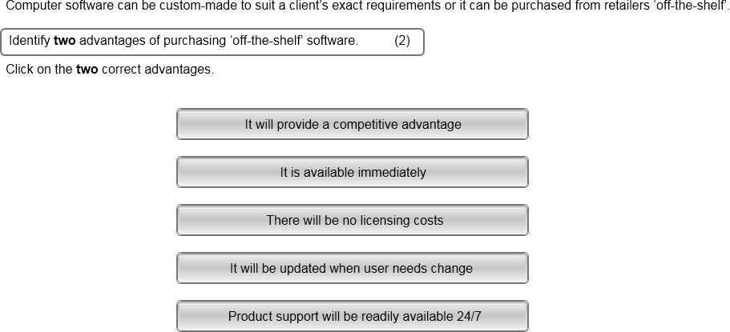

🗸

🗸

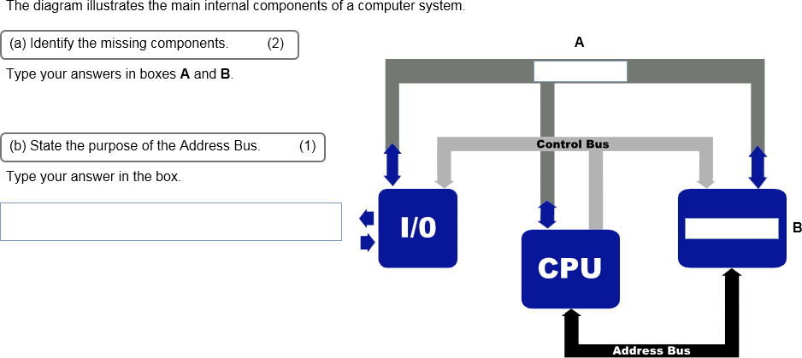

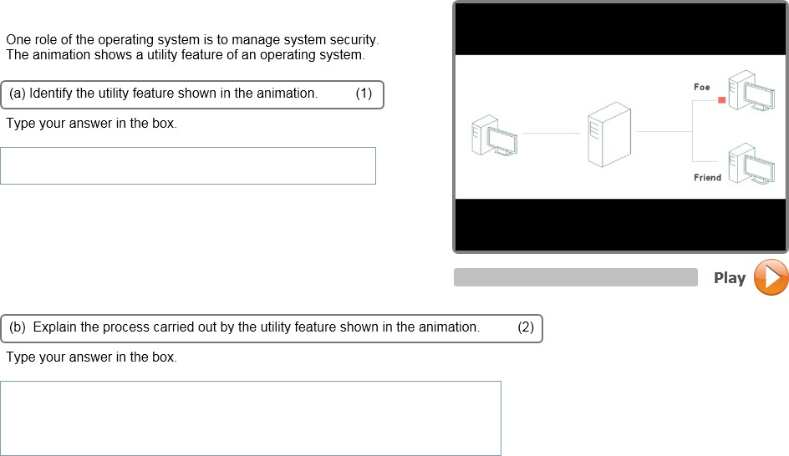

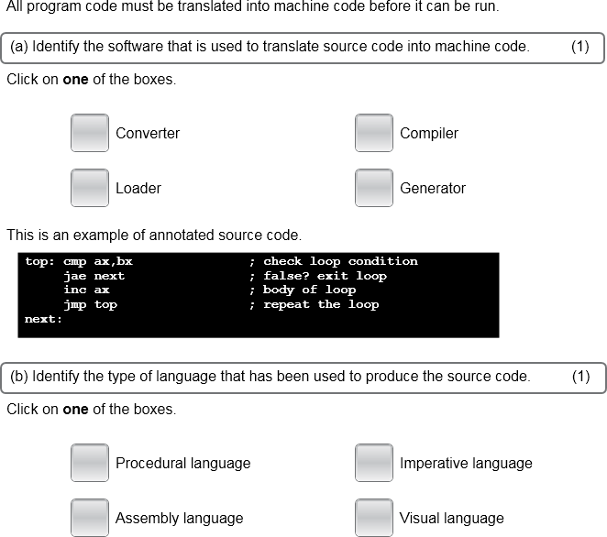

🗸

🗸

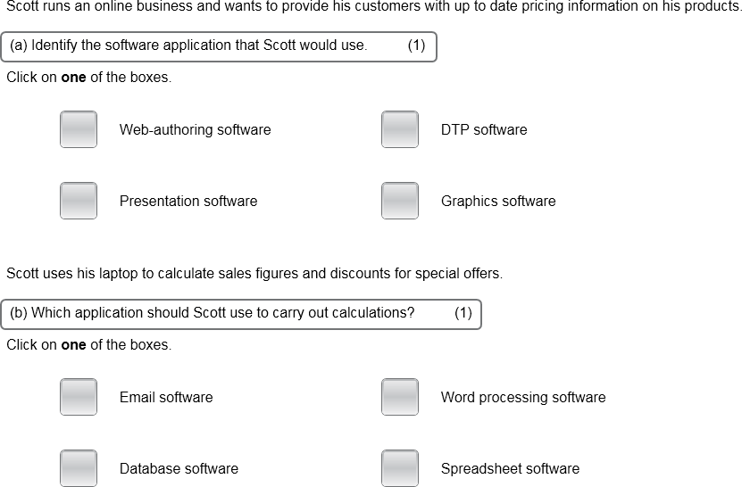

🗸

🗸

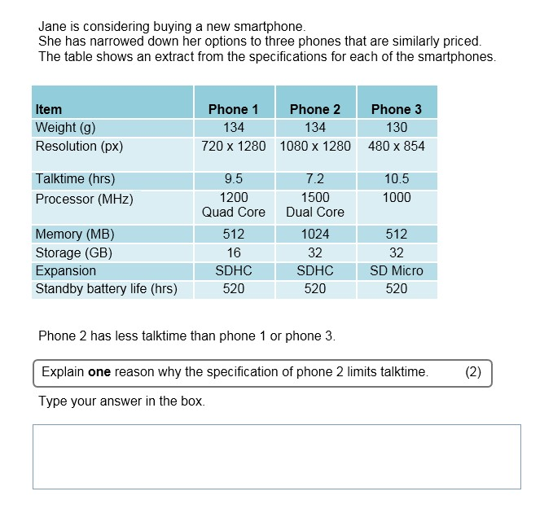

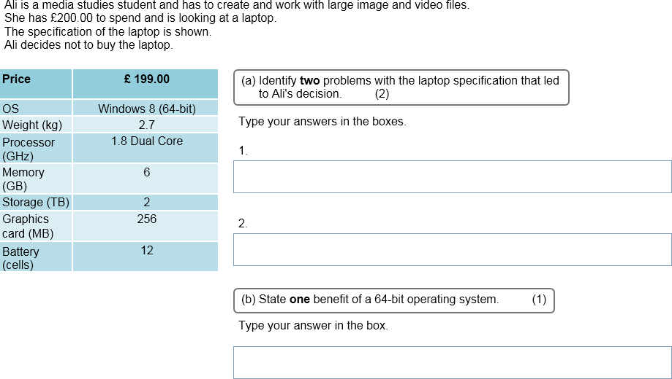

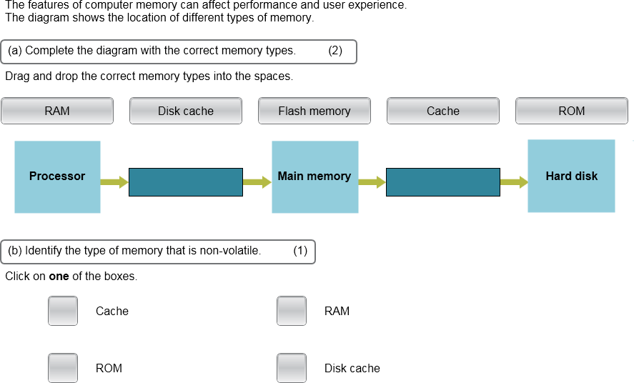

🗸

Fill in the gaps with the correct term.





