Adjusting Front Tracking Using College Equipment

Stages of the task
- Drive vehicle onto ramp, and stop with front wheels on the turning plates

- Check and adjust tyre pressures

- Fit the 4 laser pods onto each wheel in an upright position

- Input the vehicle details into the computer to select the correct make and model for the task

- Calibrate the vehicle with the computer, follow on screen instructions e.g. push the vehicle back and forwards listening for the buzzer when ok.

- Centralise the steering wheel and use tool supplied to lock the steering wheel in place

- Bring the boom to meet the pods and select ok. The reading should show you the state of the overall geometry
- The screen will show a picture of the geometry with the readings in red illustrating the setting that is out of tolerance with the manufacturers recommended settings.
In this diagram it is showing that the N/S/F wheel is toeing out.

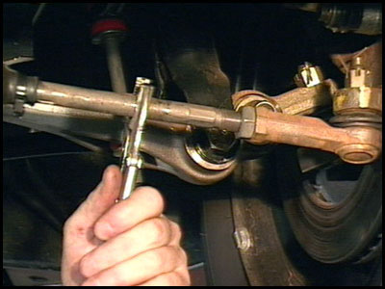
- To adjust the toe back to within manufacturers tolerance, you need to first slacken off the tie rod / track rod end locking nut.

- Once slack, you can now adjust the tie rod in or out of the track rod end depending on what your reading you require is. If in doubt move the tie rod and watch the white marker move towards or away from the green in tolerance reading you are aiming.

When both front wheels are green, the tracking has been adjusted to the manufacturer’s tolerance. Tighten up the locking nut, and the task is complete.
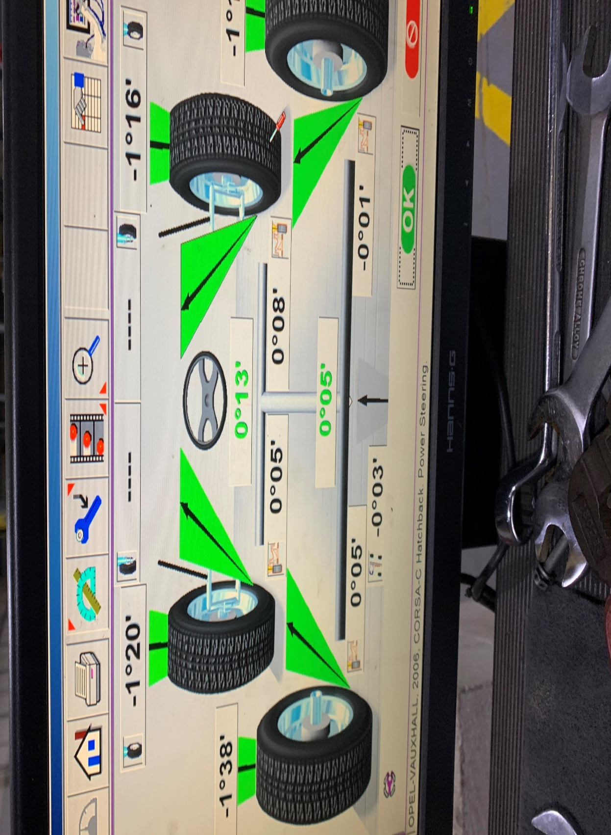
Front wheel alignment correct and set to manufacturers recommended specifications

