M1: Organisational chart explaining the group dynamics of team working.

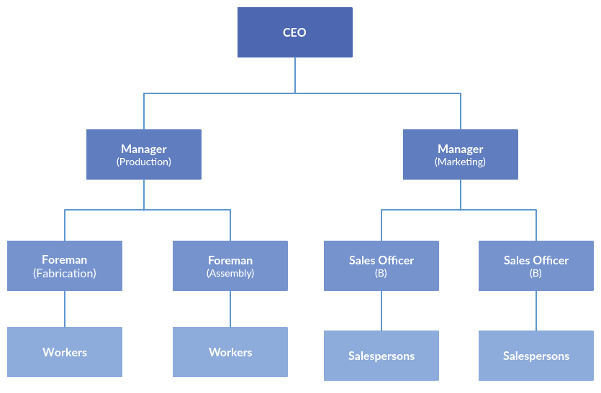

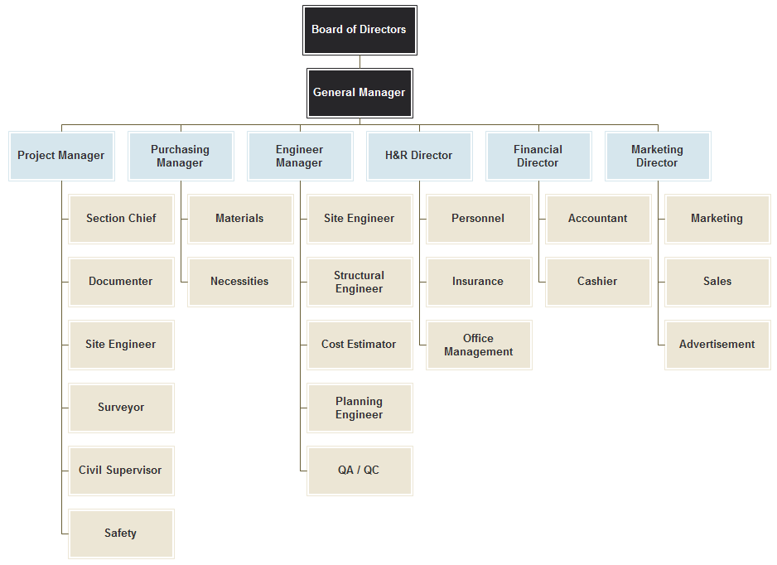
M2: The advantages and disadvantages of resource management techniques.

Here we will look at 4 different types of techniques that I am aware of:
Microsoft Project:
Microsoft Project is a programme used widely across the construction industry and many more industries to plan tasks, allocate resources and control budgets for ongoing and upcoming projects. The programme’s main positive point is the huge range of tasks that can be carried out using the software. Projects can be planned from start to finish, materials can be allocated and labour can be assigned to project to allow maximum productivity and success for the project. However, there is a downside to Microsoft Project, and that is the cost. The cost of the software ranges from £70 to £700 for Project Professional. This is fine for larger, national construction companies, but when it comes to smaller companies, it is a very expensive tool in terms of cost. This could cause a problem if there are several people needing to use the software. In addition to this, it isn’t just the upfront purchase cost that is an issue. Microsoft Project is a brilliant tool for construction which takes a substantial amount of training, if you are completely new to the software. In the busy construction environment, companies will find it difficult to allow time to train and become competent with using Project, especially if you are a smaller firm.
SAGE:
This is an accounting software package. Every invoice, timesheet or receipt will be inputted into the software and add to the job total, which can be obtained at the end of the project. The costs can also be explored while the project is active to see how much labour, plant and materials have been allocated. This software works well in partnership with Project as you can insert current costs, which will give you a proposed job cost total. By doing this, you can see if you are working to budget and what elements might be letting the project down, which means you can make changes to ensure that you come out with a profit instead of a loss. On the other hand, similar to Microsoft Project, the software, whether it be Sage or a similar product, often has a large upfront cost. Once again, this can be an issue for smaller companies as they may not have the revenue to fund this important software. As well as this, it only works well if it is set up right and if the figures inputted are accurate. If not, the software will come out with unrealistic figures and could provide a false outcome on a project. Once again, simple things like missing a zero or forgetting to input a purchase order could have a substantial financial effect on the project and on the business as a whole.

Timesheets:
Timesheets are far cheaper and easier to use. Timesheets are the most common way of logging hours and tracking labour for a project. They can be used for many different purposes, not just for getting paid at the end of the week. They can be used to track how long a job is taking, how many man hours have been taken in comparison to what was planned and assess driving time. They are the simplest form of labour tracking, and is the easiest to implement, as staff have to submit a timesheet to get paid. However, they do have their downsides. If your staff aren’t honest, they can claim more hours than what they have worked, which means it is costing the company money in terms of paying them more as well as making the job look slightly worse financially than what it should do. This scenario would only happen if you didn’t have trackers in the vans to check the hours. Another simple mistake could be putting down the wrong project on your timesheet. This would result in your hours being allocated to the wrong project, which would add an extra cost to the job.
Jobflex:
JobFLEX is an estimating and bid management app that delivers estimates on the spot, with or without a WIFI connection. Create customizable forms to preview, email, and print.
Being able to quickly and easily create estimates for customers is critical. The difference between gaining a new client and losing a potential job often hinges on how quickly and professionally you can turn an estimate around. With JobFLEX, there’s no tech savvy needed. Deliver estimates on the spot, with or without a WIFI connection. Create and edit customizable forms, then just drag and drop line item costs, materials, and photos. When you’re finished, preview, email, or print estimates with just one tap. According to recent research by Software Advice, this could help you get your bids in 20 percent faster and with four times the accuracy!

Features
- Create estimates with or without Wi-Fi/a cell signal
- Easily build editable materials list
- Include photos in estimates for reference and a professional touch
- Use customizable formats for each estimate
- Preview, email, or print estimates with just a tap
- Get access to free, unlimited support
There a positives and negatives to computer based, paper based and phone based systems. In my opinion computer based systems are far more useful and sustainable than those in the paper based form. Software like Microsoft Project can basically run a project nowadays, and alongside a good accounting package, it can make the management staff’s lives so much easier. They no longer have to estimate figures or guess what materials are needed. However, the expense and training costs can be high, which is a problem for those smaller companies. I still think paper based systems, like timesheets do work well, but as we continue moving further into the development of technology, these will become obsolete and will all end up becoming computer based.

***Microsoft project is the software package that I use on a daily basis***

M3: Discuss the factors that may have an adverse impact on planning and organisation.

Budget:
This is a very important point as this determines if the project will go ahead or not. Low budgets mean you have to adjust the limitations such as unavailability of resources, lack of time, and money. However, you cannot compromise on quality. If you have a large budget, the number of resource can be higher. However do not rush in such situations rather focus completely on delivering products or services that are of best quality, with maximum utilization of resources.
Price:
Price is an important part of the project. Price is determined by the client and the principle designer. Price is an important part of the project, sale and profit and should be determined after careful calculation. The type of product or service is an important factor to be considered when talking about price. For convenience, we will categorize products into three 3 types: perishable products, non-perishable products, and specialized products. There are two factors that need to be considered here: the quantity that needs to be sold and the price that the buyer is willing to pay for it.
Deadline:
Deadline is one of the key aspects that determine how a project is managed. Missing a deadline creates a bad impression for your team. However, completing a project on deadline does not mean that you compromise on quality. You have to be both alert about time and have a keen eye on quality. If the project has narrow deadlines with strict clients. Project/site managers should be alert to all possible hindrances and take appropriate precautions, so that on-time delivery of quality products or services can be ensured. Not only should the manager be on their toes but they should instil the same kind of attitude among the team members. Team members should flag issues, problems and hindrances the moment being faced so that solutions can be looked out for immediately. Going over the deadline could also incur possible charges and great cost to the contractor which would effect profits and future work for the company and employees.
Project Team:
Project management techniques are also determined by the challenges faced by a project/site manager which, in turn, depends on the kind of team he or she is handling. If the team consists of members with diverse backgrounds and skills, a gap in terms of team spirit may exist. This obviously impacts work. Therefore, a project/site manager should apply techniques to bring the team close. He or she should ensure that regular team meets happen which can be both formal and informal. In team meetings and outings people from various backgrounds are bound to interact. This creates a bond between members.
Supply:
In order to meet the demand within a set deadline, supply of materials is necessary. A project/site manager needs to ensure that supply is adequate, so that deadline is not compromised for want of resources. For example, the company has scheduled a training session with 15 students on a given date. Students have paid fees and they have been given the date, time and venue of the session. However, more people started registering for the session and the total number reached 25. The current venue has a capacity of 20 people. Now, the training provider should be in a position to arrange another venue immediately for the training session. If the session gets cancelled due to lack of space, it will be a big loss for the company both in terms of money and reputation.

