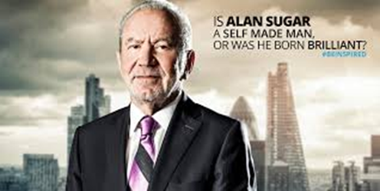
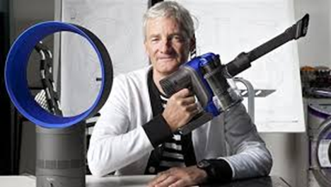

Activity 2 – Research task
You are required to research two successful entrepreneurs, preferably British. These could be anyone who has started a business and who you admire. Have your parents or you ever ran your own business? Think – Lord Sugar, Richard Branson, James Dyson etc.
Use your mobile for RESEARCH ONLY – Fill in the tasks below:
My chosen entrepreneur is:

How did they start their business – You will need to write a short paragraph on the challenges they faced. Did they take a calculated risk? Did they have any qualifications? How old were they? How much did they need to start?

What characterisitcs does your chosen entrepreneur possess?
Characteristics:

Why/ how has these made them successful?

My chosen entrepreneur is:

How did they start their business – You will need to write a short paragraph on the challenges they faced. Did they take a calculated risk? Did they have any qualifications? How old were they? How much did they need to start?

What characterisitcs does your chosen entrepreneur possess?
Characteristics:

Why/ how has these made them successful?

