**Level 2 Beauty Therapy**

**Questions on Hair**

1. Which protein is hair made from?
2. Name the three layers of the hair.
3. What is the medulla of the hair?
4. What is the cortex of the hair?
5. What is the cuticle of the hair?
6. What is vellus hair?
7. What is terminal hair?
8. Label the diagram of the layers of a hair.

A =

A =

B =

C =

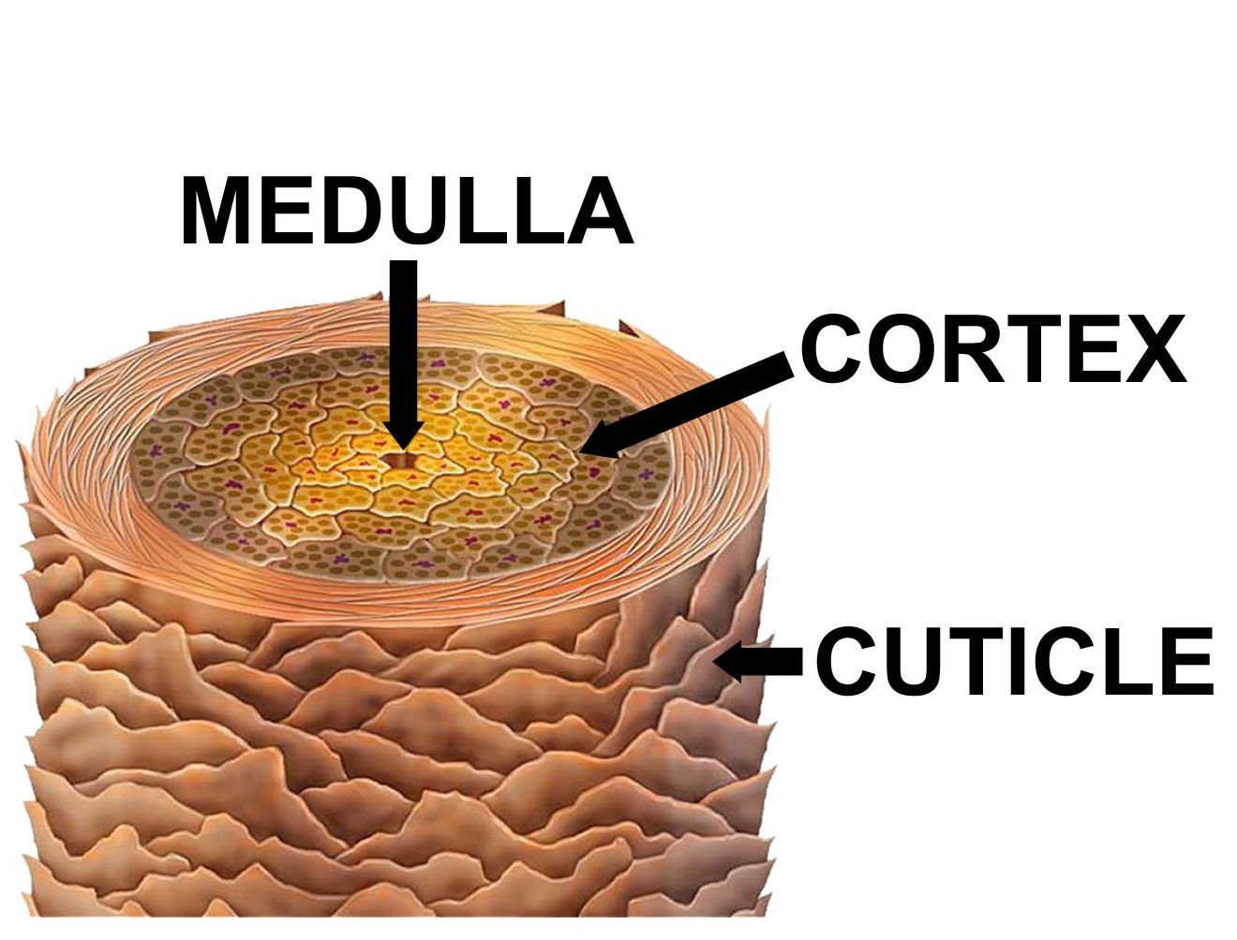

C =

B =

1. Name the three stages of hair growth.
2. Describe what happens in the anagen stage.
3. Describe what happens in the catagen stage.
4. Describe what happens in the telogen phase.
5. On the diagram below, which letters show the various stages of hair growth?

A =

B =

C =

C = 

A = 

B =

