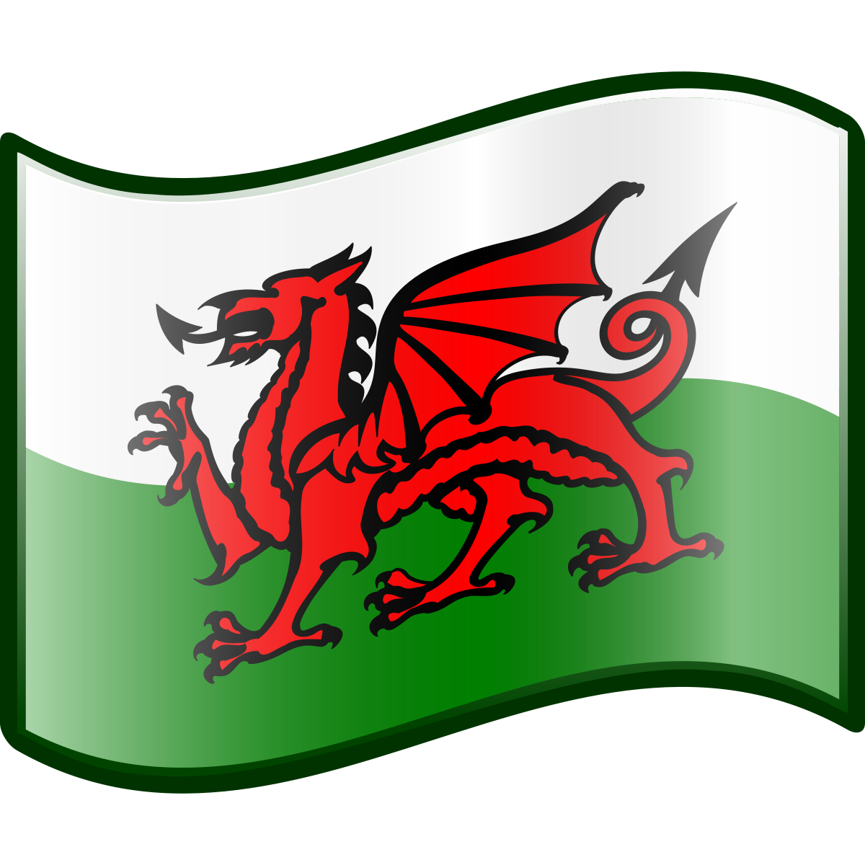
This Photo by Unknown Author is licensed under CC BY-SA

Yr Iaith ar Waith/ Work Welsh

Geirfa Ddefnyddiol/Useful Vocabulary

Dw I’n dysgu Cymraeg – I’m learning Welsh

Sa i’n deall. / Dw i ddim yn deal – I don’t understand

Allet ti/chi ddweud hynny ‘to? - Can you say that again?

Allet ti/chi siarad yn arafach? – Could you speak more slowly?

Greetings
- Bore da - Good morning
- Prynhawn da - Good afternoon
- Noswaith dda - Good evening
- Nos da - Goodnight
- Helô - Hello
- Shw mae? - How are you? (South)
- Sut mae? - How are you? (North)
- Croeso - Welcome
- Hwyl - Bye
- Hwyl am nawr - Bye for now (South)
- Hwyl am rwan - Bye for now (North)
- Beth yw enw chi? - What’s your name?
- (eich new)… dw i? – I’m….(your name)

Common words/phrases/questions

- Plîs – please
- Diolch – thank you
- Da iawn – very good
- Ga i helpu? – May I help?
- Lle dach/wyt chi’n byw? - where do you live?
- Dw i’n byw ____. - I live ____.
- Faint o’r gloch ydy hi? – What’s the time?
- Mae hi’n ___ o’r gloch. - It is ___ o’clock.
- Fi -me
- Ti – you (informal)
- Chi – you (formal)
- Ni – us
- Fe -him
- Hi – her
- Nhw – them
- Dw i'n dy garu di / Rwy'n dy garu di - I love you (formal / informal)
- Cariad - Love
- Llawer o gariad - Lots of love
- Cwtch - Cuddle (South)
- Cwtsh - Cuddle (North)
- Oddi wrth - from
Colours
- Coch – red
- Melyn – yellow
- Gwyrdd- green
- Glas – blue
- Oren – orange
- Porffor – purple
- Pinc -pink
- Brown – brown
- Du – black
- Llwyd – grey
- Gwyn - white

Numbers
- Un - One - 1
- Dau - Two - 2
- Tri - Three - 3
- Pedwar - Four - 4
- Pump - Five - 5
- Chwech - Six - 6
- Saith - Seven - 7
- Wyth - Eight - 8
- Naw - Nine - 9
- Deg - Ten – 10

- Un deg un – eleven-11
- Un deg dau – twelve – 12
- Un deg tri – three – 13
- Un deg pedwar – fourteen -14
- Un deg pump – fifteen – 15
- Un deg chwech – sixteen – 16
- Un deg saith – seventeen – 17
- Un deg wyth – eighteen – 18
- Un deg naw – nineteen – 19

- Dau ddeg – twenty – 20
- Tri deg – thirty – 30
- Pedwar deg – fourty – 40
- Pump deg – fifty – 50
- Chwech deg – sixty – 60
- Saith deg – seventy – 70
- Wyth deg – eighty – 80
- Naw deg – ninety – 90
- Cant – hundred -100
- Mil – thousand – 1000
- Miliwn – million - 1,000,000

Days of the week
- Dydd Llun - Monday
- Dydd Mawrth - Tuesday
- Dydd Mercher - Wednesday
- Dydd Iau - Thursday
- Dydd Gwener - Friday
- Dydd Sadwrn - Saturday
- Dydd Sul - Sunday

Months of the year
- Ionawr - January
- Chwefror - February
- Mawrth - March
- Ebrill - April
- Mai - May
- Mehefin - June
- Gorffennaf - July
- Awst - August
- Medi - September
- Hydref - October
- Tachwedd - November
- Rhagfyr - December
Seasons
- Gaeaf – winter
- Gwanwyn – spring
- Haf – summer
- Hydref - Autumn

Weather
- Sut mae’r tywydd? – How’s the weather?
- Mae'n bwrw glaw - It's raining
- Mae'n bwrw eira - It's snowing
- Mae'n wyntog - It's windy
- Mae'n oer - It's cold
- Mae'n heulog - It's sunny
- Mae’n dwym – It’s warm

Celebrations
- Nadolig Llawen - Merry Christmas
- Blwyddyn Newydd Dda - Happy New Year
- Cyfarchion y Tymor - Season’s greetings
- Penblwydd Hapus - Happy Birthday
- Pob lwc - Good luck
- Dymuniadau gorau - Best wishes
- Llongyfarchiadau - Congratulations
- Iechyd da! - Cheers! (Good health)
- Dydd gwyl Dewi – St David’s Day

