School of Hairdressing and Applied Therapies

Level 1 Diploma in the introduction to the Hair and Beauty sector
Unit UV30339 – Basic Make-up Application workbook

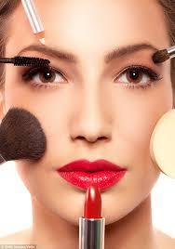
Question | √ or X
Q1
Q2
Q3
Q4
Q5
Q6

Name:

Group:

Date of completion:

Tutor signature & comments:

Literacy Alert:

Q1.State the factors that could influence the choice of basic make-up products and techniques.
Q2. State the importance of the preparation procedures for applying basic make- up.
Q3. State how and when to use products, tools and equipment for basic make-up
Product | Why do we use it? | How do we use it?
Concealers
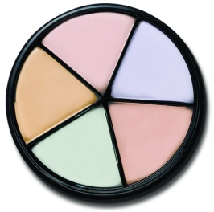

Foundations
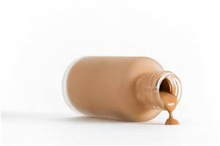

Powder
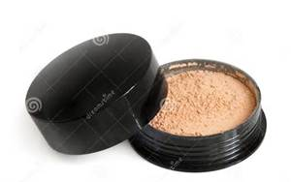

Blusher

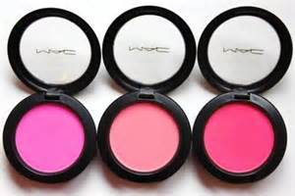

Eyeshadow

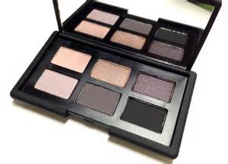

Eyeliner

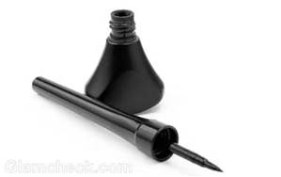

Mascara

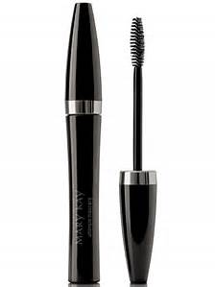

Lipstick

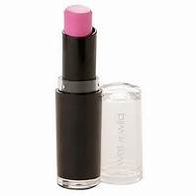

Lipgloss

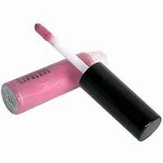

Tools | Why do we use it? | How do we use it?
Palette

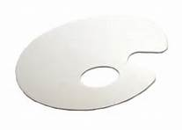

Make up wedges

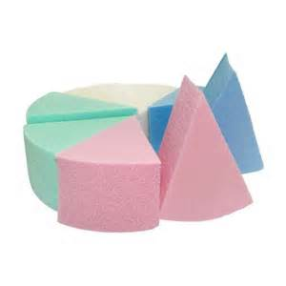
Disposable applicators

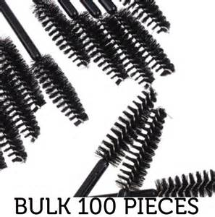

Q4. List examples of contra-indications that may prevent and restrict a make-up treatment
Prevent | Restrict

Q5. State the basic structure and function of the skin
The Skin

What are the functions of the skin?

S-___________________________________
H-___________________________________
A-___________________________________
P-___________________________________
E-___________________________________
S-___________________________________

Label the Cross Section of the Epidermis

Basal layer/ Clear layer/ Prickle cell layer/ Granular layer/ Horny layer

Label the structure of the skin

Sebaceous gland; Pore; Sweat gland; Nerve ending; Blood vessels; Hair follicle; Hair, Epidermis, Dermis; Subcutaneous layer; Erector pili muscle.

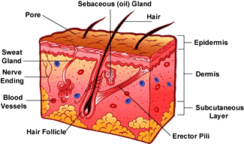

Q6. Label the diagram of the bones of the face
Frontal/ Zygomatic/ Mandible/ Maxillae/ Nasal

