What Are the Steps to Wiring a UK Plug?
- Remove the cover from the plug
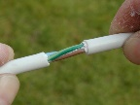
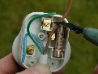
- Remove the outer sheath from the flex to expose the inner cores. Take care not to damage the inner cores while removing the sheath
- Shorten the brown wire
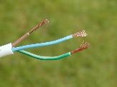
- Remove the insulation from the ends of the wires
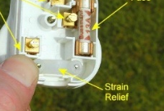
- Twist the strands of wire together
- Feed the wires under the strain relief into the plug
- Double over the ends of the wires
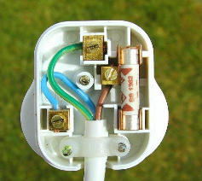
- Insert the brown wire into the live (L) screw terminal and screw tight
- Insert the green/yellow wire into the earth (E) screw terminal and screw tight
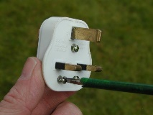
- Insert the blue wire into the neutral (N) screw terminal and screw tight
- Tighten the screws of the strain relief over the sheath (not the cores!) of the flex
- Check all wires are packed away neatly so they can't be caught by the cover
- Screw the cover back onto the plug

