School of Hairdressing and Applied Therapies

Level 1 Diploma in the introduction to the Hair and Beauty sector

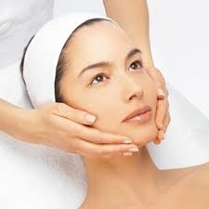
Name:

Group:

Date of completion:

Tutor signature:

Question | √ or X
Q1
Q2
Q3

Literacy Alert:

Q1. State the correct procedure for client preparation.

- Ensure you have provided a detailed consultation.
- Checked for contra-indications.
- Agreed a treatment plan with the client,
- Talk through the treatment step-by-step to ensure the client knows what to expect.
- Allow the client time to undress and get comfortable on the couch. Remove any jewellery in the treatment area. Apply a headband to protect the client’s hair.
Q2. State and BRIEFLY describe the main characteristics of each skin type
- Dry
- Oily
- Combination
- Mature
- Sensitive
Handout on skin types given in first lesson.

Q3. Why is it important to give a skin analysis before beginning treatment?
To determine the client’s skin type, to ensure we are using the correct products and the client is having the correct treatment for their skin type.

