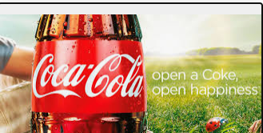

What is the purpose of this text? ________________________________________________________________________________________________________________________________

What layout (organisational) features are used? Why? ________________________________________________________________________________________________________________________________________________________________________________________________________________________________________________________________________________________________________________________________________________________________________________________________

What language features are used? Why?
________________________________________________________________________________________________________________________________________________________________________________________________________________________________________________________________________________________________________________________________

