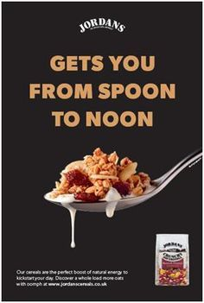

Who is the intended audience?
__________________________________________________________________________________________________________________________________________________________________________
What is the purpose of this text? ________________________________________________________________

What layout (organisational) features are used? Why? ________________________________________________________________________________________________________________________________________________________________________________________________________________________________________________________________________________________________________________________________________________________________________________________________

What language features are used? Why?
________________________________________________________________________________________________________________________________________________________________________________________________________________________________________________________________________________________________________________________________

