School of Construction and Built Environment

ACTIVITY ASSESSMENT SHEET AND ASSESSMENT CRITERIA

BTEC Extended Diploma/ Diploma in Construction
Unit: | 2 Sustainable Construction | Assessment Ref. | 1/2
Assessment title: | Sustainable Construction | Date issued:
Issued by: | Philip Meirion Lewis | Date due: | 04/01/21
Student name: |  | Date received:
Programme: | BTEC Extended Diploma | Year: | 2020/21

Assessment method/s used | Class Exercise |  | Drawing Exercise |  | End of Module Exam |  | Laboratory Activity
 | Observation |  | Portfolio Building |  | Practical Activity |  | Questioning
 | Report |  | Research Based |  | Test

Grading Criteria to be assessed in this exercise: | P1, P2, P3, P4, M1, M2,D1

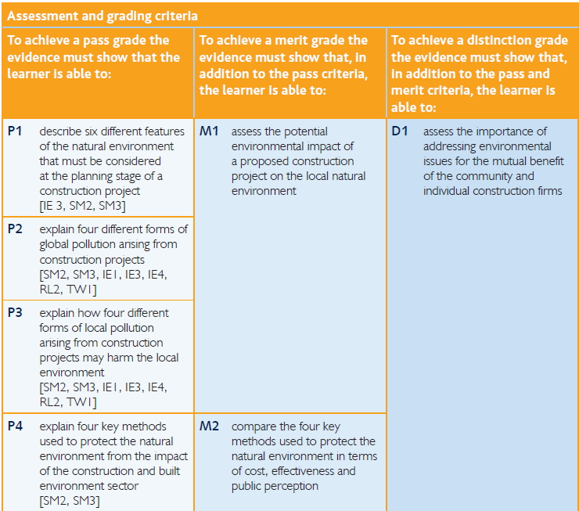

.
Brief has been Internally Verified |  | When? |  | By Who?
Interim Assessment (no grade award until all module assessments are completed) |  | Overall Grade Achieved |  | Points Awarded

STAFF COMMENTS |  | ACTION PLAN
Student signature: |  |  | Date:
Tutor signature: |  |  | Date:
Internally Verified by: |  |  | Date:

Unit Introduction

In recent times we have built far bigger and far more complex buildings than before. For many years the UK has been among the market leaders in this field and UK construction workers are taking their knowledge and expertise all over the world. Modern developments in construction technology and materials have enabled us to create more efficient and complex structures. The ability to design, plan and communicate ideas effectively is essential if a project is to be translated from an idea into reality. Poor communication will lead to poor construction. This unit will encourage You to develop their understanding of the design process and to recognise the contribution of other members of the design team. Planning and organising design activities is related to the decision-making process and the likely outcomes of decisions taken by the team within a legal framework should be considered in the wider social context, rather than as simple subjective preferences. This unit will enable You to cope with the requirements of construction-related projects as they pass through various stages from design to construction, including the implications of changes and variations in the design. You will develop their ability to produce clear drawings of construction components, using
both manual and CAD techniques, together with succinct and accurate explanations that specify for builders the exact characteristics of relevant construction details. Use of scale, proportion and appropriate description is expected of all successful You will be able to use appropriate design and planning procedures to specify for and communicate to other team members involved in a construction project requirements for the technical components of buildings.

Assessment Brief

- Individual report.

You have been employed as an environmental consultant tasked with overseeing the construction of the new super school to be situated on the existing Sandfields Comprehensive Site in Aberavon. You have to present to Neath Port Talbot Council an environmental impact assessment highlighting key areas that will affect the local environment and population.
Note: Consider the causes and effects of global warming and the impact to the environment at a local level.
Produce a report on the key environment features to be considered whilst planning the construction project.

Assessment Tasks

Task Description | Criteria Claimed | Page | Tutor Comment | Achieved | IV
Describe six different features  of the natural environment  that must be considered  at the planning stage of a  construction project | P1
Explain four different forms of  global pollution arising from  construction projects | P2
Explain how four different  forms of local pollution  arising from construction  projects may harm the local  environment | P3
Explain four key methods  used to protect the natural  environment from the impact  of the construction and built  environment sector | P4
Assess the potential environmental impact of a proposed construction project on the local natural environment. | M1
Compare the four key  methods used to protect the  natural environment in terms  of cost, effectiveness and  public perception | M2
Assess the importance of addressing environmental issues for the mutual benefit of the community and individual construction firms. | D1

Achievement Progress

The following target dates identify what grades should be achieved by key dates throughout the academic year.

Key date | Performance Criteria that should be achieved by…..
Christmas
February half term
Easter
Whitsun

Additional Guidance

A close adherence to the grading criteria and the unit specification will enable you to maximise your potential to achieve the highest possible grade.

