Level 3 Diploma in Land-based Engineering Operations (0059-3)

Unit 309 Assignment
Service & Repair Hydraulic Systems and Components

Underpinning Knowledge

Candidate:
OVERVIEW
The aim of this unit is to provide you with the knowledge, understanding and skills required to repair and service hydraulic systems.
This assignment consists of element two of this unit and successful completion will demonstrate that you understand the construction, function and operation of hydraulic circuit systems and their components.

1. Below is a schematic of a simple hydraulic circuit.
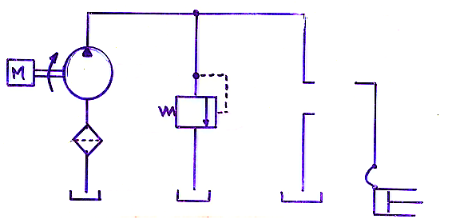
- There are eleven symbols shown. List them and state what they describe.
- There is one blank area that needs a symbol. State an appropriate component that should be inserted here and show its symbol.

2. After testing, you suspect a fault in a recently replaced hydraulic pump and need to remove it from a machines’ system to dismantle and inspect it. Describe the steps you would take from the machine coming into the workshop starting with any H&S actions and housekeeping to when the machine is signed off ready to go back to the customer.

3. State the function of EIGHT of the following listed components and for each one give an example of their application:
- Pressure relief valve | - Directional control valve
- Flow divider valve | - Priority valve
- Proportional valve | - Shock valve
- Pressure differential valve | - Orbitrol valve
- Restrictor | - Variable displacement pump
- Fixed displacement motor | - Reservoir
- Accumulator
4 a) Identify means of diagnostic testing to evaluate the performance of an hydraulic
system.
- Describe ONE suitable means of diagnostic testing used for interpreting and comparing results against manufacturers’ data.

