School of Hairdressing and Applied Therapies

Level 1 Diploma in the introduction to the Hair and Beauty sector
Unit UV30339 – Basic Make-up Application workbook

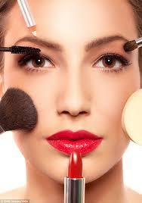
Question | √ or X
Q1
Q2
Q3
Q4
Q5
Q6

Name:

Group:

Date of completion:

Tutor signature & comments:

Literacy Alert:

Q1.State the factors that could influence the choice of basic make-up products and techniques.
- Clients preference
- Occasion
- Skin type
- Skin tone
- Time of event
- Clothes and hairstyle
- Allergies
Q2. State the importance of the preparation procedures for applying basic make- up.
- They are important to achieve a result and the outcome the client wants.
- Prevents reaction to products.
- Preparing the skin creates a good base to ensure a more flawless finish and gives better staying power to make-up.
- Cleansing/ toning and moisturising ensures the skin is fresh and hygienic before applying make-up.

Q3. State how and when to use products, tools and equipment for basic make-up
Product | Why do we use it? | How do we use it?
Concealers  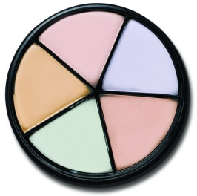 | To conceal and hide any imperfections, balance skin tones and correct colour issues. Can also be used to highlight and contour areas. | Decant the product into a palette and apply using a disposable lip brush. Blend using a sponge.
Foundations
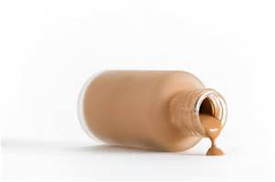

Powder
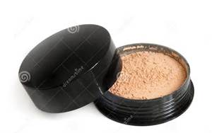

Blusher

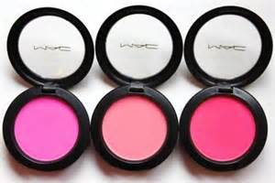

Eyeshadow

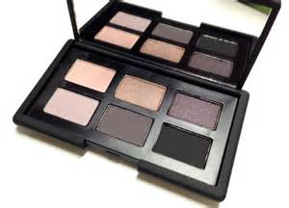

Eyeliner

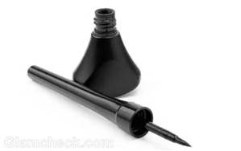

Mascara

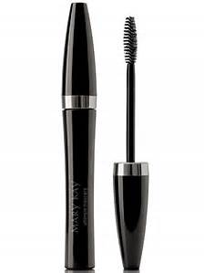

Lipstick

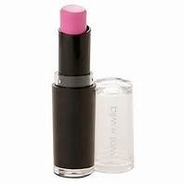

Lipgloss

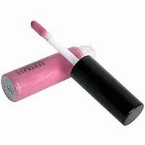

Tools | Why do we use it? | How do we use it?
Palette

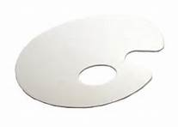

Make up wedges

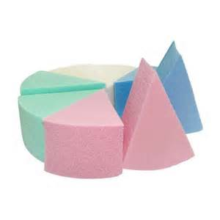
Disposable applicators

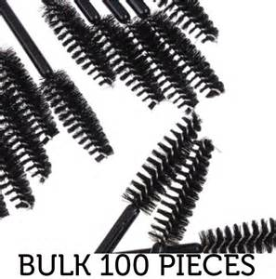

Q4. List examples of contra-indications that may prevent and restrict a make-up treatment
Prevent | Restrict
Common cold | Cuts/ abrasions
Impetigo | Mild eczema
Severe eczema | Mild psoriasis
Severe psoriasis | Piercings
Eye diseases/ disorders | Allergies to products
Warts | Mild bruising

Q5. State the basic structure and function of the skin
The Skin

What are the functions of the skin?

S-__Sensation_______________________________
H-__Heat regulation___________________________
A-__Absorption_______________________________
P-__Protection_______________________________
E-__Excretion________________________________
S-__Secretion________________________________

Label the Cross Section of the Epidermis

Basal layer/ Clear layer/ Prickle cell layer/ Granular layer/ Horny layer

Label the structure of the skin

Sebaceous gland; Pore; Sweat gland; Nerve ending; Blood vessels; Hair follicle; Hair, Epidermis, Dermis; Subcutaneous layer; Erector pili muscle.

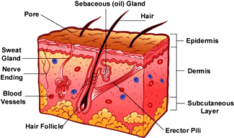

Q6. Label the diagram of the bones of the face
Frontal/ Zygomatic/ Mandible/ Maxillae/ Nasal

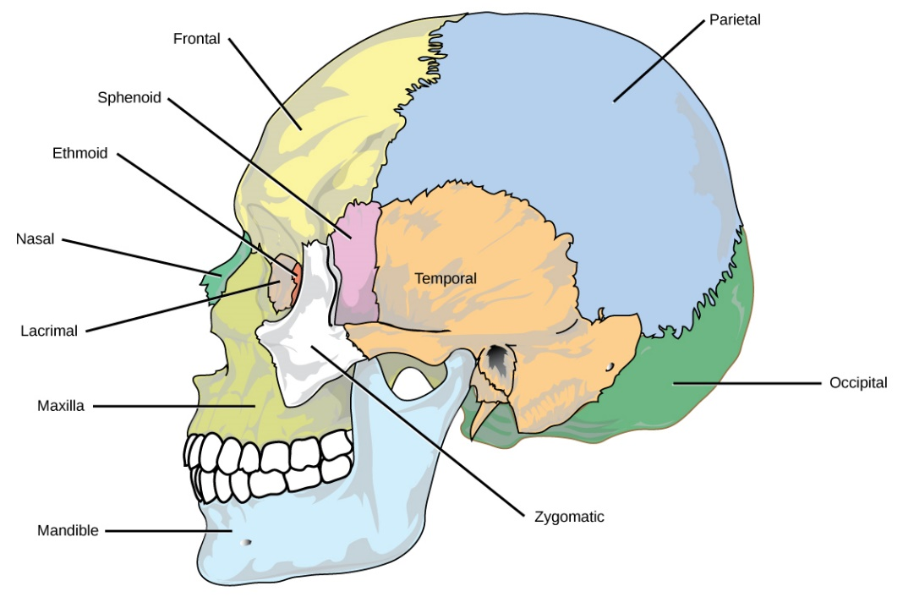
Frontal

Nasal

Maxilla

Zygomatic
Mandible

