Phil Jones
phill.jones@nptcgroup.ac.uk
Teaching & Learning Manager / PGCE Course Director NPTC Group
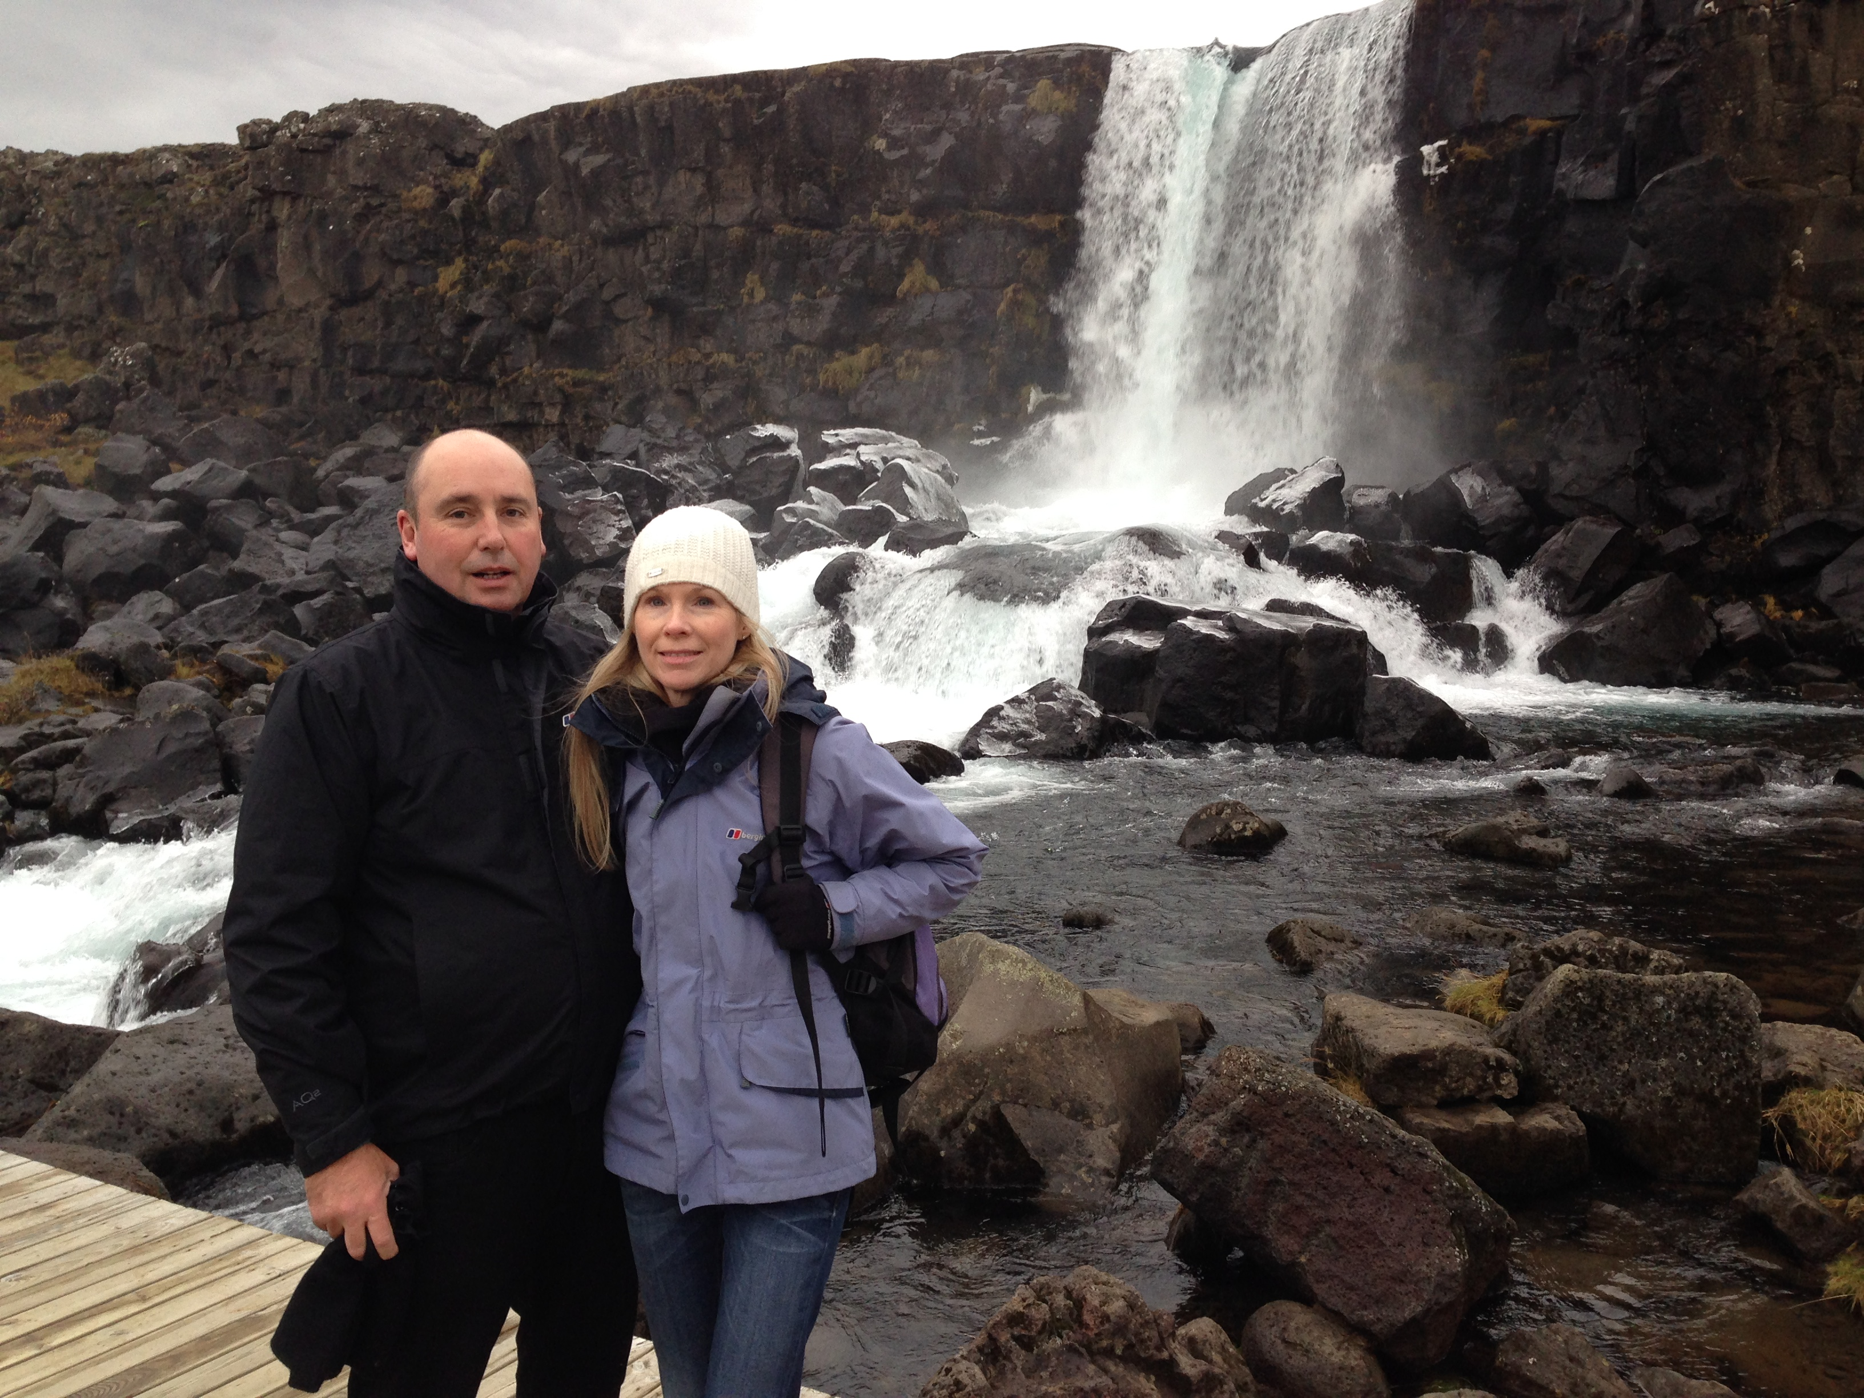
Hi everyone,
I am the Teaching & Learning Manager for NPTC Group of Colleges and the Course Director for the Teacher Training. My first degree is in Biological Sciences, I trained as a Microbiologist and worked in Industry before doing my Teaching Qualifications. I have also completed a Masters Course in Health Promotion & Education.
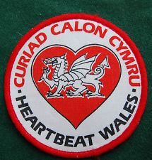
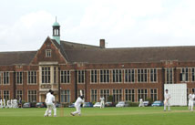
I have taught at NPTC Group for 25 years, teaching mainly Teacher Training, A Level Biology and Forensic Science Level 3 students. Before this I worked for Health Promotion Wales and for a three years I taught at Queen Elizabeth’s School in London.
I am married with one daughter and one grandson Henry who is 10 months old.
I enjoy travelling, sport and skiing. I am currently working on a project with the University of Swansea Engineering Department on developing collaborative teaching spaces.

菲尔·琼斯
phill.jones@nptcgroup.ac.uk
教学与学习经理/PGCE课程主任 NPTC 集团
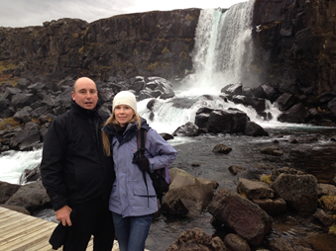

我是 NPTC 学院集团的教学经理和教师培训课程主任。我的第一个学位是生物科学，我受过微生物学家的训练，在攻读教学资格之前曾在工业界工作过。我还完成了健康促进与教育硕士课程。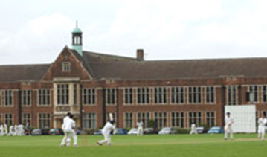

我在NPTC集团任教25年，主要教授教师培训、A级生物学和法医科学三级学生。 在此之前，我为威尔士健康促进会工作，在伦敦伊丽莎白女王学校任教三年。
我已婚，有一个女儿和一个孙子亨利，他10个月大。
我喜欢旅行、运动和滑雪。我目前正在与斯旺西大学工程系合作开发一个项目，以开发协作教学空间。

