Improving Teaching
and Learning through
Assessment for Learning
以学习过程评估促进教与学
Derek Betts

“Since we cannot know what knowledge will be most useful in the future, it is senseless to try to teach it in advance. Instead we should try to turn out people who love learning so well that they will be able learn whatever needs to be learned”.
“如果我们不知道哪些知识在未来是最有用的，那么我们提前教授知识就没有意义。相反，我们应该努力培养出热爱学习的人，使他们能够习得所需掌握的所有知识。”
Nearly 50 years ago the idea of learning to learn was heralded and education experts such as Dylan Wiliam believe that formative assessment or assessment for learning, AfL as it is commonly known, is at the heart of teaching and learning. Wiliam answered his own rhetorical question at a recent Cambridge conference: why should assessment for learning should be the focus of investment?
近50年前，教授如何进行学习的思想出现，包括迪伦·威廉（Dylan Wiliam）在内的很多教育学家就认为，形成性评价或是学习过程评价（AfL）是教育的核心。在剑桥最近举办的一次会议中，威廉提出了一个富有深意的疑问：“为什么学习过程评价应该成为教学投入的焦点？”
“If you are serious about raising student achievement, you have to change what happens in the classroom”.
“要想真的提高学生成就，那么就得改变课堂本身。”
“I would argue that there are five key strategies that encompass the terrain of assessment for learning or formative assessment. And I would say that if you’re not doing one of these five strategies you’re not doing assessment for learning, and if you are doing assessment for learning, you’re doing one of these five things.
“我认为，在学习过程评价和形成性评价中，需要使用五大策略。可以说，如果没有使用这五大策略中的一条，那就算不得进行学习过程评估。反之，如果是在进行学习过程评估，那么必然会涉及这五大策略的使用。”

The five key strategies are:五大策略的内容：

• clarifying and understanding learning intentions and criteria for success
•明确理解学习意图和成功标准。
• engineering effective classroom discussions, questions and tasks that elicit evidence of learning
•设计有效的课堂讨论、问题和任务，以获取学习证据。
• providing feedback that moves learners forward
•提供反馈，帮助学生进步。
• activating students as instructional resources for each other, and
•激励学生成为彼此的教学资源，以及
• activating students as owners of their own learning
•激励学生成为学习的主人。

The “big idea” that ties these together is that we use evidence of student learning to adapt teaching and learning, or instruction, to meet student needs”.
把这些联系在一起的“伟大的思想”是，使用学生学习的证据来适应教学需求，满足学生的需要。
“‘There are two ways to improve your teaching’:
“有两种方法可以提高您的教学水平”：
1. You can self-assess to find your areas of strength and weakness and work
on these.
1.自我评估，找出强项和弱项，集中攻克。
2. You can work on the main factors that make the biggest difference to
student learning”.
– Geoff Petty
2.研究对学生学习影响最大的因素。——杰夫·佩蒂（Geoff Petty）
Dylan Wiliam further argues that “if you are serious about improving teacher quality, you have to improve the effectiveness of existing teachers” and there
is evidence that this can be done. He prefaces this contention by arguing that the ‘quick fixes’ that governments are inclined to introduce – organisational,
curriculum, qualification changes – have little or no impact on student achievement.
迪伦·威廉进一步称，“如果真的想提高教师素质，就必须提高现有教师的工作效率。”有证据表明，这一点是可以实现的。他在这场争论之初指出，政府倾向于引入“快速解决方案”（改变组织机构、课程、资格证书），但政府的这一套方案对于学生没有什么实质性的影响。
His idea that if you are serious about raising student achievement, you have to change what happens in the classroom is echoed by another education theorist
Gert Biesta. He refers (2005) to the “rise of the concept of ‘learning’ and the subsequent decline in the concept of education.”
他认为，要想真的提高学生成就，那么就得改变课堂本身。这一观点得到了另一位教育理论家格特·比斯塔（Gert Biesta）的认同。他指出（2005）“‘学习’这一概念在发展，而教育这一概念渐趋式微。”

“The factors that make students learn best are student activity towards a
challenging goal, and informative feedback on this activity”.
“使学生能够好好学习的因素是，让学生朝着具有挑战性的目标活动迈进以及使学生对该活动进行有益反馈。”
And one expert who has a strong FE and skills following, Geoff Petty, carries the following message on his webpage:
杰夫·佩蒂（Geoff Petty）是一位未来教育和技能方面的专家。他在自己的网页上传达了以下信息：
“There are two ways to improve your teaching”:
1. You can self-assess to find your areas of strength and weakness and work on these.
“有两种方法可以提高您的教学水平”：
1. 自我评估，找出强项和弱项，集中攻克。
2. You can work on the main factors that make the biggest difference to student learning.
2.研究对学生学习影响最大的因素。
Research shows that the two factors making the biggest
difference are:
研究表明，影响最大的两个因素包括：
• Active Learning - set students challenging activities so they apply, and check their learning.
•主动学习-为学生设置具有挑战性的活动，方便学生申请活动并检查学生的学习情况。
• Feedback - learners need information on what they
do well, and how to improve, then they need to act
on this. Teachers can give feedback, but students can
too, with self-assessment and peer assessment. The best feedback (or formative assessment) uses student’s work to diagnose strengths and weaknesses, and to set
individual targets for improvement.
•反馈-学生需要了解自己的长处、改进方法，之后采取行动。教师可以提供反馈，但学生也可以通过自我评估和同伴评估的方式了解自己的情况。最佳反馈（或形成性评价）通过学生完成的任务评估学生的优势和劣势，帮助学生制定个人的改进目标。
“Teachers can give feedback, but
students can too, with self-assessment
and peer assessment”.
“教师可以提供反馈，但学生也可以通过自我评估和同伴评估的方式了解自己的情况。”
How do we know that active learning and feedback have the greatest effect on student achievement?
我们如何知道主动学习和反馈对学生成绩的影响最大？
Professor John Hattie has synthesized over half a million of the most effective research studies on teaching methods, and the other variables that affect achievement. This is the biggest and most authoritative review of classroom-based educational research ever undertaken. He concludes that the factors that make students learn best are student activity towards a challenging goal, and informative feedback on this activity.
约翰·哈蒂（John Hattie）教授整理出五十多万种最有效的教育方法研究，以及影响成绩的其他变量。这是有史以来对课堂教育规模最大也是最为权威的评估。他得出的结论是，使学生能够好好学习的因素是，让学生朝着具有挑战性的目标活动迈进以及使学生对该活动进行有益反馈。
“The challenge is to attract the attention of teachers and trainers to Assessment for Learning as a way of improving their own skills and those of their learners”.
“挑战在于如何能够促使教师和培训师对学习进行评价，让他们更好地提升自身以及学生的能力。”
And just in case we are still unsure, the Campaign for Learning has published a piece of American research, which interprets what Confucian philosophy taught the
World 1,980 years ago about hearing, seeing and doing!
如果大家仍对此抱有疑问的话，可以看看《学习运动》最近发表了一篇美国的研究报告。该报告解读了儒家在1980年以前对耳闻、眼见和行动的看法！
The Learning Pyramid*
学习金字塔*
*Adapted from National Training Laboratories, Bethel, Maine
*改编自缅因州伯特利国家培训实验室
So it seems absolutely clear that the goal is to persuade teachers and trainers and their institutions to adopt as common practice, the knowledge and skills that are encapsulated in ‘Learning to Learn’ methodology in order to improve teaching and learning performances.
因此，有一点十分明确的目标便是游说教师、培训师以及相关的机构将“教授如何进行学习”的方法中所包含的知识和技能转为普遍准则，提高教学效果。
The real issue seems to be that although we ‘know’ about AfL and ‘Learning to Learn’ methodology in the sector, ‘knowing’ doesn’t seem to equate to doing enough about it in some institutions, otherwise we wouldn’t have witnessed a number of action research projects being carried by individual teachers into the use of AfL as though it was a new idea. The challenge is to attract the attention of teachers and trainers to Assessment for Learning as a way of improving their own skills and those of their learners.
真正的问题在于，尽管我们“了解”该领域的AfL以及“教授如何进行学习”的方法，但“了解”似乎并不等于一些机构为此付出了很多的努力。否则我们就不会看到，个别教师在将一些研究项目引入AfL之时，就像之前从未接触过AfL一样。我们的挑战是如何能够促使教师和培训师进行教学评估，以便改善他们自身的技能以及学生的能力。
Average Retention Rates
Passive Teaching Methods
消极的教学方法
5% Lecture
10% Reading
20% Audio-Visual
30% Demonstration
5%的演讲
10%的阅读
20%的视听
30%的展示
Participatory Teaching Methods
参与式教学方法
50% Group Discussion
75% Practice
90% Teaching Others
50％小组讨论
75％练习
90％教他人
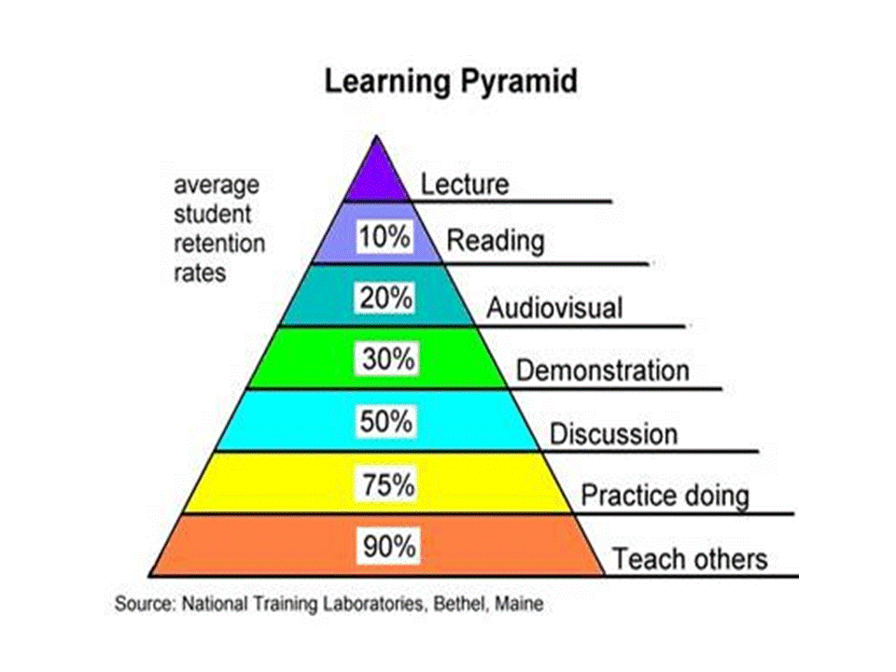
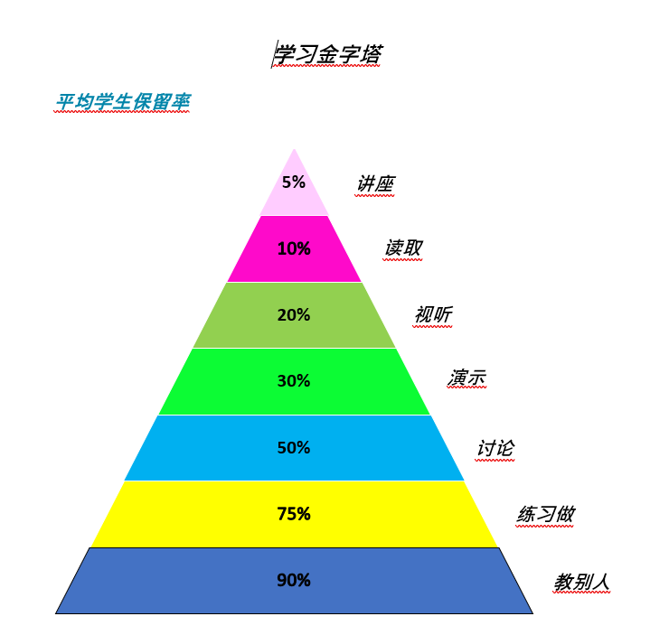

References
Assessment Reform Group (2002), Assessment for Learning: 10 principles.
Hodgson, C. and Pyle, K. (2010), A Literature Review of Assessment for Learning in Science, Slough: NFER.
Black, P. and William, D. (1998), Inside the Black Box, London: Kings’ College.
参考文献
评估改革小组（2002），《学习评估：十项原则》。
Hodgson, C. and Pyle, K. (2010),《科学学习评估的文献综述》，Slough：NFER。
Black, P. and William, D. (1998),《黑匣子中》，伦敦：国王学院。

