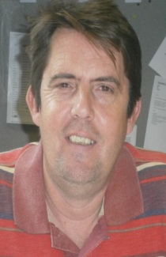

Tony Burgoyne brief statement
Having been employed in the hospitality trade from a young age, I spent most of my working life away from the UK, working and living abroad from the age of 20.
Living and working in Australia for 2 years, America 1 year, United Emirates Abu Dhabi and Sharjah 2 years, Hong Kong 1 year and i have also worked in Europe, France, Italy and Spain.
I then returned to the UK, back to Wales where I now live with my Family, my wife and two children and the dog.
Traveling to new places and meeting people has always been an important and rewarding experience for me. Culture, Ethos and different ways of life are all there to be experienced and enjoyed. I am a fluent French speaker both written and orally.
I travel to Hong Kong, Macau and the Chines new territories on a regular basis as I have family living there. I believe that you are never too old to learn and that travel defiantly broadens your horizons.
I started my teaching career by accident training apprenticeships, learners in the work place. This then led me to complete my teaching Degree in Education from the University of South Wales working for Colleg Powys, now known as NPTCgroup of colleges.
I have progressed well in my career as I am now a Senior Lecturer responsible for Hospitality and catering, Agricultures and horticulture. This covers all aspects of teaching learning and Pedagogy.
I also coordinate the Professional Graduate Teaching Programme on the Newtown Campus, as well as delivering on the programme, being an Associate lecturer for University of South Wales.
I have held the position of Staff Governor for 5 years and still have 3 more years to complete my elected term.
I have been involved with overseas student exchanges and collaborative relationships since 2008, organising and traveling with student to China, Bratislava and several European countries.
My interests are learning more about different cultures and languages, I coach rugby for WRU and work with my local scout association. I have a French wife, we were married in France and plan to live there when we retire.

