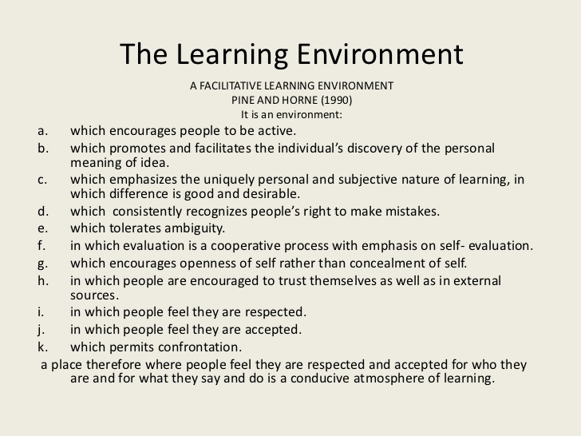
Making friends…. Put a line under all the words you are unsure of ask your if they know the meaning of these words…. If there are any words left not understood write on the white-board.
Discuss these aspects in your group. Identify how you achieve these aims.

Also add… opportunity to work in a group with others
- Interpersonal interactions. ...
- Physical environment. ...
- Program support structure. ...
- Professional and stable teacher workforce. ...
- Effective leadership. ...
- Age-appropriate curriculum. ...
- Comprehensive family engagement activities.

