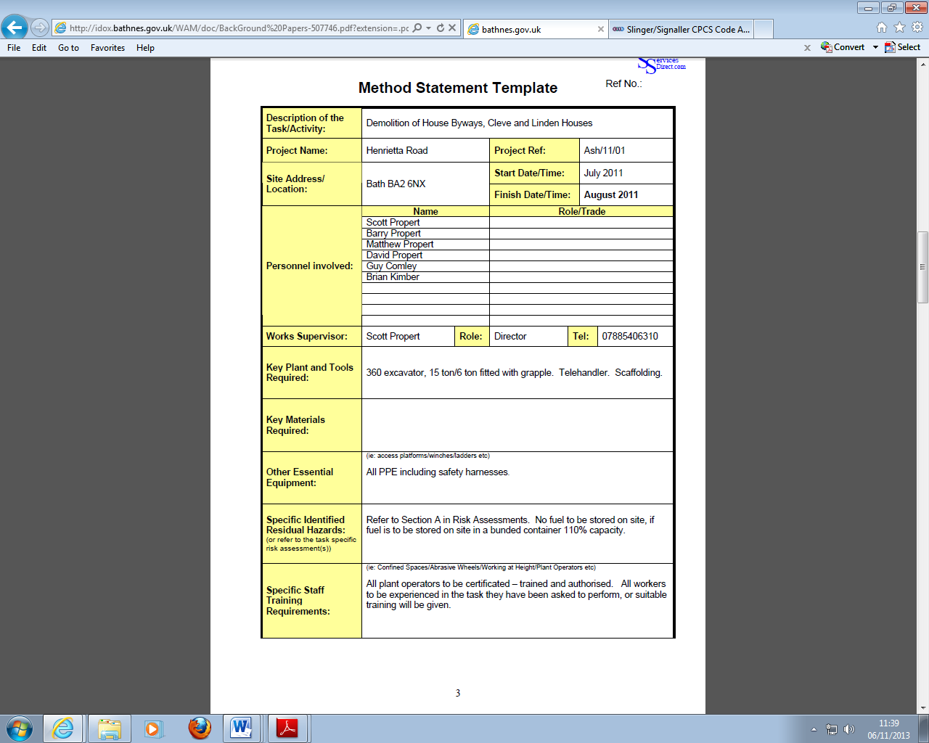

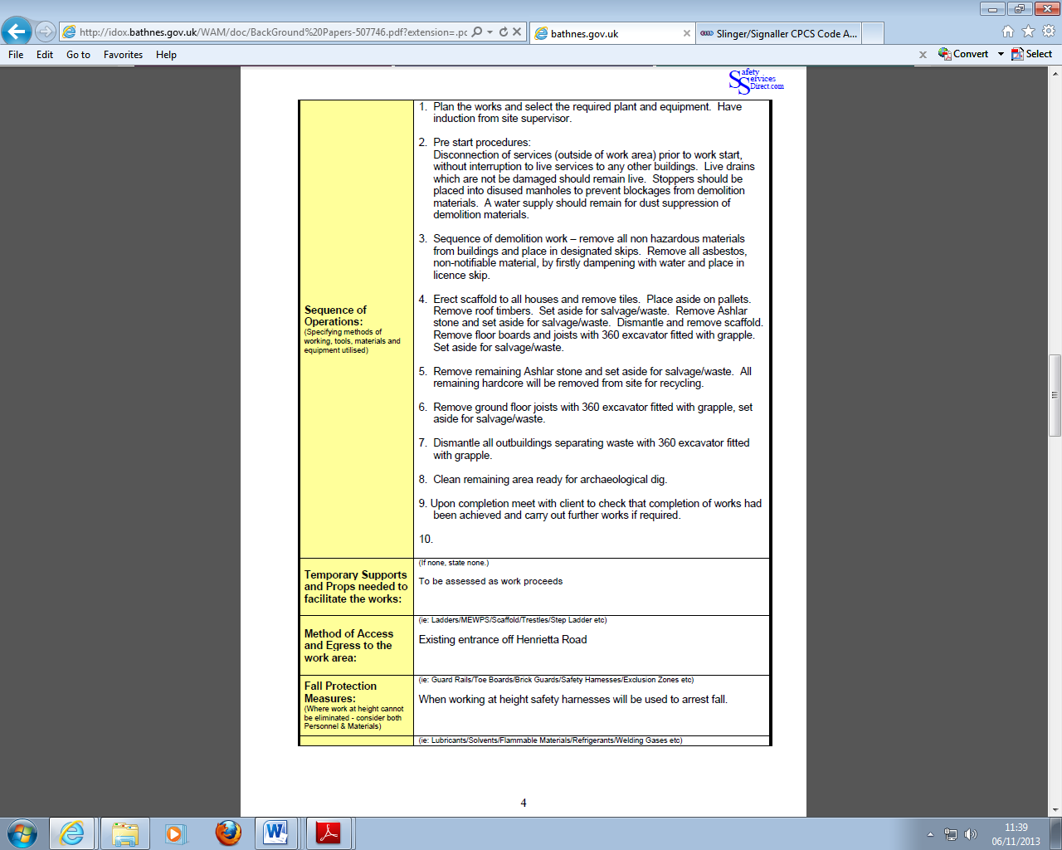

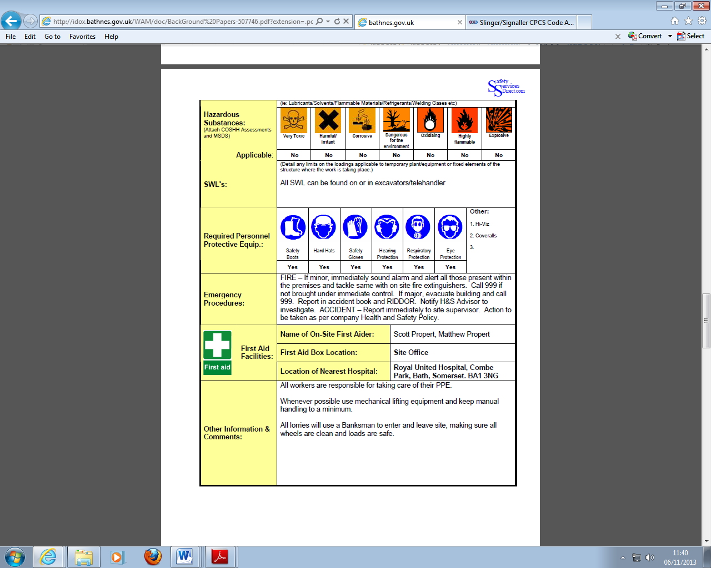

Blank:

|  |  |  |  |  |  |  |  |  |  |  |  |  |  |
| --- | --- | --- | --- | --- | --- | --- | --- | --- | --- | --- | --- | --- | --- |
| Method Statement | | | | | | | | | | | | | |
| **Description of the Task/Activity:** |  | | | | | | | | | | | | |
| **Project Name:** |  | | | | | | | | **Project Ref:** | | |  | |
| **Site Address/ Location:** |  | | | | | | | | start | | |  | |
| finish | | |  | |
| **Personnel involved:** | Name: | | Role/trade | | | | | | | | | | |
|  | |  | | | | | | | | | | |
|  | |  | | | | | | | | | | |
|  | |  | | | | | | | | | | |
|  | |  | | | | | | | | | | |
|  | |  | | | | | | | | | | |
| **Works Supervisor:** |  | | Role: | |  | | | | | Tel: | |  | |
| **Key Plant and Tools Required:** |  | | | | | | | | | | | | |
| **Key Materials Required:** |  | | | | | | | | | | | | |
| **Other Essential Equipment:** |  | | | | | | | | | | | | |
| **Specific Identified Residual Hazards:**  (or refer to the task specific risk assessment(s)) | Refer to Section A in Risk Assessments. No fuel to be stored on site, if fuel is to be stored on site in a bunded container 110% capacity. | | | | | | | | | | | | |
| **Specific Staff Training Requirements:** | (ie: Confined Spaces/Abrasive Wheels/Working at Height/Plant Operators etc)  All plant operators to be certificated – trained and authorised. All workers to be experienced in the task they have been asked to perform, or suitable training will be given | | | | | | | | | | | | |
| **Sequence of Operations:**  (Specifying methods of working, tools, materials and equipment utilised) |  | | | | | | | | | | | | |
| **Temporary Supports and Props needed to facilitate the works:** |  | | | | | | | | | | | | |
| **Method of Access and Egress to the work area:** |  | | | | | | | | | | | | |
| **Fall Protection Measures:**  (Where work at height cannot be eliminated - consider both Personnel & Materials) |  | | | | | | | | | | | | |
|  | ie: Lubricants/Solvents/Flammable Materials/Refrigerants/Welding Gases etc) | | | | | | | | | | | | |
| **Hazardous Substances:**  (Attach COSHH Assessments and MSDS) | **Very Toxic** | | | | |  | **Dangerous for the environment** | | | | | |  |
| **Harmful/ Irritant** | | | | |  | **Oxidising** | | | | | |  |
| **Corrosive** | | | | |  | **Highly flammable** | | | | | |  |
|  | | | | |  | **Explosive** | | | | | |  |
| **Applicable** | Yes/no | | | | | | | | | | | | |
| **SWL's:** |  | | | | | | | | | | | | |
| **Required Personnel Protective Equip.:** |  |  | |  | | | |  | | | other | | |
| Yes/no |  | |  | | | |  | | |  | | |
|  |  | |  | | | |  | | | other | | |
| Yes/no |  | |  | | | |  | | |  | | |
| **Emergency Procedures:** | Fire:  Injury (hospital/Ambulance): | | | | | | | | | | | | |
| **First Aid Facilities:** | **Name of On-Site First Aider:** | |  | | | | | | | | | | |
| **First Aid Box Location:** | |  | | | | | | | | | | |
| **Location of Nearest Hospital:** | |  | | | | | | | | | | |
| **Other Information & Comments:** |  | | | | | | | | | | | | |

All work will be undertaken by qualified competent persons with experience of the type of work described above, and in all cases in full accordance with safety procedures specified in the companies Health and Safety Policy.

**Prepared by: ……………………………………………………………………………..**

**Position: Date: …………………………………………………………………………..**

**Reviewed by: ……………………………………………………………………………..**

**Position:……………………………………………………………………………………**

**Date: …………………………………………………………..…………………………..**

