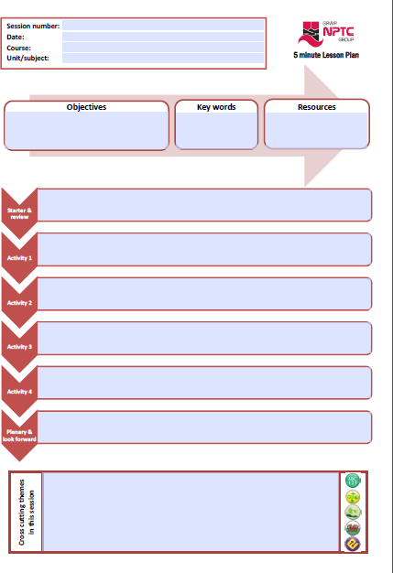
Guidance for completion of the 5 Minute Lesson Plan

完成5分钟课程计划指南
Date needs to be in the format: 01/01/2015
日期需要参照的格式：01/01/2015

E.g. Extended Diploma in Performing Arts
例如：表演艺术的扩展文凭
E.g. Unit 1 – Health and Safety
例如：第1单元-健康和安全

An objective is a clear statement of something that needs to be completed over a period of time.
目标是对于某个需要在某段时间内完成的事情的详细陈述。

A series of logical activities to enable the students to achieve the learning objectives. The focus must be on what the learners are actually doing with the knowledge, skills and competencies they are acquiring because learning does not occur through just listening, actions are also required.
一系列逻辑活动旨在让学生达成学习目标。重点必须放在学习者利用他们所获得的知识、技能和能力实际做了什么，因为学习不仅仅是通过听来发生的，还需要行动。
Cross reference the session number to the scheme of work for the unit/subject
将课程编号与单元/学科的工作计划相互对照
List the main ‘key words’ in this session and communicate these to the students – it will allow them to find the information they require around the topic faster.
列出本次课程的关键词帮和学生沟通-这会让他们更快发现他们所需要主题的信息。

Provide a list of specific resources (above and beyond what would normally be available for your session).提供一个具体资源的清单（你的课程中所有一般所用得到的）

Use an activity to review the learning that has taken place to date and to put this session in context.
用一次活动来回顾最新学习过的内容并把课程内容添加进来。

Follow this by a starter exercise to engage the students, to activate prior knowledge and provide a clear focus on the learning to create a purposeful atmosphere.
在此之后，通过一个启动练习来吸引学生，激活之前的知识，并提供一个明确的学习重点，以创建一个有目的的氛围。

A short activity to wind up the session, to summarise the main learning points and to note progress against the achievement of the session objectives. Look forward to the next session and its content and key words.

用一场简短的活动来结束整节课，概括学习要点同时记下本节课针对学习目标成就的进程。展望下一节课
及相关的内容和关键词。

IIf you naturally cover some elements of cross cutting themes during this session, 5please provide some detail about the content you will explore.
如果你在这节课中自然地涵盖了一些交叉主题的元素，请提供一些你将探索的内容的细节。
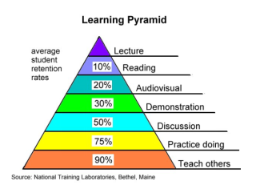
5 cross cutting themes:
Literacy and numeracy Equality and diversity
Education for sustainable development and
global citizenship (ESDGC) Welsh language and culture Enterprise and employability
5个交叉主题:
识字和算术；平等和多样性；
可持续发展教育和
全球公民(ESDGC)；威尔士语和文化；企业和就业能力

