Linda Kelly Pen Portrait 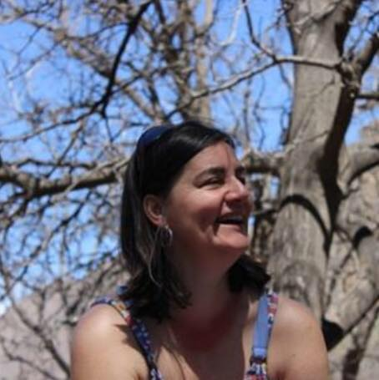

I originally studied Architectural Stained Glass at Swansea School of Art and opened a small business in 1986 for the design, manufacture and repair of stained glass and leaded lights. I specialised in creating leaded lights for restoration and renovation projects, ensuring the new fit seamlessly with the old.
I entered teaching in 1997 and have taught across a wide range of programmes, including Business, Management, Information Technology, Travel and Tourism and AAT. Since entering education I have continually updated and developed my skills including gaining a BA Hons in IT and Management; PGDip in eCommerce; CMI Executive Diploma in Management; Master’s in Business Administration and a CIPD Diploma in HR Management. I am an Associate Member of the Chartered Institute of Personnel and Development. I am currently studying towards a Doctorate in Education with the University of Wales Trinity St Davids.
My teaching career started in Coleg Powys in Brecon where I worked for 7 years before moving to Herefordshire and Ludlow College in 2004. Whilst working at HLC one of my roles was Centre Coordinator for NVQs and apprenticeships in Management, Business and Administration and Customer Service. Part of my teaching role has been to be a personal tutor for various groups where responsibilities have include providing pastoral care, tracking progress and success rates, and marketing future courses. Quality is an important part of all courses delivered, I look at quality standards in detail and conduct quality audits.
Since 2015 I have been a Standards Verifier for Pearson and monitor and review work sent to me by different centres, I am also an examiner for Pearson. Both roles require me to regularly attend standardisation meetings and complete online training to enable me to complete the role to the best of my ability.
In 2016 I returned to Brecon College, which is now part of the Neath Port Talbot Group of Colleges, where I teach Information Technology and Business Studies. I have thoroughly enjoyed returning to Brecon and its beautiful surroundings. My hobbies include walking, skiing, scuba diving and canoeing down the River Wye. I also enjoy travelling and meeting people and experiencing their culture first hand. I regularly organise treks to Morocco and the Sahara and am planning to return to Everest Base Camp in 2022.
I live in Mid Wales with my husband and two grown-up children. I also have a gorgeous grandson whom I love spending time with. I have a very soppy rescued dog called Belle.

