Paper 29.1E Bearings

Name:

These answers will form part of your assessment for this module. Think carefully about your answers.

There are many three main types of bearings, but many variations and combinations of these three basic types. Ball bearings (which use spherical balls to carry the loads), roller bearings (which replace the balls with barrel shaped rollers) and journal (or plain) bearings (which do not use rolling elements but separate the shaft from the bearing surface with a thin film of oil.

- Which type of bearing can carry the heaviest load (size for size)?

- Which bearing type can naturally carry axial (thrust) loads?

- Which type of bearing has self aligning properties?

- Who is the original manufacturer of the ‘split roller bearing’?

- What type of lubrication is used in journal bearings?

- TRUE or FALSE, the load carrying capability of a journal bearing relies on the rotation
of the shaft (when slow moving it can carry very little load).

- What type of lubrication is used in slow moving bearings?

- What type of lubrication is used in fast rotating bearings?

- How can a roller bearing be made to carry axial load (thrust)?

- How can the load bearing capacity of a ball bearing be increased?

- How can the load bearing capacity of a journal bearing be increased?

- If a lubricant with a higher viscosity than advised is used in a bearing, what might
happen?

- If we reduce the viscosity of the lubricant in a bearing, does the power consumption go
UP or DOWN?

- What type of seal is shown below?
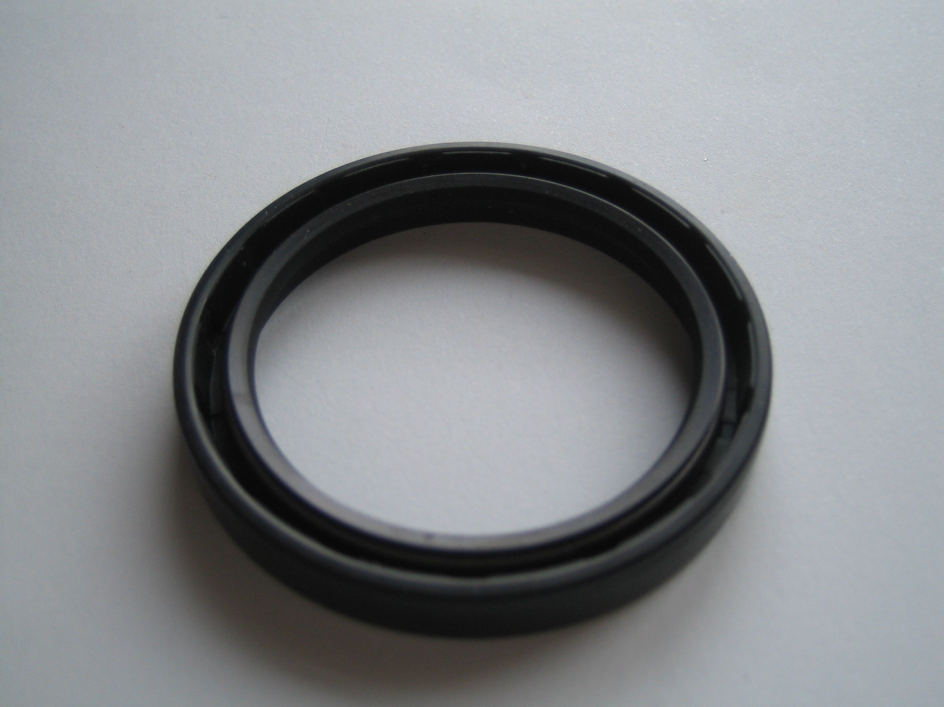

- What type of seal is shown below?
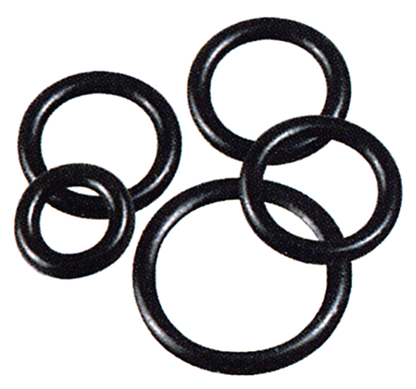

- What type of seal is shown below?
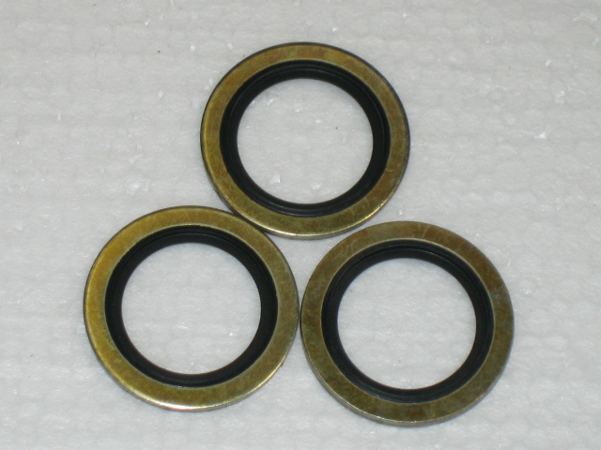

- The seal above has a steel surround and a rubber inner, what function does the steel
surrounds have?

- TRUE or FALSE, the designation number etched into the side of a bearing will be the
same whichever company manufactured it.

- What does the ‘dot fit’ of a bearing indicate?

- If a bearing is a very tight (interference fit) on a shaft, what can we do to the bearing to make it fit easier?

